COE 561, Term 091

Digital System Design and Synthesis

HW# 2 Solution

Due date: Sunday, Dec. 6

Consider the function F(A,B,C,D) with the following ON-set and DC-set:

F^{ON}= ∑m(0, 1, 2, 3, 5, 7, 8, 10, 12, 13)

F^{DC}= ∑m(4, 15)

Compute the off-set using the recursive complementation procedure outlined in section 7.3.4

Apply the EXPAND procedure on the given cover using Espresso heuristics and show the obtained expanded cover. Compare your solution with the result obtained by ESPRESSO tool. Note that if there are minterms of the same weight, expand the minterm with the least number first (i.e. expand minterm 8 before 10). Similarly if raising all literals has the same benefit, expand the literals according to their order (i.e. literal A before B).

Apply the IRREDUNDANT procedure on the expanded cover using Espresso heuristics and show the obtained irredundant cover. Compare your solution with the result obtained by ESPRESSO tool.

Determine if any of the obtained prime implicants is an essential prime implicant or not using the method outlined in section 7.4.4. If it is essential, remove it from the cover and make the on-sets covered by it don’t cares.

Apply the REDUCE procedure on the irredundant cover using Espresso heuristics and show the obtained reduced cover. Compare your solution with the result obtained by ESPRESSO tool.

Apply the EXPAND procedure again on the obtained reduced cover using Espresso heuristics and show the obtained expanded cover. Compare your solution with the result obtained by ESPRESSO tool.

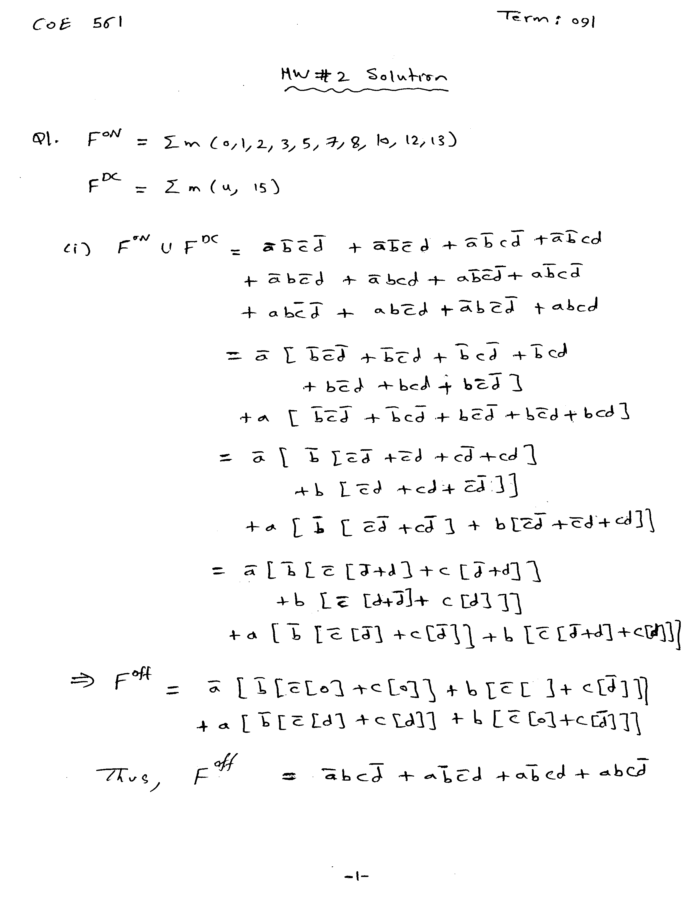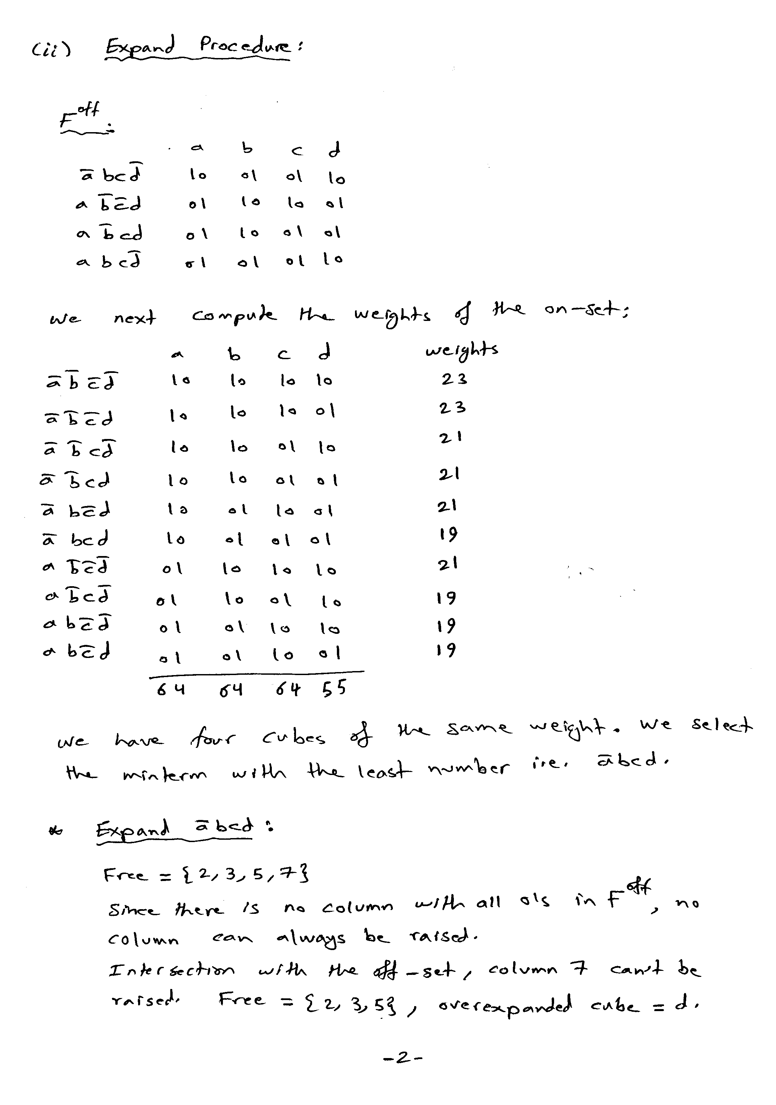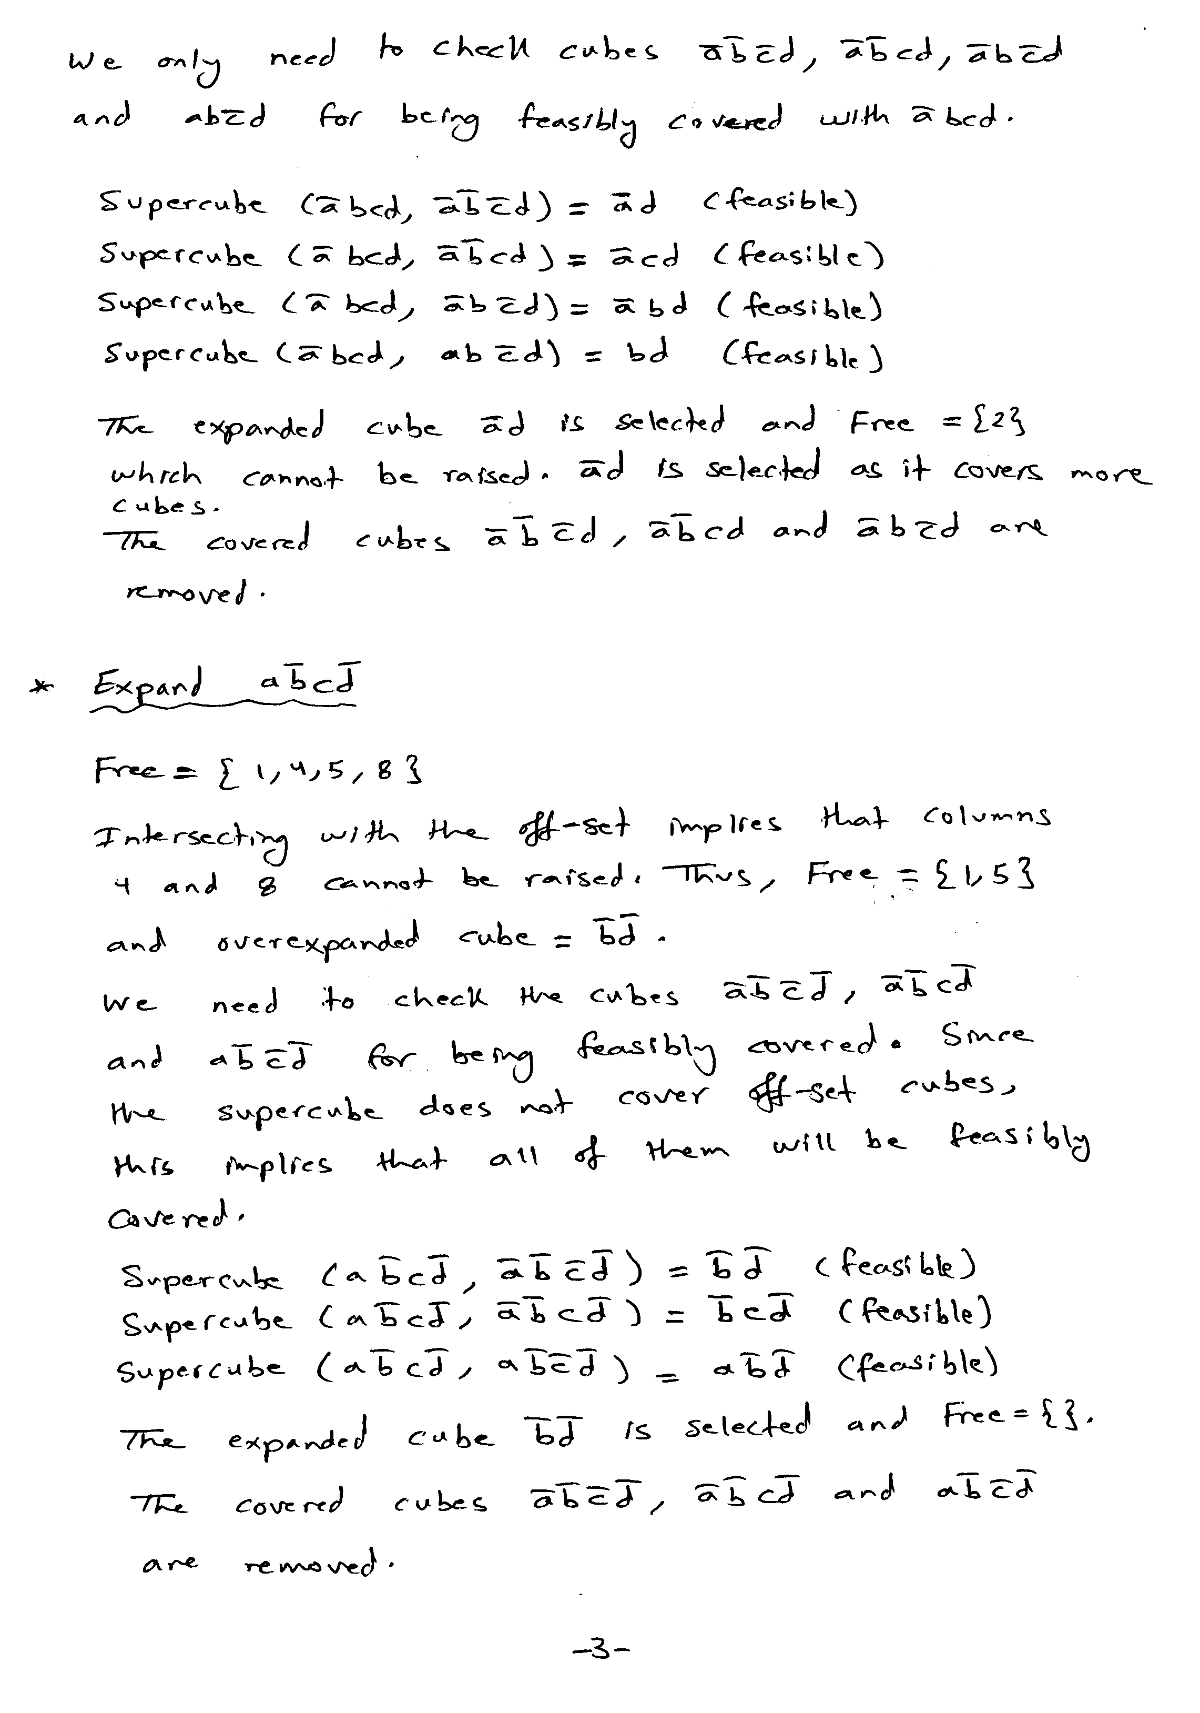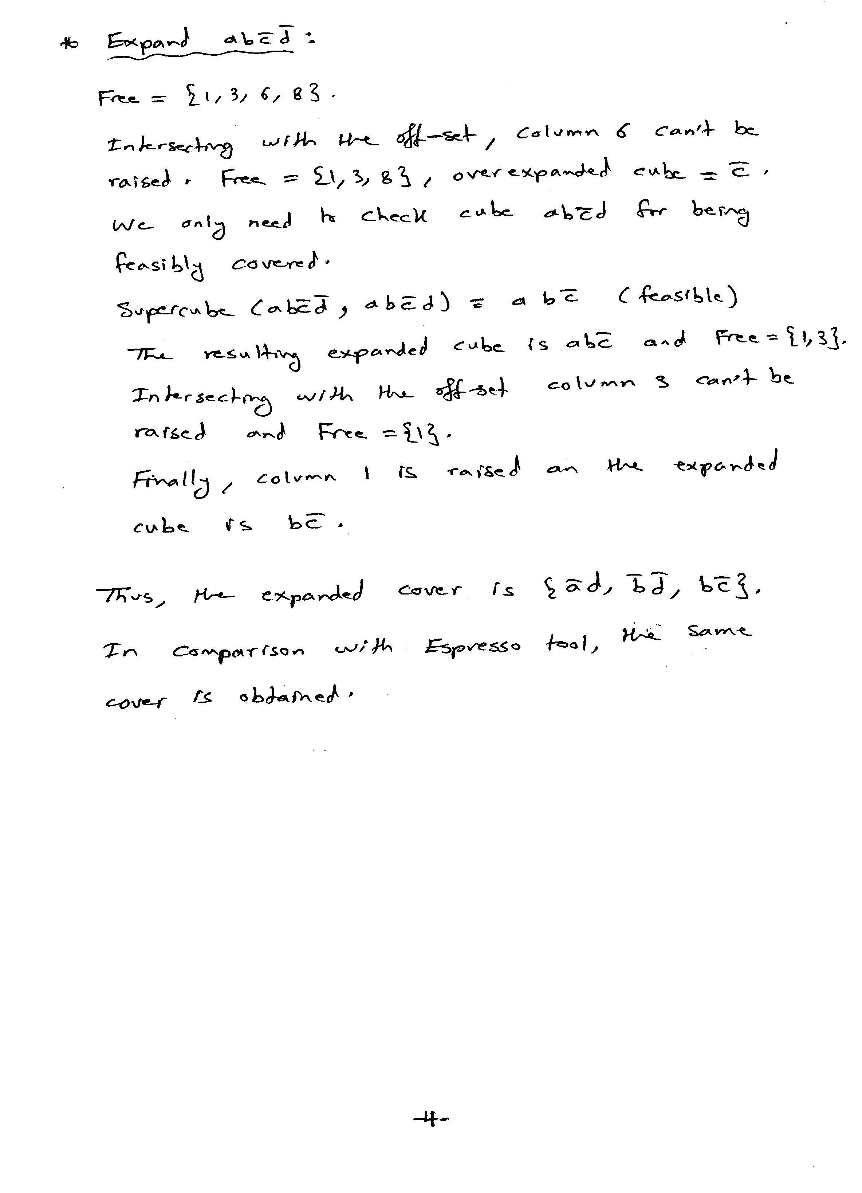

hw2q1ii.pla

.i 4
.o 1
.ilb a b c d
.olb y
.p 10
0000 1
0001 1
0010 1
0011 1
0101 1
0111 1
1000 1
1010 1
1100 1
1101 1
0100 -
1111 -
.e

D:\Courses\coe561\091>espresso -d -t -Dexpand hw2q1ii.pla > hw2q1ii_expand.pla
# espresso -d -t -Dexpand hw2q1ii.pla
# UC Berkeley, Espresso Version #2.3, Release date 01/31/88
.olb y
# READ Time was 0.00 sec, cost is c=10(10) in=40 out=10 tot=50
# COMPL Time was 0.00 sec, cost is c=2(2) in=6 out=2 tot=8
# PLA is hw2q1i.pla with 4 inputs and 1 outputs
# ON-set cost is c=10(10) in=40 out=10 tot=50
# OFF-set cost is c=2(2) in=6 out=2 tot=8
# DC-set cost is c=2(2) in=8 out=2 tot=10
EXPAND: 1100 1 (covered 2)
EXPAND: 1010 1 (covered 3)
EXPAND: 0111 1 (covered 2)
# EXPAND Time was 0.00 sec, cost is c=3(0) in=6 out=3 tot=9
# READ 1 call(s) for 0.00 sec ( 0.0%)
# COMPL 1 call(s) for 0.00 sec ( 0.0%)
# EXPAND 1 call(s) for 0.00 sec ( 0.0%)
# expand Time was 0.00 sec, cost is c=3(0) in=6 out=3 tot=9
.i 4
.o 1
.ilb a b c d
.p 3
-10- 1
-0-0 1
0--1 1
.e
# WRITE Time was 0.00 sec, cost is c=3(0) in=6 out=3 tot=9

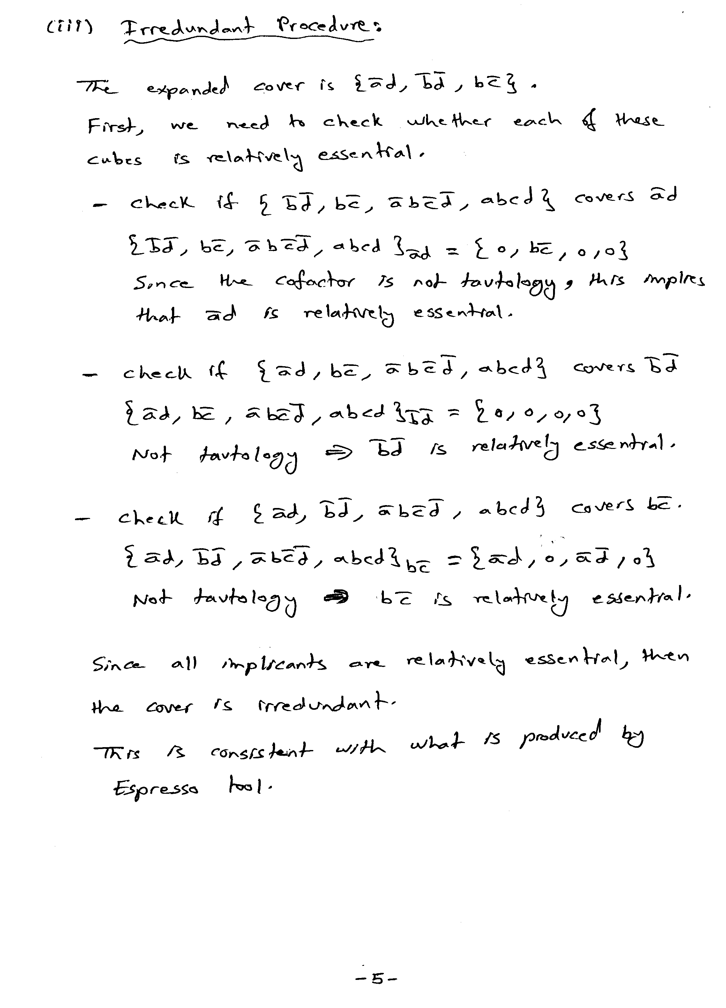
D:\Courses\coe561\091>espresso -Dirred -t -d hw2q1ii_expand.pla > hw2q1iii_irred.pla

# espresso -Dirred -t -d hw2q1ii_expand.pla
# UC Berkeley, Espresso Version #2.3, Release date 01/31/88
.olb y
# READ Time was 0.01 sec, cost is c=3(3) in=6 out=3 tot=9
# COMPL Time was 0.00 sec, cost is c=0(0) in=0 out=0 tot=0
# PLA is hw2q1ii_expand.pla with 4 inputs and 1 outputs
# ON-set cost is c=3(3) in=6 out=3 tot=9
# OFF-set cost is c=0(0) in=0 out=0 tot=0
# DC-set cost is c=0(0) in=0 out=0 tot=0
# IRRED: F=3 E=3 R=0 Rt=0 Rp=0 Rc=0 Final=3 Bound=0
# IRRED Time was 0.00 sec, cost is c=3(3) in=6 out=3 tot=9
# READ 1 call(s) for 0.01 sec (93.7%)
# COMPL 1 call(s) for 0.00 sec ( 0.0%)
# IRRED 1 call(s) for 0.00 sec ( 0.0%)
# irred Time was 0.03 sec, cost is c=3(3) in=6 out=3 tot=9
.i 4
.o 1
.ilb a b c d
.p 3
-10- 1
-0-0 1
0--1 1
.e
# WRITE Time was 0.00 sec, cost is c=3(3) in=6 out=3 tot=9

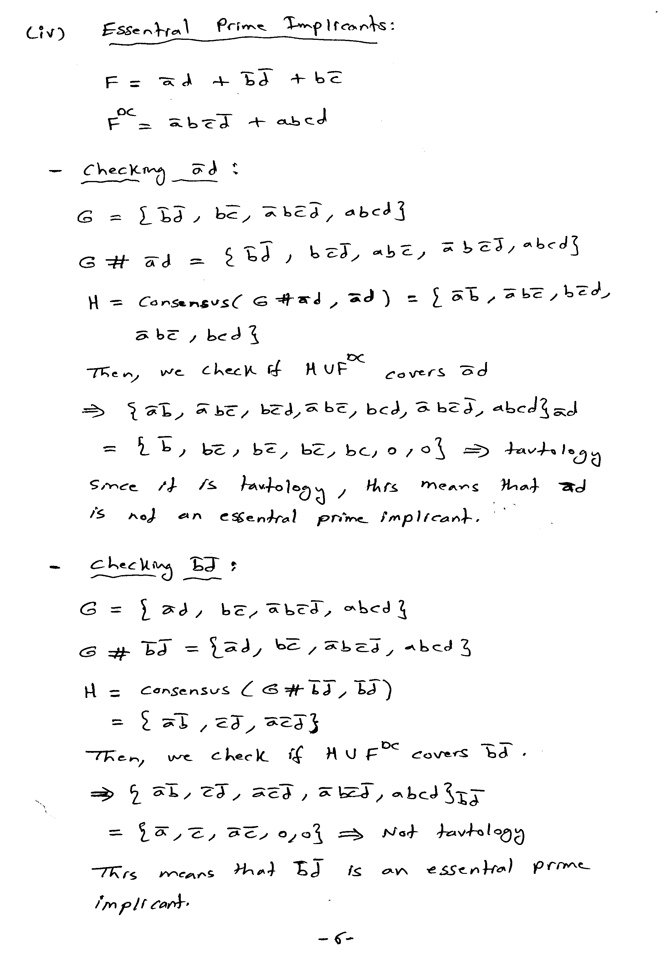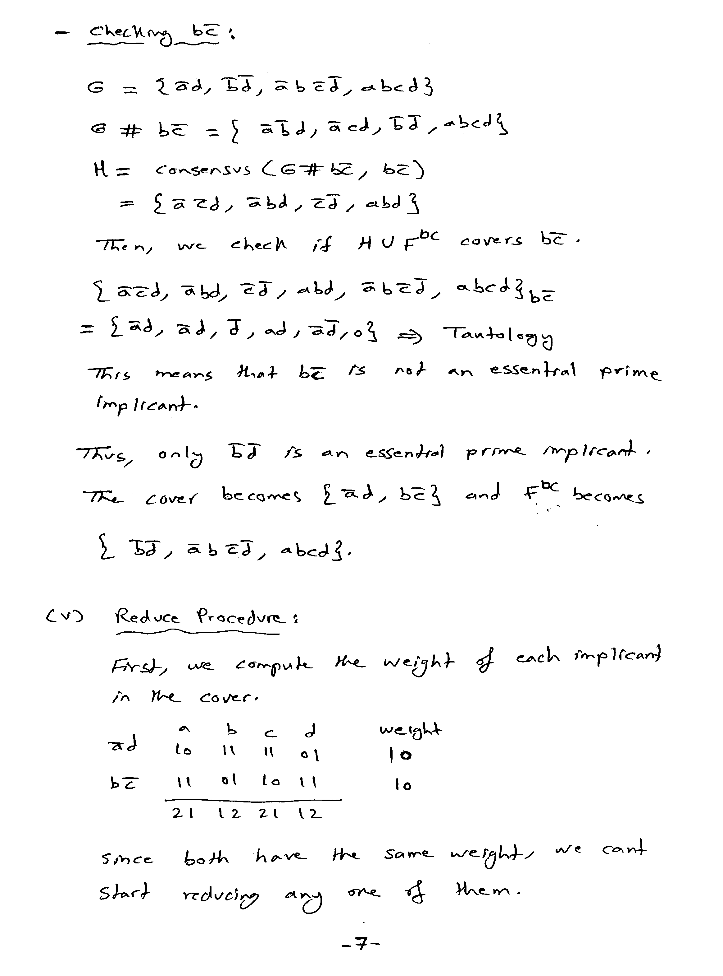

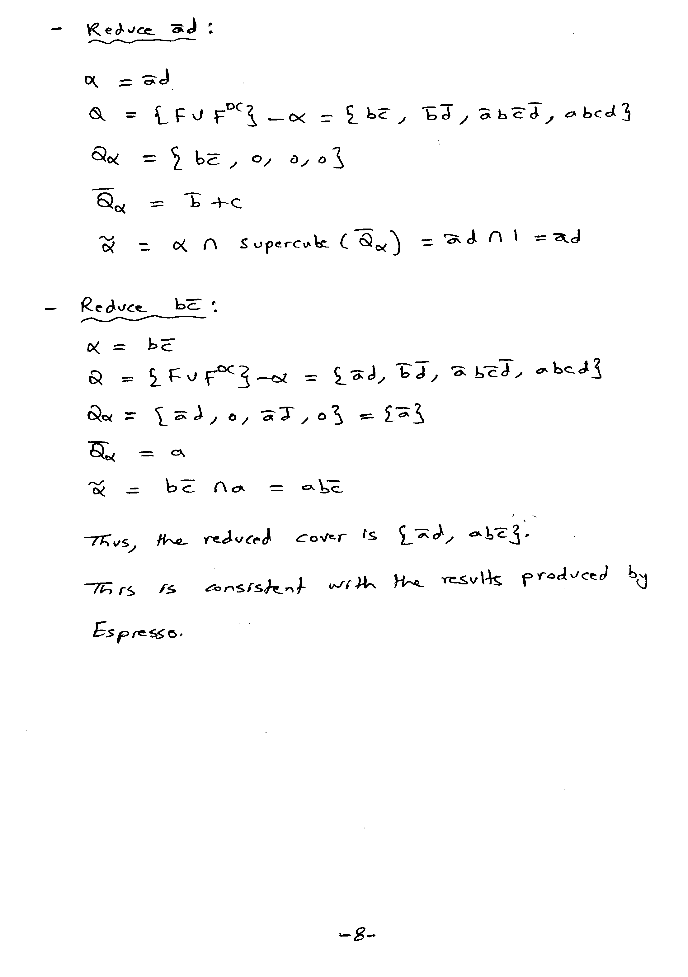

.i 4
.o 1
.ilb a b c d
.p 3
0--1 1
-10- 1
-0-0 -
0100 -
1111 -
.e

D:\Courses\coe561\091>espresso -Dreduce -t -d hw2q1v.pla > hw2q1v_red.pla

# espresso -Dreduce -t -d hw2q1v.pla
# UC Berkeley, Espresso Version #2.3, Release date 01/31/88
# READ Time was 0.00 sec, cost is c=2(2) in=4 out=2 tot=6
# COMPL Time was 0.00 sec, cost is c=0(0) in=0 out=0 tot=0
# PLA is hw2q1v.pla with 4 inputs and 1 outputs
# ON-set cost is c=2(2) in=4 out=2 tot=6
# OFF-set cost is c=0(0) in=0 out=0 tot=0
# DC-set cost is c=3(3) in=10 out=3 tot=13
REDUCE: -10- 1 to 110- 1 0.00 sec
# REDUCE Time was 0.00 sec, cost is c=2(1) in=5 out=2 tot=7
# READ 1 call(s) for 0.00 sec ( 0.0%)
# COMPL 1 call(s) for 0.00 sec ( 0.0%)
# REDUCE 1 call(s) for 0.00 sec ( 0.0%)
# reduce Time was 0.00 sec, cost is c=2(1) in=5 out=2 tot=7
.i 4
.o 1
.ilb a b c d
.p 2
110- 1
0--1 1
.e
# WRITE Time was 0.00 sec, cost is c=2(1) in=5 out=2 tot=7

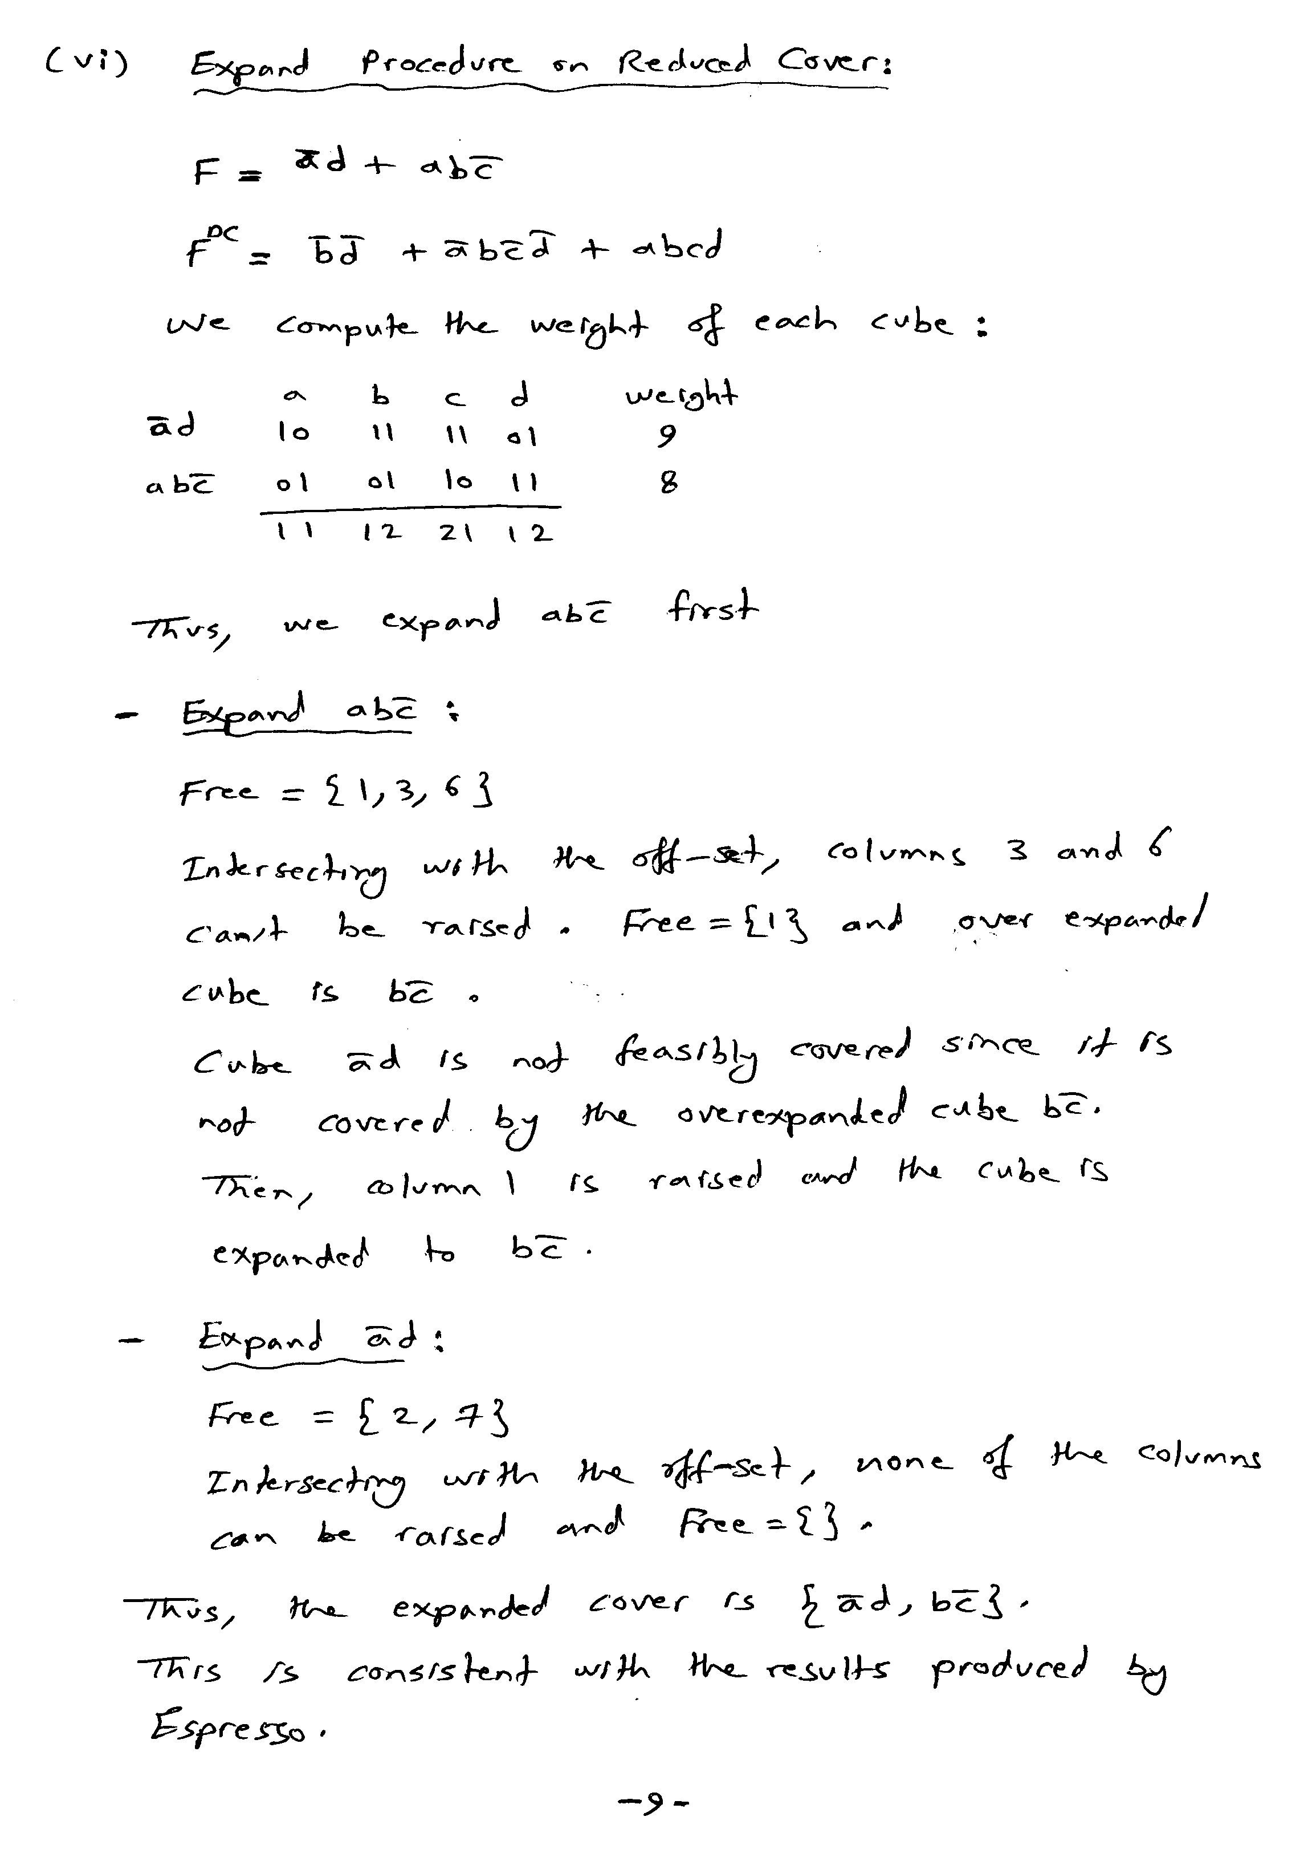

.i 4
.o 1
.ilb a b c d
.p 2
0--1 1
110- 1
-0-0 -
0100 -
1111 -
.e

D:\Courses\coe561\091>espresso -Dexpand -t -d hw2q1vi.pla > hw2q1vi_expand.pla

# espresso -Dexpand -t -d hw2q1vi.pla
# UC Berkeley, Espresso Version #2.3, Release date 01/31/88
# READ Time was 0.00 sec, cost is c=2(2) in=5 out=2 tot=7
# COMPL Time was 0.00 sec, cost is c=2(2) in=6 out=2 tot=8
# PLA is hw2q1vi.pla with 4 inputs and 1 outputs
# ON-set cost is c=2(2) in=5 out=2 tot=7
# OFF-set cost is c=2(2) in=6 out=2 tot=8
# DC-set cost is c=3(3) in=10 out=3 tot=13
EXPAND: 110- 1 (covered 0)
EXPAND: 0--1 1 (covered 0)
# EXPAND Time was 0.00 sec, cost is c=2(0) in=4 out=2 tot=6
# READ 1 call(s) for 0.00 sec ( 0.0%)
# COMPL 1 call(s) for 0.00 sec ( 0.0%)
# EXPAND 1 call(s) for 0.00 sec ( 0.0%)
# expand Time was 0.00 sec, cost is c=2(0) in=4 out=2 tot=6
.i 4
.o 1
.ilb a b c d
.p 2
-10- 1
0--1 1
.e
# WRITE Time was 0.00 sec, cost is c=2(0) in=4 out=2 tot=6

