Jan. 7, 2010

COMPUTER ENGINEERING DEPARTMENT

COE 561

Digital System Design and Synthesis

MAJOR EXAM II

(Open Book Exam)

First Semester (091)

Time: 3:30-6:00 PM

Student Name : _KEY_________________________________________

Student ID. : ______________________________________________

Question | Max Points | Score
Q1 | 30
Q2 | 15
Q3 | 15
Q4 | 20
Q5 | 20
Total | 100

[30 Points]

(Q1) Consider the function F(A, B, C, D) with ON-SET=Σm(5, 6, 7, 13) and OFF-SET=Σm(1, 8, 12). Note that you do not need to use the positional-cube notation in your solution.

Expand the minterm ABC'D using ESPRESSO heuristics.

A cover of the function is given by F = C + BD. Reduce the cube C using Theorem 7.4.1.

Use Corollary 7.4.1 to check if the implicant C is an essential prime implicant.

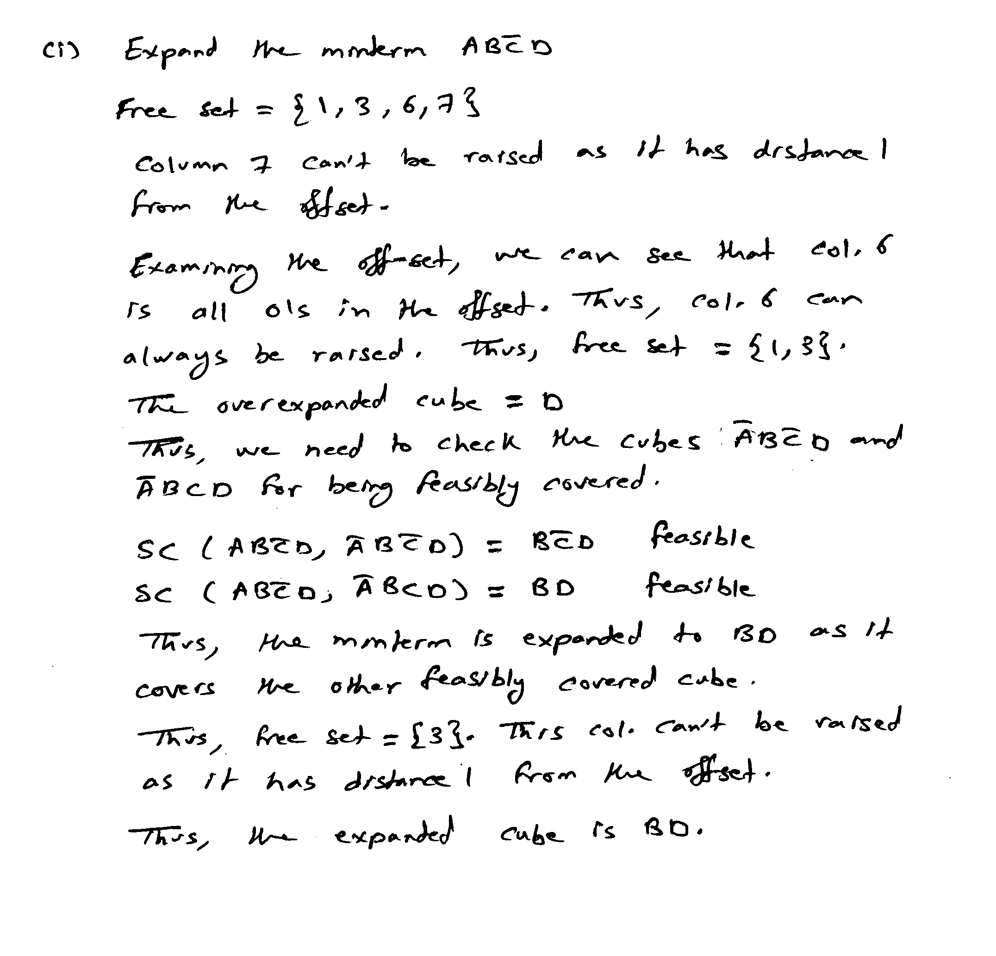

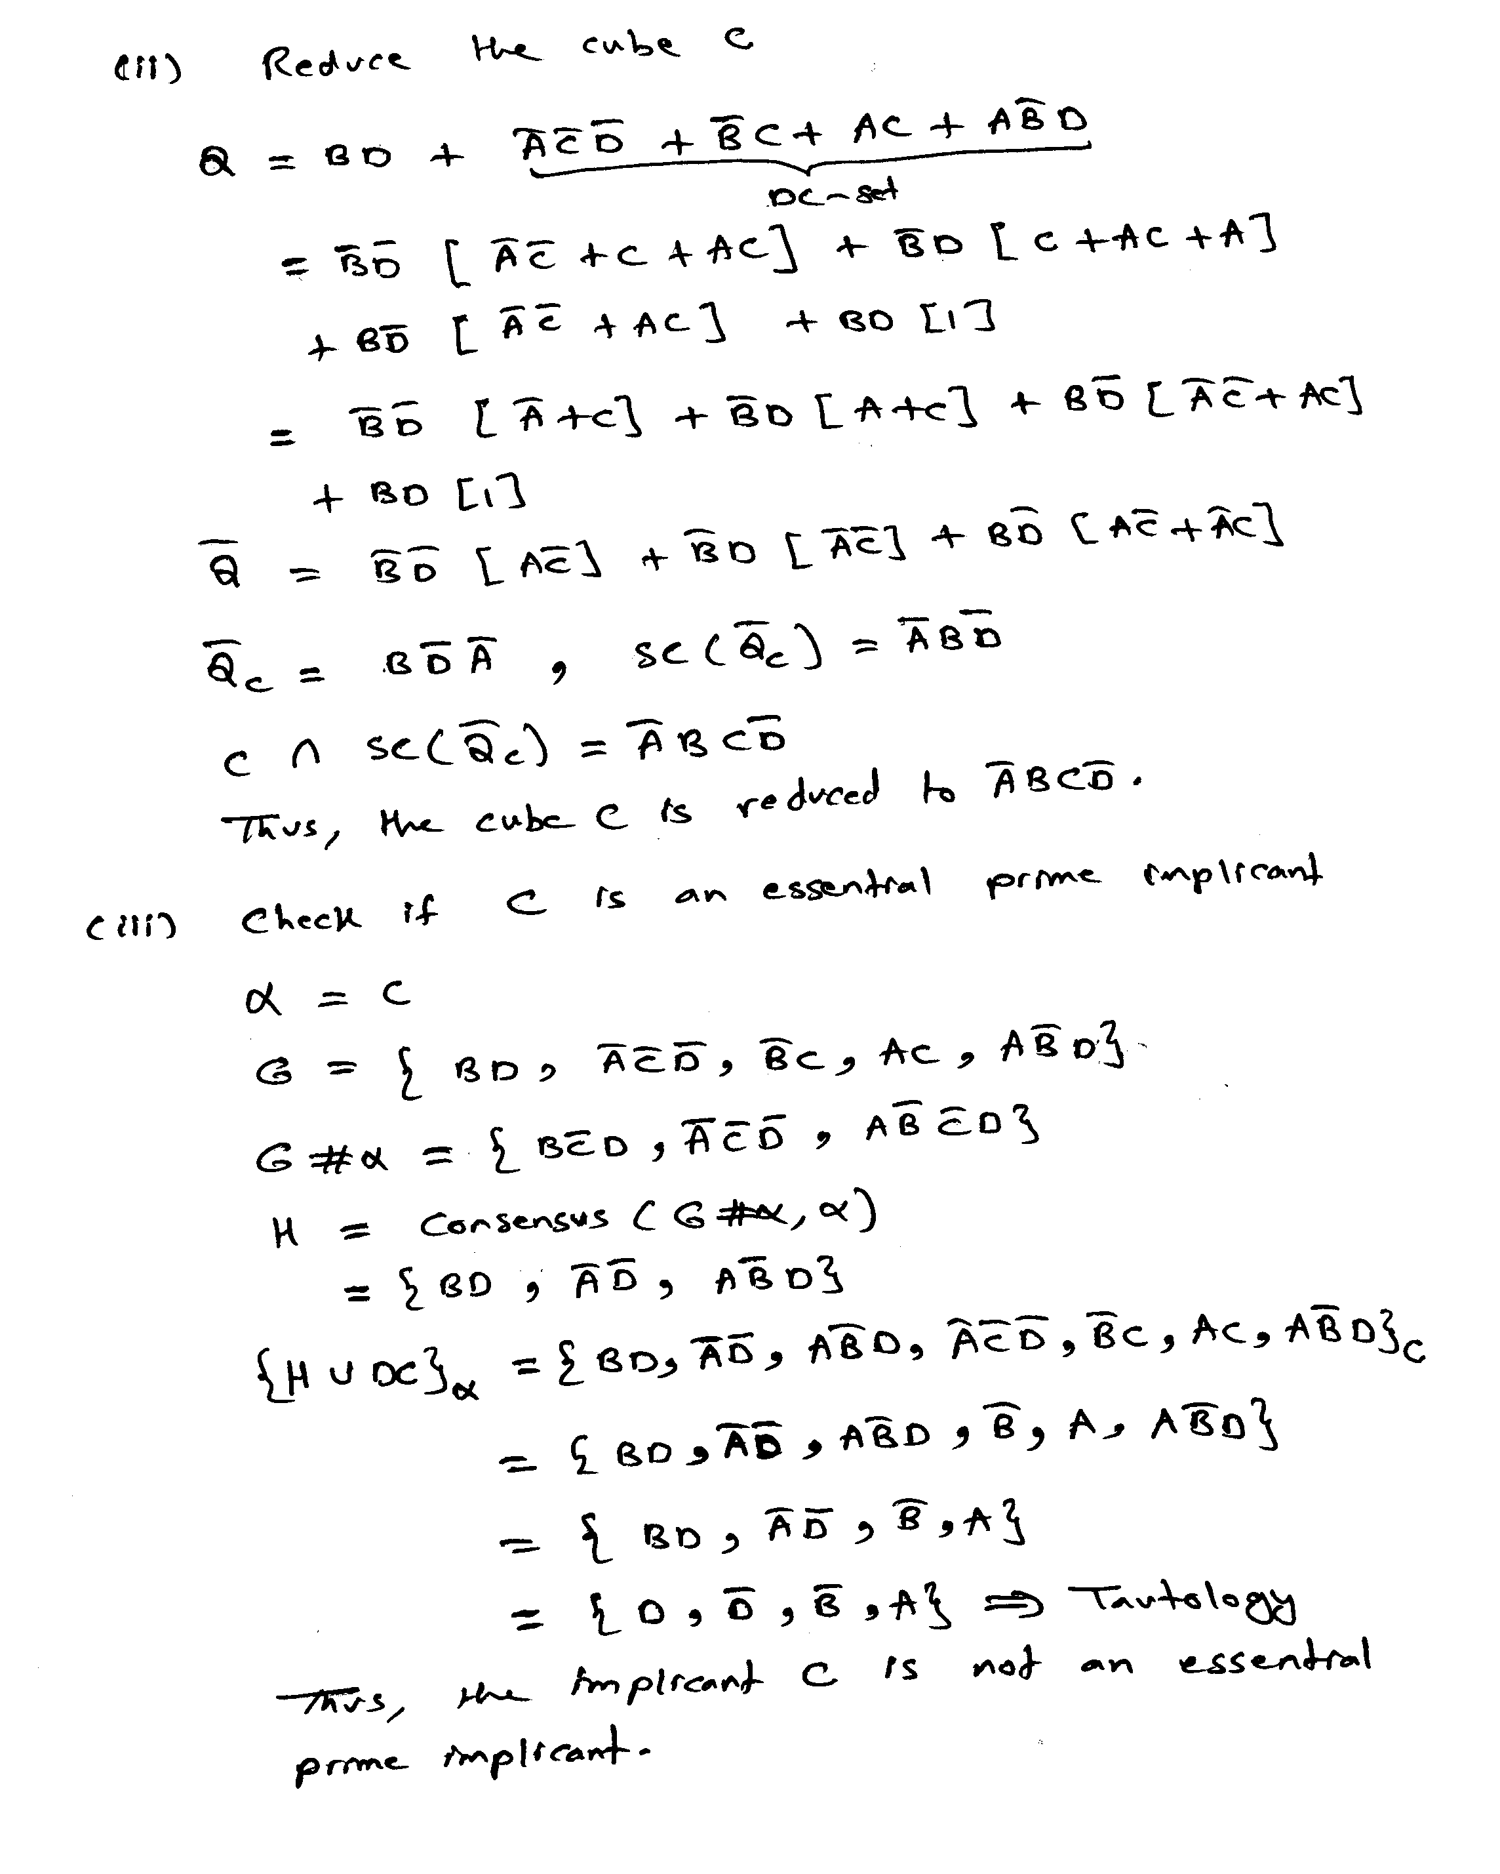

[15 Points]

(Q2) Consider the logic network defined by the following expression:

x = a c e + a c f + b c e + b c f + d e + d f

Using the recursive procedure KERNELS, compute all the kernels and co-kernels of x. Show all the steps of the algorithm. Assume the following lexicographic order: {a, b, c, d, e, f}.

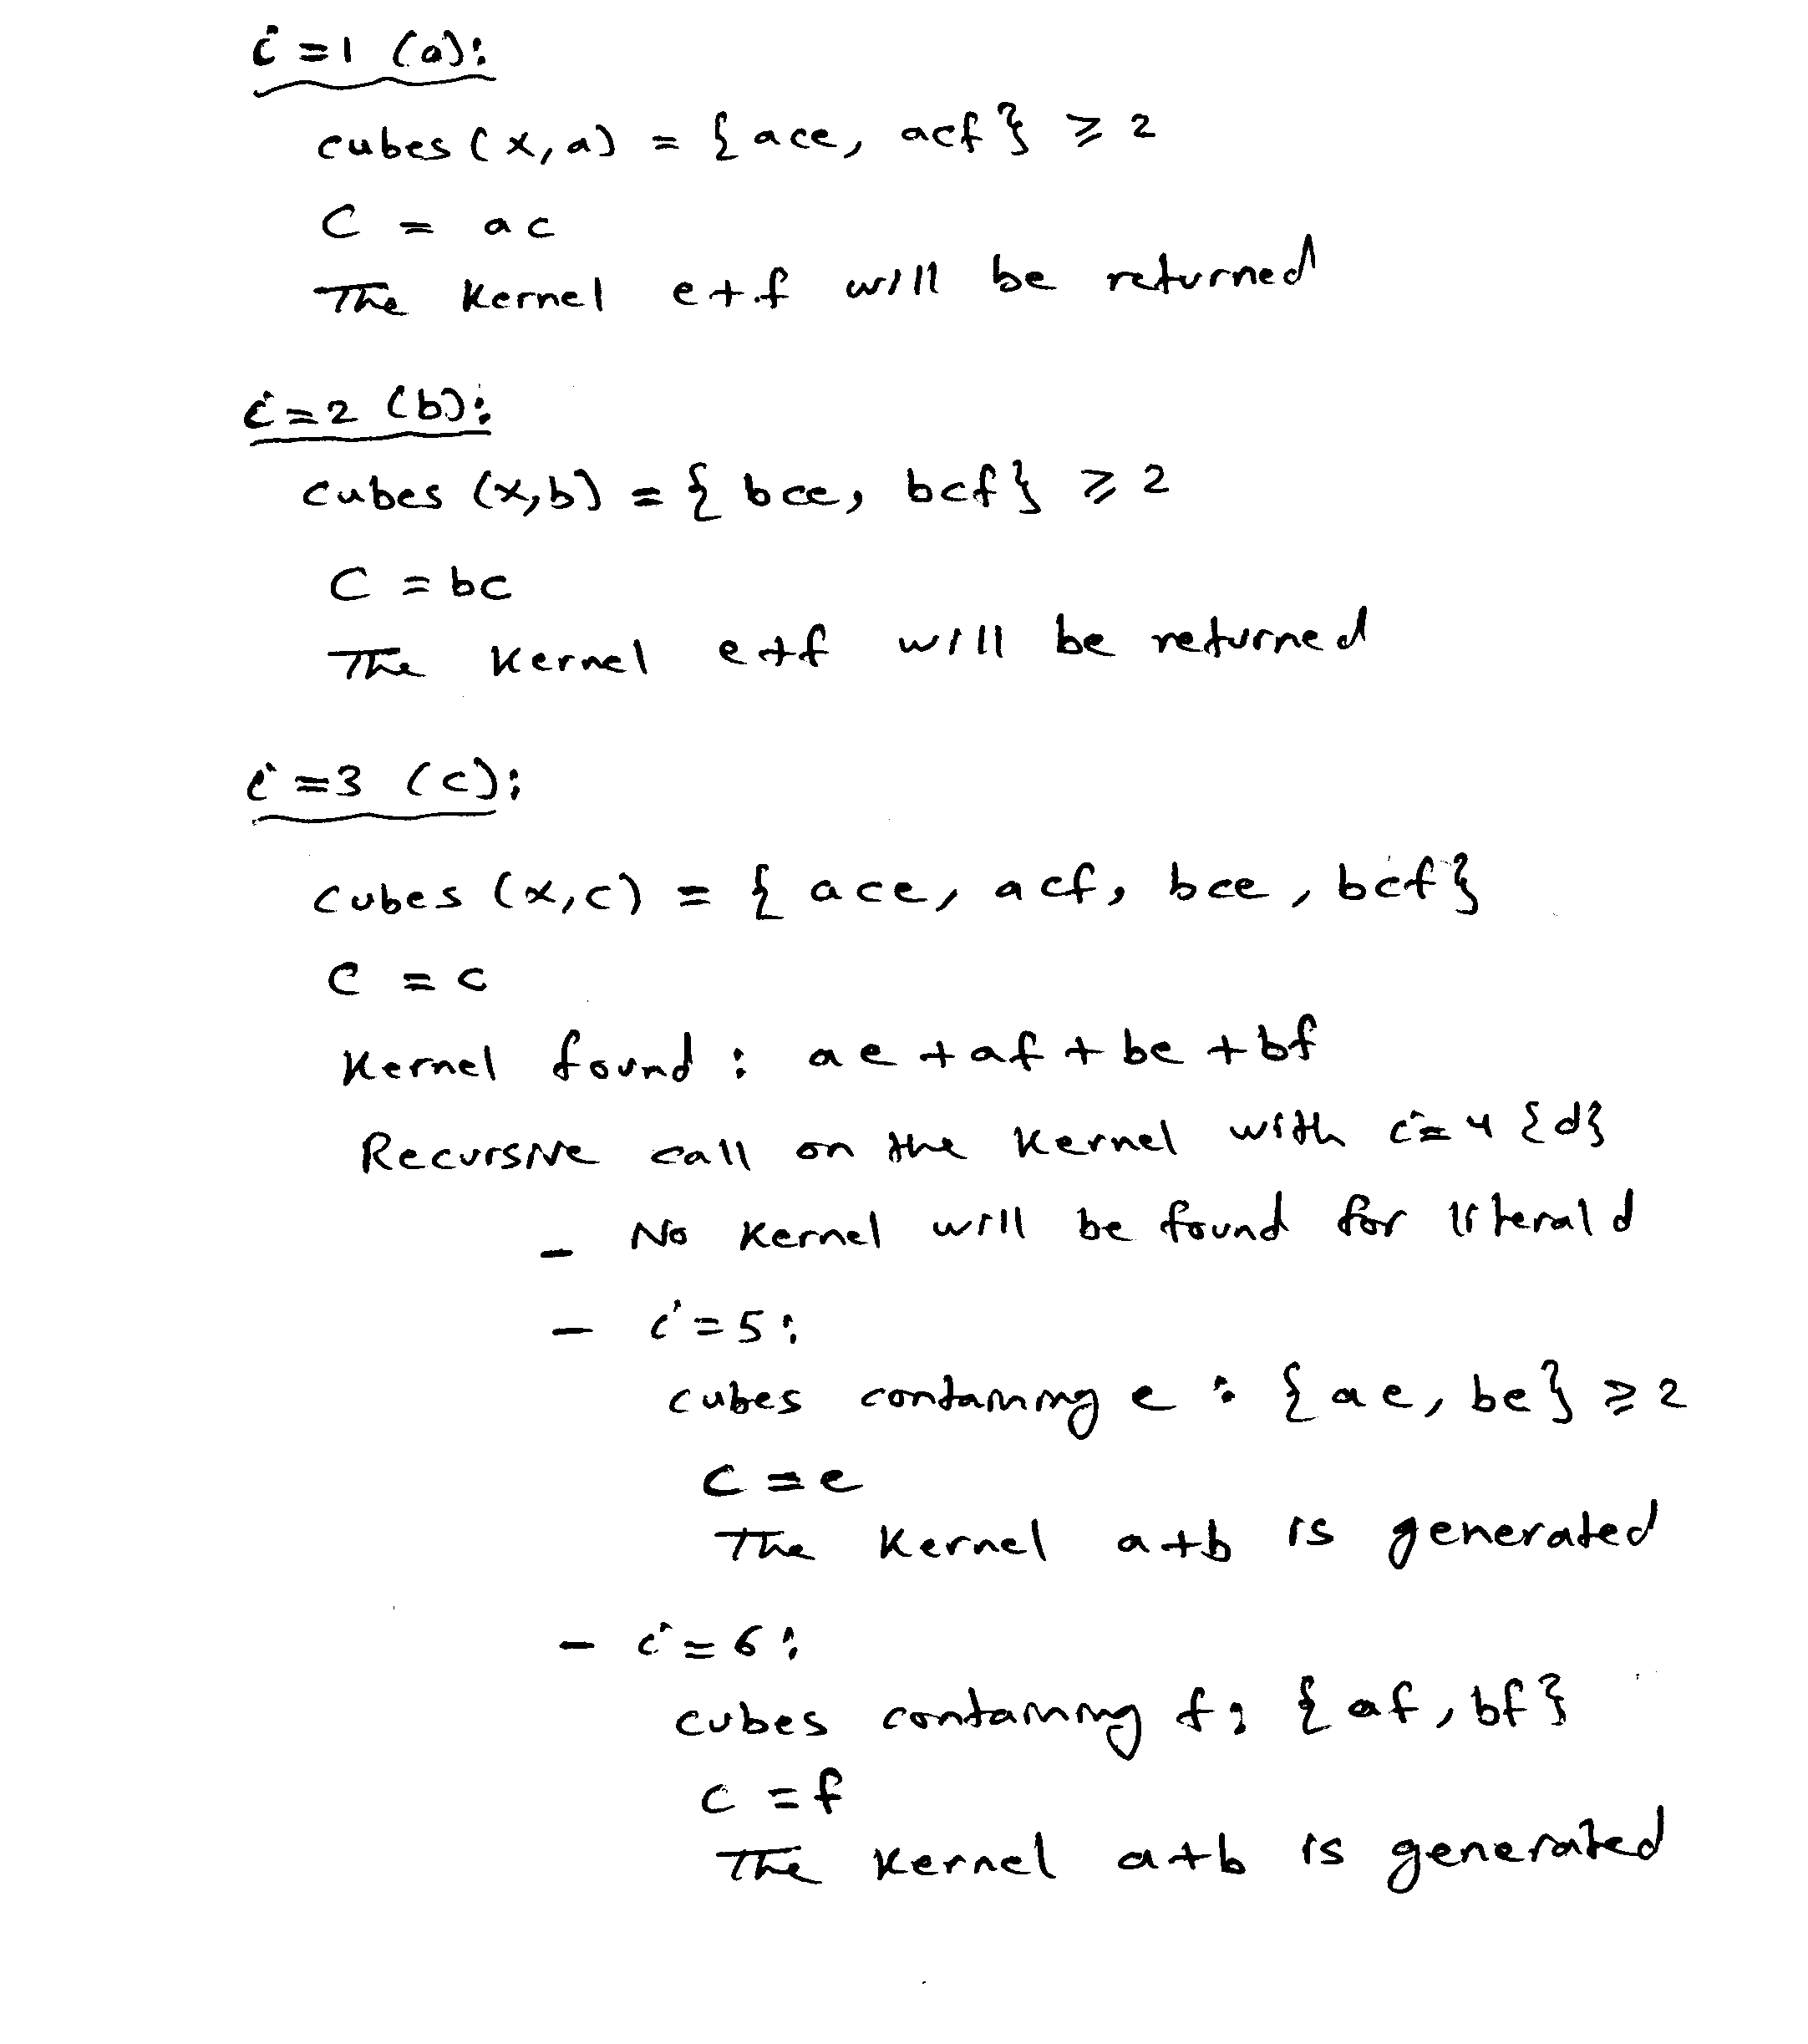

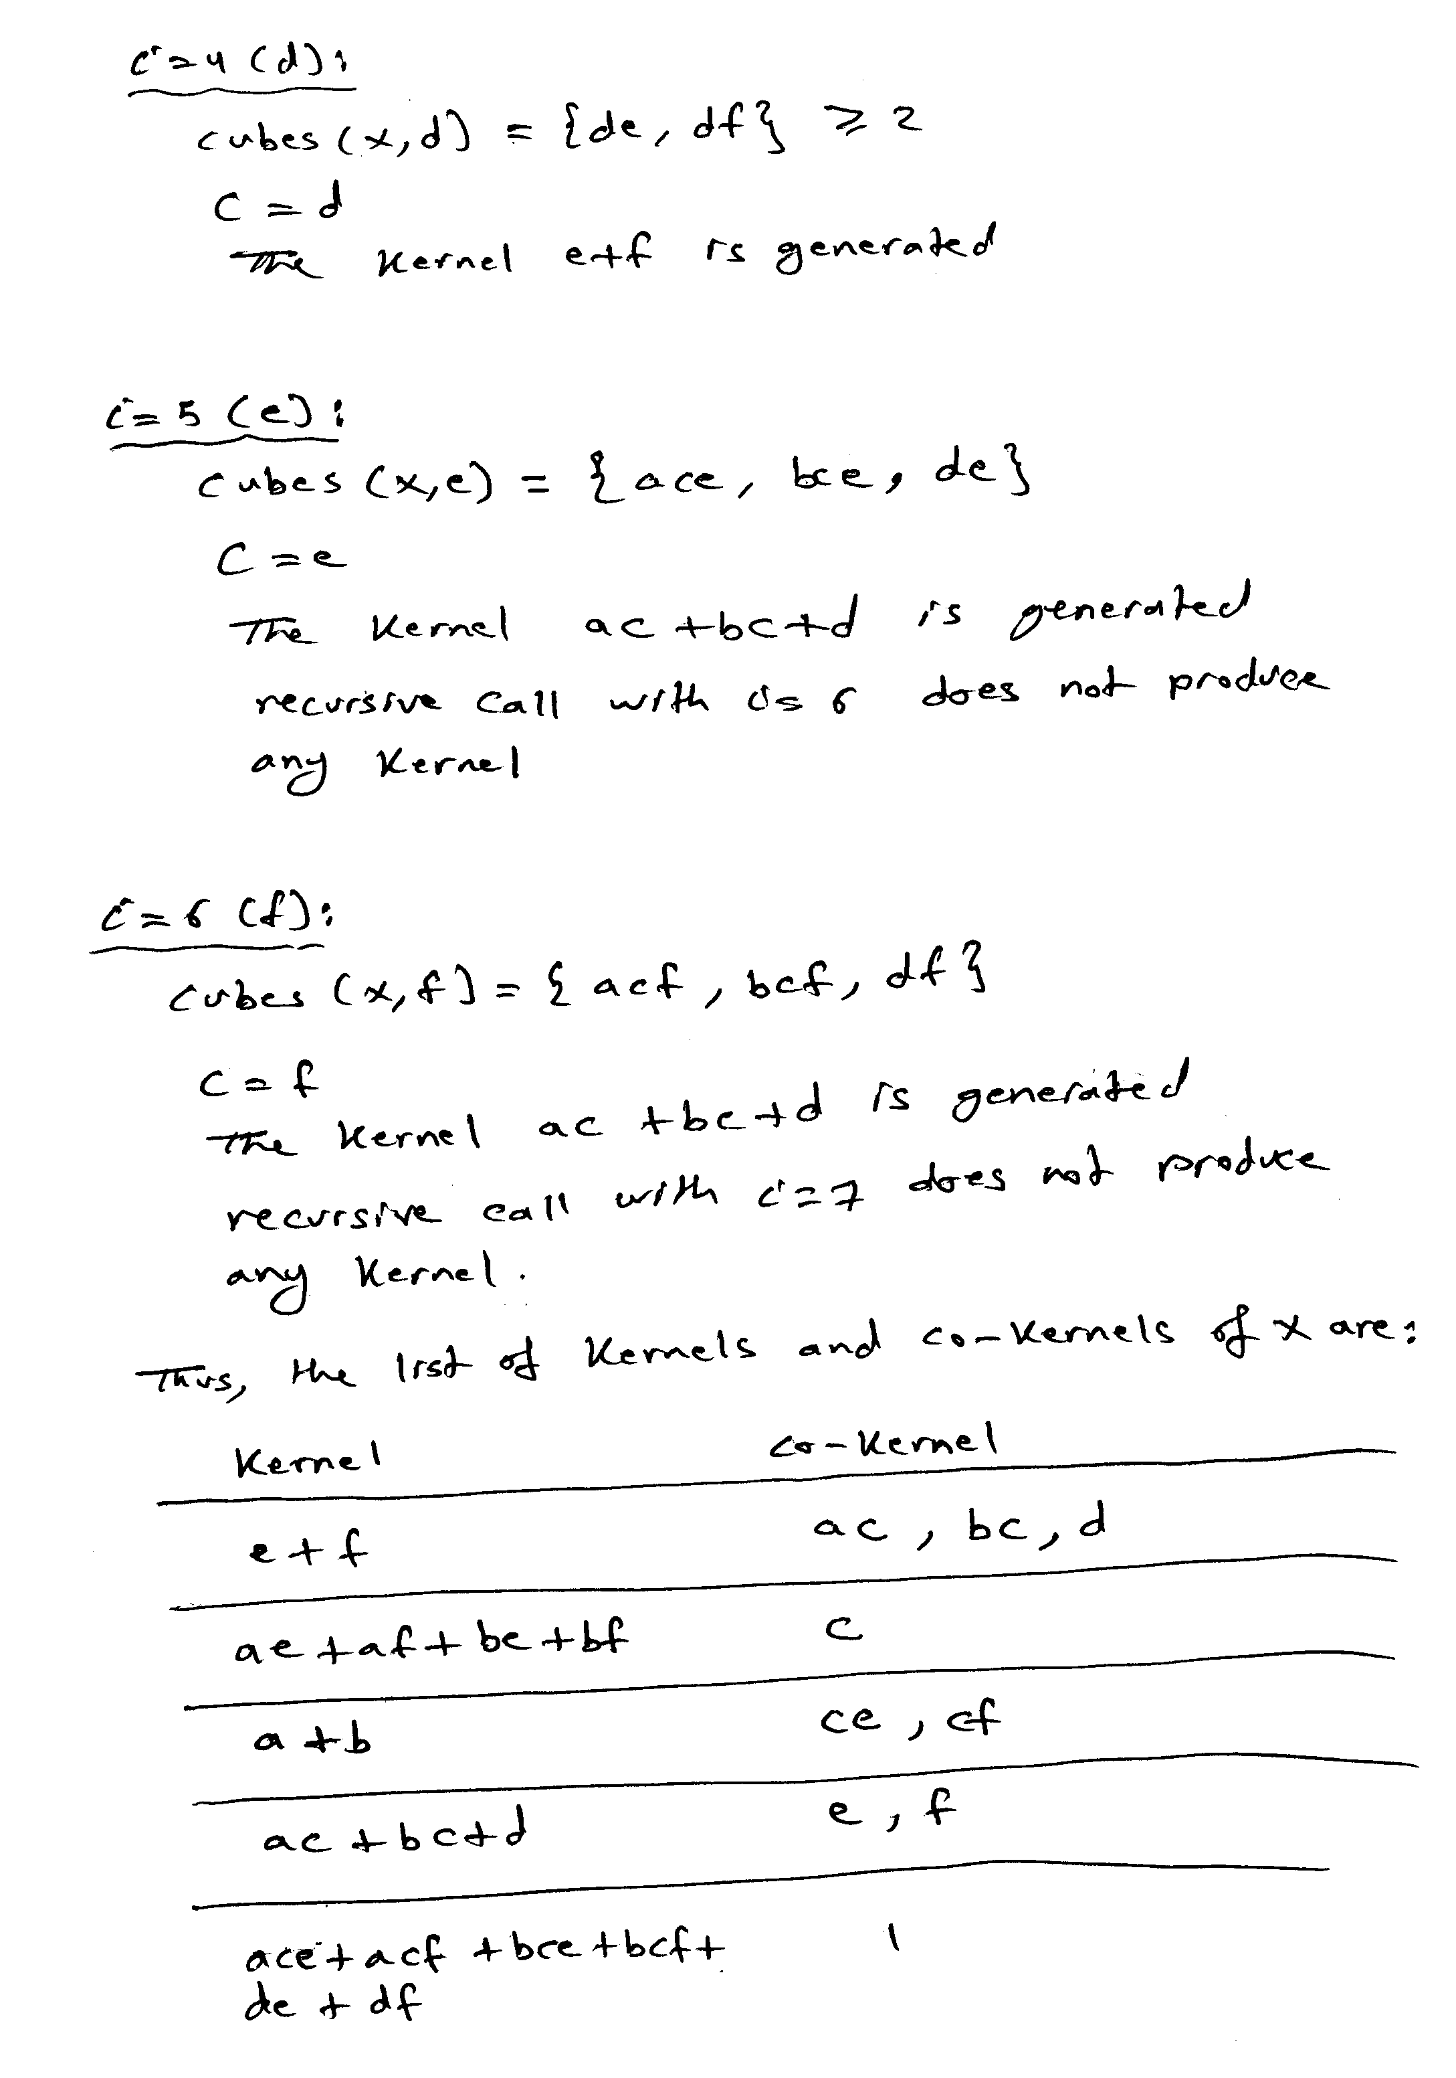

[15 Points]

(Q3) Consider the logic network defined by the following expression:

x = a b e' f' + a b' e + a b' f + a' d e' f' + a' d' e + a' d' f + c e' f'

Compute the weight of the double cube divisors d₁ = a b + a'd and d₂ = e + f. Extract the double cube divisor with the highest weight and show the resulting network after extraction and the number of literals saved.

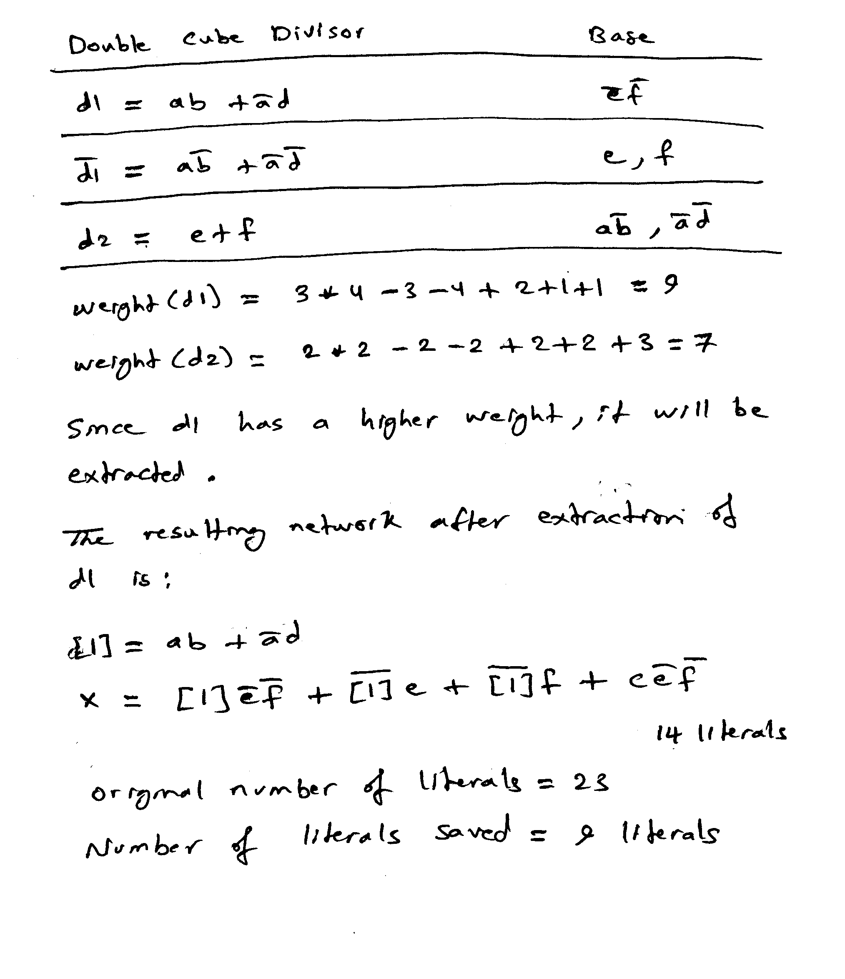

[20 Points]

(Q4) Consider the logic network defined by the following expressions with inputs {a, b, c, d, e} and output {y}:

x = a b + a' d

w = x' d' + b c'

y = (w ⊕ e) a' b

Simplify the function w based on the utilization of don't care conditions.

Based on perturbation analysis starting with the original network, determine if it is possible to change the implementation of x to x= a.
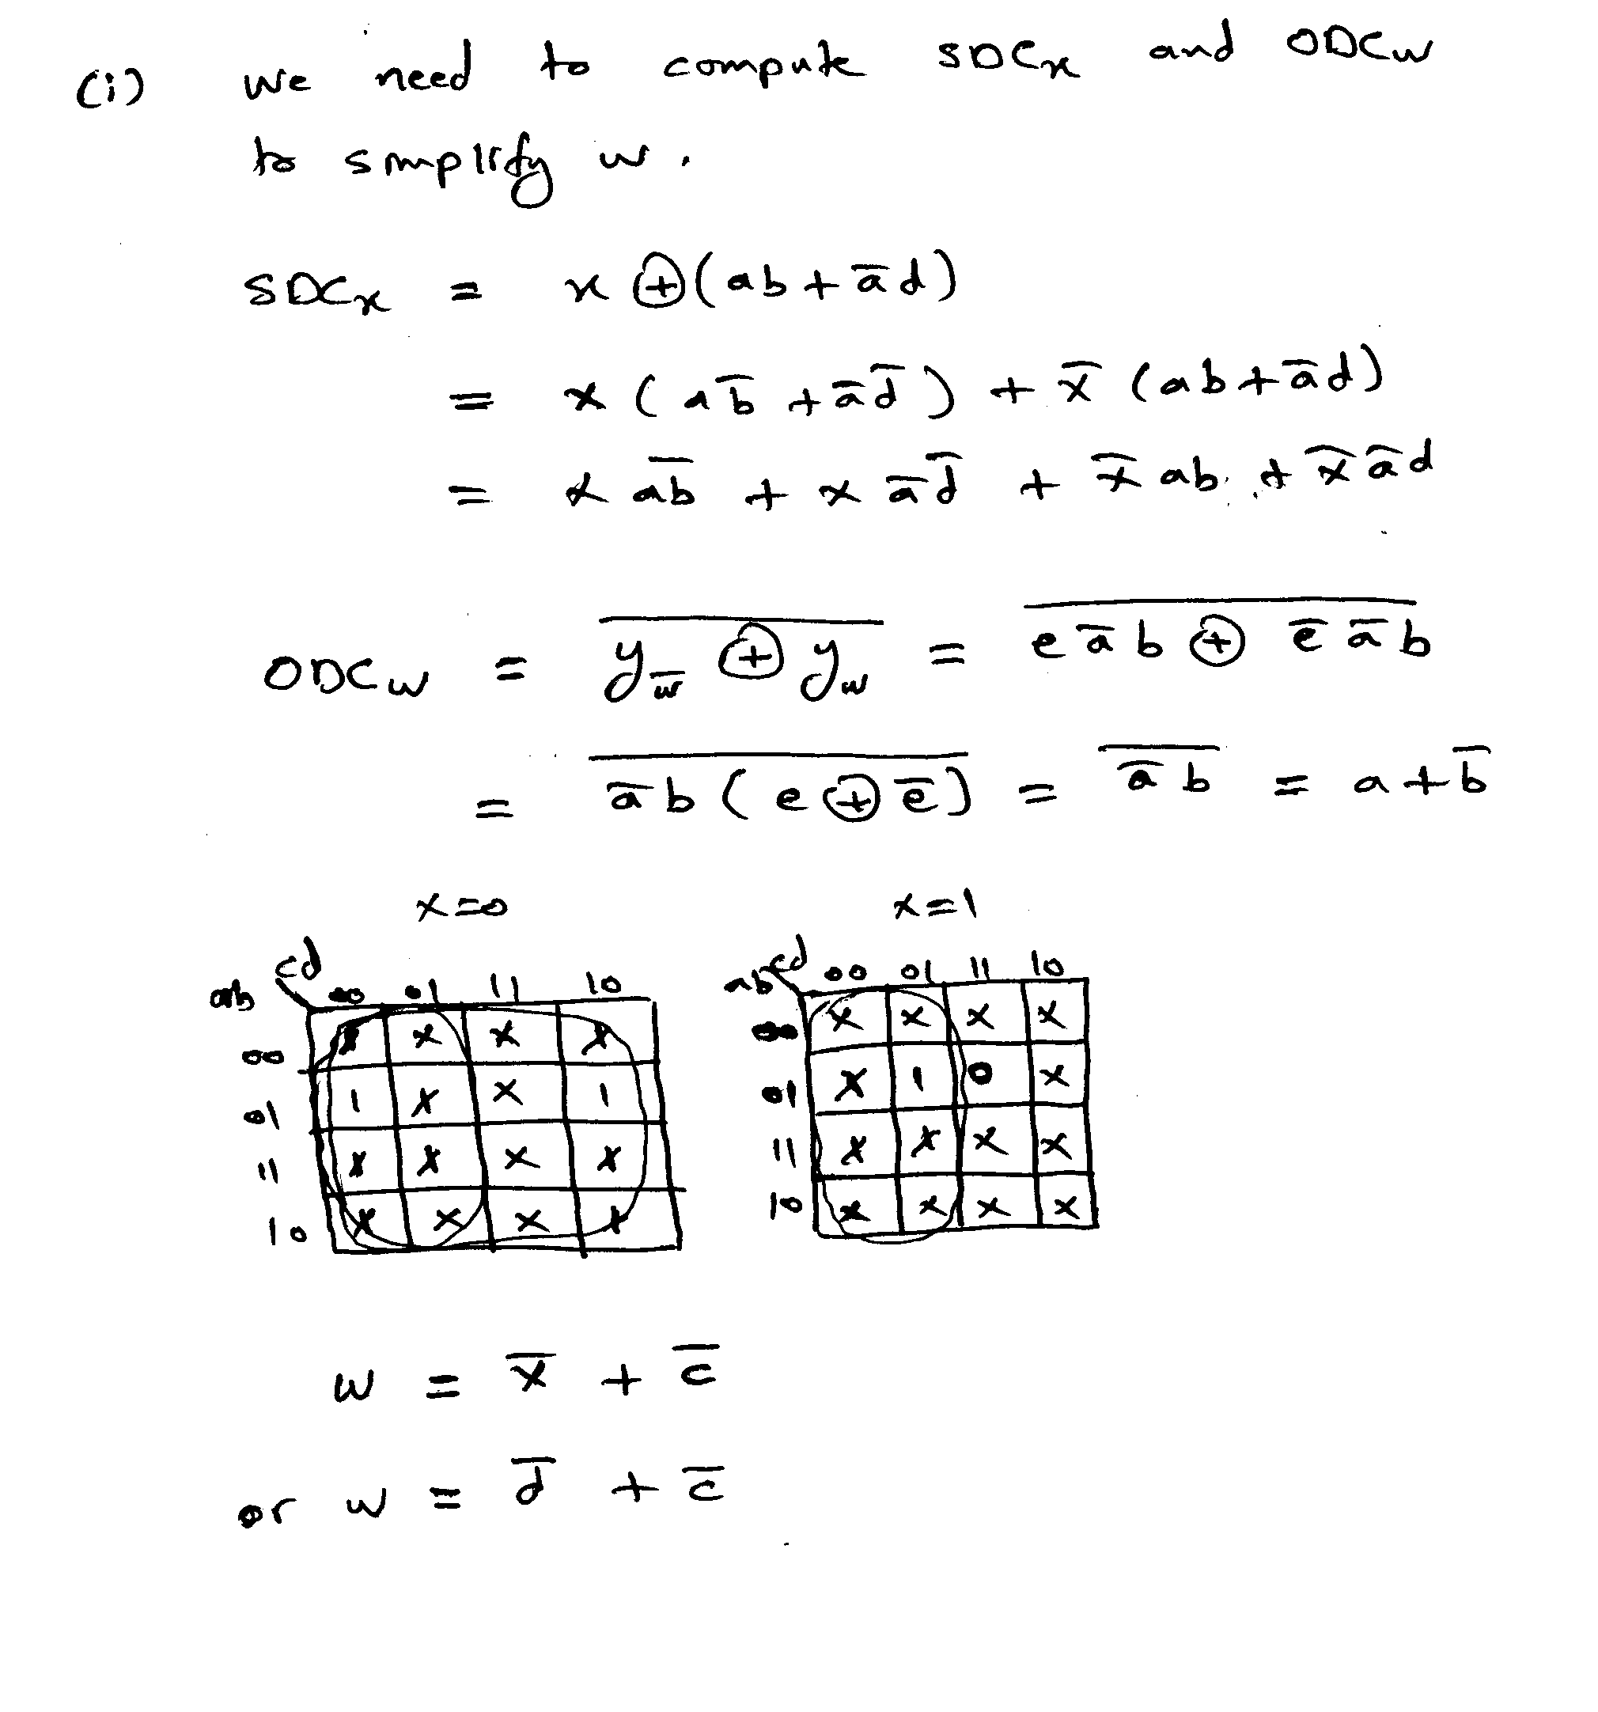

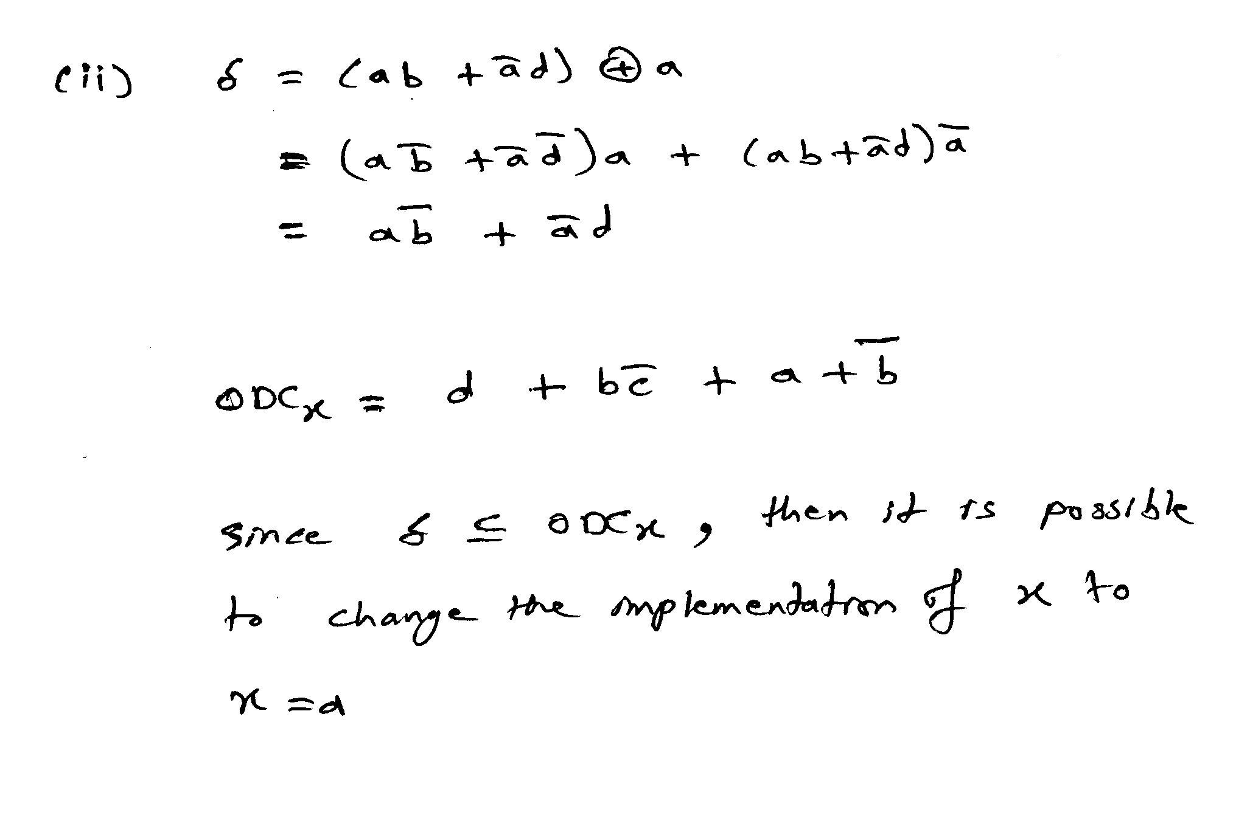

[20 Points]

(Q5) Consider the logic network below with inputs {a, b, c, d, e, f, g} and output {X}:

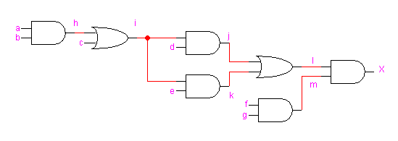

Assume that the delay of a gate is related to the number of its inputs i.e. the delay of a 2-input AND gate is 2. Also, assume that the input data-ready times are zero for all inputs.

Compute the data ready times and slacks for all vertices in the network.

Determine the topological critical path.

Suggest an implementation of the function X using only 2-input gates to reduce the delay of the circuit to the minimum possible and determine the maximum propagation delay in the optimized circuit. Has the area been affected?

