Nov. 9, 2009

COMPUTER ENGINEERING DEPARTMENT

COE 561

Digital System Design and Synthesis

Major Exam I

(Open Book Exam)

First Semester (091)

Time: 8:00-10:30 PM

Student Name : _KEY_________________________________________

Student ID. : ______________________________________________

|  |  |  |
| --- | --- | --- |
| **Question** | **Max Points** | **Score** |
| **Q1** | **15** |  |
| **Q2** | **10** |  |
| **Q3** | **10** |  |
| **Q4** | **25** |  |
| **Q5** | **20** |  |
| **Q6** | **20** |  |
| **Total** | **100** |  |

# **[15 Points]**

# **(Q1)** Consider the OBDD given below with the variable ordering {a, b, c, d}. Apply the **Reduce** function to obtain the **ROBDD**. Show the details of applying the algorithm step by step.

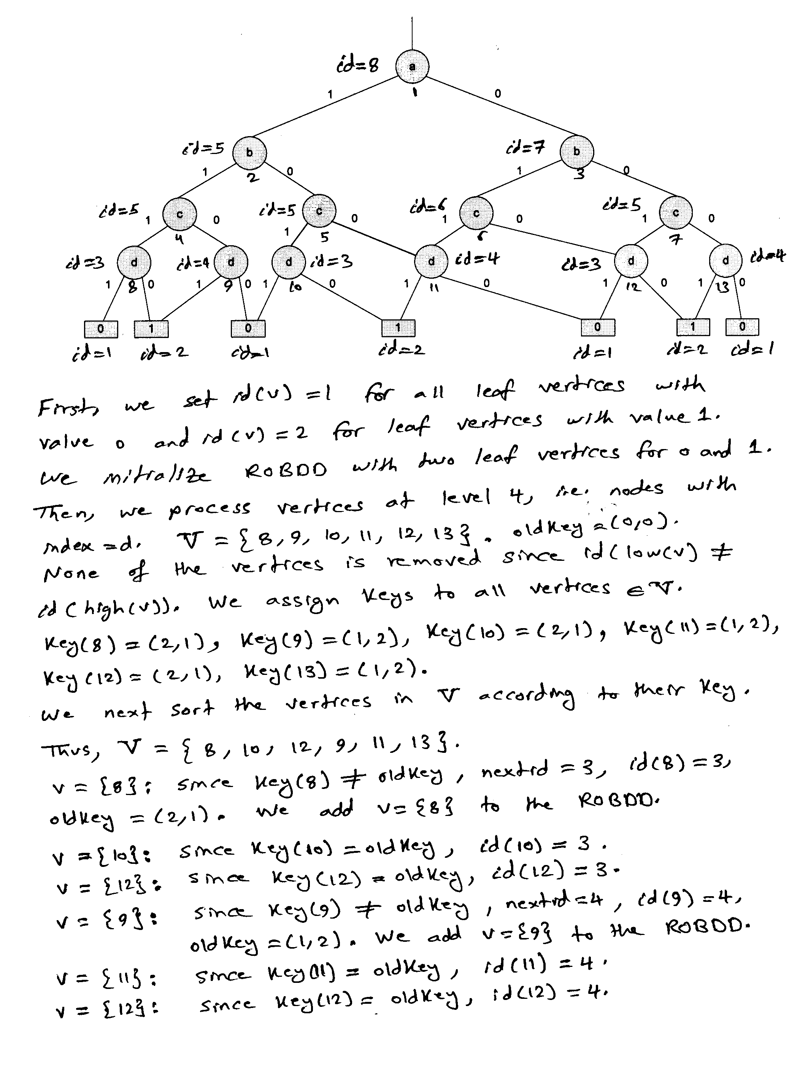

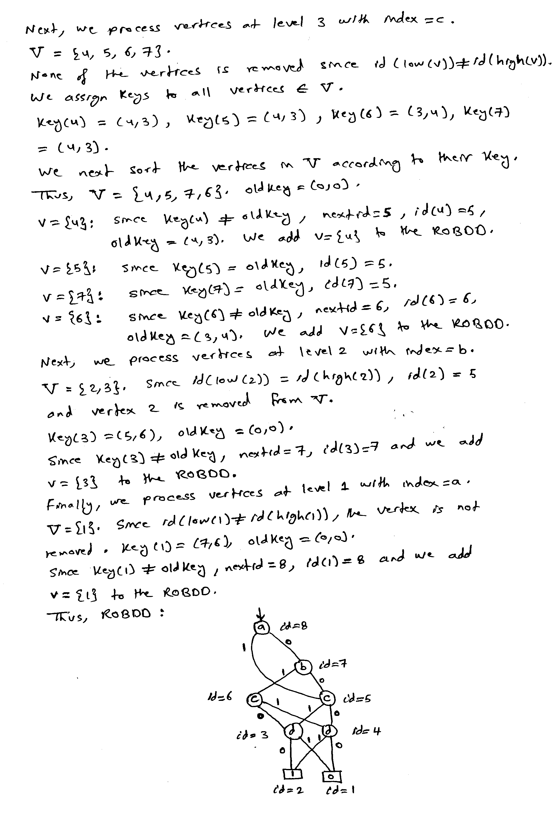

# 

# **[10 Points]**

# **(Q2)** Perform the following operations using positional cube notation:

# Cofactor of with respect to .

# #.

# Consensus of and .

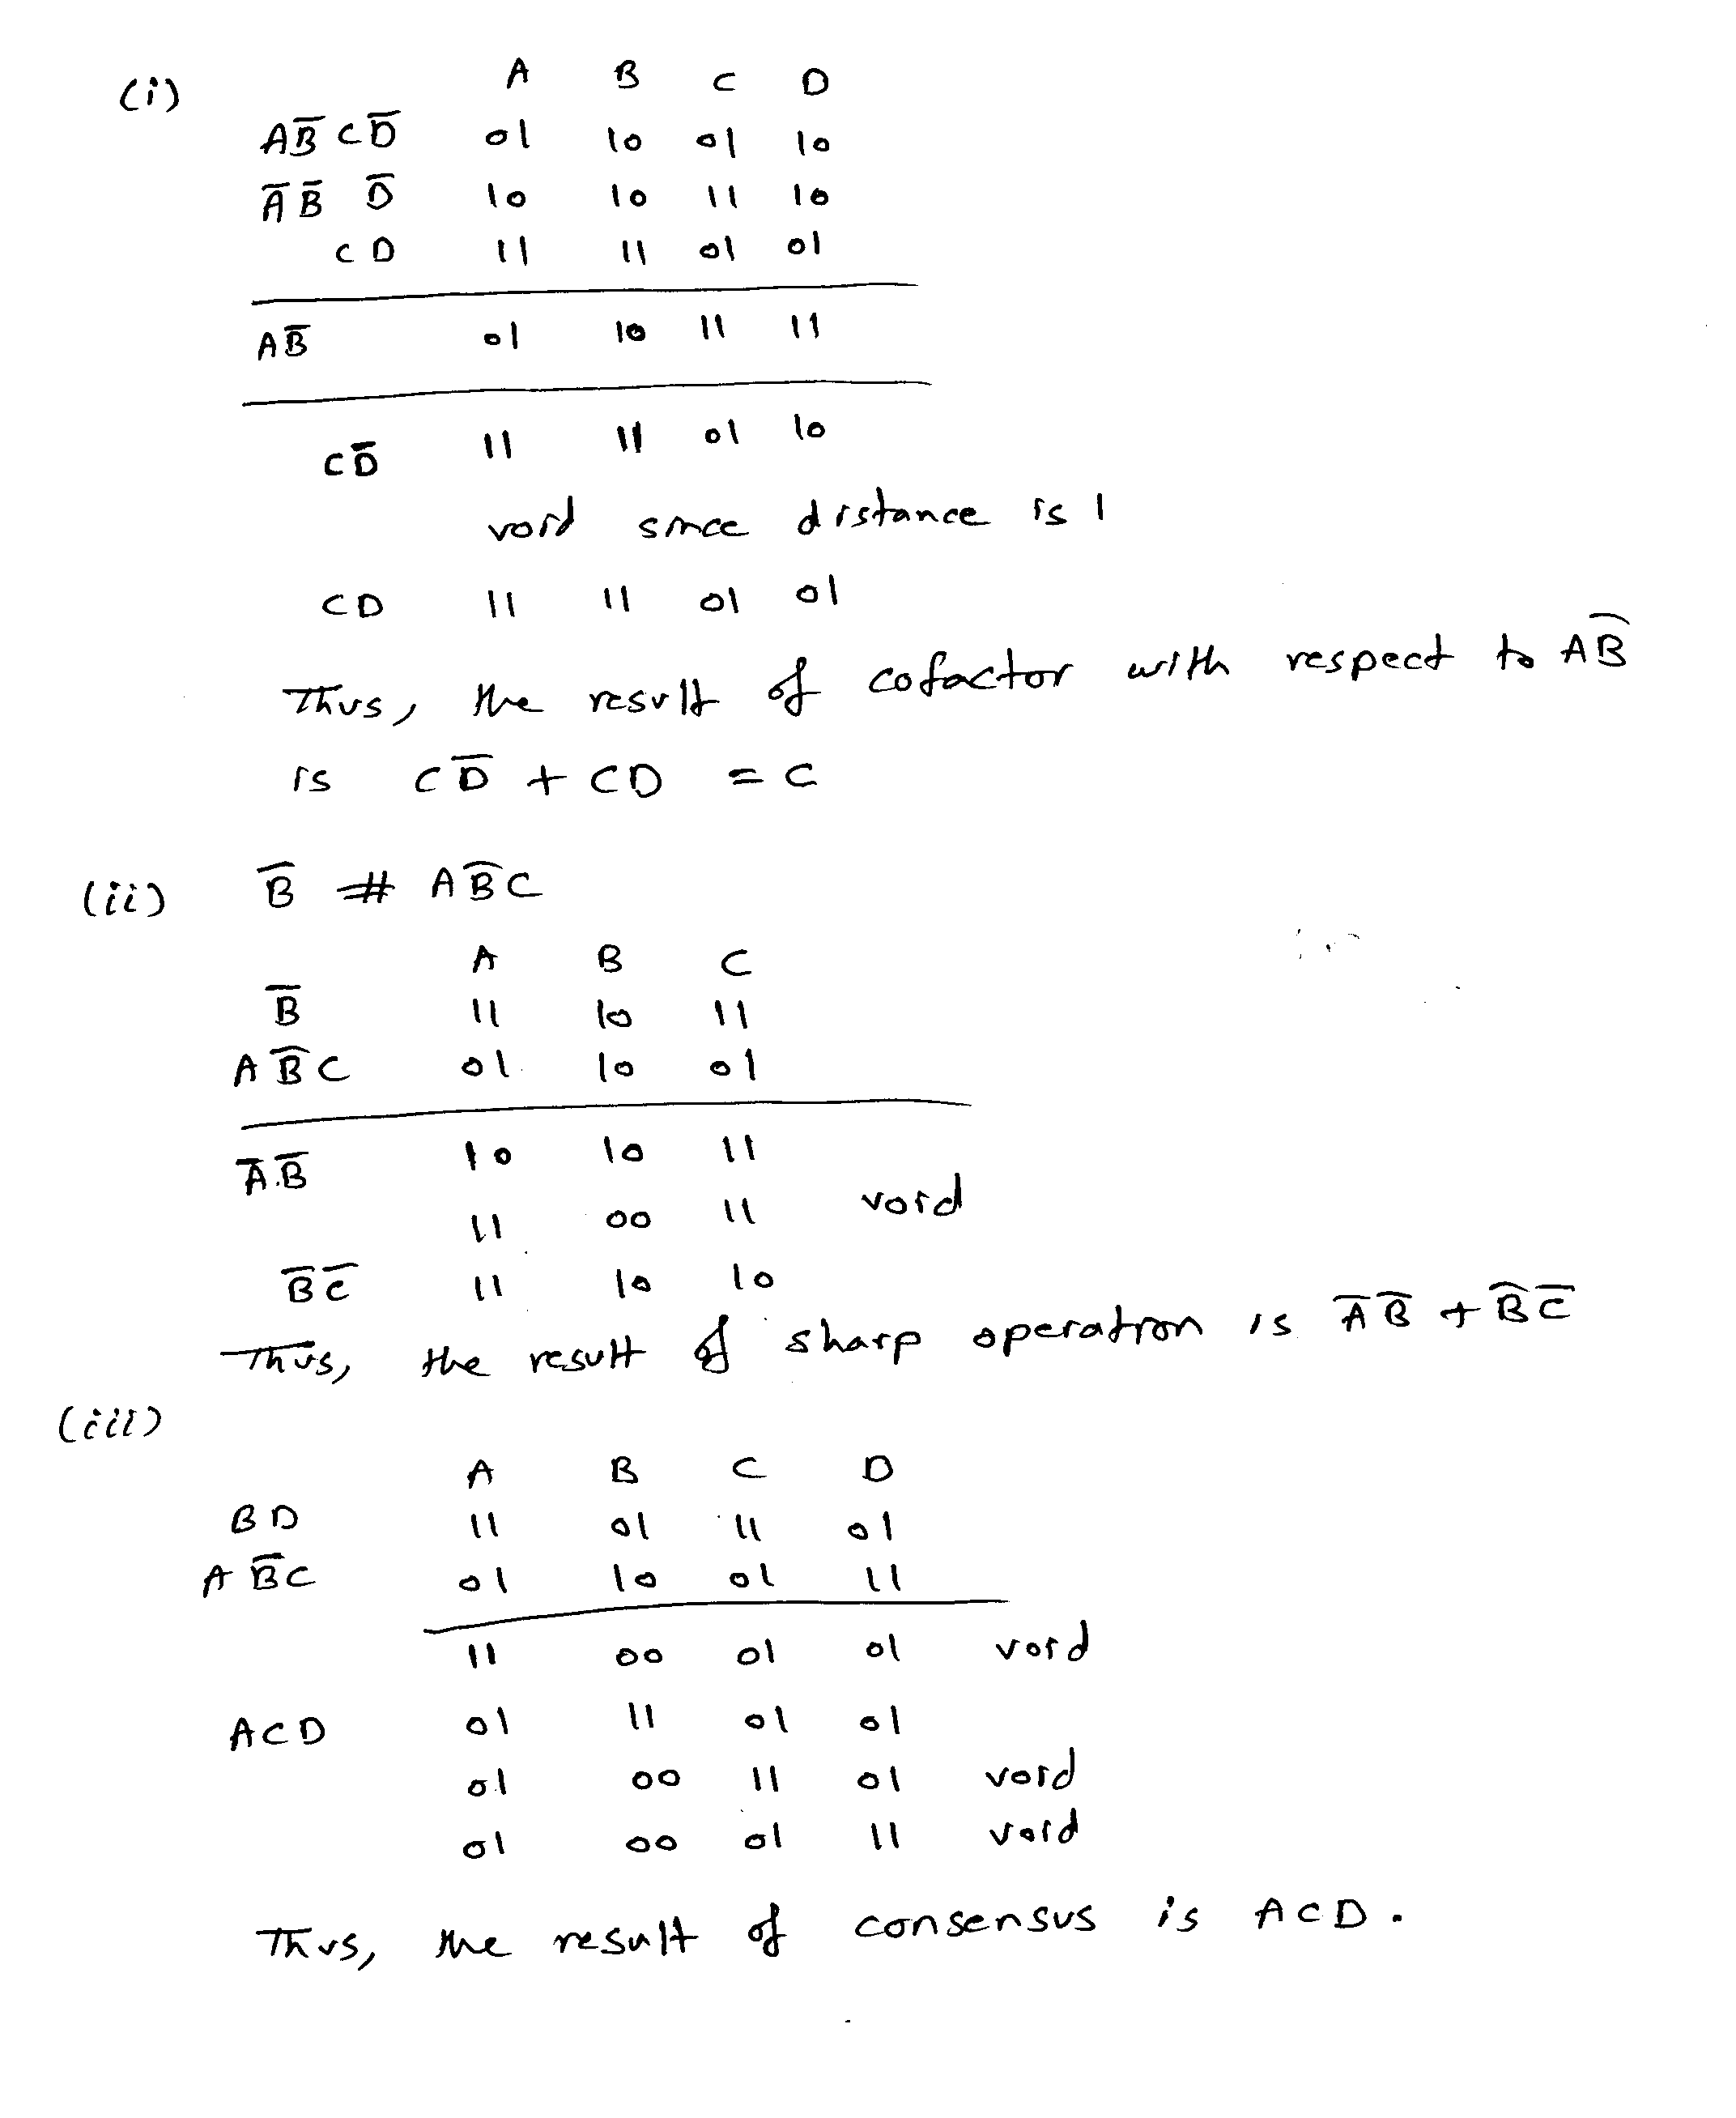

# **[10 Points]**

# **(Q3)** Consider the function. Using recursive paradigm, determine if the function F is **tautology** or not. You need to choose the right variable for expansion to minimize computations.

# 

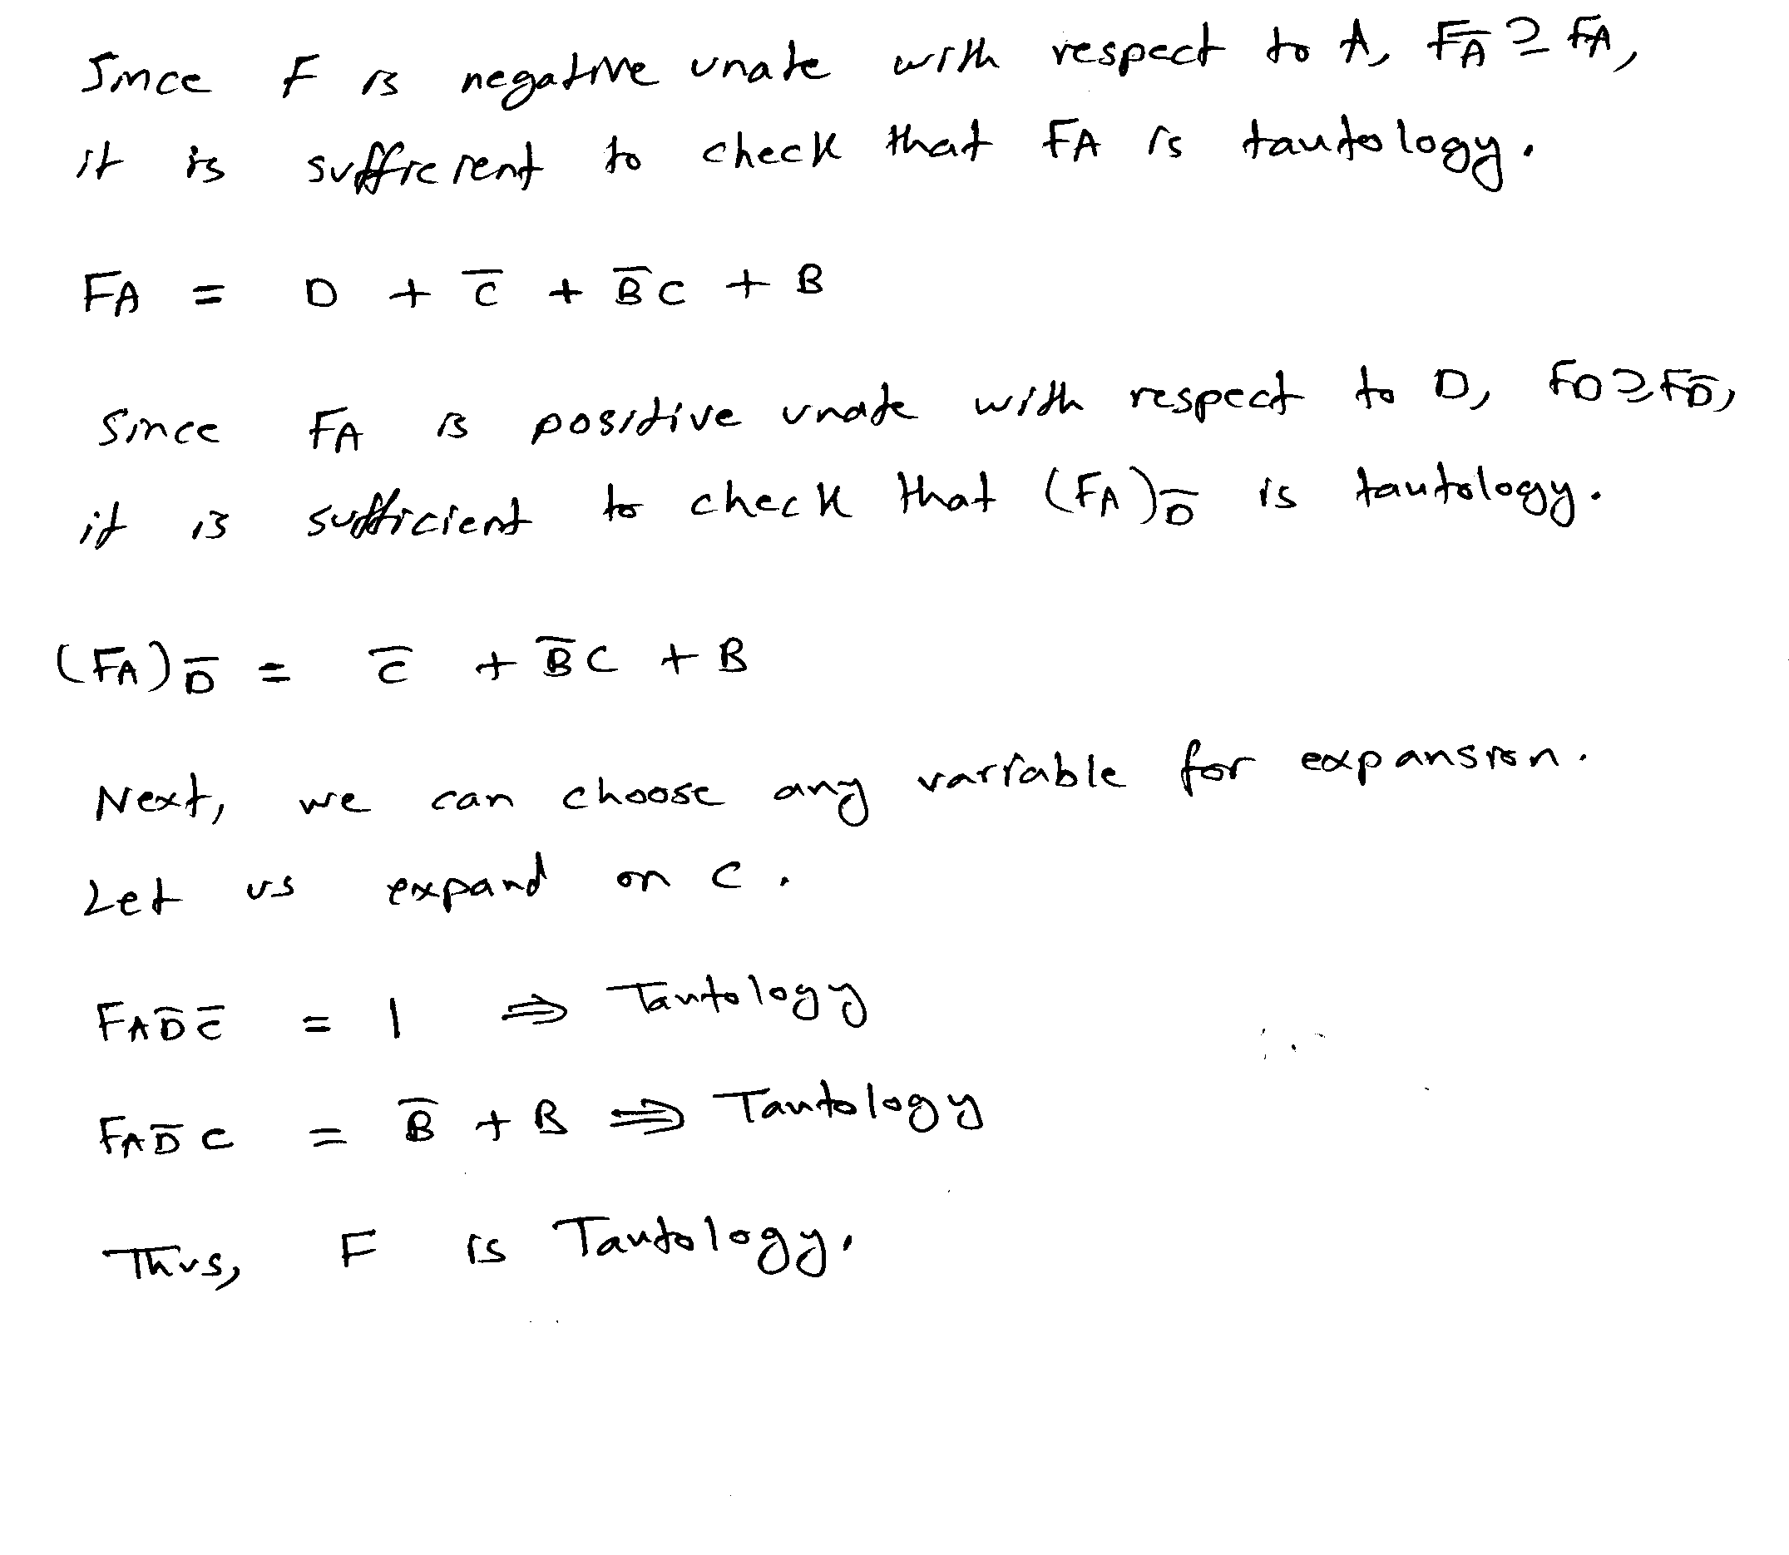

# **[25 Points]**

# **(Q4)** Consider the two Boolean functions and given below:

# 

# 

# Compute the expansion of and using the **Orthonormal Basis** {∅1=, ∅2=, ∅3=, ∅4=}.

# Compute the function.

# Draw the **ITE DAG** for the function using the variable order {A, B, C, D}. Use the given functions as is and do not start with the minimized result of. Show all the details of your solution using ITE procedure including the resulting unique table.

## 

## 

## 

# **[20 Points]**

# **(Q5)** Consider the function

## Compute the **complement** of the function using the recursive complementation procedure outlined in section 7.3.4. You need to choose the right variable for expansion to minimize computations.

## **C**ompute all the **prime implicants** of the function using the method outlined in section 7.3.4. You need to choose the right variable for expansion to minimize computations.

## 

