Name: KEY Id#

COE 405, Term 152

Design & Modeling of Digital Systems

Quiz# 5

Date: Sunday, April 24, 2016

It is required to design a circuit that counts the number of data transitions (i.e. 0→1and 1→0 data changes) through a stream of 128 bit data. The data is applied serially through an input X once the user presses a Start button, where the first bit is transmitted in the same cycle the Start button is asserted. Once the computation is finished the machine asserts a Done signal which remains asserted until the user presses the Start button again or resets the machine. Assume that the machine has Asynchronous Reset input. The ASMD chart for this machine is given below.

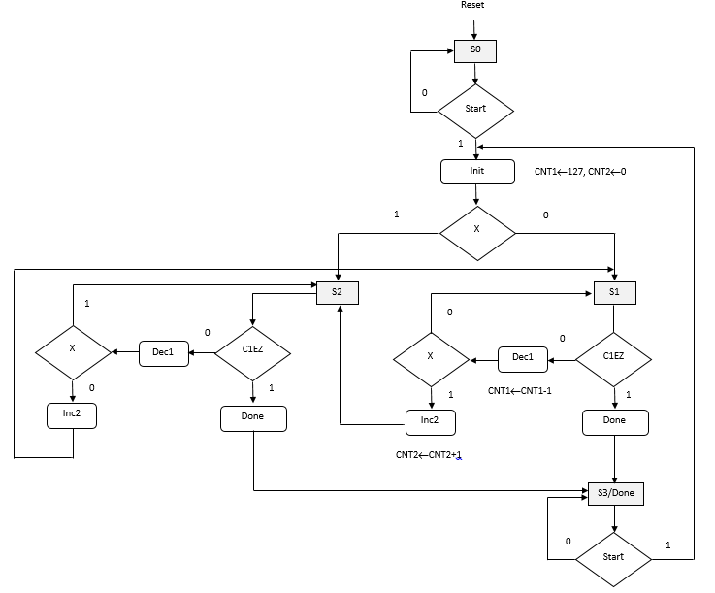

Write a behavioral Verilog module to model the data path unit for the given ASMD chart for circuit.

module Quiz5DP(output reg [6:0] CNT2, output C1EZ, input Init, Dec1, Inc2, CLK);

reg [6:0] CNT1;

assign C1EZ= ~| CNT1;

always @(posedge CLK)
if (Init) begin
CNT1 <= 127;
CNT2 <= 0;
end
else begin
if (Dec1) CNT1 <= CNT1 - 1;
if (Inc2) CNT2 <= CNT2 + 1;
end

endmodule

Write a behavioral Verilog module to model the control unit for the given ASMD chart for this circuit.

module Quiz5CU (output reg Init, Dec1, Inc2, Done, input X, Start, C1EZ, Reset, CLK);

parameter S0 = 2'b00, S1=2'b01, S2=2'b10, S3=2'b11;

reg [1:0] state, next_state;

always @(posedge CLK, posedge Reset)
if (Reset) state <= S0;
else state <= next_state;

always @(state, X, Start, C1EZ) begin
Init=0; Dec1=0; Inc2=0; Done=0;
case (state)
S0:
if (Start) begin
Init=1;
if (X) next_state=S2;
else next_state=S1;
end
else next_state=S0;
S1:
if (C1EZ) begin
Done=1; next_state=S3;
end
else begin
Dec1=1;
if (X) begin
Inc2 = 1;
next_state=S2;
end
else next_state=S1;
end
S2:
if (C1EZ) begin
Done=1; next_state=S3;
end
else begin
Dec1=1;
if (!X) begin
Inc2 = 1;
next_state=S1;
end
else next_state=S2;
end
S3: begin Done=1;
if (Start) begin
Init=1;
if (X) next_state=S2;
else next_state=S1;
end
else next_state=S3;
end
default: next_state='bx;
endcase
end

endmodule

Write a Verilog module to model the overall circuit by connecting the data path and control unit modules.

module Quiz5 (output [6:0] CNT, output Done, input X, Start, Reset, CLK);

Quiz5DP M1 (CNT, C1EZ, Init, Dec1, Inc2, CLK);

Quiz5CU M2 (Init, Dec1, Inc2, Done, X, Start, C1EZ, Reset, CLK);

endmodule

