Name: KEY Id#

COE 405, Term 152

Design & Modeling of Digital Systems

Quiz# 3

Date: Sunday, April 3, 2016

Q1. Given below the design of an n-bit magnitude comparator. The circuit receives two n-bit unsigned numbers A and B and produces two outputs GT and EQ as given in the table to the right.
 | GT EQ
IF A > B | 1 0
IF A = B | 0 1
IF A < B | 0 0

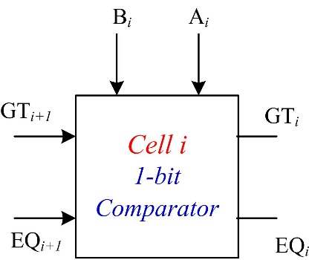

The input operands are processed in a bitwise manner starting with the most significant bit (MSB). The comparator circuit is constructed using n identical copies of the basic 1-bit cell shown to the right.

The Figure below shows the n-bit comparator circuit implemented using n copies of the basic 1-bit cell.

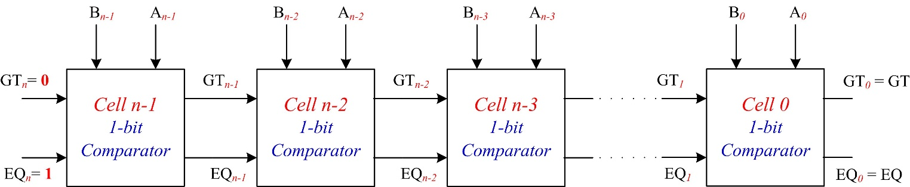

Boolean expressions of the outputs of cell i and its gate-level implementation are given below:

${GT}_{i}={GT}_{i+1}+A_{i} {\overline{B}}_{i}{ EQ}_{i+1}$
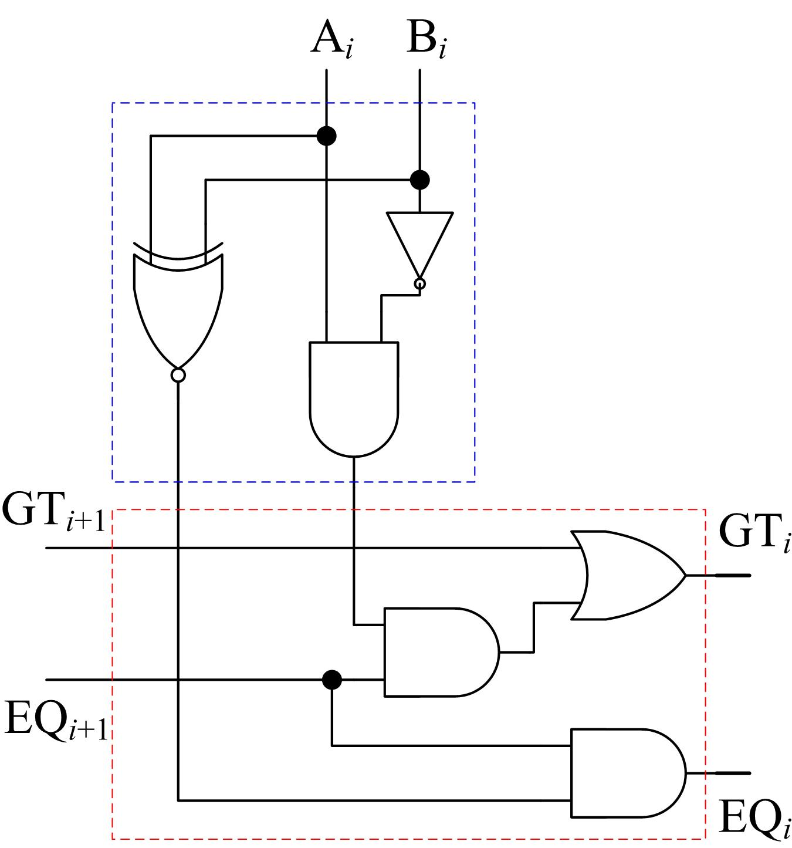
Cell i Gate Level Implementation
EQ_{i} = (A_{i} B_{i}). EQ_{i+1}

Write a Verilog model Comp1Bit to model the 1-bit comparator circuit using either a structural model of basic logic gates or a behavioral model using the assign statement.

The declaration of the Comp1Bit module is as follows:

module Comp1Bit (output GT_out, EQ_out , input GT_in , EQ_in, Ai, Bi);

module Comp1Bit (output GT_out, EQ_out, input GT_in, EQ_in, Ai, Bi);
assign GT_out = GT_in || Ai && !Bi && EQ_in;
assign EQ_out = (Ai ~^ Bi) && EQ_in;
endmodule

OR
module Comp1Bit (output GT_out, EQ_out, input GT_in, EQ_in, Ai, Bi);
not (g1, Bi);
and (g2, g1, Ai);
xnor(g3, Ai, Bi);
and (g4, g2, EQ_in);
or (GT_out, GT_in, g4);
and (EQ_out, EQ_in, g3);
endmodule

Complete the following Verilog model Comp3Bit that models a 3-bit comparator circuit.

module Comp3Bit (output Greater, Equal,
input [2:0] A , B) ;

wire [2:1] GT, EQ ; // internal wires connecting cells
/* First instance “M1” of the cell Comp1Bit with its inputs GT_in and EQ_in connected to fixed values of 0 and 1 respectively */
//
Comp1Bit M1 (GT[2] , EQ [2], 1'b0, 1'b1, A[2], B[2]);
Comp1Bit M2 (GT[1], EQ[1], GT[2], EQ[2], A[1], B[1]);
Comp1Bit M3 (Greater, Equal, GT[1], EQ[1], A[0], B[0]);
endmodule

Write a Verilog test bench to test the 3-bit comparator Comp3Bit by applying the following input patterns consecutively with a delay of 20ps:

{A=100, B=011},

{A=101, B=101},

{A=011, B=111}.

module t_Comp3Bit();
wire Greater, Equal;
reg [2:0] A, B;
Comp3Bit M1 (Greater, Equal, A, B) ;

initial begin
A=3'b100; B=3'b011;
#20 A=3'b101; B=3'b101;
#20 A=3'b011; B=3'b111;
end
endmodule

