Name: Id#

COE 405, Term 152

Design & Modeling of Digital Systems

Quiz# 3

Date: Sunday, April 3, 2016

Q1. Given below the design of an n-bit magnitude comparator. The circuit receives two n-bit unsigned numbers A and B and produces two outputs GT and EQ as given in the table to the right.
 | GT EQ
IF A > B | 1 0
IF A = B | 0 1
IF A < B | 0 0

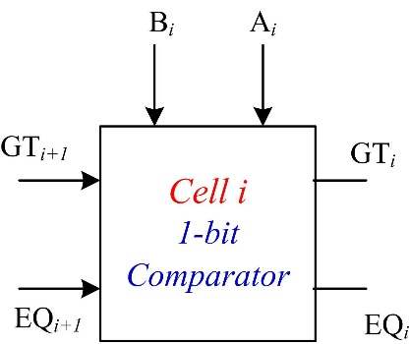

The input operands are processed in a bitwise manner starting with the most significant bit (MSB). The comparator circuit is constructed using n identical copies of the basic 1-bit cell shown to the right.

The Figure below shows the n-bit comparator circuit implemented using n copies of the basic 1-bit cell.

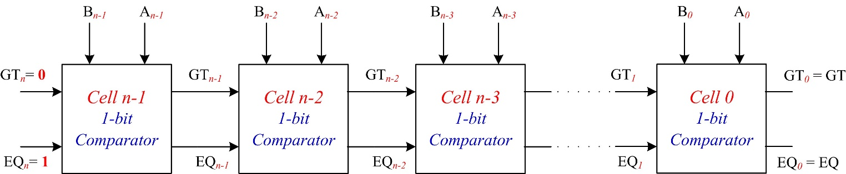

Boolean expressions of the outputs of cell i and its gate-level implementation are given below:

${GT}_{i}={GT}_{i+1}+A_{i} {\overline{B}}_{i}{ EQ}_{i+1}$
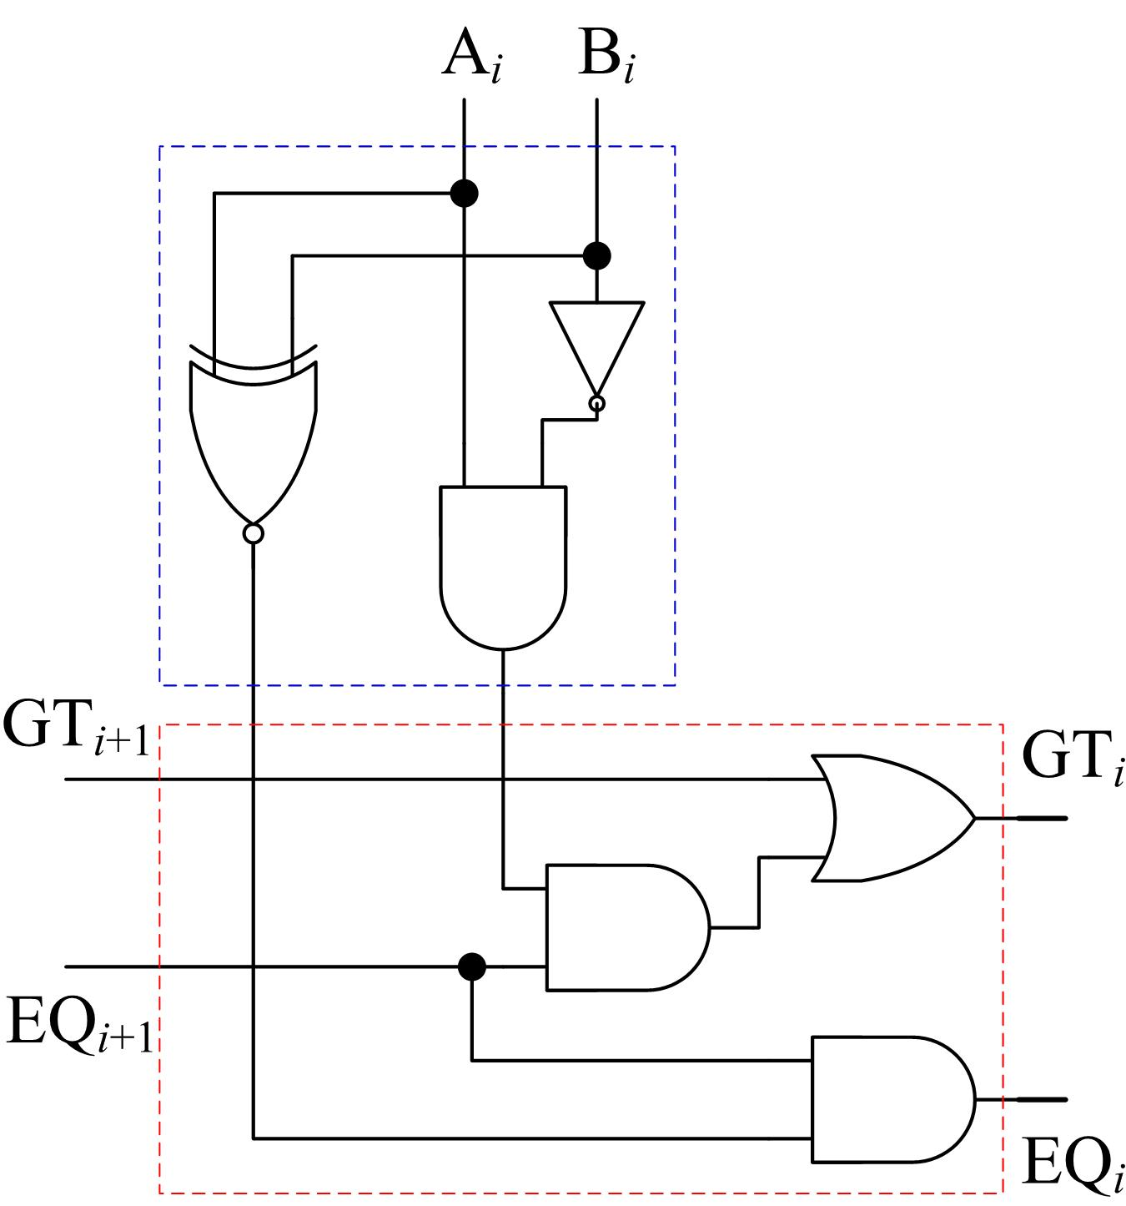
Cell i Gate Level Implementation
EQ_{i} = (A_{i} B_{i}). EQ_{i+1}

Write a Verilog model Comp1Bit to model the 1-bit comparator circuit using either a structural model of basic logic gates or a behavioral model using the assign statement.

The declaration of the Comp1Bit module is as follows:

module Comp1Bit (output GT_out, EQ_out , input GT_in , EQ_in, Ai, Bi);

endmodule

Complete the following Verilog model Comp3Bit that models a 3-bit comparator circuit.

module Comp3Bit (output Greater, Equal, input [2:0] A , B) ;

endmodule

Write a Verilog test bench to test the 3-bit comparator Comp3Bit by applying the following input patterns consecutively with a delay of 20ps:

{A=100, B=011},

{A=101, B=101},

{A=011, B=111}.

