Name: Id#

COE 306, Term 171

Introduction to Embedded Systems

Quiz# 4 Solution

Date: Tuesday, Dec. 18, 2017

Q1. Fill in the blank in each of the following questions:

The advantage of serial transmission in comparison to parallel transmission is that it is cheap while the advantage of parallel transmission is that it is fast.

The advantage of using differential signals in serial transmission is that it doubles the signal to noise ratio.

In simplex transmission, data flow is only in one direction while in duplex transmission, data flow is in both directions simultaneously.

Given 9600 baud rate and 8 voltage levels used for transmitting each symbol, the bit rate is 9600 * 3 = 28800 bps.

Given a protocol with 3 bits of protocol (start, stop and parity), 7 bits of data, 9600 baud rate, and 1 bit per symbol (binary), the information rate is 9600 * 1 * 7/10 = 6720 bps.

SPI has higher (higher/lower) throughput than I²C.

In SPI, transmission involves two shift registers one in master and one in slave connected in a virtual ring topology.

In I²C, a start condition is indicated by having the clock line high and the data line changing from 1 to 0 and a stop condition is indicated by having the clock line high and the data line changing from 0 to 1.

In UART, a framing error occurs when the stop bit of a received character is a logic 0.

In UART, an overrun error occurs when a new character is assembled while the receiver buffer or FIFO is full.

Q2. It is required to interface a microcontroller as a master to three peripheral devices as slaves.

- Show the block diagram interconnection of the master and slaves using SPI interface.

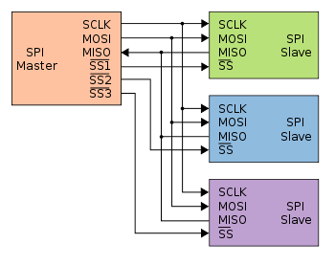

- Show the block diagram interconnection of the master and slaves using I²C interface.

