Name: Id#

COE 306, Term 161

Introduction to Embedded Systems

Quiz# 4

Date: Sunday, Dec. 4, 2016

Q1. It is required to implement the following FIR filter using a circular buffer:

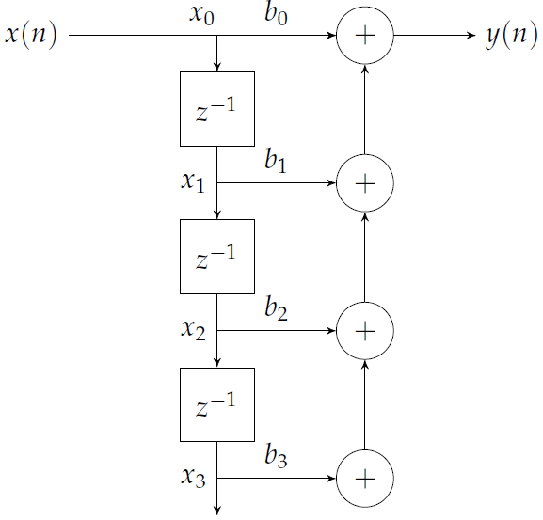

Define the necessary variables for the circular buffer.

Show the C code for the function init( ) for initializing the buffer.

Show the C code for the function put( ) for adding a new value to the buffer.

Show the C code for the function get( ) for getting a value from the buffer. The function gets the ith value from the circular buffer with zero being the newest value.

Show the C code for the function fir( ) that receives a new value x(n) and returns a computed value y(n) .

Q2. Consider the data block given below:

w = a + b;
x = c + d;
w = w * a;
x = x * d;
y = x + w;

Rewrite the given data block in single-assignment form, and then draw the data flow graph for that form.

Determine the minimum number of registers required to perform the operations when they are executed in the order shown in the code. Show the lifetime graph.

Determine the order of execution of operations that gives the smallest number of required registers and state the number of registers required. Show the lifetime graph.

