Name: Id#

COE 306, Term 171

Introduction to Embedded Systems

Quiz# 3 Solution

Date: Thursday, Nov. 16, 2017

Q1. Fill in the blank in each of the following questions:

DMA allows transfers between the CPU and I/O devices without involving the CPU.

In a microprocessor system, a high speed bus is connected to a low speed bus using a bridge

In AMBA, the UART is connected to the APB bus.

In AMBA basic AHB transfer, a slave can insert wait states by setting the HREADY signal to low.

Complete the given timing diagram for an AMBA AHB pipelined burst write transfer:

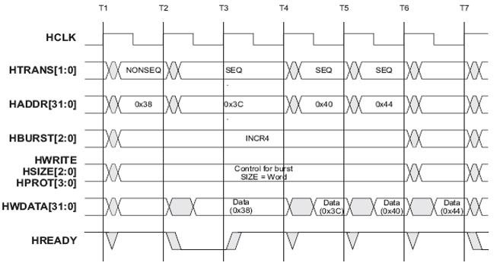

Complete the given timing diagram for an AMBA APB write transfer:

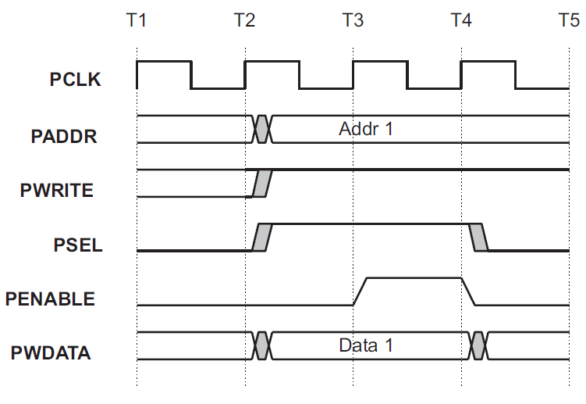

Given that the match registers are set to have the following values: MR0=100, MR1=41, MR2=78, MR3=53, MR4, 27 and MR5=65. Assume that the timer is configured for PWM mode and that control bits PWMENA2, PWMENA4, PWMENA5, PWMSEL2 and PWMSEL4 are set. Complete the given timing diagram for one PWM cycle:

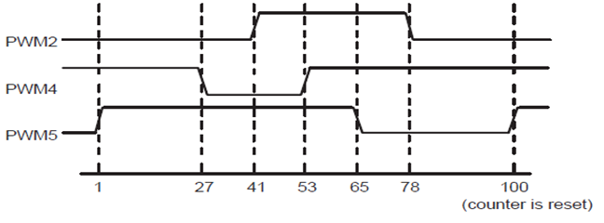
Q2. A sensor generates 10000 bytes of data every 10ms, and sends them to the CPU over a 2-MHz peripheral bus. The bus is 32-bit wide, and each bus transfer on the bus takes 3 bus cycles, 1 of which is used to transfer data, and the remaining cycles are used by the bus protocol.

What is the CPU’s time budget (in seconds) for processing each 10000 bytes of sensory data?

T_{bus} = (D +O) N / W = (3) 10000 / 4 = 7500 bus cycles
t_{bus} = T P = T / f = 7500 / (2 x 10⁶) = 3750 μs = 3.75 ms
Then, the time budget available to the CPU for processing each 10000 bytes is:
t_{CPU} = 10 – 3.75 = 6.25 ms

If the CPU needs 30 cycles to process each byte of sensory data, what is the lowest frequency at which the CPU can run in order to process the data in time?

For each 10000 bytes:
T_{CPU} = 30 x 10000 = 300,000 cycles
f_{CPU} = T_{CPU} / t_{CPU} = 300,000 / 6.25 x 10⁻³ = 48,000,000 Hz = 48MHz

