King Fahd University of Petroleum and Minerals
College of Computer Science and Engineering
Computer Engineering Department

COE 306: INTRODUCTION TO EMBEDDED SYSTEMS
Term 161 (Fall 2016-2017)
Major Exam 1
Saturday Oct. 29, 2016

Time: 90 minutes, Total Pages: 10

Name:______________________________ ID:__________________ Section: _______

Notes:
- Do not open the exam book until instructed
- Answer all questions
- All steps must be shown
- Any assumptions made must be clearly stated

Question | Max Points | Score
Q1 | 28
Q2 | 12
Q3 | 12
Q4 | 8
Total | 60

Dr. Aiman El-Maleh

[28 Points]

(Q1) Fill in the blank in each of the following questions:

The difference between hard and soft real time deadlines is ___________________________________________________________________________________________________________________________________.

Microprocessors have higher ________________ and lower ______________ than ASICS.

Requirements are ___________________________________________________.

An example of a non-functional requirement is _________________________________________________________________.

Specification is _____________________________________________________.

The difference between von Neumann architecture and Harvard architecture is _________________________________________________________________.

A _______________ processor uses specialized logic to identify at run time instructions that can be executed simultaneously while a _______________ processor relies on the compiler to determine what combinations of instructions can be legally executed together.

In a RISC system with memory-mapped I/O, input/output operations are performed using _______________________ instructions.

The PICmicro PIC16F has a _____________ (von Neumann /Harvard) architecture.

The TI C55X DSP has a _____________ (RISC /CISC) architecture.

The ____________________ processor has the capability of executing up to eight instructions per cycle.

The ____________________ processor has instructions to allow repeating the execution of a block of instructions.

In an interrupt-based I/O system, a device knows that its request is accepted by _________________________________________________________________.

Given that two devices A and B are connected to a CPU through two interrupt lines with device A having higher priority than B. Suppose that the interrupt handler of device A executes in 30 cycles while that of B executes in 25 cycles. Assume that each instruction in the handlers executes in one clock cycle. If device A initiates an interrupt at the end of cycle 5 when the handler of device B is executing, then the handler of device B will finish execution by the end of cycle______.

If more than one device have the same priority and are connected to the same interrupt pin, then the interrupt handler will know the device who initiated the interrupt by ________________________________________________________.

_____________________ allow an interrupting device to specify its handler.

Two Cache memory organizations are _________________________________________________________________.

Given that h is the cache hit rate, t_{cache} is the cache access time and t_{main} is the memory access time, then the average memory access time is _________________________________________________________________.

Two basic schemes for mapping logical addresses to physical addresses are: _________________________________________________________________.

[12 Points]

(Q2)

[6 points] Translate the given C code into ARM assembly code with minimum instructions:

volatile static int Array[10] = {75,20,50,40,55,60,10,85,100,90};
int Max=Array[0];
int Min=Array[0];

for (int i=1; i<10; i++)
if (Array[i]<Min)
Min = Array[i];
else if (Array[i] > Max)
Max = Array[i];

[3 points] Write an ARM code fragment that multiplies the content of register r0 by 217 without the use of multiplication instructions with the minimum number of instructions. HINT: 217=31*7.

[3 points] Determine the content of register 0x27 after executing the following PIC16F assembly code:

MOVLW 0xA7
MOVWF 0x25
MOVLW 4
MOVWF 0x26
CLRF 0x27
NEXT MOVF 0x25, w
ANDLW 3
ADDWF 0x27, f
RRF 0x25, f
RRF 0x25, f
DECFSZ 0x26
GOTO NEXT

[12 Points]

(Q3) A system has two memory-mapped I/O devices. The first device has a 16-bit status register at address 0xA000, immediately followed by a 32-bit data register. The second device has an 8-bit status register at address 0xB000, followed by a 32-bit data register. The first device is used to receive data (i.e., input device). The most-significant bit in the status register is a data ready flag, which is set automatically by the device whenever new data is received. For the device to receive more data, the data ready flag must be manually reset by software to indicate that the current data have been processed.

The second device is used to send data (i.e., output device). Bit 0 of its status register is a read-only ready to send flag, and bit 7 is a transmit enable command bit that is automatically reset by the device after each transmission.

We would like to write software that collects 32-bit words of unsigned values received through the first device, and computes the maximum of received data until the second device becomes ready to send. Once the second device becomes ready to send data, the maximum word is sent using the second device. Once the maximum is sent, the maximum computation is restarted for the next sample of data, ignoring the previously received data samples.

  - Write a C program that implements this behavior using polling only.
  - Assuming that each device has its own interrupt handler, write the handlers for each device in C. The first device generates an interrupt request upon receiving new data. The second device generates an interrupt request upon becoming ready to send new data.
Use the signatures:
void device1_handler(void);
void device2_handler(void);

[8 Points]

(Q4) In a virtual memory system, 20 bits are used to identify the page number, and 12 bits are used to specify the offset of an address within a page. The system supports up to 64 GB of physical memory.

- How large is the virtual memory?

- How wide are physical addresses?

- How many entries are there in the full flat page table?

- How wide is each entry of the page table for storing the physical page number?

- Given the logical address 0x000100B8, what is the page number, in hexadecimal, for the page that contains this address? What is the offset of this address within its page (hexadecimal)?

- Suppose that the page of the logical address 0x000100B8 got mapped into physical page number 0xFF, what is the physical address corresponding to this logical address?

- If two-level page tables are used with the first-level page table having 1024 entries, how many entries will be in each of the second-level page tables?

ARM Instruction Set

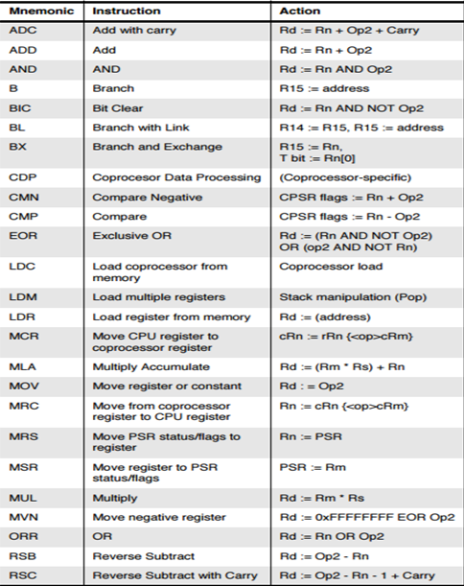
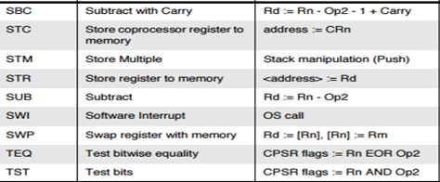

PIC16 Instruction Set

