Name: Id#

ICS 103, Term 092

Computer Programming in C

Quiz# 3

Date: Tuesday, April 27, 2010

Q1. Write function that receives as input a character and returns true if the character is an alphabetic character.

Q2. Write a program to open an input file, myinput, and count the number of non-space characters and the number of alphabetic characters and print the results in the output file myoutput. Use the function developed in Q1. Your program should handle the case of file not found error.

Sample Input: | Sample Output:
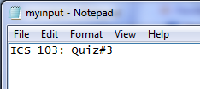 | 