ICS 103, Term 083

Computer Programming in C

HW# 2 Solution
Due date: Saturday, August 8, 2009

You are required to write a C program to do the following:

Ask the user to enter the length and width of a rectangle and read them.

Ask the user to enter a displacement number indicating the position of the rectangle from the left side of the screen and read it.

Ask the user to enter a fill character that will be used to fill the rectangle and read it.

Display the rectangle according to the entered specification. Use functions and modular programming in your solution.

A sample execution of the program is shown below:

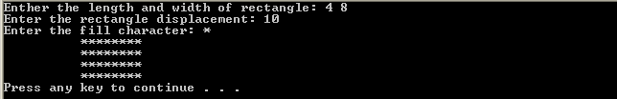

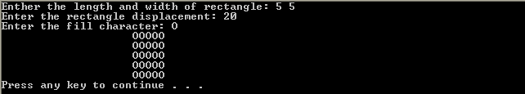

#include <stdio.h>
#include <stdlib.h>

void disps(int size);
void displ(int size, char fill);
void dispr (int length, int width, int dis, char fill);

int main(void)
{
int length, width, dis;
char fill;
int i;
printf("Enther the length and width of rectangle: ");
scanf("%d %d",&length, &width);
printf("Enter the rectangle displacement: ");
scanf("%d",&dis);
printf("Enter the fill character: ");
scanf(" %c", &fill);
dispr (length, width, dis, fill);

system("pause");
return 0;
}

void disps(int size){
int i;
for (i=0; i<size; i++)
printf(" ");
}

void displ(int size, char fill){
int i;
for (i=0; i<size; i++)
printf("%c",fill);
printf("\n");
}

void dispr (int length, int width, int dis, char fill)
{
int i;

for (i=0; i<length; i++){
disps(dis);
displ(width, fill);
}
}

You are required to write a program to read a text file and encrypt it and store the encrypted text into another file. The same program can be used to decrypt the encrypted file. Encryption/decryption is performed according to a password entered by the user. To implement your program, do the following:

Ask the user to enter the file name to encrypt/decrypt and read it. Then, ask the user to enter the output file name and read it. You can define the input and output file names as char infname[40], outfname[40]. You can read the input file name using the function gets(infname), which is available in stdlib.

Open the input file for reading and the output file for writing handling file not found error.

Ask the user to enter a password number, pwd, and read it.

Read each character in the input file and encrypt/decrypt it if it is not a new line character. Save the encrypted/decrypted character in the output file. A new line character should be written as is. Encryption/decryption of each character is performed by XORING the character with a randomly generated value in the range [0-15]. Initialize the random number generator in the beginning of your program by the entered password using the function srand(pwd). You can generate a random number in the range [0-15] using the function rand()%16.

Test the correctness of your program by encrypting and then decrypting the message given below using the password 1967:
“Welcome to ICS 103!!
This question of HW#2 is interesting.”

A sample execution of the program is shown below:

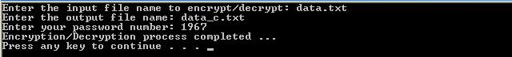

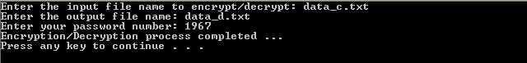

Encrypted file:

Decrypted file:

#include <stdio.h>
#include <stdlib.h>

int main(void)
{

int i, j, pwd;
FILE *inf, *outf;
char c;
char infname[40], outfname[40];

printf("Enter the input file name to encrypt/decrypt: ");
gets(infname);
inf = fopen( infname, "r");
if (inf == NULL){
printf("Cannot open %s for reading \n", infname);
exit(1);
}
printf("Enter the output file name: ");
gets(outfname);
outf = fopen( outfname, "w");

printf("Enter your password number: ");
scanf("%d",&pwd);
srand(pwd);

while ( fscanf(inf,"%c",&c) != EOF ) {
if ( c != '\n' ){
j = rand()%16;
c ^= j;
fprintf(outf,"%c",c);
}
else
fprintf(outf,"%c",c);

}

printf("Encryption/Decryption process completed ...\n");

system("pause");
return 0;
}

You are required to write a program that reads students ID’s along with their exam scores from a file and computes the average, maximum and minimum. In addition, the program should assign a letter grade to each student according to the criteria given below:

Score | Grade
score>= 90 | A+
85<= score <90 | A
80<=score<85 | B+
75<=score<80 | B
70<=score<75 | C+
65<=score<70 | C
60<=score<65 | D+
55<=score<60 | D
score<55 | F

Then, your program should compute for each letter grade the number and percentage of students who got that grade. Finally, the program should compute the GRADE POINT AVERAGE (GPA) according to the following formula:

4A⁺ + 3.75A + 3.50B⁺ + 3B + 2.50C⁺ + 2C + 1.50D⁺ + 1D
GPA = ------------------------------------------------------------------------
A⁺ + A + B⁺ + B + C⁺ + C + D⁺ + D + F

All the results should be written in a file specified by the user.

A sample execution of the program is shown below:

scores.txt file:
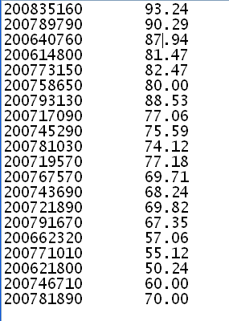
grades.txt file:
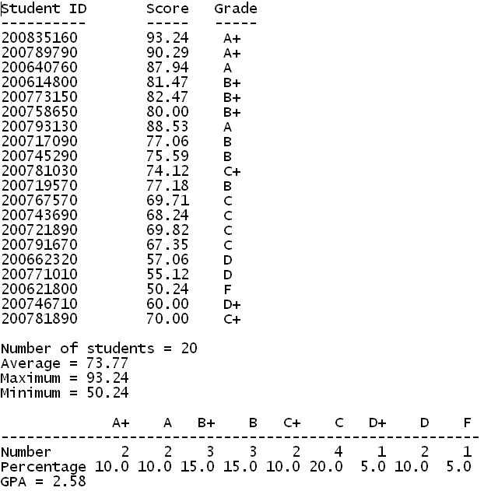

#include <stdio.h>
#include <stdlib.h>

int main(void)
{

FILE *inf, *outf;
char infname[40], outfname[40];
int status, id;
int apc=0, ac=0, bpc=0, bc=0, cpc=0, cc=0, dpc=0, dc=0, fc=0, tc=0;
double score, sum, max=0, min=100, gpa;

printf("Enter the input file name: ");
gets(infname);
inf = fopen( infname, "r");
if (inf == NULL){
printf("Cannot open %s for reading \n", infname);
system("pause");
exit(1);
}
printf("Enter the output file name: ");
gets(outfname);
outf = fopen( outfname, "w");

fprintf(outf,"Student ID \t Score \t Grade\n");
fprintf(outf,"---------- \t ----- \t -----\n");
status =fscanf(inf,"%d %lf",&id, &score);
while ( status != EOF ) {
fprintf(outf,"%d \t %.2f \t ",id, score);
if (score>= 90) {fprintf(outf,"A+\n"); apc++;}
else if (score>= 85) {fprintf(outf,"A\n"); ac++;}
else if (score>= 80) {fprintf(outf,"B+\n"); bpc++;}
else if (score>= 75) {fprintf(outf,"B\n"); bc++;}
else if (score>= 70) {fprintf(outf,"C+\n"); cpc++;}
else if (score>= 65) {fprintf(outf,"C\n"); cc++;}
else if (score>= 60) {fprintf(outf,"D+\n"); dpc++;}
else if (score>= 55) {fprintf(outf,"D\n"); dc++;}
else {fprintf(outf,"F\n"); fc++;}
tc++;
sum += score;
if (score>max) max = score;
if (score < min) min = score;
status =fscanf(inf,"%d %lf",&id, &score);

}

fprintf(outf,"\nNumber of students = %d\n",tc);
fprintf(outf,"Average = %.2f\n",sum/tc);
fprintf(outf,"Maximum = %.2f\n",max);
fprintf(outf,"Minimum = %.2f\n\n",min);

fprintf(outf," A+ A B+ B C+ C D+ D F \n");
fprintf(outf,"--------------------------------------------------------\n");
fprintf(outf,"Number %4d %4d %4d %4d %4d %4d %4d %4d %4d\n",\
apc,ac,bpc,bc,cpc,cc,dpc,dc,fc);
fprintf(outf,"Percentage %4.1f %4.1f %4.1f %4.1f %4.1f %4.1f %4.1f %4.1f %4.1f\n",\
apc*100.0/tc,ac*100.0/tc,bpc*100.0/tc,bc*100.0/tc,\
cpc*100.0/tc,cc*100.0/tc,dpc*100.0/tc,dc*100.0/tc,fc*100.0/tc);

gpa = (4*apc+3.75*ac+3.5*bpc+3*bc+2.5*cpc+2*cc+1.5*dpc+1*dc)/tc;
fprintf(outf,"GPA = %.2f\n",gpa);

printf("Grades generated successfully...\n");

system("pause");
return 0;
}

