ICS 103, Term 132

Computer Programming in C

HW# 2
Due date: Tuesday, March 4, 2014

The table below shows the normal boiling points of several substances. Write a program that prompts the user for the observed boiling point of a substance in °C and identifies the substance if the observed boiling point is within 5% of the expected boiling point. If the data input is more than 5% higher or lower than any of the boiling points in the table, the program should output the message Substance unknown.

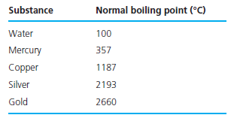

Your program should define and call a function, within_x_percent, that takes as parameters a reference value ref, a data value data, and a percentage value x and returns 1 meaning true if data is within x % of ref —that is, (ref – x% * ref) ≤ data ≤ (ref + x % * ref) . Otherwise, the function within_x_percent would return zero, meaning false. For example, the call within_x_percent(357, 323, 10) would return true, since 10% of 357 is 35.7, and 323 falls between 321.3 and 392.7.

Test your program by applying 10 different inputs, where two inputs are related to one substance type such that for one input the substance is identified and for another it is not.

The solution should be well organized and your program should be well documented. Submit a soft copy of your solution in a zip file. Your solution should be submitted in a word file that contains the following items:

Your name and ID

Homework number

Problem statement

Your solution along with the code

Discussion of what worked and what did not work in your program. Include snapshots that demonstrate the working parts of your program. If things did not work and you attempted to solve them, mention that and write about the difficulty that you have faced.

The soft copy should also contain the source code file (i.e. .c) and the executable (i.e. .exe).

