ICS 103, Term 083

Computer Programming in C

HW# 2
Due date: Saturday, August 8, 2009

You are required to write a C program to do the following:

Ask the user to enter the length and width of a rectangle and read them.

Ask the user to enter a displacement number indicating the position of the rectangle from the left side of the screen and read it.

Ask the user to enter a fill character that will be used to fill the rectangle and read it.

Display the rectangle according to the entered specification. Use functions and modular programming in your solution.

A sample execution of the program is shown below:

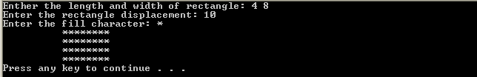

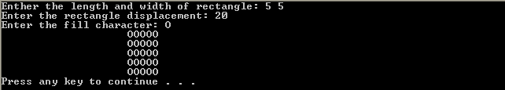

You are required to write a program to read a text file and encrypt it and store the encrypted text into another file. The same program can be used to decrypt the encrypted file. Encryption/decryption is performed according to a password entered by the user. To implement your program, do the following:

Ask the user to enter the file name to encrypt/decrypt and read it. Then, ask the user to enter the output file name and read it. You can define the input and output file names as char infname[40], outfname[40]. You can read the input file name using the function gets(infname), which is available in stdlib.

Open the input file for reading and the output file for writing handling file not found error.

Ask the user to enter a password number, pwd, and read it.

Read each character in the input file and encrypt/decrypt it if it is not a new line character. Save the encrypted/decrypted character in the output file. A new line character should be written as is. Encryption/decryption of each character is performed by XORING the character with a randomly generated value in the range [0-15]. Initialize the random number generator in the beginning of your program by the entered password using the function srand(pwd). You can generate a random number in the range [0-15] using the function rand()%16.

Test the correctness of your program by encrypting and then decrypting the message given below using the password 1967:
“Welcome to ICS 103!!
This question of HW#2 is interesting.”

A sample execution of the program is shown below:

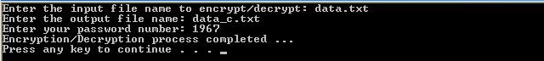

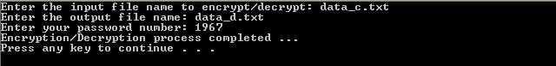

Encrypted file:

Decrypted file:

You are required to write a program that reads students ID’s along with their exam scores from a file and computes the average, maximum and minimum. In addition, the program should assign a letter grade to each student according to the criteria given below:

Score | Grade
score>= 90 | A+
85<= score <90 | A
80<=score<85 | B+
75<=score<80 | B
70<=score<75 | C+
65<=score<70 | C
60<=score<65 | D+
55<=score<60 | D
score<55 | F

Then, your program should compute for each letter grade the number and percentage of students who got that grade. Finally, the program should compute the GRADE POINT AVERAGE (GPA) according to the following formula:

4A⁺ + 3.75A + 3.50B⁺ + 3B + 2.50C⁺ + 2C + 1.50D⁺ + 1D
GPA = ------------------------------------------------------------------------
A⁺ + A + B⁺ + B + C⁺ + C + D⁺ + D + F

All the results should be written in a file specified by the user.

A sample execution of the program is shown below:

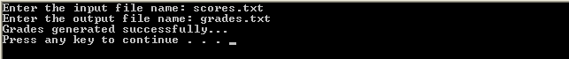

scores.txt file:

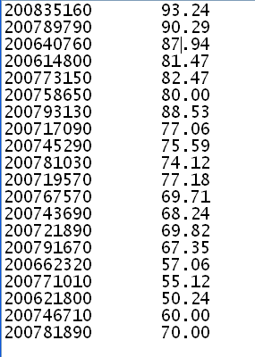

grades.txt file:

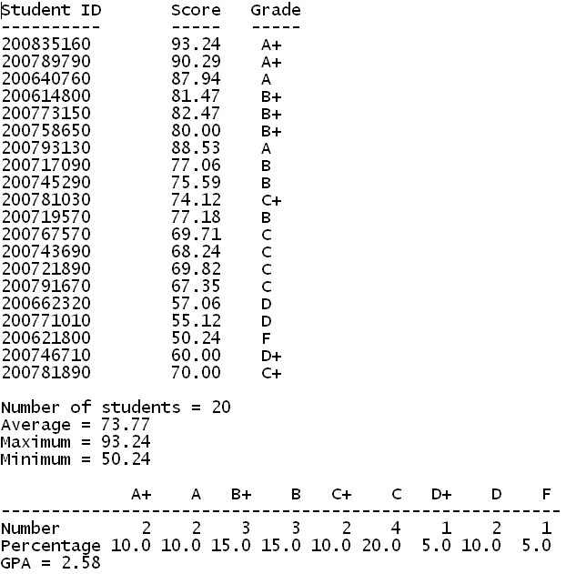

The solution should be well organized and your program should be well documented. Submit a soft copy of your solution in a zip file. Your solution should be submitted in a word file that contains the following items:

Your name and ID

Homework number

Problem statement for each question

Your solution along with the code for each question

Discussion of what worked and what did not work in your programs. Include snapshots that demonstrate the working parts of your programs. If things did not work and you attempted to solve them, mention that and write about the difficulty that you have faced.

The soft copy should also contain the source code files (i.e. .c) for each question separately.

