June 30, 2010

COMPUTER ENGINEERING DEPARTMENT

COE 205

COMPUTER ORGANIZATION & ASSEMBLY PROGRAMMING

Final Exam

First Semester (091)

Time: 7:30 -10:00 AM

Student Name : _KEY__________________________________________

Student ID. : ______________________________________________

Question | Max Points | Score
Q1 | 15
Q2 | 8
Q3 | 22
Q4 | 40
Q5 | 15
Total | 100

Dr. Aiman El-Maleh

[15 Points]

(Q1) Fill the blank in each of the following:

When an interrupt occurs, the CPU suspends its execution of the current program, and transfers control to an Interrupt Service Routine (ISR) that will provide the requested service by the interrupt.

Three main differences between interrupts and procedures include: Interrupts can be initiated by both software and hardware while procedures can be initiated only by software, Interrupt mechanism provides an efficient way to handle unanticipated events, Interrupts are identified by numbers while procedures are identified by names.

Interrupts initiated by the keyboard belong to interrupts of the following type: Maskable Hardware Interrupts.

Interrupts initiated due to division by 0 belong to interrupts of the following type: Processor Interrupts of type Fault.

Interrupts initiated due to execution of a break point in debugging mode belong to interrupts of the following type: Software Interrupts.

Maskable Hardware interrupts can be masked.

The Interrupt Flag (IF) controls whether maskable interrupts are delayed or not.

The CPU identifies the interrupting hardware through its number placed on the data bus.

An example of an interrupt Fault is divide error or segment-not-present.

In real mode, when the CPU executes the instruction INT 0Fh, it performs following actions:
  - Push FLAGS register onto the stack,
  - Clear interrupt and trap flags to disable further interrupts
  - Push CS register onto the stack,
  - Push IP register onto the stack,
  - Load CS register with the 16-bit at memory address from IDT at offset 3E
  - Load IP register with the 16-bit from IDT at offset 3C

To send control back to the interrupted program, the interrupt service routine should end up with the instruction IRET.

[8 Points]

(Q2) Given the CPU-Memory interface circuit shown below, complete the given timing diagram assuming the following given control sequnce as shown below:

T4 R1out, MDRin,
T5 R2out, MARin, Write, WMFC

Note that the control unit is assumed to be rising-edge triggered.

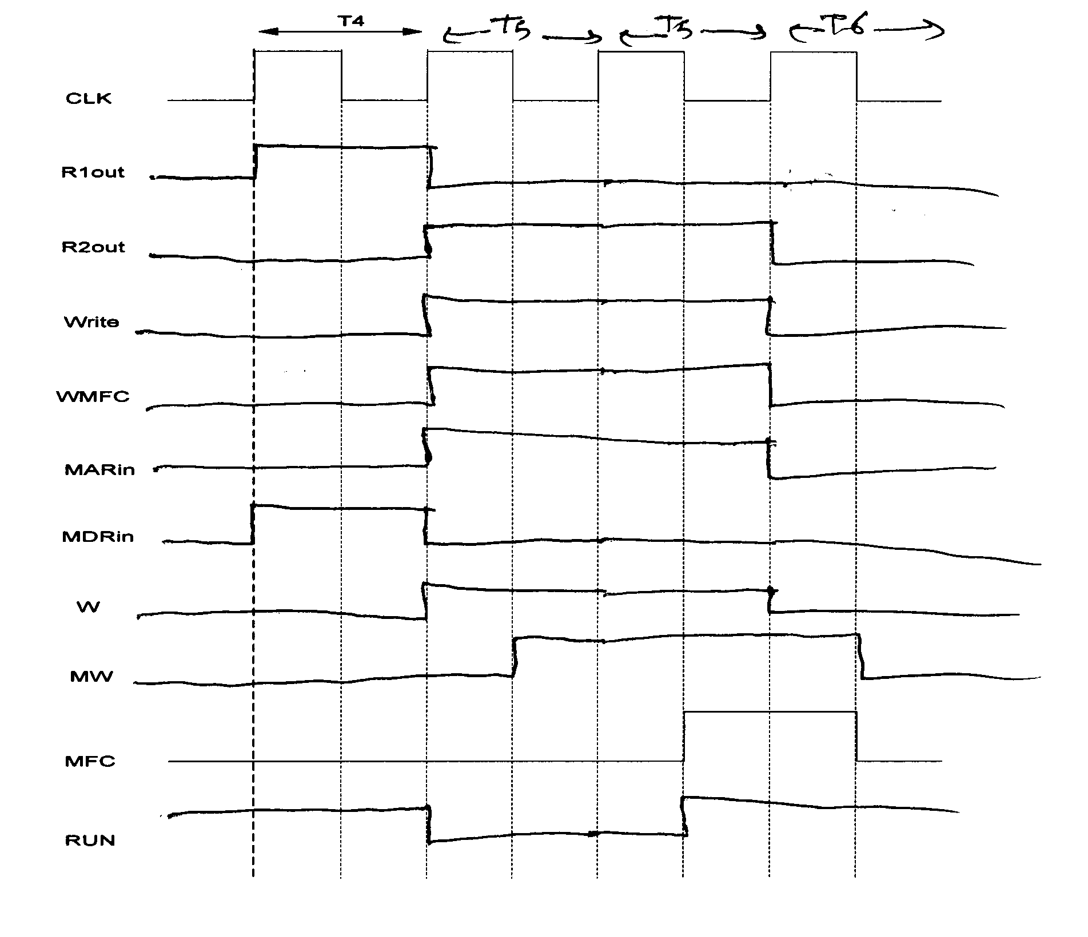

[22 Points]

(Q3) It is required to design an 8-bit CPU the has four 8-bit registers, namely R0, R1, R2, and R3. Assume that the data bus and address bus are 8-bits. The CPU has 8-bit instructions with the following foramt:

4 bits | 2 bits | 2 bits
OPCODE | Rdst | Rsrc

The CPU has the following set of instructions:

Instruction | Register Transfer
MOV Rdst, Rsrc | Rdst Rsrc
XCHG Rdst, Rsrc | Rdst Rsrc; Rsrc Rdst
ADD Rdst, Rsrc | Rdst Rdst + Rsrc
SUB Rdst, Rsrc | Rdst Rdst – Rsrc
INC Rdst | Rdst Rdst + 1
DEC Rdst | Rdst Rdst – 1
SHL Rdst, Rsrc | Rdst shift left Rdst by Rsrc
SHR Rdst, Rsrc | Rdst shift right Rdst by Rsrc
ROL Rdst, Rsrc | Rdst rotate left Rdst by Rsrc
ROR Rdst, Rsrc | Rdst rotate right Rdst by Rsrc
NOT Rdst | Rdst NOT Rdst
AND Rdst, Rsrc | Rdst Rdst AND Rsrc
OR Rdst, Rsrc | Rdst Rdst OR Rsrc
XOR Rdst, Rsrc | Rdst Rdst XOR Rsrc

Design a single-bus data path for this CPU. Clearly illustrate all design details and all the required control signals. Assume that you can only use the following combinational logic blocks in addition to basic gates like AND, OR, INV, XOR, MUX and Tri-state Buffers:

An 8-bit Adder that has the inputs A[7:0], B[7:0] and Cin, and produces the Sum in C[7:0] and Cout.

An 8-bit Shifter that has the inputs A[7:0] for specifiying the input to be shifted, B[2:0] to specify the amount of shift to be performed and two select lines SS1 and SS0 to determine the required operation as follows: SS1=0, SS0=0 to shift left, SS1=0, SS0=1 to shift right, SS1=1, SS0=0 to rotate left, and SS1=1, SS0=1 to rotate right. The resulting operand is produced on the output C[7:0]. The last bit shifted or rotated is produced on the output signal LS.

Assume that the CPU has a flags register consisting of 4 flags: sign flag, carry flag, overflow flag, and zero flag. Assume that all instructions affect the 4 flags except, the mov and xchg instructions, similar to 8086 instructions. Design the data path to minimize the number of clock cycles needed for the execution of the specified instructions.

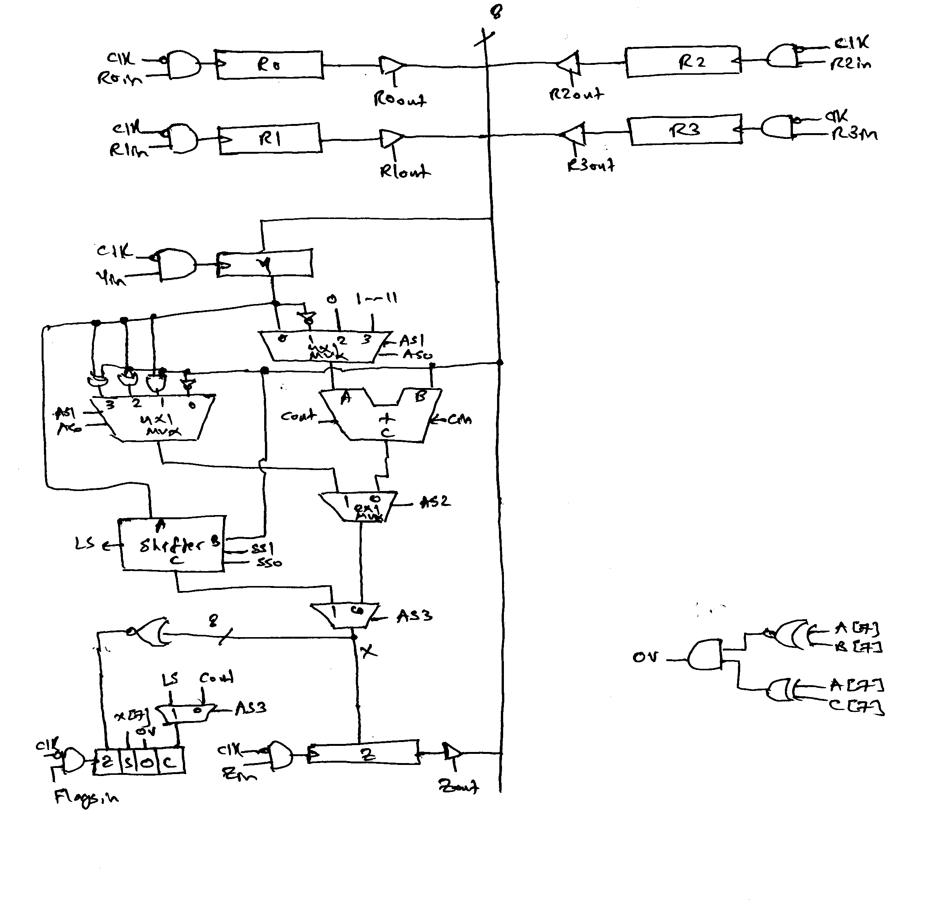

[40 Points]

(Q4) Assume that a CPU has 16 instructions with an opcode of 4 bits, seven 16-bit general purpose registers namely AX, BX, CX, DX, SI, DI and SP, a 16-bit data bus, and a 16-bit address bus. Assume that all the instructions are 16-bit. The CPU has an Arithmetic and Logic Unit (ALU) with inputs A and B and output C, that can perform any of the following functions shown below based on the three selection lines AS2, AS1, and AS0:

AS2 AS1 AS0 | Operation
000 | C=A+B
001 | C=A-B
010 | C=A+1
011 | C=A-1
100 | C=B
101 | C=A+2
110 | C=A-2
111 | C=NOT A

The CPU has also a Shift Unit that can perform shifting as shown below based on the two selection lines SS1 and SS0:

SS1 SS0 | Operation
00 | No shift
01 | W=Shift logic right(X) by M bits
10 | W=Shift logic left(X) by M bits
11 | W=Shift arithmetic right(X) by M bits

Assume that the IR, PC, MAR, and MDR registers are also 16-bit regiters. Also assume that the instructions for this processor follow the syntax and semantics and addressing modes of the 8086 processor. Also assume that registers play the same role as assumed in the 8086 processor.

Assume that the data path of this processor is implemented using a three-bus architecture as shown in the next page.

Determine the maximum speed at which this design will work given the following delay parameters:

Name | Parameter | Delay
Tri-state buffer propagation time | t_{g} | 50 ps
Bus propagation time | t_{bp} | 150 ps
ALU delay | t_{ALU} | 400 ps
Shifter delay | t_{shifter} | 250 ps
Flip-flop propagation time | t_{ff} | 150 ps
Flip-flop setup time | t_{su} | 100 ps
Flip-flop hold time | t_{h} | 50 ps

The clock speed should be greater than the longest delay in the data path
- T ≥ tg+tbp+talu+tg+tbp+tsu+tff = 50+150+400+50+150+100+150=1050 ps
- F=1/T≤1/1050 ps = 952.4 MHZ

AX
BX
CX
DX
IR
PC
MAR
MDR
ALU
A
B
C
A Bus
B Bus
C Bus
Data Path Design
SI
DI
SP
TMP
SHIFTER
M
X
W

Write the minimum number of control steps required for fetching an instruction from memory.

T1 PCout, MARin,A, AS2, AS0 ALU(C=A+2), ALUout, PCin, Read, WMFC
T2 MDRout,B, AS2 ALU(C=B), ALUout, IRin

Write the minimum number of control steps required for the execution of each of the following instructions:

MOV [BX], 20

T3 BXout,A, MARin,A, IRout, AS2 ALU(C=B), ALUout, MDRin, Write, WMFC
T4 End

SUB AX, [BX]

T3 BXout,A, MARin,A, Read, WMFC
T4 AXout,A, MDRout,B, AS0 ALU(C=A-B), ALUout, AXin, End

CALL Next

T3 SPout,A, AS2, AS1 ALU(C=A-2), ALUout, Spin, MARin,C
T4 PCout, Shifter(W=X) , Wout, MDRin, Write, WMFC
T5 PCout, IRout, ALU(C=A+B), ALUout, PCin, End

RET

T3 SPout,A, MARin,A, Read, AS2, AS0 ALU(C=A+2), ALUout, Spin, WMFC
T4 MDRout,B, AS2 ALU(C=B), ALUout, PCin, End

LOOPNE Next

T3 CXout,A, AS1, AS0 ALU(C=A-1), ALUout, CXin, if (ZF=1) End
T4 PCout, IRout, ALU(C=A+B), ALUout, if (CX≠ 0) PCin, End

JNE Next

T3 PCout, IRout, ALU(C=A+B), ALUout, if (ZF=0) PCin, End

SHL AX, CX

T3 AXout,A, CXout,B, SS1 Shifter(shift left), Wout, AXin, End

Based on the fetch and execution control sequence of the seven instructions given in this question, show the logic equation required for generating the signal PCin.

PCin = T1 + T5.CALL + T4. RET+T4.LOOPNE.CXZ’ +T3.JNE.ZF’

Note that it is assumed here that the signal CXZ is 1 if the content of register CX is 0.

[15 Points]

(Q5) Using the CPU described in the previous question and the given data path, it is required to implement the control unit for this CPU using both hardwired and microprogrammed approach. Assume that the number of signals that have to be generated by the control unit to control the data path and the memory interface circuit for this CPU is 35 signals.

Assume that the maximum number of control steps required for the fetch and execution of any of the 16 instructions is 5 control steps. Show the block diagram of the hardwired control unit organization for this CPU indicating all the necessary components and signals. Assume that the flags needed for the execution of the instruction are the zero, sign and carry flags. Clearly indicate the size of the various components.

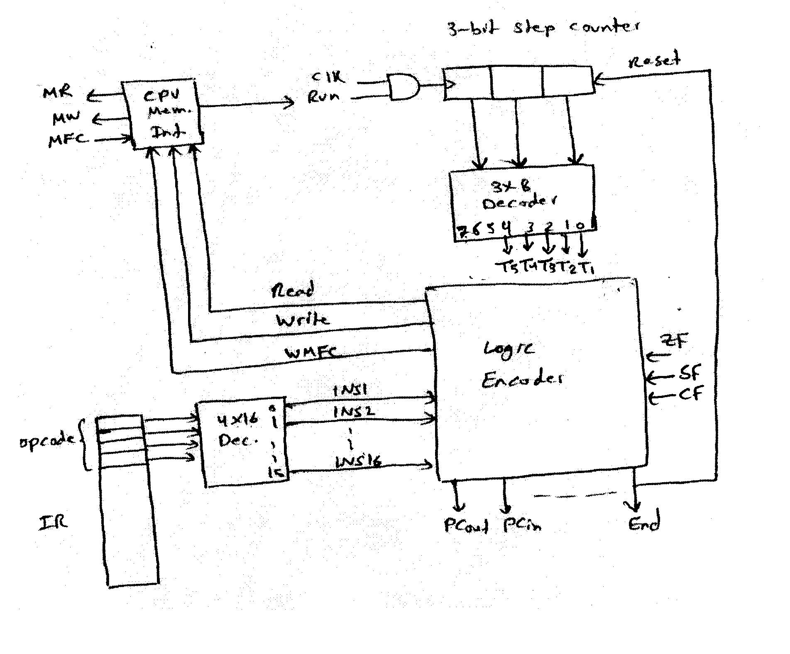

Assume that the control unit for this CPU is to be implemented using a microprogrammed approach and that the number of different control words to be stored in the control store for all the microroutines is 24 CWs. Also, assume that the microprogrammed control unit design should support unconditional branch (UBR), branch on zero (BRZ), branch on not zero (BRNZ), branch on negative (BRN), branch on not negative (BRNN), branch on carry (BRC) and branch on no carry (BRNC).

Show the format and size of the control word using horizontal control store. What is the size of the control store needed?
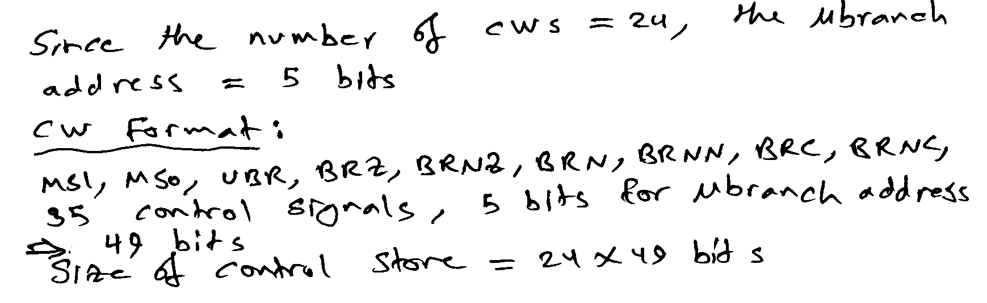

Show the block diagram of the microprogrammed control unit organization for this CPU indicating all the necessary components and signals. Clearly indicate the size of the various components.

