

King Fahad University of Petroleum and Minerals
Construction Engineering and Management Department

CONSTRUCTION QUALITY ASSURANCE

CEM-515

Project Paper
Project Title: Reactor Improvement Level Control

Prepared To: Dr.

ABDULAZIZ A. BUBSHAIT

Abdulrahman Al-Ghamdi (ID# 230143)

4 Decembers 2004

TABLE OF CONTENTS

- Abstract
- Introduction
- Phase 1: Define the quality issue
- Phase 2: Understand and define the process
- Phase 3: Select improvement opportunities
- Phase 4: Analyze the improvement opportunities
- Phase 5: Take action
- Phase 6: Check results
- Phase 7: Implement the improvement
- Phase 8: Monitor results

- Conclusion
- References

ABSTRACT
In this paper, the eight phases of the customer-driven project management improvement methodology are used to solve the unexpected process shutdowns during the operation of the Plant due to the quality of the level control that used on the Reactor.

INTRODUCTION
Chemical plants must operate under known and specified conditions. There are several reasons why this is so, formal safety and environmental constraints must not be violated. Concern for safety is paramount in designing a chemical plant and its control systems. Ideally a process design should be ‘intrinsically safe’, that is, and plant and equipment should be such so that any deviation, such as an increase in reactor pressure, will itself change operating conditions so that it is rapidly removed. Plants are expensive and intended to make money. Final products must meet customer specifications. Otherwise, they will be unsaleable. Conversely the manufacture of products not meeting the specifications will involve unnecessary cost. The majority of control loops in a plant control system are associated with operability. Specific flow rates have to be set, levels in Reactor maintained and chosen operating temperatures for reactors and other equipment achieved. The top level of process control, what we will refer to as the strategic control level, is thus concerned with achieving the appropriate values principally of: production rate, product quality, and energy economy. The feedback level control system seeks to bring the measured quantity to its required value or setpoint.

Phase one Define the Quality issue

The mission of this Project is to improve the Reactor level control measurement system in terms of quality. It is desired that improve the reliability of this system will help and avoid unexpected process shutdowns during the operation of the Plant. Polymerization reactor is fluidized bed reactor; it used to produce polyethylene resin (granules). This reactor is operated at 21 Brag and temperature ranges from 80-100 deg C. The bed level should be controlled between 14 & 17 m because of process impact if it is out of this range. The Customer (Operation) expectation to have a good system for the reactor level control

Phase two understand and define the Process

This reactor has two type of controlling for the Bed Level. The first system is purge type DP transmitters. The Purge taps system works well in terms of measurement and control, however the most problems in this system reliability and maintenance. The purge taps are frequently getting plugged and need to be purged and oftentimes drilled. Drilling is a very critical operation in term of safety. The second system is Remote seal differential pressure transmitter was installed on the reactor for monitoring the bed level in the reactor as a back up to the purge type DP transmitters for reactor level and control. Since the remote seal type transmitters had installed, the reading of these transmitters are swing, not accuracy and not matching with the Purge type due to the ambient temperature variation. This problem could result in plant shutdown and production rate reduction. I followed the improvement methodology and arrived at a conclusion in which the problem would be resolved at lower cost and without jeopardizing the quality of the work and/or impacting the performance of the system.

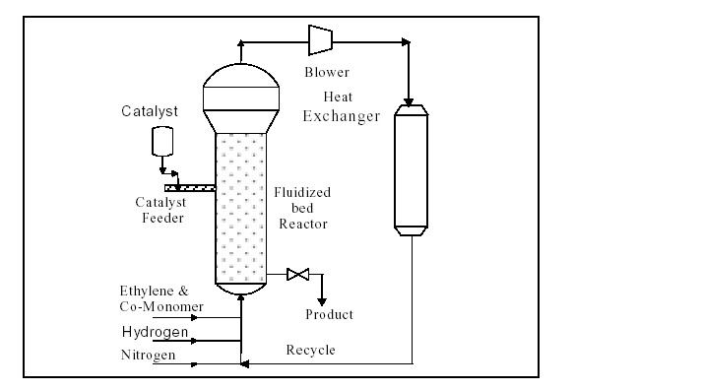
Transmitter

Fiq1: Reactor design and configuration

Phase three Select Improvement opportunities
It not essays to select any type of measurement form the market .I came up with different solutions to these problems. However, I did feasibility study with different instrument, Process Engineers and vender, this feasibility was survey to select the best solution for improvement the Reactor bed Level Measurement for both systems.
During this phase, different proposals evaluated to improve the remote seal and the purge taps. I went further and looked for other available technology and support in the market for one of the two systems. Normally this phase should have a creative session to generate ideas. These ideas should be listed and captured. So, I generated different ideas during the creative phase. I did feasibility study by sent these ideas to different Engineers and vendor for ranking the ideas; I had very good result with the feasibility study. The Engineers were very open in accepting others ideas which helps me to come up with 5. All these ideas were studied in-depth and two ideas were selected to be the best among others ideas. Ideas and suggestions generated by the Engineers are listed below:

No | Ideas/Suggestions | Ranking
1 | Improve the purge tap DP Measurement by install purge valves near the affected transmitter to keep the leads swept clean | 4
2 | To reduce the error caused by temperature swing, both the capillary lengths needs to be revisit and reduced, if possible. | 2
3 | Use Model 3051S electronic seal system Ultra Scalable DP transmitter with Remote seal to get better performance | 2
4 | Install camera with light | 3
5 | Install radioactive sources and detector | 2

Ranking: (Not acceptable = 0, Poor =1, Fair = 2, Good=3, Very Good=4, Excellent =5)

As a result of the creative session, the team selected the highest ranked ideas for further development and evaluation. The selected ideas are listed below:
- Improve the purge tap DP Measurement by install purge valves near the affected transmitter to keep the leads swept clean.
- . Install camera with light
- Install radioactive sources and detector
Improve the purge tap DP Measurement by install purge valves near the affected transmitter to keep the leads swept clean.

The ethylene purge is also located very close the nozzle. The distance between the entry point of the purge and the actual instrument lead is very long (leaving large unpurged pocket). Pressure fluctuations in the C2 purge header and/or reactor can allow resin fines to travel (intermittently) backwards in the tubing pass the purge point (see sketch below). When this happens, the tubing becomes partially fouled and errors are seen in the Dp signals. Fluctuations in pressure during manual blowback often dislodge the material and it eventually makes it way to the purged portion of the tubing and flows back in to the reactor. Often this material remains lodged in the tubing leads and the taps must be vented or drilled. So, to mitigate this issue we will install purge valves near the affected transmitter to keep the leads swept clean. The existing purge lines that go directly to the nozzle can be left intact but manually blocked. When drilling or excessive purge is required, the existing manual block can then be utilized (opened). The concept & design is shown in the sketch below. This will improve the quality of the Existing purge tap.

Install camera with light.
Function: The Canty Vision and Vector systems provide a unique ability to view and control difficult reactor processes allowing operators to maximize throughput, detect and eradicate foaming and to document process events anytime during the duration of the reaction. In order to accomplish process control a quality image of the reactor internals is required. The Canty Vision system is ideally suited for this purpose due to it’s rugged construction and patented design features that combine to overcome process variables that would otherwise prevent a quality image capture. The Canty Vision system provides illumination and video function through a single port. This design optimizes the viewing area resolution by directing illumination to the reactor area that the camera “sees”. This also eliminates the need for multiple ports, which can be expensive and valuable for process considerations. The fused glass design of the lens also provides for high pressure, high temperature performance capabilities.
The Canty system is completed with the optional Jet Spray Ring, which is used to provide cleaning fluid to the lens system. In many reactors splashing, vapor condensation or other process deposits on the lens can obstruct the view of the camera. With the Jet Spray Ring, cleaning agents can be introduced to the front of the lens to remove any obstructing materials and prevent them from condensing onto the lens.
Once a process image is obtained, the Vector NT system can provide the control features to maximize process efficiency. The system operates as does the human eye – by differentiating light intensities at object boundaries. Detecting the level in a reactor then becomes a straightforward analysis of the image for the interface of fluid (solid) and the reactor wall. Because the process sensing is done visually, the system can provide control on agitated reactors with accuracy. In addition, the system can track level as product changes phase (foams) and can provide immediate detection of the occurrence of foam so it can be eliminated.

The image from a single camera can be analyzed several times for different data – level, foam and color (Vector can also provide turbidity, %solids, particle size with the appropriate companion hardware). Finally, because the system is visual there is a constant, real time verification on the monitor for the operator to use as a check.

Equipment: Canty Vision System – Camera/Light combination unit, EXP/WP ratings, B/W or Color, standard flange mount (other available), stainless steel, hastelloy wetted materials standard, various view angles available.

Canty Vector NT – NT based image processing unit with up to 4 camera input, 8 channel 4-20 mA output, modem for factory support, Excel based data output, user friendly operator interface.

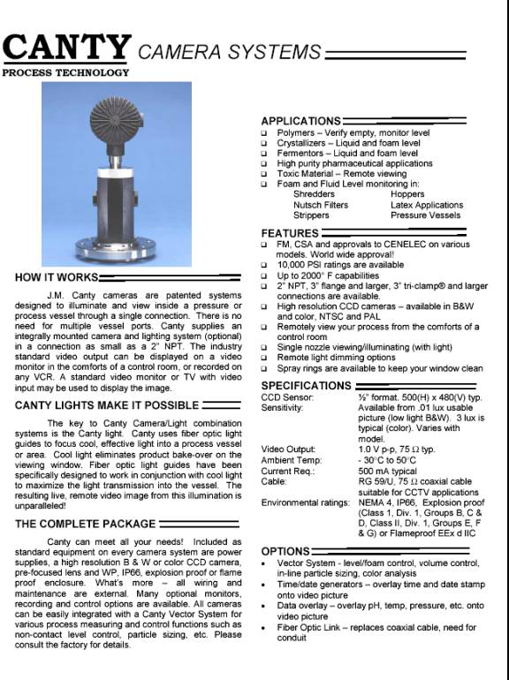

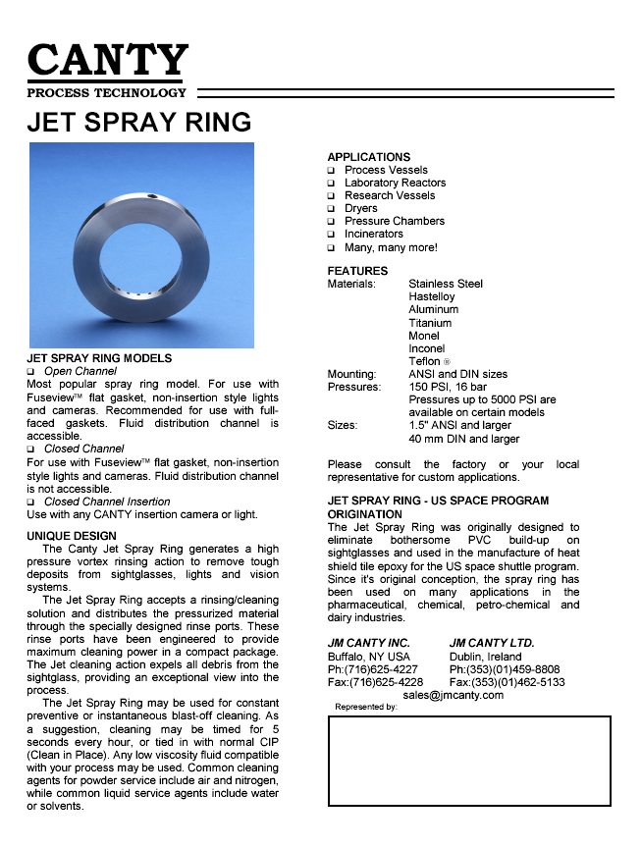
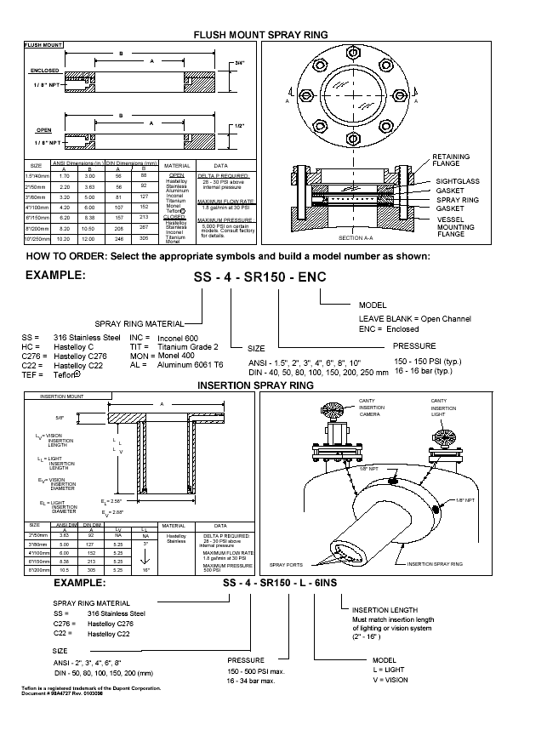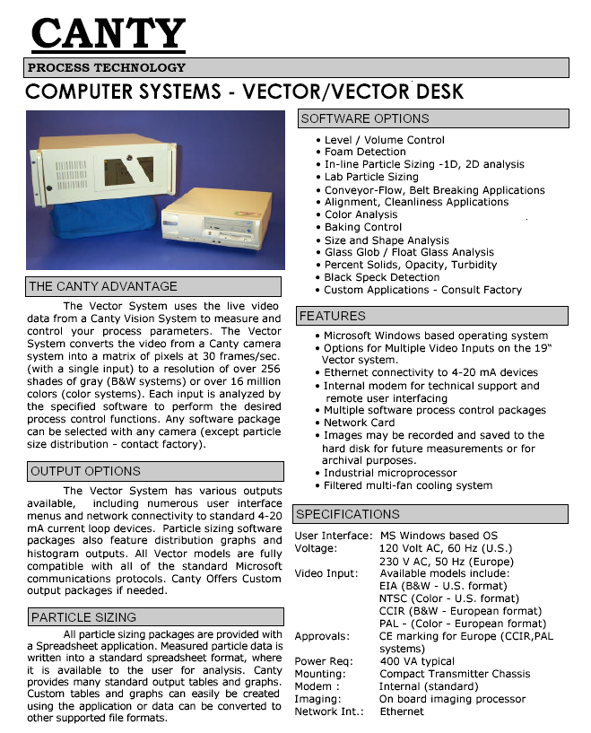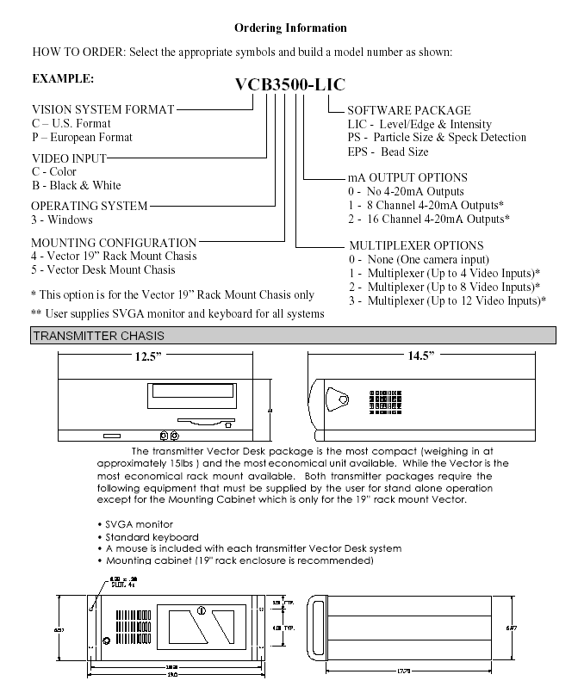
Phase Five Tack Action

DCR Initiation Form Flow Chart

DCR initiator fills the DCR Initiation Form providing the clear Description & Justification for the Change with drawings and support documents as necessary
DCR Evaluation by assigned Engineer
Project Engg. Document controller secures Project Engineer assignment by Project Engg. Manager and obtains Project Engineer acceptance sign-off. Copy of the form is sent to the area secretary for record update.
Area Operations Manager / Supdt. Reviews the DCR with relevant area specialist and engineers and assigns an engineer for the technical evaluation and DBM.
Area Secretary logs the issuance of Form and assigns a temporary tracking number. Update tracking for DCR No. and Project Engineer
Area Manager/Supdt. reviews the evaluation done by the assigned engineer for quality and completeness, approves the change request. Area Secretary updates DCR log and sends the form with attachments to projects document controller.

Phase 6: Check results

Phase 7: Implement the improvement

Phase 8: Monitor results

References
Dear Mr. Abdulrahman,

My apologies. I could not send you the reply yesterday because my computer crashed and it took several hours to get it back online.

further to my detailed discussions with Emerson technical support manager regarding the Fluidized bed Reactor powder level application at KEMYA and following are the details and suggestions

1. For Purge Type DP Level measurement, the purge connections should be near to the process tapping point. The purging medium should not flow thro the transmitter. The back pressure created for level measurement should be stagnant not flow thro.

2. It is recommended to stay with Purge type DP level measurement due to the following reasons.
a) 3051S DP transmitter with impulse line plugging Diagnostics and Fieldbus Host to detect & report line plugging can not be used for level measurements. At present this facility is available only for flow applications.
b) Due to high Ambient temperature variations, Remote seal transmitters may cause additional measurement error and it could not be eliminated due to the application requirements of long capillary. purge type measurements do not have this temperature effect error in measurement.
c) Electronic seal system is also not recommended due to 10 to 14% measurement error and Fieldbus host requirements also the system is not yet tested for this kind of application.

3. Due to the above reasons, purge type Dp level measurement may be the right solution with additional accessories ( Automatic Blow back system ) to improve the performance of the system and reduce frequent line plugging problem.

4. The over all accuracy of the purge Type transmitter can be improved by using Model 3051S ultra Scalable DP Transmitter ( 0.04% accuracy, 10 year stability, 12 year warranty Transmitter).

trust this clarify all your questions and should you require any further details, please let us know.

thanks & best regards

Kumar.

PLEASE CONFIRM RECEIPT OF THIS MAIL.

Lakshman Kumar
Manager - Rosemount Measurement Systems
Saudi Fal Co. Ltd., (EMERSON Process Management)
P.O.Box 3070, Al-Khobar 31952, Saudi Arabia.
Tel : +966 3 857 3157 Ext. 146
Fax : +966 3 857 8491
Mobile : 00966 504821094
e-mail : kumar.lakshman@saudifal.com.sa
website : <http://www.saudifal.com.sa/>
Emerson Process Management <http://www.emersonprocess.com>, an Emerson business, is a leader in helping businesses automate their production, processing and distribution in the chemical, oil and gas, refining, pulp and paper, power, food and beverage, pharmaceutical and other industries. A division of Emerson, Rosemount Inc. is a global leader in high-precision pressure, temperature, level, and flow instrumentation. Rosemount's best-in-class technology and expertise play a key role in Emerson's combining of superior products and technology with industry-specific engineering, consulting, project management and maintenance services.
Emerson Process include: Fisher® <http://www.fisher.com>, Rosemount® <http://www.rosemount.com>, Intellution® <http://www.intellution.com>, Micro Motion® <http://www.micromotion.com>, Daniel<http://www.daniel.com>, Westinghouse Process Control <http://www.westinghousepc.com>, PlantWeb® <http://www.plantweb.com>>, DeltaV <http://www.easydeltav.com> and AMS <http://www.emersonprocess.com/ams>.
Abdulrahman Al-Ghamdi
Senior.Instrument & PLC Engr.
Al-Jubail Petrochemical Co. (KEMYA)
Phone: 03 357 6539
Fax: 03 357 6058
mobile 055911014
E-mail: mailto:ghamdiaa2@kemya.sabic.com

-----Original Message-----
From: GHAMDI AL-, Abdulrahman A
Sent: Tuesday, June 08, 2004 11:52 AM
To: 'KUMAR LAKSHMAN [Saudi Fal/Al-Khobar]'
Subject: RE: Level Transmitters in Fluidized Bed Reactor-R0401
Kumar Please find the attached files for your action
Best regard
Abdulrahman Al-Ghamdi
Senior.Instrument & PLC Engr.
Al-Jubail Petrochemical Co. (KEMYA)
Phone: 03 357 6539
Fax: 03 357 6058
mobile 055911014
E-mail: mailto:ghamdiaa2@kemya.sabic.com
-----Original Message-----
From: KUMAR LAKSHMAN [Saudi Fal/Al-Khobar] [mailto:kumar.lakshman@saudifal.com.sa]
Sent: Wednesday, April 21, 2004 9:42 AM
To: GHAMDI AL-, Abdulrahman A
Cc: P. SIVA; Suresh V [FRCO/DUB] (E-mail); Pattabhiraman Ganesh [FRCO/DUB] (E-mail)
Subject: Level Transmitters in Fluidized Bed Reactor-R0401
Dear Abdulrahman,
This is in response to our site visit and discussions regarding the Level transmitters installed on the Reactor R0401 for Fluidized Bed Level Measurements. We thank you for your excellent support and the details provided to study this application. We carefully gone thro the application details and the documents provided by you and following are our findings.
Objective:
1. Reduce error on level measurement introduced by Remote seals due to ambient temperature changes.
2. Increase response time.
3. Increase reliability of the measurement by removing impulse line chocking.
1. Electronic seal System:
We have studied the possibility of introducing the Latest Rosemount 3051S Electronic seal System for this application. Though it eliminates the temperature effects of the capillary, but the over all % of error in level measurement is not better than the Standard remote seal for this particular application. Hence we do not recommend this system for this application.
2. Standard Remote seal Smart DP Transmitter with capillary:
We understand the main concern on this application is swinging of ambient temperature causes the measurement error. Measurement accuracy and reliability may be improved by the following methods.
1. Shorten the capillary.... Study the possibility of reducing the capillary length to the minimum.
2. Insulate and electric heat trace the capillaries to keep constant temperature of the capillary fill fluid.
3. Increase the seal diaphragm size from 2" to 3" to get better performance.
4. Use Model 3051S Ultra Scalable DP transmitter with Remote seal to get better performance.
find attached the performance calculations of the Model 3051S DP remote seal transmitter for this application.
trust the above details are sufficient for your immediate purpose to study and conclude.
Should you require any further details, please let us know.
thanks & best regards
Kumar
Lakshman Kumar
Manager - Rosemount Measurement Systems
Saudi Fal Co. Ltd., (EMERSON Process Management)
P.O.Box 3070, Al-Khobar 31952, Saudi Arabia.
Tel : +966 3 857 3157 Ext. 146
Fax : +966 3 857 8491
Mobile : 00966 5 4821094
e-mail : kumar.lakshman@saudifal.com.sa
website : <http://www.saudifal.com.sa/>
Emerson Process Management <http://www.emersonprocess.com>, an Emerson business, is a leader in helping businesses automate their production, processing and distribution in the chemical, oil and gas, refining, pulp and paper, power, food and beverage, pharmaceutical and other industries. A division of Emerson, Rosemount Inc. is a global leader in high-precision pressure, temperature, level, and flow instrumentation. Rosemount's best-in-class technology and expertise play a key role in Emerson's combining of superior products and technology with industry-specific engineering, consulting, project management and maintenance services.
Emerson Process include: Fisher® <http://www.fisher.com>, Rosemount® <http://www.rosemount.com>, Intellution® <http://www.intellution.com>, Micro Motion® <http://www.micromotion.com>, Daniel<http://www.daniel.com>, Westinghouse Process Control <http://www.westinghousepc.com>, PlantWeb® <http://www.plantweb.com>>, DeltaV <http://www.easydeltav.com> and AMS <http://www.emersonprocess.com/ams>.
Dear Abdulrahman,

This is in response to our site visit and discussions regarding the Level transmitters installed on the Reactor R0401 for Fluidized Bed Level Measurements. We thank you for your excellent support and the details provided to study this application. We carefully gone thro the application details and the documents provided by you and following are our findings.

Objective:
1. Reduce error on level measurement introduced by Remote seals due to ambient temperature changes.
2. Increase response time.
3. Increase reliability of the measurement by removing impulse line chocking.

1. Electronic seal System:
We have studied the possibility of introducing the Latest Rosemount 3051S Electronic seal System for this application. Though it eliminates the temperature effects of the capillary, but the over all % of error in level measurement is not better than the Standard remote seal for this particular application. Hence we do not recommend this system for this application.

2. Standard Remote seal Smart DP Transmitter with capillary:
We understand the main concern on this application is swinging of ambient temperature causes the measurement error. Measurement accuracy and reliability may be improved by the following methods.
1. Shorten the capillary.... Study the possibility of reducing the capillary length to the minimum.
2. Insulate and electric heat trace the capillaries to keep constant temperature of the capillary fill fluid.
3. Increase the seal diaphragm size from 2" to 3" to get better performance.
4. Use Model 3051S Ultra Scalable DP transmitter with Remote seal to get better performance.

find attached the performance calculations of the Model 3051S DP remote seal transmitter for this application.

trust the above details are sufficient for your immediate purpose to study and conclude.

Should you require any further details, please let us know.

thanks & best regards
Kumar
Lakshman Kumar
Manager - Rosemount Measurement Systems
Saudi Fal Co. Ltd., (EMERSON Process Management)
P.O.Box 3070, Al-Khobar 31952, Saudi Arabia.
Tel : +966 3 857 3157 Ext. 146
Fax : +966 3 857 8491
Mobile : 00966 5 4821094
e-mail : kumar.lakshman@saudifal.com.sa
website : <http://www.saudifal.com.sa/>
Emerson Process Management <http://www.emersonprocess.com>, an Emerson business, is a leader in helping businesses automate their production, processing and distribution in the chemical, oil and gas, refining, pulp and paper, power, food and beverage, pharmaceutical and other industries. A division of Emerson, Rosemount Inc. is a global leader in high-precision pressure, temperature, level, and flow instrumentation. Rosemount's best-in-class technology and expertise play a key role in Emerson's combining of superior products and technology with industry-specific engineering, consulting, project management and maintenance services.
Emerson Process include: Fisher® <http://www.fisher.com>, Rosemount® <http://www.rosemount.com>, Intellution® <http://www.intellution.com>, Micro Motion® <http://www.micromotion.com>, Daniel<http://www.daniel.com>, Westinghouse Process Control <http://www.westinghousepc.com>, PlantWeb® <http://www.plantweb.com>>, DeltaV <http://www.easydeltav.com> and AMS <http://www.emersonprocess.com/ams>.

.
Abduralum,

Per our conversation this morning I think it has been made clear that the purge near the instrument will only be utilized as a manual blowback - not constant --- impact on instrument accuracy is not an issue, Refer to diagram below.

David

-----Original Message-----

From: GHAMDI AL-, Abdulrahman A
Sent: Saturday, August 28, 2004 12:06 AM
To: LABORDE, David M; THAWADI AL-, Ahmed Y; QAHTANI AL-, Abdullah H; FAIFI AL-, Mohammed Masoud; HAGRY AL-, Ershaid M; JAZAIRI AL-, Tawfiq Mohammed
Cc: WADAEY AL-, Mohammad Z; ZAHRANI AL-, Matar A; REFAEE, Ibrahim Mohammed; QAHTANI AL-, Mushabeb Z; SAIF BIN, Abdulaziz A
Subject: RE: Reactor Instrument Taps & Frequent Plugging

Ibrahim/ David

1. Install the Purge Near the instrument to keep the leads swept clean:
General practice is that the transmitter should not be purged thro the instrument for better accuracy and stability of the measurement. But we agree with you and recommend to install the purge between the transmitter and process tapping which is acceptable and valid considering the process nature.

2. Relocate the transmitter and re engineer the impulse lines with less bends:
this is also a very good suggestion to improve the performance of the measurement loop. lat us have a team to study this issue in more detail and have final recommendation.
Thanks

Abdulrahman Al-Ghamdi
Senior.Instrument & PLC Engr.
Al-Jubail Petrochemical Co. (KEMYA)
Phone: 03 357 6539
Fax: 03 357 6058
mobile 055911014
E-mail: mailto:ghamdiaa2@kemya.sabic.com

-----Original Message-----

From: LABORDE, David M
Sent: Sunday, May 30, 2004 2:41 PM
To: THAWADI AL-, Ahmed Y; QAHTANI AL-, Abdullah H; FAIFI AL-, Mohammed Masoud; HAGRY AL-, Ershaid M
Cc: WADAEY AL-, Mohammad Z; ZAHRANI AL-, Matar A; REFAEE, Ibrahim Mohammed; QAHTANI AL-, Mushabeb Z; GHAMDI AL-, Abdulrahman A
Subject: Reactor Instrument Taps & Frequent Plugging

Gents,

Today, Ibrahim and myself made a cursory inspection (outside) and review of existing designs for purge to the reactor instruments (nozzles). We found that the existing instruments (with purged taps) are not adequate. It appears that over time the existing instrument leads have been modified, relocated and/or re-tubed with numerous bends / dents and direction changes. The ethylene purge is also located very close the nozzle. The distance between the entry point of the purge and the actual instrument lead is very long (leaving large unpurged pocket). Pressure fluctuations in the C2 purge header and/or reactor can allow resin fines to travel (intermittently) backwards in the tubing pass the purge point (see sketch below). When this happens, the tubing becomes partially fouled and errors are seen in the Dp signals. Fluctuations in pressure during manual blowback often dislodge the material and it everntually makes it way to the purged portion of the tubing and flows back in to the reactor. Often this material remains lodged in the tubing leads and the taps must be vented or drilled.
<< OLE Object: Picture (Metafile) >>

The solution is to install purges near the instrument to keep the leads swept clean, The existing purge lines that go directly to the nozzle can be left in tact but manually blocked. When drilling or excessive purge is required, the existing manual block can then be utilized (opened). The concept & design is shown in the sketch below. (see other recommendations below sketch).
<< OLE Object: Picture (Metafile) >>

Many of the Dp leads are very long on one side and very short on the other. I suggest we re-locate the instrument Dp cell at mid-point to equalize the leads. The existing leads (tubing ) is also in poor conditions (many dents and bends). I suggest we re-tube all leads and relocate. All tubing "runs" should be very straight and when bends are required (minimized to as few as possible). New orifices should be sized for each purge to insure 1.8 m/s velocity at the entry point of the nozzle. All purges should be as close to the instrument as possible. I suggest we run new tubing and insure proper amounts are provided for optimum location of each instrument (to avoid tubing length and bends). These could be caped (to avoid contamination) and ready for tie-in any time the reactor is down. I believe 99% of our tap plugging problems can be attributed to the designs & conditions noted above. Every effort should be made to quickly fabricate tubing to correct errors. Ibrahim has the specifics for all of this and can be consulted for this quick improvement project.

David
Dear Mr. George

We had conference call yesterday regarding the above subject . You requested me for more detail about our process reactor . please find the attached file regarding to this issue . your feedback highly appreciated .

Thanks

Abdulrahman Al-Ghamdi
Our ref KC0413842
Thank you for the details.
I do not see any existing sight glass on the vessel. You may need a new nozzle in the pressure vessel.
Please state where the view of the level can be made and which, if any, nozzle can be used.
Linda: Please put a copy in the sales file.

Best regards
George Heyes
Regional Sales Office
KC Controls Ltd
2nd Floor
The Portergate
Ecclesall Road
Sheffield S11 8NX
Off tell# 01142 096203

