

College of Environmental Design
Department of Construction Engineering & Management (CEM)
CEM 515
First Semester 2006 (061)
A case study of Quality Standards implementaion in TASNEE Company
ISO 9001: 2000, ISO 14001:2004 & OHSAS 18001

For
Dr. Abdulaziz Bubshait

Submitted by:
Abdulgader Al-Harthi (923179)

A case study of Quality Standards implementaion in TASNEE Company
ISO 9001: 2000, ISO 14001:2004 & OHSAS 18001
Paper Outline
Introduction 3
Literature Review 6
orgnization in Breif 8
Methodology 10
Case Analysis and Discussion 10
Limitation 15
Conclusion 16
References 17
Introduction
One of the biggest challenges that are facing current organizations is to have an integrated management system that comply with the international standards and meet the organization goals and objectives.
In this paper we will explore the implementation of such integrated system in TASNEE/SPC. The integrated quality management system complies with the following international standards:
ISO 9001 : 2000
ISO 9001:2000 specifies requirements for a quality management system for any organization that needs to demonstrate its ability to consistently provide product that meets customer and applicable regulatory requirements and aims to enhance customer satisfaction. ISO 9001:2000 has been organized in a user-friendly format with terms that are easily recognized by all business sectors. The standard is used for certification/registration and contractual purposes by organizations seeking recognition of their quality management system.

The following paragraphs of the standard are excluded because they are not part of TASNEE/SPC’s business processes.

§ 7.3 (ISO 9001:2000), Design and / or development, including all subsections justification. At present SPC does not design or develop products. All grades of product SPC is producing are specified by standards coming directly from the major Customer, which is also a market leader in petrochemicals. SPC engineering / technical activities are limited to improve the process and for small modifications of the plant.
§ 7.5.2 (ISO 9001:2000), Validation of Processes for Production and Services Provision.
Our processes for production are continuously and subsequently monitored by DCS, laboratory analysis and the control room operators. Processes outputs are released and verified on real time bases. Where deficiencies become apparent within any stage of the production process, adjustments are applied on the spot, and therefore process validation for production is not applicable.
§7.5.4 (ISO9001:2000), Customer Property. SPC does not handle any material coming from Customers.
None for health, safety and environment

ISO 14001 : 2004
ISO 14001:2004 specifies requirements for an environmental management system to enable an organization to develop and implement a policy and objectives which take into account legal requirements and other requirements to which the organization subscribes, and information about significant environmental aspects. It applies to those environmental aspects that the organization identifies as those which it can control and those which it can influence. It does not itself state specific environmental performance criteria.
ISO 14001:2004 is applicable to any organization that wishes to establish, implement, maintain and improve an environmental management system, to assure itself of conformity with its stated environmental policy, and to demonstrate conformity with ISO 14001:2004 by
a) Making a self-determination and self-declaration, or
b) Seeking confirmation of its conformance by parties having an interest in the organization, such as customers, or
c) Seeking confirmation of its self-declaration by a party external to the organization, or
d) Seeking certification/registration of its environmental management system by an external organization.
OHSAS 18001 : 1999 Occupational Health & Safety Management Systems
The specification has superseded the BS8800:1996 Guide to occupational health & safety management systems.
The specification gives the requirements for an Occupational Health and Safety management system, to enable an organization to control its OH&S risks and improve its performance.
It requires an organization to conduct a risk assessment, and manage those risks that must include objectives to demonstrate continuous improvement. Similar to the ISO 14001 Environmental Management compliance with legislation must be demonstrated

Literature Review
To achieve global competitiveness, firms need to create and develop strategies to deal with changing organizational operations and external environments. This includes situations such as creating business networks, improving productivity and quality, and promoting entrepreneurship orientation. Adopting an international standard is a concrete strategy for increasing competitiveness. ISO 9000 is the most commonly adopted form of such a standard and it refers to a series of five international standards that provide guidance in the development and implementation of an effective quality management system (Ritter, 1998). It was issued by the International Organization for Standardization (ISO) in 1987 and was revised in 1994 and 2000 (Houten , 2000).
ISO 9000 has become an important requirement for exporters and multinational enterprises that wish to do business with the European Union and other countries. In 1992, the European Union required that companies must provide a universal framework for quality assurance of products (Marquardt, 1992). In 1999, the National Aeronautic and Space Administration (NASA) also required that all agency sites must become ISO 9000 registered (Gano, 2001).
Thus, international firms that wish to become or remain competitive must attempt to achieve ISO 9000 certification.
Accordingly, ISO 9000 adoption has increased rapidly. To date, some 410,000 firms around the world have obtained ISO 9000 certification (Karapetrovic, 2001). Prior studies have noted that these firms have also adopted ISO 9000 because of other reasons; internal improvement, marketing positioning, supplier control, customer needs, and regulatory
requirements (Kochan, 1993). Firms that have successfully adopted ISO 9000 are likely to exhibit higher levels of quality improvement, business excellence, international competitiveness, cost reduction, sales, human resource development, and customer orientation (Huarng, F ,1999). ISO 9000 also promotes inter-firm relationships (Casper, 1999).

Different research shows that companies who adapted ISO 14001 reports significant improvements in their operating and manufacturing procedures after adopting
ISO 14001. The operating and manufacturing improvements include (Darnall, 2001):
• Increased employee involvement
• Increased document control
. Improved operational control
• Improved calibration and retooling
• Increased process automation
• Increased reuse of chemicals and water in production cycles
• Increased focus on non-regulated impacts
• Increased focus on supply chain impacts
• Increased focus on vendor impacts

The Organization in brief
Saudi Polyolefins Company (SPC) is a Saudi Joint Stock Company established in year 2001 by a partnership between NPIC (Tasnee Group) and BASELL. The relationship on the shareholding is represented below:
NIC
OTHERS
BASF
SHELL
NPIC
Tasnee group
BASELL
SPC

SPC industrial complex is consisting of two chemical plants, a 455 Kt propane dehydrogenation plant providing propylene and a 450 Kt polypropylene plant.
SPC is located in Al-Jubail industrial area.

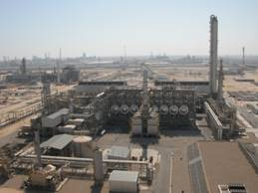

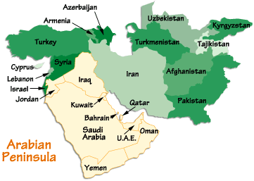

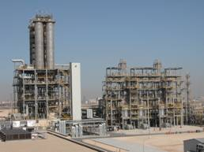

Polypropylene is a thermo plastic multi-purpose material, being used in an extensive range of application in many industries, such as films, fiber, injection molding and blow molding. It is also largely used in automotive industry. Besides Polypropylene can be easily recycled which makes it a safe product and considered as an environmental friendly material.

The production is provided by two different interrelated plants:

The dehydrogenation plant (PDH) which is converting propane into propylene. It has a capacity of 455.000 tpa and uses the Catofin process.
The polypropylene plant (PP) converting the propylene coming from PDH into polypropylene. It has a capacity of 450.000 tpa and uses the Novolen process.

The schematic flow of the process is showed below:

PDH plant
Catofin
Process

PP plant
Novolen
Process

Propane
Propylene
Polypropylene
(Homopolymer & Random Copolymers)
Capacity
455,000 tpa
Capacity
450,000 tpa

Methodology

A case study approach was used to write this paper. The information was gathered through review of available documentation and observations/interviews of personnel involved in the implementation of the quality management system.

Analysis and Discussion

The quality management system in TASNEE/SPC was developed to meet the mission statement of the organization and to comply to the three international standards:
ISO 9001 : 2000
ISO 14001 : 2004
OHSAS 18001 : 1999
This system is unique because it is an integrated system covering all the three standards. Below are more details about TASNEE/SPC quality system

The Quality Management System in Tasnee/SPC was developed based on a continual improvement process, as shown in the picture below, reflecting the Deming circle, Plan, Do, Check, Act.

D
C
A
P
CUSTOMERS, STAKEHOLDERS
Requirements
Continual
Improvement
Management
Responsibility
Product
realization
Resource
Management
Measurements
Analysis and
Improvement
CUSTOMERS, STAKEHOLDERS
Satisfaction
Suppliers, Contractors, Partners

QMS
Input
Output
Product
Realization

Tasnee/SPC has established, documented, implemented and it is maintaining a Quality Management Systems and is continually improving its effectiveness in accordance with the requirement of the international standards.
The organization has:
Identified the processes needed for the quality, safety, health & environment management system and their application throughout the organization
Determined the sequence and interaction of these processes
Determined the criteria and methods needed to ensure that both the operation and control of these processes are effective
Ensured the availability of resources and information necessary to support the operation and monitoring of the processes
Monitored, measured and analyzed these processes
Implemented and implementing actions necessary to achieve planned results and continual improvement of all of these QSHE and business processes.
These processes have been managed by the organization in accordance with the requirements of
ISO 9001:2000, OHSAS 18001:1999 and ISO 14001:2004
Measurement data are important for making fact-based decisions. The management ensures effective and efficient measurement, collection and validation of data to ensure organization’s performance and the satisfaction of interested parties.
In this chapter is described how SPC is replying to the ISO 9001:2000, OHSAS 18001:1999 and ISO 14001:2004 requirements on:
Customer satisfaction: customer satisfaction is the principal objective of Quality Management system, and the level of customer satisfaction is the most important measure of the effectiveness of the system. Customer satisfaction is measured by collecting and analyzing direct feed back, and by measuring secondary indicators of customer satisfaction. Customer satisfaction data and complaints are analyzed and reported to The Management Review to identify opportunities and priorities for improvement.
Auditing and internal auditing: all activities and areas relevant to the QSHE system are audited at least once a year. Audits are scheduled on the basis of the status and importance of the activity. Internal audits are independent of those having responsibility for the audited activity. Identified nonconforming conditions are brought o the attention of the responsible managers and corrective actions are implemented in response to audit findings.
Monitoring: QSHE system processes are monitored to ensure that they achieve planned results. Day to day activity monitoring is applied to the most of the processes such as production, safety, Logistics management, quality assurance, procurement and finance.
Analysis of NC: non-confirming product is identified, documented evaluated and prevented from being used or shipped. Responsibility for the disposition of nonconforming product is defined. The appropriate authorities are notified. SPC establishes, implement and maintains documented procedures to initiate corrective actions for conditions adverse to quality and to eliminate the causes of potential nonconformities in order to their occurrence. This procedure is documented in, “Non-conformity of finish product”.
Measurement and monitoring of system performance: Key performance indicators are applied to those processes that need to be monitored. The results of the KPI are collected and shown during the periodical management reviews.

The basic philosophy of Risk Control within in the Quality Management System is shown in figure 1.

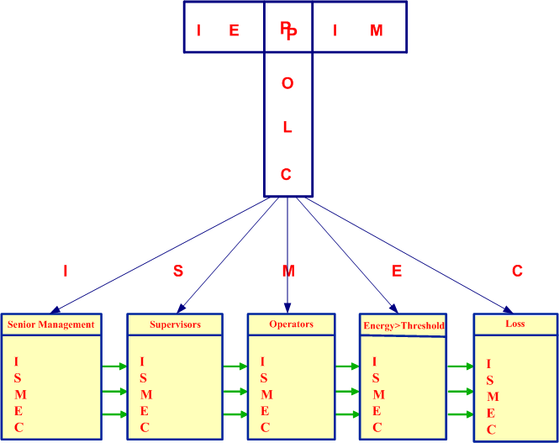

Figure 1 Basic philosophy of Risk Control within SPC

The basic philosophy of Risk Identification and Control within in the Quality Management System consists of five steps;
1: Identification of all hazards and risks
2: Evaluation of the risk element within each hazard
3: Planning of control measures and development of an action plan
4: Implementation of the control measures and action plan
5: Monitoring the progress & implementation on a periodical basis
These steps correspond to section 4.3.1 of the OHSAS 18001 and ISO 14001 standards.
To comply with the management control and continual improvement aspects (section 4) of the OHSAS 18001 en ISO 14001 standards the ISMEC section of the model is applied.
1: Identification of the work to be performed
2: Standards, procedures & work instructions for activities at all operational levels within the organisation
3: Measurement of performance against these standards (external and internal)
4: Evaluation of the performance in comparison with the standards
5: Commendation for adherence, implementation of corrective & improvement actions

Limitations

The main limitation of this report was that not all related information included in this paper due to the confidentiality nature of such documents.

Conclusion

After reviewing the quality management system implemented in Tasnee/SPC, it was clear that such system is a great system and it took a lot of effort to develop, however, to gain the real benefits of such system, it is not enough to have the system in filled documents but needs to be used on daily activities by all members of the organizations.
The system needs to be communicated properly to all employees through official meetings, newsletters, posters, and public events.

Finally as with all other system the critical success factor is full commitment from management team to the system practice in all organization levels.

References
1. Casper, S. & Hancke, B. (1999). Global quality norms within national production regimes: ISO 9000 standards in the French and German car industries. Organization Studies, 20 (6), 961-985.

2. Darnall, Nicole. J. Sarkis (ed.) 2001. Greener Manufacturing and Operations: From Design to Delivery and Back, (Chapter 12). Sheffield: Greenleaf Publishing, pp. 178-190.

3. Gano, D. L. 2001. Effective problem solving: A new way of thinking. Annual Quality Congress Proceedings, 110-122.

4. Houten, G. V. (2000). ISO 9001: 2000: A standard for all industries. The Information Management Journal, April, 28-37

5. Huarng, F., Horing, C., & Chen, C. (1999). A study of ISO process, motivation and performance. Total Quality Management, 10 (7), 1009-1025

6. Karapetrovic, S. & Willborn, W. 2001. ISO 9000 quality management standards and financial investment services. The Service Industries Journal, 21 (2), 117-136

7. Kochan, A. (1993). ISO 9000: Creating a global standardization process. Quality, 32 (10), 26-31

8. Marquardt, D. (1992). ISO 9000: A universal standard of quality. Management Review, 81 (1), 50-53.

9. Peach, R. W. & Ritter, D. S. (1998). The memory jogger 9000. New Hampshire: GOAL/QPC.

