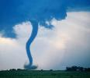

Unit 1: Natural Disasters

Activity 1— Your teacher will show you a short animation. What is happening? What was the cause? What was the effect?

cause:
effect:

Activity 2— Work in pairs. Match the pieces of text on the next page with the pictures below? The first one is done for you.

A Text 5  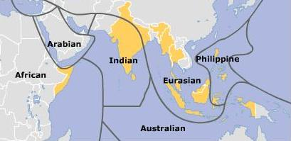 | B  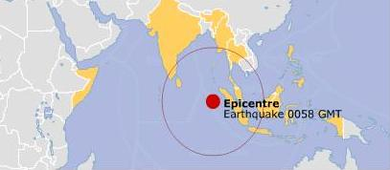 | C  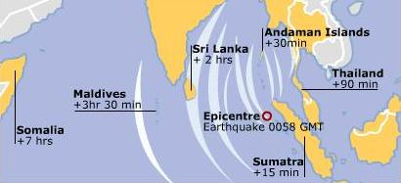
D  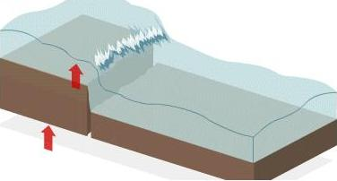 | E  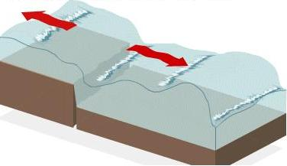 | F  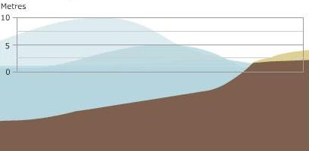
G | H  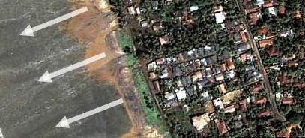 | I  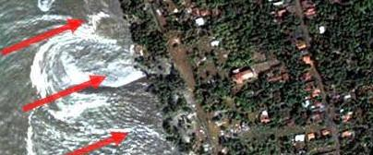

Text 1: On December 26 2004 the biggest earthquake for 40 years occurred between the Australian and Eurasian plates in the Indian Ocean. The quake triggered a tsunami—a series of large waves—that spread thousands of kilometres over several hours.

Text 2: Large waves began moving through the ocean, away from the earth’s epicentre. The tsunami’s journey had begun.

Text 3: The several waves of the tsunami came at intervals of between every five and 40 minutes. In Kalutara the water reached at least 1km inland, causing widespread destruction.

Text 4: In deep water the tsunami moved at up to 800km/h. When it reached shallow water near coastal areas, the tsunami slowed but increased in height.

Text 5: Earthquakes happen when the plates that make up the Earth’s surface suddenly move against each other.

Text 6: The tsunami formed when energy from the earthquake vertically jolted the seabed by several metres, displacing hundreds of cubic kilometers of water.

Text 7: Coastal areas like the Sri Lankan tourist of Kalutara, as seen in this satellite picture from earlier in 2004, had almost no warning of the approaching tsunami.

Text 8: The earthquake caused the sea floor to rupture along the fault line north of the epicentre, causing a giant wave which carved a path of destruction across the 4,500 km-wide Indian Ocean over 7 hours.

Text 9: The only sign came just before the tsunami struck when the waterline suddenly retreated, exposing hundreds of metres of beach and seabed.

Your teacher will show you an animation. Correct your answers while watching.

Activity 3— Work in pairs. Refer back to the pictures and the texts in activity 2 to complete the cause/effect table.

text | cause | effect
6 |  | displacing hundreds of cubic kilometres of water
 | the plates that make up the Earth’s surface suddenly move against each other
 |  | exposing hundreds of metres of beach and seabed
 | the sea floor ruptured along the fault line north of the epicentre
 |  | a series of large waves
 | the water reached 1km inland
 |  | the tsunami slowed but increased in height

Activity 4— Work in pairs. Look at the following sentences. Underline the cause and effects? How are the cause and effect phrases connected? Circle the connecting word(s).

- The earthquake in Chile caused a tsunami to hit Japan.
- The tsunami that hit Japan led to a lot of homes being destroyed.
- Heavy rain resulted in a lot of accidents happening.
- A high number of accidents caused a lot of deaths.
- A strong wind blowing from the north led to a fall in the temperature.
6. The lowering of the temperature resulted in snow in the mountains.

(Note: To do activities 5, 6, and 7, refer to language points 1 and 2 if necessary.)

Activity 5— Work in pairs. In your completed table in activity 3, identify the causes and effects needing to be modified before a correct sentence can be written.

Activity 6— Work in pairs. Write sentences by connecting the causes and effects in activity 3.

Activity 7— Work on your own. Write six sentences (using any appropriate information) linking cause and effect. Use all the connectors (led to, caused and resulted in) twice.
e.g. “The traffic jams resulted in the student being late for school.”

---------- CALL lab activities (self-study)----------

Activities 8-11— Listening (to be completed in one class)

- Log on to WebCT.
- Go to the “Homepage>Unit1: Natural Disasters>activities8-11” folder.
- Click on the “activities8-11” file.
- A popup with the activities will appear. Follow the instructions in the popup.

Note 1: Quiz 1 must be completed within the class time.
Note 2: Assignment 1 must be sent before the deadline set by the teacher.

---------- CALL lab activities (with teacher)----------

Activity 12-14— Reading/Writing (to be completed in one class)

- Log on to WebCT.
- Go to the “Homepage>Unit1: Natural Disasters>activities12-14” folder.
- Click on “activities12-14” file.
- A popup with the activities will appear. Follow the instructions in the popup.

Note 2: Assignment 2 must be sent before the deadline set by the teacher.

Activity 15— Your teacher will show you some photographs. Discuss them with your classmates. Here is some language that can be used in the discussion.

The tsunami | caused  resulted in  led to |  | ……..
I think  Maybe |  | the government  people |  | should ……..  could ……..
It would be a good idea to ……..

Activity 16— Work in groups. Design a wall poster outlining the problems caused by the tsunami and what can be done to solve these problems. Look at the sample wall poster below for ideas, but you can also use your own design.

Tsunami
problem 1 problem 2
problem 3

solution 1 solution 2
idea solution idea

Language Point 1

cause |  |  | connector |  |  | effect
The earthquake in Chile |  |  | caused |  |  | a tsunami to hit Japan.
A high number of accidents |  |  |  |  |  | the road a lot of deaths.
The tsunami that hit Japan |  |  | led to |  |  | a lot of homes being destroyed.
A strong wind blowing from the north |  |  |  |  |  | a fall in the temperature.
Heavy rain |  |  | resulted in |  |  | a lot of accidents happening.
The lowering of the temperature |  |  |  |  |  | snow in the mountains.

Use the following connectors to link cause and effect:

… CAUSE …

… RESULT IN …
… LEAD TO …

Language Point 2

The connectors cause / result in / lead to link nouns and noun phrases only.

“An earthquake off the coast of Chile” and “a tsunami hitting Japan” are noun phrases. So they can be used with cause / result in / lead to.

Look at the following sentence: “The tsunami hit Japan caused a lot of deaths”.

Is this sentence correct? Why not?

It can be changed into a noun phrase by using the following methods.

Method 1: By changing the verb into a –ing form.
“The tsunami hitting Japan caused a lot of deaths.”

Method 2: By using “the fact that”.
“The fact that the tsunami hit Japan caused a lot of deaths.”

Look at the following sentence: “The tsunami which hit Japan led to destroying of many homes.”

Is this sentence correct? Why not?

It can be changed into a correct noun phrase by using the following methods.
Method 1: By changing the verb into a noun form
“The tsunami hitting Japan led to the destruction of many homes.”

Method 2: By using the passive voice
“The tsunami hitting Japan led to many homes being destroyed.”

Note: These three connectors can also connect single nouns. The pattern
“noun + cause/result in/lead to + noun” can be used. The following sentences are examples of this pattern.

“Rain causes accidents.”
“The cold weather resulted in snow.”
“An error led to the crash.”

