Q1.

The function $y(x, t)=(15.0 cm) cos(πx-15πt)$, with *x* in meters and *t* in seconds, describes a wave on a taut string. What is the magnitude of the transverse acceleration for a point on the string at an instant when that point has a displacement of $y=+12 cm$?

A) 266 m/s2

B) 110 m/s2

C) 166 m/s2

D) 466 m/s2

E) 90.1 m/s2

Sec# Wave - I - Wave Speed on a Streched String

Grade# 80

Q2.

The ship in **Figure 1** travels along a straight line parallel to the shore and 600 m from it. The ship’s radio receives simultaneous signals of the same frequency from antennas *A* and *B*. The signals interfere constructively at point *C*, which is equidistant from *A* and *B*. If the signal goes through the first minimum at point *D*, determine the wavelength of the radio waves.

Fig#

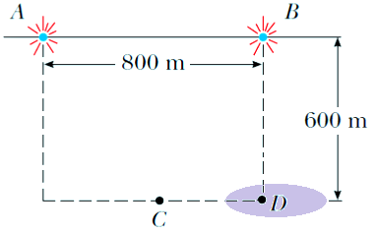

A) 8.00×102 m

B) 1.60×103 m

C) 4.00×102 m

D) 1.20×103 m

E) 1.00×103 m

Sec# Wave - II - The Speed of Sound Waves

Grade# 70

Q3.

A steel rod is 3.000 cm in diameter at 25.0 $℃$. A brass ring has an interior diameter of 2.992 cm at 25.0 $℃$. At what common temperature will the ring just slide onto the rod?

The coefficient linear expansion for steel = $11×{10}^{-6}/℃$.

The coefficient linear expansion for brass = .

A) 360 o*C*

B) 220 o*C*

C) 450 o*C*

D) 107 o*C*

E) 565 o*C*

Sec# Temerature, Heat, and the First Law of Thermodynamics - The Zeroth Law of Thermodynamics

Grade# 40

Q4.

The temperature of 2.0 moles of an ideal monatomic gas is raised by 15 K under a constant pressure process. What is the change in the average kinetic energy per atom?

A) 3.1×10-22 J

B) 5.2×10-22 J

C) 1.0×10-22 J

D) 2.1×10-22 J

E) 4.1×10-22 J

Sec# The kinetic Theory of Gases - The Distribution of Molecular Speeds

Grade# 70

Q5.

The temperature of 1.00 mole of a monatomic ideal gas is raised reversibly from 300 K to 400 K, with its pressure kept constant. What is the entropy change of the gas?

A) 5.98 *J*/K

B) 3.59 *J*/K

C) 9.85 *J*/K

D) 6.85 *J*/K

E) 4.95 *J*/K

Sec# The kinetic Theory of Gases - The Distribution of Molecular Speeds

Grade# 60

Q6.

In **Figure 2**, if the electric force on particle 4 due to particle 3 is ${\vec{F}}_{43}=5N\hat{i}$, what is the magnitude of the net electrostatic force on the particle $4$ due to the other three particles? All four particles are fixed in the *xy* plane, $θ={45}^{o}$, $D=4.0$ cm, and $d=2.0$ cm.

Fig#

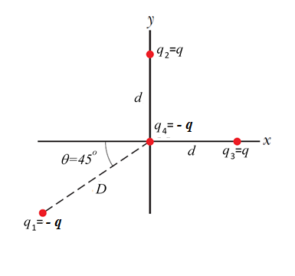

A) 8.3 N

B) 9.8 N

C) 1.6 N

D) 1.2 N

E) 4.3 N

Sec# Electric Charge - What is Physics

Grade# 40

Q7.

The dipole moment of an electric dipole in a 300 N/C electric field is initially opposite to the field, it then rotates so that it becomes in the same direction as the field. If the electric dipole moment has a magnitude of 2.00 x 10-9 C.m. How much work is done by the electric field during this rotation?

A) $1.20×{10}^{-6}$ J

B) $-1.20×{10}^{-6}$ J

C) $4.00×{10}^{-6}$ J

D) $-4.00×{10}^{-6}$ J

E) $0.600×{10}^{-6}$ J

Sec# Electric fields - The Electric Field Due to a Charged Disk

Grade# 50

Q8.

**Figure 3** shows cross sections through two very large, parallel, non-conducting sheets with identical surface charge densities σ = 1.77×10-22 C/m2. What is the electric field  at point *P* located 2.00 cm above the lower sheet?

Fig#

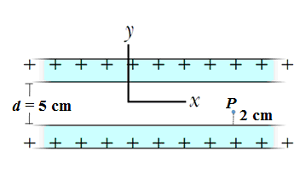

A) 0.0  N/C

B) −2.0×10-11  N/C

C) +2.0×10-11  N/C

D) −1.0×10-11  N/C

E) +1.0×10-11  N/C

Sec# Gauss's law - Gauss's Law and Coulomb's Law

Grade# 60

Q9.

The potential difference between two charged plates such as those in a TV is about 25.0 kV. If the distance between the plates is 1.50 cm, find the magnitude of the uniform electric field in the region between the plates.

A) 1.67×106 N/C

B) 3.34×106 N/C

C) 1.00×106 N/C

D) 2.84×106 N/C

E) 5.24×106 N/C

Sec# Electric Potential - Electric Potential

Grade# 60

Q10.

A parallel-plate capacitor with area 0.20 m2 and plate separation of 3.0 mm is connected to a 6.0 V battery. Without disconnecting the battery, the plates are moved farther apart to new separation of 6.0 mm. What is the ratio of the final charge to the initial one $Q_{f}/Q_{i}$?

A) 1/2

B) 4/3

C) 1/4

D) 3/2

E) 3/4

Sec# Capacitance - Capacitance

Grade# 50

Q11.

A 600 W heater is designed to operate with an applied potential difference of 120 V. Find the power output of this heater if the applied potential is reduced to 100 V?

A) 417 W

B) 217 W

C) 600 W

D) 120 W

E) 100 W

Sec# Current and Resistance - Ohm’s Law

Grade# 60

Q12.

**Figure 4** shows the electric potential *V*(*x*) along a copper wire carrying a uniform current, from a point of higher potential *V=*24.0 $μV$ at *x*= 0 to a point of zero potential at *x=*3.00 m. The wire has a radius of 2.00 mm. What is the current in the wire? (resistivity of copper $ρ=1.69 ×{10}^{-8} Ω·m$)

Fig#

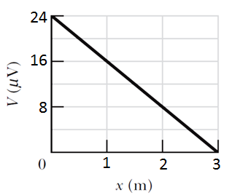

A) 5.95 mA

B) 2.97 mA

C) 1.49 mA

D) 11.9 mA

E) 0.00 mA

Sec# Current and Resistance - Current density

Grade# 40

Q13.

A copper wire with a diameter of 1.02 mm carries a constant current of 1.67 *A* to a 200 W lamp. The free-electron density in the wire is 8.50×1028 m-3. What is the magnitude of the drift velocity of the electrons in the wire $v_{d}$.

A) 0.150 mm/s

B) 1.80 mm/s

C) 3.35 mm/s

D) 4.50 mm/s

E) 2.50 mm/s

Sec# Current and Resistance - Current density

Grade# 60

Q14.

The given pair of capacitors in **Figure 5** are fully charged by a 12.0 V battery. The battery is then disconnected and the switch ***S*** is closed. How much charge remains on the 3.00 F capacitor after 1.00 ms?

Fig#

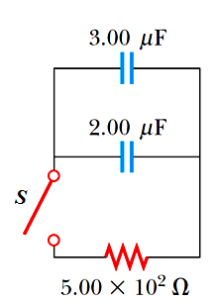

A) 24.1 C

B) 10.0 C

C) 20.0 C

D) 42.5 C

E) 15.0 C

Sec# Circuits - Calculating the Current in a Single-Loop nCircuit

Grade# 50

Q15.

When the switch S in the circuit in the **Figure 6** is closed, the equivalent resistance between points *a* and *b* decreases by 50.0%. What is the value of *R*?

Fig#

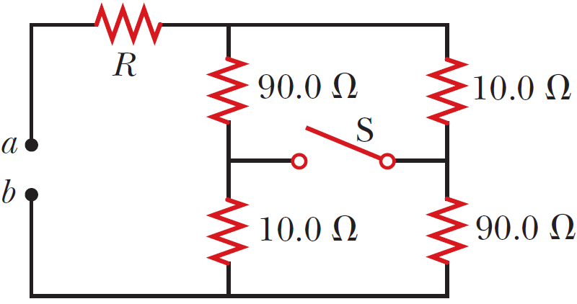

A) 14.0 Ω

B) 12.0 Ω

C) 20.0 Ω

D) 10.0 Ω

E) 17.0 Ω

Sec# Circuits - What is Physics

Grade# 40

Q16.

In **Figure 7**, the ideal batteries have emf **10.0 V and * *, and the resistances are identical and equal to 4.00 Ω each. What is the current in resistance R3?

Fig#



A) 1.25 A

B) 4.00 A

C) 2.50 A

D) 5.50 A

E) 3.00 A

Sec# Circuits - "Pumping" Charges

Grade# 50

Q17.

A particle with positive charge *q=*3.20×10-19 C moves with a velocity $\vec{v}=\left(2\hat{i}+3\hat{j}-\hat{k}\right)$ m/s through a region where both a uniform magnetic field and a uniform electric field exist. What is the total force on the moving particle (in unit-vector notation), taking $\vec{B}=\left(2\hat{i}+4\hat{j}+\hat{k}\right)$ T and $\vec{E}=\left(4\hat{i}-\hat{j}-2\hat{k}\right)$ V/m?

A) (+3.52 −1.60 )×10-18 N

B) (+2.32 −5.55 )×10-18 N

C) (−1.32 +2.45 )×10-18 N

D) (−4.86 +2.25 )×10-18 N

E) (+0.528 +6.63 )×10-18 N

Sec# Magnetic Fields - What is Physics

Grade# 50

Q18.

A rod of mass 0.720 kg rests on two parallel, frictionless rails that are *d =* 12.0 cm apart and *L =* 45.0 cm long. The rod carries a current of *i =* 48.0 A in the direction shown in **Figure 8** and slides along the rails. A uniform magnetic field of magnitude 0.240 T is also shown in **Figure 8**. If it starts from rest at the beginning of the rails, what is the speed of the rod as it leaves the rails?

Fig#

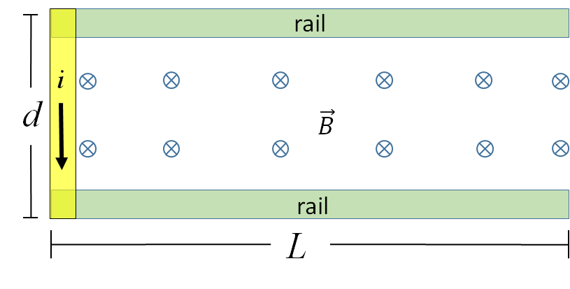

A) 1.31 m/s

B) 2.63 m/s

C) 1.97 m/s

D) 3.71 m/s

E) 4.63 m/s

Sec# Magnetic Fields - A Circulating Charged Particle

Grade# 40

Q19.

The amount of charge that passes through the filament of a certain lightbulb in 2.00 s is 1.67 C. Find the number of electrons that pass through this filament in 5.00 s.

A) 2.61x1019 electrons

B) 1.41x1019 electrons

C) 3.52x1019 electrons

D) 4.34x1019 electrons

E) 5.67x1019 electrons

Sec# Current and Resistance - What is Physics

Grade# 80

Q20.

In **Figure 9**, two concentric circular arcs have radii *a* =13.5 cm and *b* =10.7 cm, subtend an angle = 74.0°, carry current *i=*0.411 A. What are the magnitude and direction (into or out of the page) of the net magnetic field at *P*?

Fig#



A) 1.03×10-7 T out of the page

B) 1.03×10-7 T into the page

C) 2.40×10-7 T into the page

D) 2.40×10-7 T out of page

E) 5.02×10-7 T into the page

Sec# Magnetic Fields Due to Currents - What is Physics

Grade# 50

Q21.

A long conducting wire of radius r = 1.00 mm is coiled in the form of a single layered long solenoid of radius R as shown in **Figure 10**. Considering the turns of the solenoid are closely packed, find the magnetic field at the center of the solenoid if the current i = 5.00 A passes through it.

Fig#

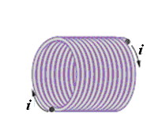

A) 3.14 mT

B) 5.04 mT

C) 4.51 mT

D) 2.12 mT

E) 1.15 mT

Sec# Magnetic Fields Due to Currents - Solenoid and Toroids

Grade# 50

Q22.

In **Figure 11**, *R*1=10.0 k Ω, *R*2=15.0 k Ω, *C*=0.400 **F, and the ideal battery has *emf* = 25.0 V. If the switch ***S*** is closed for a long time so that the steady state is reached, find the electric current in resistor R2.

Fig#

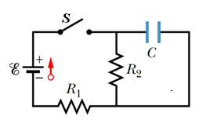

A) 1.00 mA

B) 1.51 mA

C) 2.51 mA

D) 3.54 mA

E) 4.05 mA

Sec# Magnetic Fields - Crossed Fields: Discovery of the Electron

Grade# 80

Q23.

In **Figure 12**, the magnetic flux through the loop increases according to the relation

*ΦB =* 6.0 *t*2 +7.0 *t +5*, where *ΦB* is in milli-webers and *t* is in seconds. Find the magnitude of the *emf* induced in the loop when *t* = 5.0 s*.*

Fig#

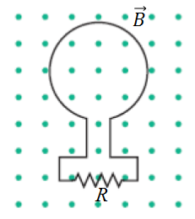

A) 67 mV

B) 22 mV

C) 47 mV

D) 85 mV

E) 75 mV

Sec# Induction and Inductance - What is Physics

Grade# 60

Q24.

If 50 cm of a copper wire is formed into a circular loop and placed perpendicular to a uniform magnetic field that is increasing at the constant rate of 10 mT/s, find the induced *emf* in the circular loop?

A) 2.0 x 10-4 V

B) 3.0 x 10-4 V

C) 4.0 x 10-4 V

D) 5.0 x 10-4 V

E) 6.0 x 10-4 V

Sec# Induction and Inductance - Two Experiments

Grade# 60

Q25.

Two parallel wires are separated by 6.0 cm, each carrying 3.0 A of current in same direction. What is the magnitude of the force per unit length between the wires? Is this force attractive or repulsive?

A) 3.0 x 10-5 N *attractive*

B) 3.0 x 10-5 N *repulsive*

C) 4.0 x 10-5 N *attractive*

D) 4.0 x 10-5 N *repulsive*

E) 1.0 x 10-5 N *attractive*

Sec# Magnetic Fields Due to Currents - Calculating the Magnetic Field Due to a Current

Grade# 60

Q26.

**Figure 13** shows a cross section across a diameter of a long cylindrical conductor of radius *a=*2.00 cm carrying a uniform current 170 A. What is the magnitude of the magnetic field at a radial distance of *r* = 1.00 cm?

Fig#

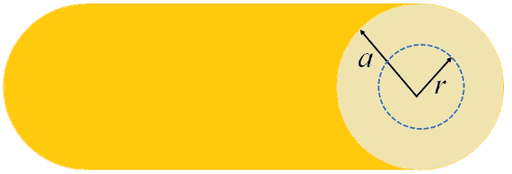

A) 0.850 mT

B) 3.25 mT

C) 4.15 mT

D) 1.00 mT

E) 0.00 mT

Sec# Magnetic Fields Due to Currents - Force Between Two Parallel Currents

Grade# 50

Q27.

You are facing a loop of wire which carries a current of 3.0 A and surrounds an area of 5.8×10−2m2. What is the magnetic dipole moment of the loop?

A) 0.17 A  m2

B) 2.17 A  m2

C) 5.17 A  m2

D) 7.17 A  m2

E) 0.00 A  m2

Sec# Magnetic Fields - Magnetic Force on a Current-Carrying Wire

Grade# 50

Q28.

In **Figure 14**, an electron is moving with a velocity $\vec{v}$ parallel to a long wire which carries a current *i* to the right. The magnetic force on the electron is

Fig#

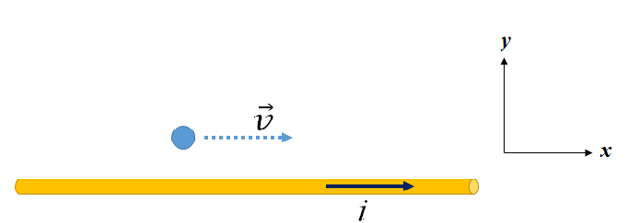

**A)** up (along positive y-axis)

B) down (along negative y-axis)

C) zero

D) out of the page (along positive z-axis)

E) into the page (along negative z-axis)

Sec# Magnetic Fields - Crossed Fields: Discovery of the Electron

Grade# 70

Q29.

Each of the eight conducting wires in **Figure 15** carries 2.0 A of current into or out of the page. Two closed paths are indicated for the line integral $\oint{\vec{B}.d\vec{S}}$. What are the values of the integral for path 1 and path 2, respectively?

Fig#

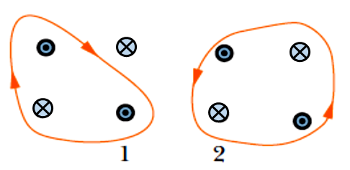

A) 2.5 T.m, 0

B) 2.5 T.m, 0

C) 0,0

D)  T.m, 2.5 T.m

E)  T.m, -2.5 T.m

Sec# Magnetic Fields Due to Currents - Force Between Two Parallel Currents

Grade# 70

Q30.

Capacitors A and B are identical. Capacitor A is charged so that it stores 4 J of energy and capacitor B is uncharged. The capacitors are then connected in parallel. What is the total stored energy in the capacitors now?

A) 2 J

B) 8 J

C) 4 J

D) 16 J

E) 1 J

Sec# Capacitance - Capacitors in Parallel and in Series

Grade# 50

Test Expected Average = 57

|  |  |  |
| --- | --- | --- |
| ,                ,  ,        , | ,  ,    ,  ,            ,    ,  ,  ,      ,  ,  , | ,        εo = 8.85 × 10-12 C2/N.m2  k = 9.00 × 109 N.m2/C2  qe = – e = –1.60 × 10-19 C  qp = + e = +1.60 × 10-19 C  me = 9.11 × 10-31 kg  mp = 1.67 × 10-27 kg   = micro = 10-6, n =nano =10-9  p = pico = 10-12  μ0 = 4π × 10-7 Wb/A. m  kB = 1.38 × 10-23 J/K  NA = 6.02 × 1023molecules/mole  1 atm = 1.01 × 105 N/m2  R = 8.31 J/mol. K  g = 9.8 m/s2  1L = 10-3 m3  ------------------------  For water:  *LF* = 333 kJ/kg  *LV* = 2256 kJ/kg  *c* = 4190 J/kg.K  ----------------------- |