Coupled Oscillations Homework
Due on Friday evening, 2nd Rabi-II

Question #1:
A system consists of two-pendula of equal mass and equal length oscillating in a vertical plane. The pendula are connected by a spring that is unstretched when the masses are in the vertical positions. Consider small oscillations only.
- From symmetry arguments discuss the expected normal modes for the system). Is there anything to be said about the eigenfrequencies?
- Formally (i.e. mathematically) determine the normal frequencies and normal modes of oscillation.
- Use a computer code to find the results above
- Find the general motion of the masses as a function of time if initially the two masses were struck (from rest at equilibrium position) in opposite directions with an impulse of magnitude I.
Hint: read the textbook

Question-2:
Masses m and M are connected with a spring of stiffness κ. Collinearly, mass m is connected to a wall with a spring of stiffness k. Similarly, mass M is connected to a wall by a spring of stiffness k. See the figure.

It is given that M = 4 m, and κ = 2/3 k.

- Find the frequencies of free vibrations
- What are the normal coordinates
- Assume the systems starts with mass m displaced by (A) and speed zero while mass M has no displacement, and speed zero. Find the consequent position of the two masses.

Hint: you will probably need to get assistance from Mathematica, as discussed in class.

Question-3:
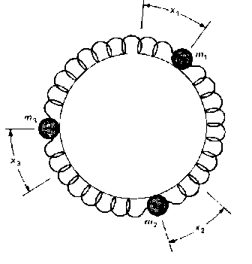
Three particles of the same mass (m = 120 grams) are constrained to move in a common circular path (see figure). They are connected by three identical springs each with stiffness 25 N/m.
- Find the general motion of the three masses.
- Assume it is noticed that the displacements of the first and third particles are of the same amplitude but opposite phase (i.e. x₁ = -x₃) while the x2 is continuously stationary. Find the frequency of vibration of the first particle.

