**Problems Chapter 11**

1. 3, (b) 1, (c) 2, (d) 4

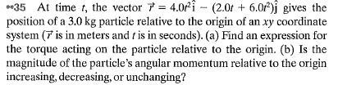D, B, A = C = 0 (torque = slope of graph L vs. t)

1. 48 t **k**, (b) 24 t2 increasing



(a) 4.64 x 10-3 kg m2, (b) 1.13 x 10-3 kg m2/s, (c) 3.94 x 10-3 kg m2/s



1. 24 kgm2/s, (b) 1.5 kgm2/s
2.  22.6 rad/s, (b) 3, (c) the man by moving the bricks toward him.
3. 750 rev/min, (b) 450 rev/min, (c) counterclockwise



1286 m/s



12 m/s



****400 m/s

1.5 rad/s