Contents

Abstract 2

1 Introduction 3

1.1 Inelastic scattering of fast neutrons, (n,n',γ) reaction 4

1.2 Generation of neutrons 5

1.3 Characteristic gamma radiations 5

1.4 LaBr3:Ce Detector 6

2 Experimental details 7

3 Results and discussion 10

3.1 Calibration for the measurement of carbon concentration 10

3.2 Energy calibration 13

3.3 Measurement of oil contamination in soil 15

4 Conclusions 17

References 18

**Figures**

Figure 1 Neutron scattering and generation of propt gamma rays 4

Figure 2 De-excition process of C12 and O16 compound nuclei 6

Figure 3 Schematic diagram of 14 MeV neutron-based PGNAA setup 8

Figure 4 The block diagram of control electronics for PGNAA experimental setup 9

Figure 5 Intrinsic activity spectrum of the cylindrical 76 X 76 mm2 (diameter X height) LaBr3:Ce gamma ray detector 11

Figure 6 Prompt gamma ray exp. Yield of samples used for calibration 12

Figure 7 Pompt gamma ray Exp. yield of samples used for calibration 12

Figure 8 gmma ray exp. yield complete spectrum of samples used for calibration 13

Figure 9 Energy calibration curve of the LaBr3: Ce detector 14

Figure 10 prompt gmma ray Exp. yieldspectrum of wet soil 15

Figure 11 prompt gmma ray Exp. yieldspectrum of wet soil and benzene doped wet soil sample 16

## 

Abstract

The oil contamination in soil is measured successfully by prompt gamma neutron activation analysis. The 14 MeV neutron beam is generated by the reaction of deuteron beam with tritium source. The fast moving neutron scattered form by sample inelastically by exciting the nuclei of sample and formed compound nuclei. The compound nuclei emitted the prompt gamma rays to stable phase and these prompt gamma rays is detected by using LaBr3:Ce detector. The spectrum is obtained of these prompt gamma rays with the help of multichannel buffer. For the measurement of oil contamination in wet soil, the calibration of system is done by using known value of carbon concentration samples Butyl alcohol (65 % C), Urea (28 % C) and Melamine (20 % C). It is cleared from the calibration spectrum the prompt gamma ray exp. yield is directly related to the concentration. In addition with calibration for carbon concentration, energy calibration is also done successfully by using the same sample. It is cleared that energy has linear relation with storage position in multichannel buffer. The prompt gamma ray exp. yield spectrum of wet soil did not show carbon peak. When the wet soil is contaminated with benzene (hydrocarbon) then the carbon peak is observed in prompt gamma ray exp. yield spectrum of contaminated wet soil.

# 

# 1 Introduction

Prompt gamma-ray activation analysis (PGAA) is a non-destructive nuclear method for performing both qualitative and quantitative multi-element analysis of major, minor, and trace elements in samples. Especially, the technique is used for the analysis of light elements such as H, B, C, N, Si, P, S and Cl, as well as for heavy elements such as Cd, Sm, Gd and Hg. The nuclear reaction used for prompt gamma-ray activation analysis is the neutron capture or inelastic scattering also called (n, γ) and (n, n’, γ) reactions respectively. When a neutron is absorbed or inelastically scattered by a target nucleus, the compound nucleus is in an excited state with energy equal to the binding energy of the added neutron. Then, the compound nucleus will almost instantaneously (<10-14s) de-excite into a more stable configuration through emission of characteristic prompt gamma rays. In many cases, this new configuration yields a radioactive nucleus which also de-excites (or decays) by emission of characteristic delayed gamma rays. PGNAA is based on the detection of the prompt gamma rays emitted by the target during neutron irradiation, while neutron activation analysis (NAA) is utilizing the delayed gamma rays from the radioactive daughter nucleus [1, 2]. The process of generation of prompt gamma ray is shown in figure 1.

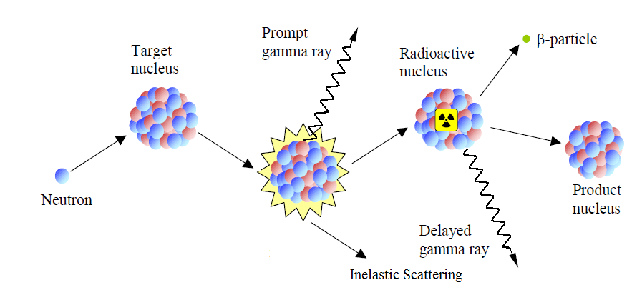

Figure 1 Neutron scattering and generation of propt gamma rays

## Inelastic scattering of fast neutrons, (n,n',γ) reaction

The inelastic scattering of neutrons (n, n', γ) take place if the neutron energy is above the energy of the first excited state of the scattering nucleus, i.e. it is a threshold reaction. The energy of the neutron will be reduced by the excitation energy, and the same amount of energy will be released by the scattering nucleus in form of characteristic prompt gamma radiations. These radiations can also be used for chemical analysis. This reaction is particularly used for carbon and oxygen measurement. The inelastic neutron scattering (n, n') cross-section, σinel has an energy dependence close to the threshold of ${ σ}_{inel }∝ \sqrt{{(E}_{n}}-E_{level})$. It reaches its maximum a few hundred keV above the threshold. The cross-section value at the maximum is a few tenths of barns (1 barn = 10-24cm2) for most nuclides. From the maximum value it decreases exponentially due to the increase in the number of competing levels [2]. The sum of the individual inelastic cross-sections for all the levels increases to a maximum at a few MeV above the threshold. The total inelastic cross-section has a value of a few barns around its maximum.

## 1.2 Generation of neutrons

A neutron generator is usually used as a neutron source in which deuterons are accelerated at a few hundred keV onto a deuterium or tritium target (or vice versa) with a yield of about 5-10 neutrons/deuteron. The neutron energy from the fusion reaction $H^{2}+H^{2}→{He}^{3}+n$ is about 2.5 MeV, and from $H^{2}+H^{3}→{He}^{4}+n$ it is about 14 MeV. In the PGNAA technique, fast neutrons were used to irradiate a material. Some of the fast neutrons are moderated by the material in an external moderator. The neutrons interact with the material through neutron inelastic scattering (n, n/, γ) or thermal neutron capture (n, γ) reactions to produce prompt γ-rays. The elemental composition of the sample can then be determined from the intensity of prompt γ- rays produced, either through neutron inelastic scattering (n, n’,γ) or thermal neutron capture (n, γ) or both [4].

## 1.3 Characteristic gamma radiations

As a result of nuclear reactions involving the isotopes contained in the object under scrutiny, exited nuclei emit gamma rays with specific energies in the de-excitation process. They act as the “finger prints” of these isotopes. Most γ-rays are emitted promptly after the reaction. The “prompt” photon emission from excited nucleus occurs within approximately 10-9 seconds after initial excitation. However in some cases, a nucleus with a half-life of a few seconds to a couple of minutes is formed. This radioactive nucleus decays to a daughter nucleus emitting various particles (α, β+, β-, etc.) and delayed photons [2, 4]. The prompt gamma ray emission occurs either in the single transition as it happens in the case of hydrogen 2.223-MeV gamma rays, or through several transitions emitting many prompt γ-rays of lower energy. The examples of energy level schemes for 12C and 16O nuclei are shown in Fig 2.



Figure 2 De-excition process of 12C and 16O compound nuclei

The intensities of the obtained specific gamma rays provide information about the number of atoms in the sample. Hence, the information on its chemical composition can be extracted from the measured gamma ray spectrum. The list of isotopes, nuclear reactions, and energies of most prominent characteristic gamma rays are shown in Table 1 [4, 5].

Table 1 Prompt gamma rays energies emitted from different elements

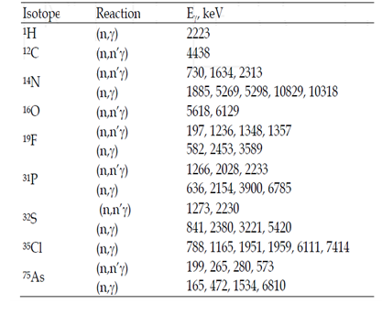

## 

## 1.4 LaBr3:Ce Detector

In recent years new scintillators materials like cerium-doped lanthanum chloride and bromide as well as cerium bromide have been developed and proven to have promising features for the detection of γ-rays compared to previously known materials. Especially the good timing resolution (better than 350 ps) allows clean separation of γ-rays depending on the diﬀerent processes of their creation by means of the time-of-ﬂight method. Even though lanthanum halide detectors have an intrinsic activity due to radioactive decay of a naturally occurring unstable La isotope, they have been successfully employed in high count rates studies because this type of detector can handle higher count rates than the conventional NaI detectors. But, due to their intrinsic activity, lanthanum-halide detectors may not be suitable in low-level counting experiments [6].

In the past, the response of the LaBr3:Ce detector has been tested for high energy gamma rays using a 14MeV neutron-based PGNAA setup. Prompt gamma rays with a maximum energy of 6.13MeV were produced through thermal neutron capture and inelastic scattering of 14 MeV neutrons from butyl, methyl blue, melamine, water and benzene bulk samples. PNGAA setup employing lanthanum halide detectors are expected to have better performance than those employing NaI detectors because lanthanum halide detectors have surpassed conventional NaI detector in terms of light decay time, energy resolution and high count-rate handling capabilities. This detector also has faster decay time of 60 ns and can operate over wide dynamic range of count rate with little variation in the energy resolution. Moreover, LaBr3:Ce has approximately a factor of two improved energy resolution as compare to NaI, and with full width at half maximum (FWHM) less than 3% at 662 keV and 30% higher detection efficiency [2, 6].

## 2 Experimental details

The oil contamination (carbon concentration) in soil sample was measured using 14MeV neutron based prompt gamma rays neutron activation analysis (PGNAA). The setup of this experiment is shown in figure 3.

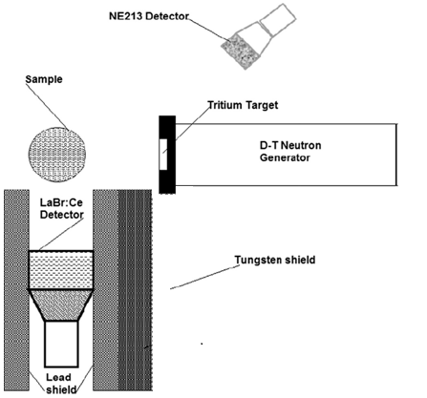

Figure 3 Schematic diagram of 14 MeV neutron-based PGNAA setup

The identification of oil contamination in soil cannot be measured directly by PGNAA. Firstly, the calibration of system is very important. For calibration of system, different samples of known carbon concentration were used. Here in our research, Butyl alcohol (65 %C), Melamine (28.6% C) and Urea (20 % C) are used as reference materials for calibration of the system. The reference materials explain the position of carbon peaks as well as the change in the counts of prompt gamma rays vs. concentration of carbon. All samples for calibration and for to measure the oil contamination were filled in plastic containers those were 90 mm to 140 mm in dimensions (diameter × length). The sample was placed in front of 14 MeV neutron rays at zero degree and the sample center was 17 mm from titanium target. The detector LaBr3:Ce was placed perpendicular to the neutron beam and the distance between the centers of sample and detectors is approximately 122 mm. The detector is shielded from scattering neutrons, thermal neutrons and gamma rays using tungsten, lead and paraffin to avoid from any damage [4-7]. The pulse beam of 14 MeV neutrons was produced by the collision of deuteron with tritium source. The deuteron beam was 200 nm wide and the frequency of beam was 31 KHz. The current of this beam was recorded 60 µA. when deuteron hit the tritium target then 14 MeV neutron beam is generated and the flux of neutron beam was monitored by cylindrical NE312 detector (76 mm × 76 mm). When the fast neutron beam hits the sample then fast neutron scattered inelastically by forming compound nuclei. The compound nuclei are in excited state and unstable and at the same time the nuclei of the atoms of the sample were de-excited by emitting the prompt gamma rays and the atoms of different materials emit prompt gamma rays of different energies. The emitted prompt gamma rays are detected by LaBr3:Ce detector and detector generates the pulses according to the energy deposited on the detector [8]. The prompt gamma-ray data from the samples were acquired for 1 h using a personal computer-based data acquisition system with a multichannel buffer module analog as the digital module. The schematic diagram of setup is shown in figure 4.

**LaBr3: Ce**

**Detector**

**High voltage Battery**

**(588 V)**

**Pre-amplifier**

**Liner Gate and**

**Stretcher**

**Multichannel Buffer**

**Desktop PC**

Figure 4 The block diagram of control electronics for PGNAA experimental setup

## 3 Results and discussion

The oil contamination (carbon concentration) in soil was successfully identified by Prompt gamma rays neutron activation analysis (PGNAA). The oil contamination measurement cannot be done directly. Firstly, the known carbon concentration samples are used to calibrate the system. Before calibration, to know about the intrinsic activity of LaBr3:Ce detector is very important.

## 3.1 Intrinsic activity of LaBr3:Ce detector

In LaBr3:Ce detector “La” is also radioactive material and it emits gamma rays by *β* decay. The peaks associated to gamma rays coming form due to the decay of Lanthanum is known as intrinsic peaks. The LaBr3:Ce gamma ray detector has 588 volts with positive polarity, and its intrinsic activity was measured, as a reference, using standard NIM electronics modules. The intrinsic peak was founded in channel number 104. Figure 4 shows the pulse height spectrum of the detector itself recorded over a period of 2000 seconds. It shows the 1468 (1436+32) keV gamma line of the detector’s intrinsic activity resulting from the sum of the 1436 keV gamma due to beta decay of 138-La isotope and the 32 keV X-ray fluorescence peak due to K shell X-ray fluorescence of Ba produced in the electron capture by La. The intrinsic activity rate was determined from the integrated counts under the 1468 keV peak [1, 2].

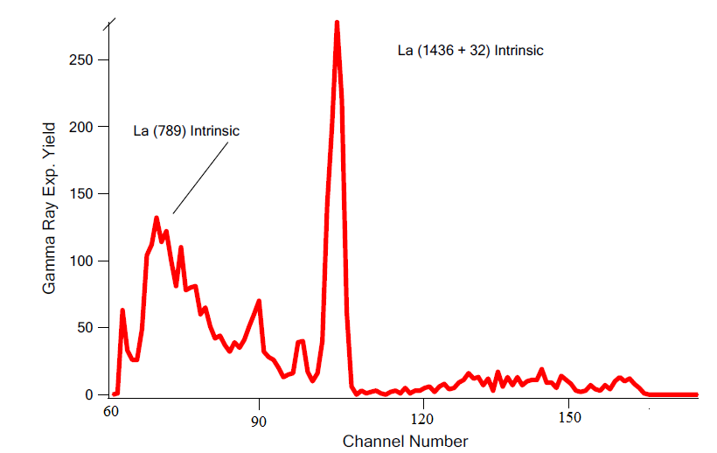

Figure 5 Intrinsic activity spectrum of the cylindrical 76 X 76 mm2 (diameter X height) LaBr3:Ce gamma ray detector

## 3.2 Calibration for the measurement of carbon concentration

The calibration of system was done using the materials of known concentration of carbon. Here in our research, we used Butyl alcohol (65% C), Melamine (28.6 % C) and Urea (20 % C) as reference materials for Calibration. Now after getting the spectrum of detector then the samples for calibration put in plastic container (90 mm ×140 mm). Each sample is irradiated for 30 minutes and prompt gamma ray exp. yield spectra are obtained with the help of multichannel buffer. The carbon peaks of energy 4440 keV were observed at channel 302. The comparison spectrum of all samples used for calibration is shown in figure 6 [4]. It is cleared from the spectrum, Butyl alcohol have maximum gamma ray Exp. yield because carbon concentration in butyl alcohol was 65 %. The gamma rays Exp. yield due to carbon atoms of Melamine and Urea are also shown in figure 6.

Figure 6 Prompt gamma ray exp. Yield of samples used for calibration

After that getting the gamma rays Exp. yield of Butyl alcohol, Melamine and urea, then a calibration curve is drawn between the carbon concentration and the number of counts of prompt gamma rays and that calibration curve is shown in figure 7.

Figure 7 Calibration line for the measurement of carbon concentration

This calibration curve is very useful and it is used to find out the carbon concentration in any unknown sample. For this purpose, the unknown sample will be irradiated with neutron beam and the number of gamma rays coming from carbon atoms of sample will be counted. Using the calibration curve, the concentration of carbon can be calculated precisely [1, 5].

## 3.3 Energy calibration

The energy of the any unknown peak that is present in spectrum can be calculated by using energy calibration line. For this purpose, the known energy materials are used to draw the energy calibration curve between the channel number and corresponding energy. Mostly, known energies of the gamma rays of H’ O and C elements are used for energy calibration. The spectrums of samples those are used for calibration are shown in figure 8.



Figure 8 The complete gmma ray exp. yield spectrum of samples used for calibration

The known energies of H’ O and C and their corresponding position (channel Number) in spectrum is used to draw the calibration line. The position and their corresponding energies are given in table 2 [8].

Table 2 The position and their corresponding energies of peaks in spectrum

|  |  |  |
| --- | --- | --- |
| **Peak** | **Channel Number** | **Corresponding Energy (KeV)** |
| H | 160 | 2223 |
| O  C | 397  302 | 6116  4440 |

The best fitted curve for energy calibration as shown in figure 9. The energy of any unknown peak can be calculated using that calibration energy line.

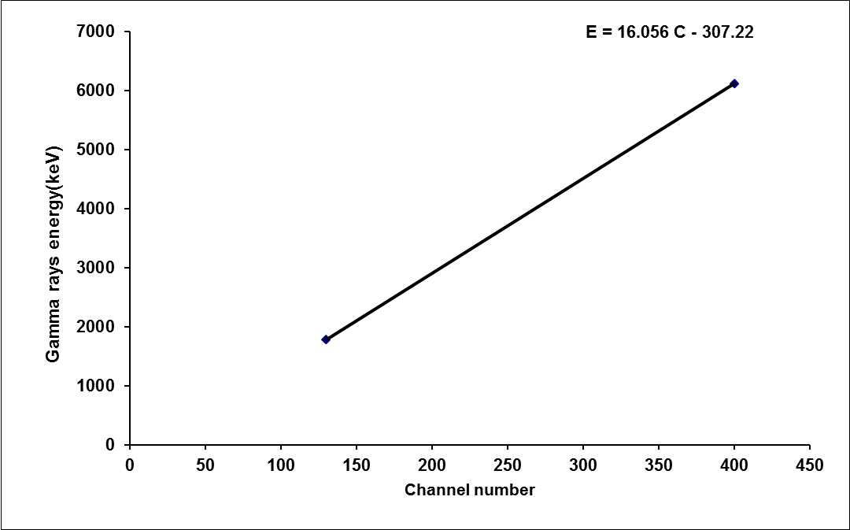

Figure 9 Energy calibration curve of the LaBr3: Ce detector

## 3.4 Measurement of oil contamination in soil

The oil contamination in soil can be measured by observing the carbon concentration in soil. Initially, wet soil was taken as our background sample and the prompt gamma ray exp. yield spectrum of wet soil is obtained with the help of multichannel buffer. It is cleared from the spectrum no peak is observed at 302 channel number. It means that no carbon is present in our sample and our sample is not contaminated by oil. The spectrum of wet soil is shown in figure 10.



Figure 10 prompt gmma ray Exp. yield spectrum of wet soil

This spectrum depicts that hydrogen and Silicon is present in the wet soil and no carbon peak. The peak intensity of Si is very high because Si is present in abandoned amount in soil and hydrogen peak is observed due to water content in soil. After that in sample 75 ml benzene is added as contaminant because benzene has carbon content in much amount. The contaminated sample is irradiated again with fast neutron and the spectrum of prompt gamma rays is obtained with the help of multichannel buffer. Now the prominent carbon peak is observed in sample it means that oil contamination can be measured by prompt gamma rays neutron activation analysis. Figure 11 depicts the carbon peak is present in the spectrum and by PGNAA we can check the oil contamination in soil sample [2, 9].

Figure 11 prompt gmma ray Exp. yieldspectrum of wet soil and benzene doped wet soil sample

## 4 Conclusions

The oil contamination in wet soil was successfully determined by Prompt gamma rays activation analysis. For this purpose, the calibration of system for the measurement of carbon concentration and energy was done accurately by using known samples whose carbon concentration known. In our research, Butyl alcohol (65% C), Urea (28% C) and Melamine (20% C) materials are used as reference samples for calibration. The prompt gamma ray exp. yield spectrum of reference sample is obtained with the help of multichannel buffer. It is cleared from the spectrum the carbon peaks of all reference samples are lie at 302 channel number. The number of counts of prompt gamma rays is calculated by calculating the area of carbon peaks and the calculated vales of counts are 36845 for urea, 37297 for melamine and 38361 for butyl alcohol. After that, using the number of counts values and known values of carbon concentration of reference samples a calibration curve for the measurement of carbon concentration is drawn. The energy calibration curve is also successfully drawn by using the known values of energies of carbon, oxygen and hydrogen peaks vs. channel number. The energies of all unknown peaks in prompt gamma ray exp. yield spectrum of wet soil were calculated by using energy calibration line. The prompt gamma ray exp. yield spectrum depicts that at 302 channel number no peak is observed. Its mean no carbon content is present in wet soil sample. When wet sample is contaminated by adding 75 ml benzene (as a contaminant) then a prominent carbon peak is observed at 302 channel number.

**Acknowledgement**

I would like to express my special thanks and appreciation to Dr. Akhtar Abbas Naqvi, who personally take interest to make my research successful. I am also very thankful to the all people who supported me during this research, Dr. Fatah Z.Khiari, Mr. Rashid, and Mr. Khokhar and also the department of physics.

## References

[1] A. A. Naqvi., Z. Kalakad, M. S. Al-Anzi, M. Raashid, Khateeb-ur-Rehman, M. Maslehuddin, & M. A. Garwan, (2012) Low energy prompt gamma-ray test of large volume BGO detector. Applied Radiation and Isotopes, 70, 222-226.

[2] G. L. Molnar. Hand book of Prompt Gamma Activation Analysis with Neutron Beam. Kluwer Academic Publishers, 1st edition (2004).

[3] Naqvi A. A., M. Maslehuddin, M. A. Garwan, M.M. Nagadi, O.S. B. Al-Amoudi,M. Raashid, and Khateeb-ur-Rehman, "Effect of Silica Fume Addition on the PGNAA Measurement of Chlorine in Concrete." Appl. Radiat. Isot.,Vol. 68(2010),pp.412-417.

[4] Naqvi A. A., Fares A. Al-Matouq, F. Z. Khiari, A. A. Isab. Khateeb-ur-Rehman, M. Raashid. Prompt gamma tests LaBr3:Ce and BGO detectors for detection of hydrogen, carbon oxygen in bulk samples. Nuclear Inst. and Methods in Physics Research, A 684 (2012) 82-87.

[5] M. Balcerzyk, M. Moszynski, M. Kapusta, Nuclear Instruments and Methods in Physics Research, Section A: Accelerators, Spectrometers, Detectors and Associated Equipment 537 (2005) 50.

[6] Naqvi A. A., ZameerKalakada,, M.S. Al-Anezi, M. Raashid, Khateeb-ur-Rehman, M. Maslehuddin and M. A. Garwan , F.Z. Khiari, A. A. Isab and O.S. B. Al-Amoudi. Detection Efficiency of Low Levels of Boron and Cadmium with a LaBr3:Ce Scintillation Detector. Nuclear Inst. and Methods in Physics Research, A 665 (2011) 74–79.

[7] Naqvi, A.A. , Al-Matouq, F.A., Khiari, F.Z., Isab, A.A., Raashid, M., Khateeb-ur-Rehman . Hydrogen, carbon and oxygen determination in proxy material samples using a LaBr:Ce detector. Applied Radiation and Isotopes , Volume 78, August 2013, Pages 145-150.

[8] A. Favalli, H.C. Mehner, V. Ciriello, B. Pedersen, Applied Radiation and Isotopes 68 (2010) 901.

[9] http://petrowiki.org/Glossary%3ACarbon/hydrogen_ratio. (April 7th ,2014).6