Suggested Problems
Chapter 21

The quiz questions will be same or very similar to the following text-book problems.
Refer to the course website for the latest version of this document.
You are encouraged to seek the help of your instructor during his office hours.

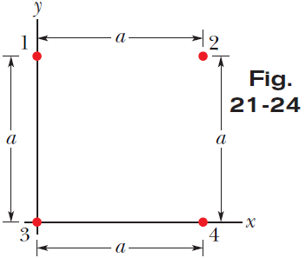
11. In Fig. 21-24, the particles have charges $q_{1}=- q_{2}=100$ nC and $q_{3}=-q_{4}=200$nC, and distance a = 5.0 cm. What are the (a) x and (b) y components of the net electrostatic force on particle 3?

Answer: (a) 0.169 N ; (b) 0.0465 N
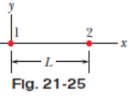
13. In Fig. 21-25, particle 1 of charge +1.0 μC and particle 2 of charge $-$3.0 μC are held at separation L = 10.0 cm on an x axis. If particle 3 of unknown charge $q_{3}$ is to be located such that the net electrostatic force on it from particles 1 and 2 is zero, what must be the (a) x and (b) y coordinates of particle 3?

Answer: (a) −13.7 cm ≅ 14 cm ; (b) 0
24. Two tiny, spherical water drops, with identical charges of $-1.00×{10}^{-16}$ C, have a center-to-center separation of 1.00 cm. (a) What is the magnitude of the electrostatic force acting between them? (b) How many excess electrons are on each drop, giving it its charge imbalance?

Answer: (a) 8.99×10⁻¹⁹ N ; (b) 625 electrons
59. What is the total charge in coulombs of 75.0 kg of electrons?

Answer: −1.32×10¹³ C
64. Two small, positively charged spheres have a combined charge of $5.0×{10}^{-5}$C. If each sphere is repelled from the other by an electrostatic force of 1.0 N when the spheres are 2.0 m apart, what is the charge on the sphere with the smaller charge?

Answer: 1.16×10⁻⁵ C = 1.2×10⁻⁵ C
66. An electron is in a vacuum near Earth’s surface and located at y = 0 on a vertical y axis. At what value of y should a second electron be placed such that its electrostatic force on the first electron balances the gravitational force on the first electron?

Answer: 5.077 m ≅ 5.1 m

