**King Fahd University of Petroleum and Minerals**

**Physics Department**

**PHYS 503 - Graduate Lab Report**

**Moisture Effect on Silicon Determination in Soil Samples**

**Using PGNAA Technique**



**Prepared by:**

**Name : Lutfi Mulyadi Surachman**

**ID : g201408060**

**Supervisor : Prof. Dr. Akhtar Abbas Naqvi**

**Coordinator : Dr. Abdul Aziz Mohammad Al-Jalal**

|  |
| --- |
|  |

TABLE OF CONTENTS

1. INTRODUCTION 1

2. EXPERIMENTAL DETAILS 2

3. RESULTS AND DISCUSSION 7

4. CONCLUSSION 11

5. ACKNOWLEDGMENT 11

REFERENCES 12

**Moisture Effect on Silicon Determination in Soil Samples using PGNAA Technique**

**ABSTRACT**

Moisture Effect on the silicon determination was measured in the soil samples using 14 MeV Neutron Inelastic Scattering. Silicon concentration was determined via 1.78 MeV gamma ray of Silicon. Soil samples with different moisture concentrations wt.% (3.9%, 5.3%, 8.15%, 13.32%,15.5%) were analyzed. It was observed that Silicon peak intensity from soil samples decreases with increasing moisture due to loss of 14 MeV neutron flux caused by moisture. This decreasing trend is also observed in this peak intensity of Oxygen from soil sample.

# INTRODUCTION

* 1. **Basic Principle**

PGNAA technique has wide range applications including the study of environmental contamination problems such as oil spill on soil. The amount of environmental contamination can be measured through concentration of carbon and hydrogen in the soil. Since the soil can be either moist or dry, the study of moisture effect on the carbon and oxygen determination in soil is needed. Moisture effect addition means the effect of adding hydrogen and oxygen on the existing hydrogen and oxygen in the soil. PGNAA technique can be used to analyze silicon, carbon, oxygen in large size of samples.

The PGNAA (Prompt Gamma Neutron Activation Analysis) is an analytically elemental method using either fast or thermal neutrons to irradiate a material. Prompt gamma ray induced by scattering of 14 MeV neutrons will be discussed in the following.

These fast neutrons produce prompt γ-rays by interacting with the sample materials through neutron inelastic scattering (n, n’γ). Inelastic scattering can occur both within the sample and from the sample into the apparatus. The fast neutrons interact with the nucleus without exciting it. The neutron changes its outgoing direction and loses kinetic energy by transferring energy to the recoil of the scattering nucleus. This energy loss is the mechanism to thermalize the neutrons. If the neutron energy is above the energy of the first excited state of the nucleus, it can inelastically scatter by exciting the nucleus which ultimately emits prompt gamma rays [1].

Figure 1 shows inelastic scattering of carbon and oxygen sequentially produces gamma ray energy 4.44 MeV and 6.13 MeV. The intensity of carbon and oxygen gamma ray energy can be decreased because of losing the neutron flux as a result of water moderation effect (adding moisture). Consequently, moisture contents in soil may cause an error in determining the carbon and oxygen. To avoid error in studying soil contamination, we should take the contaminated samples that have the smaller moisture percentage.



**Figure 1:** Gamma Ray decay from inelastic scattering of neutrons from C, N and O.[2]

* 1. **Objectives**

The objective of this experiment is to study effect of moisture on the silicon determination in soil samples.

# EXPERIMENTAL DETAILS

* 1. **Description of Equipments**

The experimental setup consists of a cylindrical plastic container filled with a (ϕ90 mm x 145 mm) sample placed 7.0 cm away from a tritium target at a 0o angle with respect to the 14 MeV neutron beam. The gamma ray detector is actually placed at a center-to-center distance of 19 cm from the sample at an angle of 90o-130o with respect to the 14 MeV neutron beam. Tungsten blocks are inserted between the neutron target and the gamma ray detector to shield it from the direct beam of 14 MeV neutrons, further the detector is also shielded from 14 MeV neutron-induced gamma ray background through massive lead shielding inserted between the detector and the tungsten shield [2,3].

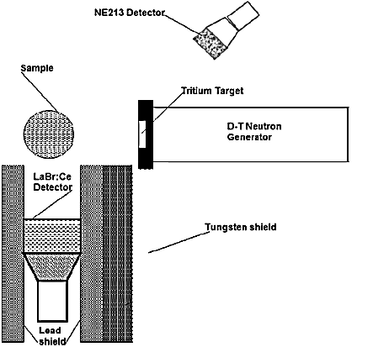

**Figure 2:** Schematic diagram of 14 MeV neutron-based PGNAA setup used for detection of Si concentration in Soil samples [2].

The signals are processed using standard NIM electronics modules connected to a personal PC as a multichannel analyzer (MCA) [2,3]. The NIM electronics block of the experiment is shown in Figure 3. The gamma ray yield spectra have been recorded for about 30 minutes each. Subsequently, we plot the gamma ray yield as a function of energy and we observe the correlation with the percentage of moisture.



**Figure 3:** The block diagram of control electronics for PGNAA experimental setup [2]

* + 1. **The LaBr3: Ce Detector**

The LaBr3:Ce has an intrinsic peak due to its radioactive 138La contents. It means that the detector is also detecting its own radioactivity. The measurement of this intrinsic peak is performed to check the stability of detector pulse height. The intrinsic peak is found in channel number 83. Figure 4 shows the pulse height spectrum of the detector itself recorded over a period of 1016 seconds. It shows the 1468 (1436+32) keV gamma ray line of the detector’s intrinsic activity which is the sum of the 1436 keV gamma ray due to beta decay of 138La isotope and the 32 keV X-ray fluorescence peak due to K shell X-ray fluorescence of 137Ba produced in the electron capture by 138La.

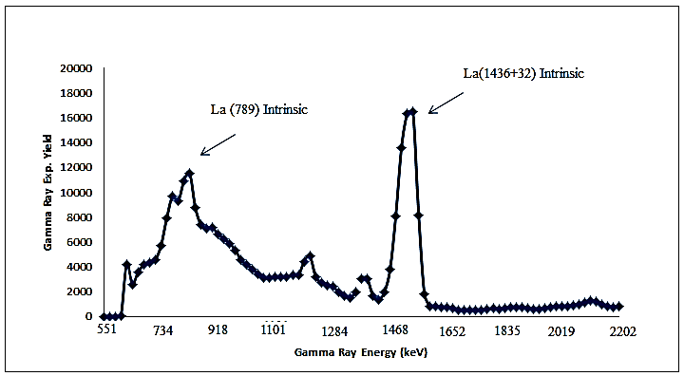

**Figure 4:** Intrinsic activity spectrum of LaBr3:Ce gamma ray detector.

* 1. **Sample Preparation**

Eight soil samples were prepared by filling in cylindrical plastic bottles which have 58 gram mass each. We fill each bottle with dry soil and measure the mass. Subsequently, we add water (75 ml, 100 ml, 125 ml, 150 ml, 250 ml, and 300 ml) to every soil sample and each of the samples was thoroughly mixed together and filled in the bottle. Then mass of each filled bottle was measured and listed in table 1. The percentage of moisture was calculated from dry sand mass and water mass and is shown against each sample in Table 1.

Table 1: Moisture and samples Mass data

|  |  |  |
| --- | --- | --- |
| Sample | Moisture (% of Water) | Sample Mass (g) |
| Dry-sand-1 | 0 | 1886 |
| 1 | 5.3 | 1760 |
| 2 | 8.15 | 1802 |
| 3 | 13.32 | 1935 |
| Dry-Sand-2 | 0 | 1938 |
| 4 | 15.5 | 2188 |
| 5 | 3.9 | 1794 |
| 6 | 6.42 | 1769 |

* 1. **Description of Methods**

A pulsed beam of 14 MeV neutrons was produced via the T (d,n) reaction using a pulsed deuteron beam with 200 ns width and a frequency of 31 kHz. The typical pulsed beam current of the accelerator was 60 A dc beam current. As shown in Fig. 2, the fast neutron flux from the tritium target was monitored using a 7.6 cm  x 7.6 cm cylindrical NE213 fast neutron detector, placed at a distance of 1.8 m from the target and at a backward angle of 130 degrees with respect to the beam axis on the opposite side of the LaBr3:Ce detector gamma-ray detector. The prompt gamma-rays spectrum of the LaBr3:Ce was recorded for a preset time in the data acquisition PC.

# RESULTS AND DISCUSSION

There are two main observed elements in the soil samples we use in this experiment – Silicon (29.84%) and Oxygen (63.912%). Other elements are neglected since they have small amount of concentration. Therefore we need to choose one sample to identify the full gamma ray intensity spectrum of the main elements. Of all samples, sample 4 contains the highest moisture (15.5 %). For that reason, it will be more representative if we take the highest moisture sample to analyze full spectrum. Figure 5 shows the prompt gamma ray peaks of Silicon Si (1780 keV) as well as Oxygen full energy peak O(6130 keV), Oxygen single and double escape peak, and also shown in intrinsic peak for La(1468 keV).

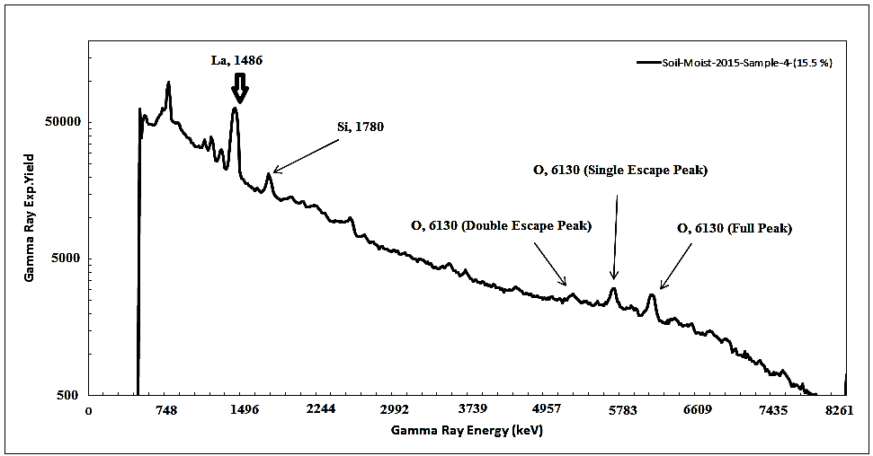

**Figure 5:** Full gamma ray Spectrum of main elements

To make the explanation more clearly, we can enlarge the plot of peak intensity of silicon and oxygen in such a way that we can get better image. Figure 6 shows the enlarged silicon peak intensity for dry sand 1, sample 1, 2 and 3 while Figure 7 shows the enlarged silicon peak intensity for dry sand 2, sample 4, 5 and 6.

Figure 6 and 7 show decreasing peak height of silicon with increasing moisture concentration in the sample.

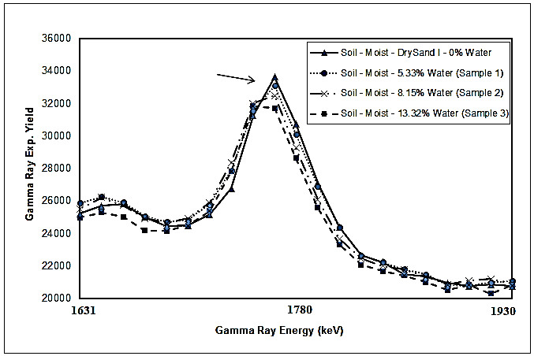

**Figure 6:** Silicon Prompt gamma ray spectra of soil samples (Window)

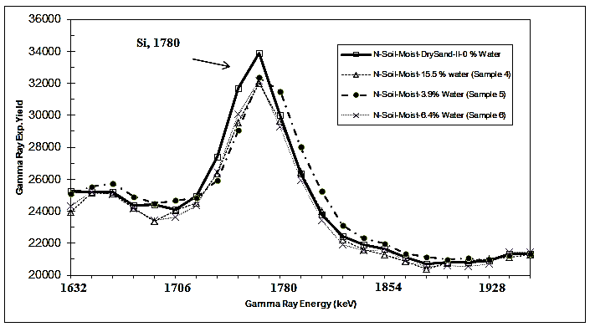

**Figure 7:** Silicon Prompt gamma ray spectra of soil samples (Window)

Similarly, Figure 8 shows the relationship between oxygen’s gamma ray yield and the moisture for dry sand 1, sample 1, 2 and 3 while Figure 9 shows the relationship between oxygen’s gamma ray yield and the moisture of dry sand 2, sample 4, 5 and 6. Figure 8 and 9 have similar trend as that of silicon. There might be some interference of oxygen’s gamma ray peak with that of other elements which have similar energy.

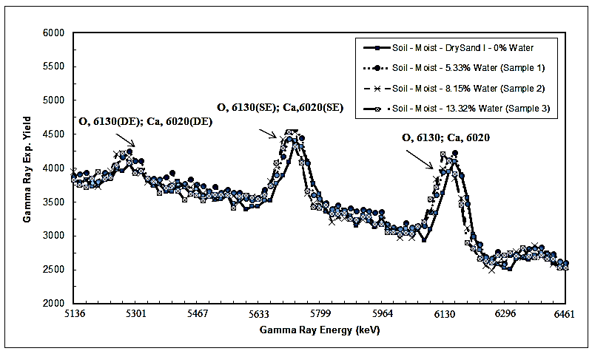

**Figure 8:** Oxygen Prompt gamma ray spectra of soil samples (Window)

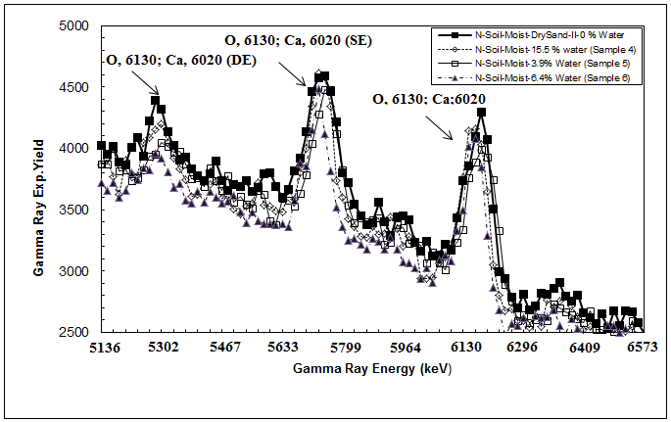

**Figure 9:** Oxygen Prompt gamma ray spectra of soil samples (Window)

The decrease of Silicon and Oxygen proves the fact that the more water we have, the more hydrogen will be with the result that the 14 MeV neutron beam can be more and more increasingly lost. In other words, we can say that water works as a moderator for the fast incident neutrons and makes the fast neutrons attenuated. That is the reason why silicon located on channel number 119(1780 keV)andoxygen located on chanel number370 (6130 keV)decrease with increasing moisture.

**Analysis**

In data analysis, Total counts under gamma ray peaks of silicon and oxygen were calculated by choosing 13-15 channel wide window about the peak. Then integrated counts were normalized to dry sample mass. Integrated-normalized counts under the silicon and oxygen peaks are plotted as a function of moisture for six samples as shown in figure 10 and 11. The integrated counts of silicon and oxygen peak decrease with increase in moisture. This is due to loss of 14 MeV neutrons in scattering from hydrogen in the moisture.

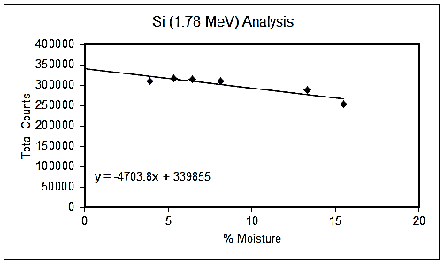

**Figure 10:** Integrated Si (6130) peak counts plotted as a function of moisture (%wt).

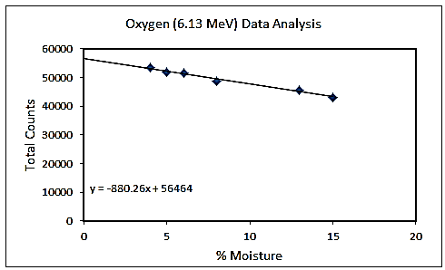

**Figure 11:** Integrated O (6130) peak counts plotted as a function of moisture (%wt).

# CONCLUSSION

# Moisture effect on Silicon determination was measured by using the 14 MeV neutron inelastic scattering. The PGNAA technique was used to mainly identify the peak intensity of Silicon and Oxygen elements. Adding water in the soil, we find a considerable peak intensity decrease of Silicon and Oxygen because of the fact that the fast neutron flux becomes more and more increasingly lost with increase in moisture. Therefore we conclude that the loss of neutron beam as a result of adding moisture may cause an error in this experiment.

# ACKNOWLEDGMENT

I would like to express my special thanks and appreciation to Prof. Dr. Akhtar Abbas Naqvi, who personally takes interest to make my research successful. I am also very thankful to the all people supporting me during this research. They are Dr. Fatah Z.Khiari, Mr. Rashid, and Mr. Khokhar.

# REFERENCES

[1] Naqvi A. A., M. Maslehuddin,M. A. Garwan, M.M. Nagadi, O.S. B. Al-Amoudi,M. Raashid, and Khateeb-ur-Rehman, "Effect of Silica Fume Addition on the PGNAA Measurement of Chlorine in Concrete." Applied Radiation and Isotopes 68(2010), 412-417.

[2] Naqvi, A.A., Al-Matouq, F.A., Khiari, F.Z., Isab, A.A., Raashid, M., Khateeb-ur-Rehman. Hydrogen, carbon and oxygen determination in proxy material samples using a LaBr:Ce detector. Applied Radiation and Isotopes, Volume 78 (2013), 145-150.

[3] Naqvi A. A., Fares A. Al-Matouq, F. Z. Khiari, A. A. Isab. Khateeb-ur-Rehman, M. Raashid. Prompt gamma tests LaBr3:Ce and BGO detectors for detection of hydrogen, carbon oxygen in bulk samples. Nuclear Inst. and Methods in Physics Research, A 684 (2012) 82-87.

[4] Naqvi A. A., ZameerKalakada,, M.S. Al-Anezi, M. Raashid, Khateeb-ur-Rehman, M. Maslehuddin and M. A. Garwan , F.Z. Khiari, A. A. Isab and O.S. B. Al-Amoudi. Detection Efficiency of Low Levels of Boron and Cadmium with a LaBr3:Ce Scintillation Detector. Nuclear Inst. and Methods in Physics Research, A 665 (2011) 74–79.