**HW-7-Ch-11-NT**



**N(t)=N0e-λt; linearized form: ln N(t)= lnN0-λt; w=1/ln N**

**Solution**

**Use Excell Sheet for calculation**

|  |  |  |  |  |  |  |  |  |  |
| --- | --- | --- | --- | --- | --- | --- | --- | --- | --- |
| **N** | **ln-N** | **time** | **w=1/ln-N** | **wy** | **wx** | **wx2** | **wxy** |  | **calc-ln-N** |
| **500** | **6.2146** | **0.0000** | **0.1609** | **1.0000** | **0.0000** | **0.0000** | **0.0000** |  | **6.1870** |
| **430** | **6.0638** | **1.0000** | **0.1649** | **1.0000** | **0.1649** | **0.1649** | **1.0000** |  | **5.9958** |
| **310** | **5.7366** | **2.0000** | **0.1743** | **1.0000** | **0.3486** | **0.6973** | **2.0000** |  | **5.8046** |
| **265** | **5.5797** | **3.0000** | **0.1792** | **1.0000** | **0.5377** | **1.6130** | **3.0000** |  | **5.6134** |
| **240** | **5.4806** | **4.0000** | **0.1825** | **1.0000** | **0.7298** | **2.9194** | **4.0000** |  | **5.4222** |
| **186** | **5.2257** | **5.0000** | **0.1914** | **1.0000** | **0.9568** | **4.7840** | **5.0000** |  | **5.2310** |
| **164** | **5.0999** | **6.0000** | **0.1961** | **1.0000** | **1.1765** | **7.0590** | **6.0000** |  | **5.0398** |
| **130** | **4.8675** | **7.0000** | **0.2054** | **1.0000** | **1.4381** | **10.0667** | **7.0000** |  | **4.8486** |
| **92** | **4.5218** | **8.0000** | **0.2212** | **1.0000** | **1.7692** | **14.1537** | **8.0000** |  | **4.6574** |
| **89** | **4.4886** | **9.0000** | **0.2228** | **1.0000** | **2.0051** | **18.0456** | **9.0000** |  | **4.4662** |
| **75** | **4.3175** | **10.0000** | **0.2316** | **1.0000** | **2.3162** | **23.1616** | **10.0000** |  | **4.2750** |
|  |  |  | **2.1303** | **11.0000** | **11.4429** | **82.6651** | **55.0000** | **Sum** |  |
|  |  |  |  |  |  |  |  |  |  |
| **D** | **45.1588** |  |  |  |  |  |  |  |  |
| **a1** | **6.1994** |  | **T1/2 =** | **3.59** | **min** | **** | **0.85** | **min** |  |
| **a2** | **-0.1928** |  |  |  |  |  |  |  |  |
| **sig-a1** | **1.8305** |  |  |  |  |  |  |  |  |
| **sig-a2** | **0.0472** |  |  |  |  |  |  |  |  |
| **sig-a2/a2** | **23.8000** | % |  |  |  |  |  |  |  |



**Lagrange Three points interpolation formula**



**x0=20, x1=25, x2=30 and y0=0.93693, y1=0.90631, y2=0.86603**

**then y(x)= 0.93693*[(22-25)(22-30)]/[(20-25)(20-30)]+ 0.90631*[(22-20)(22-30)]/[(25-20)(25-30)]+ 0.86603*[(22-20)(22-25)]/[(25-20)(30-25)]**

**y(x) =0.93693*(24/40)+ 0.90631*(16/25)+ 0.86603*(-6/25)**

**y(x) =0.562158+0.5800384-0.2078472=0.9343492**

**By least square = 0.9479**





**x0=20, x1=25, and y0=0.93693, y1=0.90631**

**Y= [0.93693 *(22-25)]/(20-25)+ [0.90631*(22-20)]/(25-20)**

**=0.93693 *(3/5)+ [0.90631*(2/5)]=0.562158+0.362524=0.924682**



**Error=(22-20)(22-25)x [4(0.90631-2*0.924682+0.93693)]/(5*5)**

**=-6x[4(1.84324-(2*.924682)]/25= -1.46976x10-3=-0.00146976**



**Use Excell Sheet for calculation**

**Solution**

|  |  |  |  |
| --- | --- | --- | --- |
| **X** | **original-y** | **3-points** | **5-points** |
| **10.0** | **12.0** |  |  |
| **11.0** | **10.0** | **12.0** | **14.8** |
| **12.0** | **14.0** | **17.3** | **30.8** |
| **13.0** | **14.0** | **31.3** | **15.0** |
| **14.0** | **24.0** | **33.3** | **1.8** |
| **15.0** | **30.0** | **18.0** |  |
| **16.0** | **40.0** | **10.3** |  |
| **17.0** | **34.0** | **3.0** |  |
| **18.0** | **26.0** |  |  |
| **19.0** | **18.0** |  |  |
| **20.0** | **10.0** |  |  |
| **21.0** | **12.0** |  |  |
| **22.0** | **9.0** |  |  |

**For three points n=1 and y2= [y1+y2+y3]/3**

**For five points n=2 and y is given by**

|  |  |
| --- | --- |
|  | **y= [-3y1+12y2+17y3+12y4-3y5]/35** |

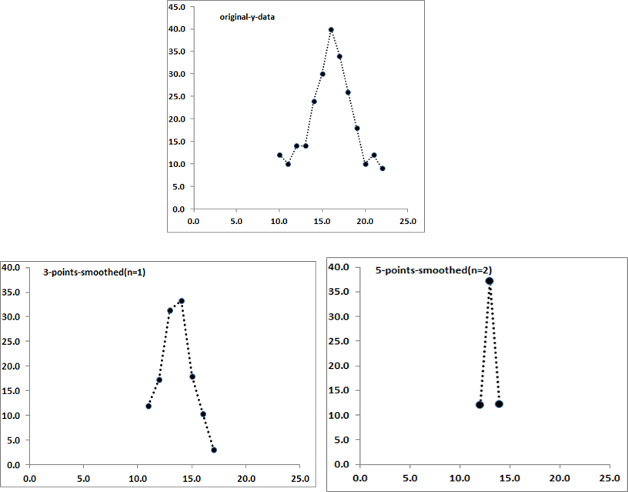

**Calculate FWHM for three figures and compare !!!!**