Old Exams. Questions Chapter 28-082 (Dr. Naqvi-Phys102-04-06)
T081
Q5. A particle (mass = 6.0 mg) moves with a speed of 4.0 km/s in a direction that makes an angle of 37° above the positive x axis in the x-y plane. At the instant it enters a magnetic field of (5.0 x 10⁻³ ) T, it experiences an acceleration of (8.0 ) m/s². What is the charge of the particle? (Ans: – 4.0 μC)
Q6. A square loop of side 0.20 m consists of 50 closely wrapped turns, each carrying a current of 0.50 A. As shown in Fig 4, the loop is oriented in a uniform magnetic field of 0.40 T directed in the positive y direction. What is the magnitude of the torque on the loop? (Ans: 0.35 N.m)
Q8. Fig 5 shows a loop of wire carrying a current of 2.0 A. The loop has the shape of a right angled triangle with two equal sides, each 20 cm long. A 1.5 T uniform magnetic field is parallel to the hypotenuse. The resultant magnetic force on the two equal sides has a magnitude of: (Ans: 0 N)
Q9.An ion with a charge of +4.8×10⁻¹⁹ C is in a region where a uniform electric field of 6.0×10⁴ V/m is perpendicular to a uniform magnetic field of 1.8 T. If its acceleration is zero then its speed must be: (Ans: 3.3 × 10⁴ m/s)
T072: Q#18: A 2.0 C charge moves in a uniform magnetic field with a velocity of (2.0 i + 4.0 j) m/s and experience a magnetic force of 12 N along the +z-axis. The x component of the magnetic field is equal to zero. Determine the y component of the magnetic field? (Ans: +3.0 T)
Q19. A current loop is oriented in three different positions relative to a uniform magnetic field. In position 1 the plane of the loop is perpendicular to the field lines. In position 2 and 3 the plane of the loop is parallel to the field lines as shown in Fig. 1. The torque is maximum in: (Ans: positions 2 and 3)
Q20. A charged particle has a kinetic energy of 10-7 joules and moves in a circular path in a uniform magnetic field. If the magnitude of the magnetic force on the particle is 1.5 x 10-4 N, what is the radius of the circular motion? (Ans: 1.3 mm)
Q21. What is the kinetic energy of an electron that passes in a straight line through perpendicular electric and magnetic fields if E= 4.0 kV/m and B= 8.0 mT ? (Ans: 0.71 eV)

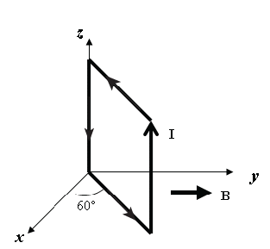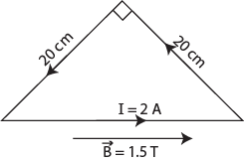
Fig. 4, T081 Fig. 5, T081 Fig. 1, T072
T071: Q19. A loop of wire carrying a current of 3.0 A is in the shape of a right triangle with two equal sides, each 16 cm long. A 0.8T uniform magnetic field is parallel to the hypotenuse. The total magnetic force on the two equal sides has a magnitude of: (Ans: 0)
Q20. A potential difference of 600 V is applied to accelerate an electron from rest. This accelerated electron enters a uniform magnetic field and completes one revolution in 9 nano seconds. Determine the radius of the electron orbit? (Ans: 0.021 m)
Q21. An electron with a velocity of v = (4.0×10⁴ i + 3.0×10⁶ j) m/s enters a region of magnetic field B = (0.40 i) T. The magnetic force on the electron is: (A 1.9×10⁻¹³ k N)
Q22. A 300 turn square loop, having a side length of 6 cm, carries a current of 15 A. The loop is placed in an external magnetic field of magnitude 3.0 T. Determine the magnitude of the maximum torque exerted on the loop. (A: 49 N.m)
T062: Q18.The following figure shows a loop of wire carrying a current of 2.0 Ampere is in the shape of a right triangle with two equal sides, each 15 cm long. A 0.7 T uniform magnetic field is parallel to the hypotenuse as shown in the figure. The resultant magnetic force on the two equal sides has a magnitude of: (Zero)
Q19. An electron moving perpendicular to a 50 µT magnetic field goes through a circular trajectory. What is the time required to complete one revolution? (7.15 x 10⁻⁷ s )
Q20. An electron has a velocity: v = (5 x 10⁶ – 3 x 10⁶ ) m/s and moves through a uniform magnetic field: B = ( 0.5 + 0.3 ) T. Find the magnetic force (in Newtons) on the electron. (- 4.8 x 10⁻¹³ ).
Q21: The following Fig. 1 shows a straight horizontal length of copper wire of mass m = 50 g and length L = 1.0 m lies in a uniform magnetic field B = 0.5 T directed out of the page. What is the magnitude and direction of the current in the wire to balance the gravitational force? (Ans: 0.98 A, to the left)

L = 1.0 m
x
y
z
I
+ x
+ y
+ z
p
v

Fig. 1, T062 Fig. 2, T062 Fig. 3, T062
Q22. A 100 turns coil, lies in xz-plane, has an area of 2.0 m² and carries a current I = 0.3 A in the direction indicated in the Fig. 2. The coil lies in a magnetic field directed along the x-axis and has a magnitude of 1.5 T. What is magnitude and direction of the torque on the coil? (Ans: 90 N.m along the positive z axis)
Q23.The Fig. 3 shows a proton moving at a constant speed of 300 m/s along the negative x-axis through uniform electric and magnetic fields. The electric field is directed along the positive y-direction and has a magnitude of 900 N/C. What is the magnitude and direction of the magnetic field?
T-061: Q18. A charged particle is moving with speed v perpendicular to a uniform magnetic field. A second identical charged particle is moving with speed 2v perpendicular to the same magnetic field. The frequency of revolution of the first particle is f. The frequency of revolution of the second particle is (Ans: f )
Q19. An electron with a velocity $\vec{v}=5\text{.}0×{\text{10}}^{7}\hat{i}$(m/s) enters a region of space where perpendicular electric and magnetic fields are present. The electric field is $\vec{E}=−{\text{10}}^{4}\hat{j}$ (N/C). What magnetic field (in Tesla) will allow the electron to go through un-deflected? (Ans: $\vec{B}\text{=+}(2\text{.}0×{\text{10}}^{−4})\hat{k}$)
Q20. A moving charge has a velocity $\vec{v}=v_{o}\hat{i}$ (v_{o} > 0) when it enters in a region where there is a uniform magnetic field. The magnetic force acting on the charge is where F_{o} > 0. Which of the following expressions correctly represents the orientation of the magnetic field? (Take B_{o} > 0). (Ans: $\vec{B}=B_{o}\hat{i}+B_{o}\hat{j}$)
Q21. A horizontal, long current-carrying wire is hanging from a vertical thread. The current is oriented into the plane of the figure 1 shown below. A uniform magnetic field is applied and the wire is pulled away from the vertical. Which of the arrows labeled A to D correctly indicates the direction of the magnetic field? (Ans: C)
Q29. A wire of length carries a current , is bent in the form of a circle. The magnitude of its magnetic moment is: (Ans: )
T-052: Q#14. What is the angle between a 1.0-mT uniform magnetic field and the velocity of an electron, if the electron has an acceleration of 7.0×10¹² m/s² and a speed of 7.0×10⁴ m/s?(Ans: 35º )
Q#9. A wire lying along the y axis from y = 0 to y = 0.36 m carries a current of 2.0 mA in the negative direction of the y axis. The wire fully lies in a uniform magnetic field given by B=0.36 i + 0.46 j (T). What is the magnetic force on the wire? (Ans: 2.6 × 10⁻⁴ N in the positive z direction.)
Q#29. A uniform magnetic field of 2.0 T along the positive z-axis crosses an electric field E. What is the electric field needed to guide an electron with a speed of 40 km/s along a straight line in the positive x-axis direction? (Ans: 80 kV/m along the positive y-axis. )
T-051: Q#5. An electric field of magnitude 400 V/m is normal to a magnetic field of magnitude 0.25 T. If an electron moving through these two fields experiences no force, what is the speed of the electron? (Ans: 1.60 km/s.)
Q#17. In the figure 1, an electron of speed 2.0×10 5 m/s moves along positive x axis in a uniform magnetic field of 0.2 T pointing into the page –z direction. The magnetic force on the electron is: (Ans: 6.4 × 10 ⁻¹⁵ N, -y axis.)
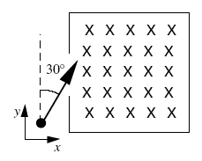
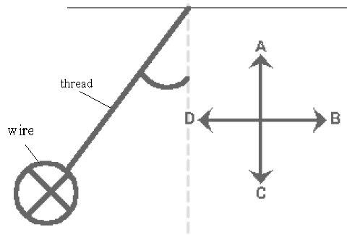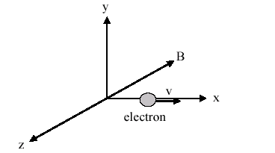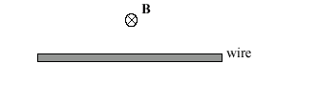
Figure 7

Fig. 1, T061 Fig. 1, T051 Fig. 2 T051 Fig. 7, T042
Q#23. In a uniform magnetic field, a particle of charge 1.5 µC and mass 2.0 µg completes 5 revolutions in one second. What is the magnitude of the magnetic field? (Ans: 42 mT.)
Q#25. A straight wire of linear mass density 100 g/m is located perpendicular to a magnetic field of 0.5 T as shown in the figure 2. What current in the wire is needed to balance the gravitational force on the wire?( Ans: 2.0 A to the right)
T-042: Q#17 An electron enters a region that contains a magnetic field directed into the page as shown in figure 7. The velocity of the electron makes an angle of 30 degrees with the +y axis. What is the direction of the magnetic force on the electron when it enters the field? (A1: at an angle of 30 degrees below the positive x axis and in the plane of the page.)
Q#19: An electron is accelerated from rest through a potential difference of 500 Volts, then injected into a uniform magnetic field. Once in the magnetic field, it completes one revolution in 4.0 nano-s. What is the radius of the orbit? (A1 8.4 mm)
Q#20 A charged particle is projected with velocity v into a region where there exists a uniform electric field of strength E perpendicular to a uniform magnetic field of strength B. If the velocity of the charged particle is to remain constant, the minimum velocity must be (A1 of magnitude E/B and perpendicular to both E and B.)
Q#21: A circular coil of 160 turns has a radius of 1.90 cm and carries a current I. If the maximum torque that the coil can experience in a uniform 35.0 mT magnetic field is 0.08 N*m, what is the value of I. (A1 12.6 A.)
T-041 Q#1: In figure 5, an electron moves toward the west at speed of 1.0*10**7 m/s in a downward (normal into the page) uniform magnetic field of 3.0*10**(-4) T. The magnetic force on the electron is (Ans: 4.8*10**(-16), north.)
Q#3: An electron is accelerated by a potential difference of 2.0 kV. Then it passes normally through a region of magnetic field, where it moves in a circular path with radius 0.2 m. What is the magnitude of the magnetic field? (Ans: 7.5*10**(-4) T.)
Q#4: The plane of area 4.0 cm**2 rectangular loop of wire is parallel to a 2.0 T magnetic field. The loop carries a current of 6.0 A. Calculate the magnitude of the torque acts on the loop. (Ans:4.8*10**(-3) N*m.)
Q#5: A charged particle is placed in a region of space and it experiences a force only when it is in motion. It can be conclude that the region encloses (Ans: A magnetic field only.)
Q#6 An electric field and a magnetic field normal to each other. The electric field is 4.0 kV/m and the magnetic field strength is 2.0 mT. They are act on a moving electron to produce no force, calculate the electron speed. (Ans: 2.0*10**6 m/s.)
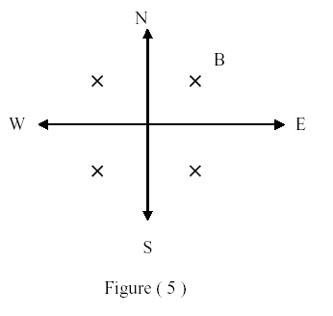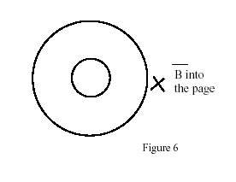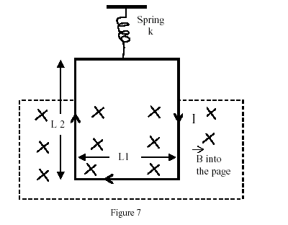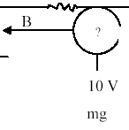
T041-Figure 5 T032-Figure 6 T032-Figure 7 T031-Figure 5
T-032:Q#1: Figure 6 shows the circular paths of an electron and a proton that travel at the same speed in a uniform magnetic field B, which points into the page. (a) Which particle follows the bigger circle, and (b) does that particle travel clockwise or counterclockwise? (Ans: (a) proton (b) counterclockwise)
Q#2: In figure 7, a rectangular loop, L1 = 2.0 cm by L2 = 3.0 cm, carrying a current I = 0.1 A, is suspended from a spring of spring constant, k = 8.0*10**(-2) N/m. The loop is placed into a uniform magnetic field, which points into the page, and the spring is observed to stretch 1.0 cm. What is the magnitude of the magnetic field? [Neglect the mass of the loop] (Ans:0.4 T.)
Q#3: At a point in a uniform magnetic field the acceleration of an electron is 5.0*10**14 m/s**2 and its speed is 7.0*10**6 m/s. If the magnitude of the magnetic field is 1.0 mT, what is the angle between the electron’s velocity and the magnetic field? (Ans:24 degrees.)
Q#4:A proton moves with constant velocity, v = (8.0*10**5 m/s) i, through crossed electric and magnetic fields. If the magnetic field is B = (2.5 mT) j, what is the electric field? [i, j and k are the unit vectors in the positive x, y and z directions, respectively]. (Ans: (-2.0 kV/m) k.)
Q#5: Which one of the following statements is FALSE (NOT TRUE). A uniform magnetic field (Ans: changes the kinetic energy of a charge.)
T-031: Q#1: An electron that has velocity v = 3.2*10**7 i m/s traveling parallel to a uniform magnetic field of strength 2.60*10**(-3) Tesla. The force on the electron is: [i is the unit vectors in the directions of x] (Ans:zero.)
Q#2: A straight horizontal length of copper wire is located in a place where the magnetic field of the earth B = 0.5*10**(-4)T (see figure 5). What minimum current in the wire is needed to balance the gravitational force on the wire? [The linear density of the wire is 60.0 gram/m] (Ans:1.2*10**4 A into the page.)
Q#3: The path of a charged particle in a magnetic field, when its direction of motion is not at right angle to the magnetic field, will be a: (Ans: helix.)
Q#4: An electron moving at right angle to a uniform magnetic field completes a circular orbit in 10**(-8) s. What is the magnitude of the magnetic field. (Ans: 3.6*10**(-3) T.)
T-011: Q#1: An electric field of 1.5*10**3 V/m and a magnetic field of 0.50 T act on a moving electron to produce no net force. Calculate the minimum speed of the moving electron. (Ans:. Zero.)
Q#3: A proton that has velocity v=( 3.0*10**6 i- 2.0*10**6 j ) m/s moves in a magnetic field B = (0.50 i) T. Find the force on the proton. (i, j and k are the rectangular unit vectors.) (Ans: -1.6*10**(-13) kN.)
Q#6: What uniform magnetic field, applied perpendicular to a beam of electrons moving at 1.4*10**6 m/s is required to make the electrons travel in a circular orbit of radius 0.40 m? (Ans: 7.0*10**(-5) T.)
Q#7: What is the initial direction of the deflection of an electron, moving in the y direction as it enters the magnetic field shown in figure (7)? [The magnetic field is in the xy-plane and makes an angle of 45 degrees with the x axis]. (Ans: y direction.).
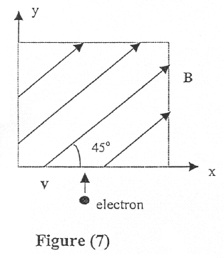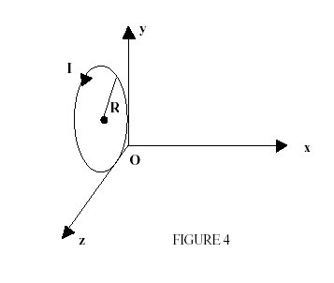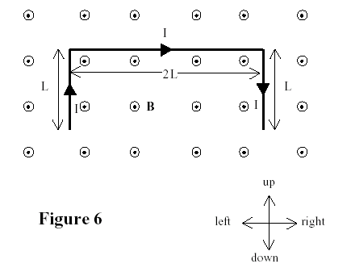
T011-Figure 7 T992-Figure 4 T991-Figure 6
T-002:Q#1: An electron is projected into a uniform magnetic field B = (0.8 k) T. Find the magnitude of the magnetic force, on the electron when the velocity is: v = (5.0*10**5 i + 3.0*10**5 j) m/sec. (i, j and k are the unit vectors in the x, y and z directions, respectively). (Ans:7.5*10**(-14) N.)
Q#2: In figure (4), a loop of wire carrying a current, I, of 2.0 A is in the shape of a right triangle with two equal sides, each 15 cm long. A 0.7 T uniform magnetic field is in the plane of the triangle and is perpendicular to the hypotenuse. The resultant magnetic force on the two equal sides is: (Ans: 0.30 N, into the page.)
Q#3: A magnetic field CANNOT: (Ans: cannot change the kinetic energy of a charge.)
Q#4: Electrons are accelerated from rest through a potential difference of 500 V. They are then deflected by a magnetic field of 0.2 T that is perpendicular to their velocity. The radius of the electrons trajectory is: (Ans: 0.38 milli-m.)
T-992: Q#1: An electron enters a region of magnetic field B = (0.40 i) T with a velocity v = (3.0*10**4 i + 2.0*10**5 j) m/s. (i, j and k are the unit vectors in x, y and z directions, respectively). The magnetic force that the electron experiences is: (Ans: ( 1.3*10**(-14) k) N)
Q#2: An electron moving perpendicular to a 50 micro-T magnetic field, goes through a circular trajectory. What is the time required to complete one revolution? (Ans: 715 nano-seconds)
Q#3: A current of 17 mA is maintained in a circular loop of 2 m circumference which is parallel to the y-z plane (see Figure 4). A magnetic field B = (- 0.8 k) T is applied. Calculate the torque exerted on the loop by the magnetic field. (i, j and k are the unit vectors in x, y and z directions, respectively). (Ans:( 4.33*10**(-3) j) N*m)
T-991: Q#1: An electron is projected into a uniform magnetic field B = (1.4i + 2.1j) T. Find the force on the electron when the velocity is v = (3.7*10**5 j) m/sec (i, j and k are the unit vectors in the x, y and z directions, respectively). (Ans: (8.3*10**(-14) k) N)
Q#2: An electron moving in a circular path perpendicular to a uniform magnetic field takes 1.0 nano-second to complete one revolution. Determine the magnitude of the magnetic field. (Ans: 36 milli-T)
Q#3: A wire of total length 4L and carrying a current I is placed in a uniform magnetic field B that is directed out of the page as shown in Figure 6. Determine the net magnetic force on the wire. (Ans: 2ILB down)
Q#4: A square loop, of side a = 5 cm and 200 turns, carries a current of 10 A. The loop is placed in an external magnetic field of 2.0 T. Determine the magnitude of the maximum torque exerted on the loop. (Ans: 10 N*m)

