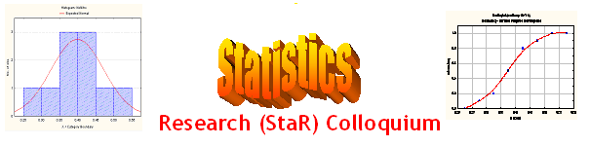
Seminar

Dept of Mathematical Sciences
King Fahd University of Petroleum and Minerals

Presenter | Dr. Abdullahi Umar  Dept of Mathematical Sciences, KFUPM
Title | A Remark About Independent Events
Topic & (Level) | Probability Issues  (Methodological, Educational)
Audience | All KFUPM community are cordially Invited
Date | Tuesday, Nov 14, 2006
Time | 1:00 PM
Location | Building 5, Smart Classroom # 203

Abstract

An example concerning (in)dependent events is given in the textbook of Math 131: "Introductory Mathematical Analysis for Business, Economics and the Life and Social Sciences" by Haeussler et al. The curious thing about this example is that the events given are dependent when the number of events considered is n = 2 and independent when n = 3. We shall discuss what happens when n > 3, and a generalization of the problem is also discussed. The answers we got are at least surprising to me.

Tea and Coffee will be served

