INTRODUCTION
Bluetooth is a standardized technology that is used to create temporary (adhoc) short-range wireless communication systems. These Bluetooth wireless personal area networks (WPAN) are used to connect personal accessories such as headsets, keyboards, and portable devices to communications equipment and networks.
Bluetooth was named after Harald Blatand, King of Denmark. King Blatand was head of Denmark from 940 to 985 A.D and he is known for uniting the Danes and Norweigans. It seems appropriate to name the wireless technology that unifies communication between diverse sets of devices after King Blatand.
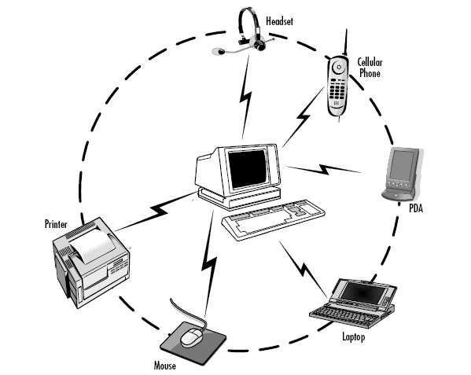

Figure1. A Network using Bluetooth
- Physical Layer

Bluetooth radio operates in (ISM) band at 2.4 GHz. Because the ISM band is free, it allows Bluetooth to share this frequency band with many other systems. Bluetooth uses for modulation a frequency hopping (FH) spread spectrum technology. There are 79 channels , each with a bandwidth of 1 MHz. During communication, the system makes 1,600 hops per second. The signal is transmitted using binary Gaussian frequency shift keying. The raw bit rate is 1 Mbps, but due to various kinds of protocol overhead, the user data rate cannot exceed 723 Kbps[3].

1.1 Topology
When two or more Bluetooth unites share a channel, they form a piconet. A Bluetooth unit can be master or slave. Each piconet may contain only one mater and up to seven active slaves. Two or more piconets can be connected together to form a scatternet [3].
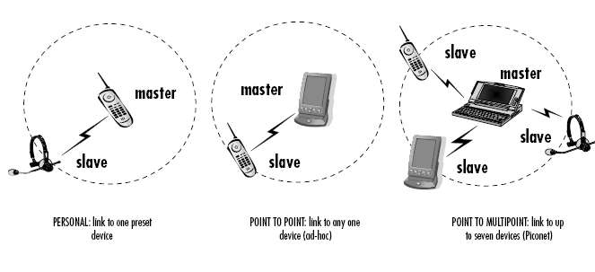
Figure 2. Three piconets forming a scattenet.

1.2 Traffic Types

Bluetooth operates on less than 10 meter using 2.4GHz ISM band. The ranges of transmission are actually depending on the transmission power which is divided into three classes shown in table 1. All Bluetooth devices support only one of these classes.
Table 1 .All possible transmission powers
Class | Transmission Power | Covering Range
1 | 100 mW | 100 m
2 | 2.5 mW | 20 m
3 | 1 mW | 10m

- Data Link Layer
Bluetooth provides two services. One is synchronous service and the other is asynchronous service. Both services complement the main features of Bluetooth (i.e. synchronous service is used for voice traffic and asynchronous service is used for burst data traffic).
2.1 ACL
ACL is a link that can be established between a master and a slave such that a single link is between them. The mechanism of the connection is of packet-switched type between the master and active slaves. When a slave in a piconet is addressed from another master in another piconet, it can transmit ACL packets to the other. The master arrange ACL packets in slots [2].
Table 2 .ACL packet types
Type | Slot(s) | Payload  (bytes) | Forward Error Correction  (FEC) | Asymmetric data rate  (kbps total)
DM1 | 1 | 17 | 2/3 | 217.6
DH1 | 1 | 27 | none | 341.6
DM3 | 3 | 121 | 2/3 | 516.2
DH3 | 3 | 183 | none | 692.0
DM5 | 5 | 224 | 2/3 | 514.1
DH5 | 5 | 339 | none | 780.8

2.2 SCO
SCO link supports bounded information like voice for 64 kbps speech. In a piconet The SCO link is a circuit-switched connection between the master and slave involving reserved slots in the connection end-to-end. The master gets the link using timeslots and supports up to three SCO links to slave(s) [2].
Table 3. SCO Packet types
Type | Payload  (bytes) | Speed duration  (ms) | Forward Error  Correction  (FEC) | SCO interval  (slots)
HV1 | 10 | 1.25 | 1/3(repetition) | 2
HV2 | 20 | 2.5 | 2/3(polynomial) | 4
HV3 | 30 | 3.75 | None | 6

2.3 ESCO
ESCO is used for stream transmission and uses special packet types as shown in the table below [2].
Table 4 Packet types over ESCO link.
Type | Slot(s) | Payload  (bytes) | CRC | FEC | Data  (KBPS)
EV1 | 1 | 1-30 | Yes | none | 96
EV3 | 3 | 1-120 | Yes | 2/3 | 192
EV4 | 3 | 1-180 | Yes | none | 288

- Transport Layer
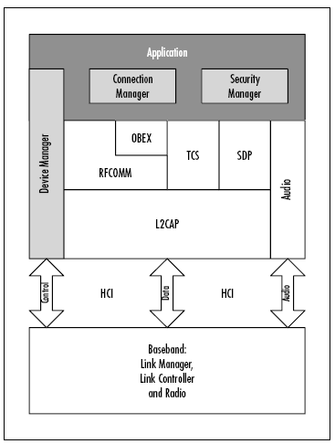
Figure3. the protocol stack of the Bluetooth

3.1 L2CAP
Logical Link Control and Adaptation Protocol multiplexes upper layer data onto the single (ACL) connection between two devices .In the case of a master device, it directs data to the appropriate slave.It also segments and reassembles the data to fit into the maximum HCI payload[1].
3.2 RFCOMM
RFCOMM (Radio Frequency [RF]-oriented emulation of the serial COM ports on a PC) emulates full 9-pin RS232 serial communicationover an L2CAP channel. A master device must have separate RFCOMM sessions running for each slave requiring a serial port connection [1].
3.3 OBEX
The Object Exchange standard (OBEX) was developed by the Infrared Data
Association (IrDA) to facilitate operations common to IR-enabled devices like
personal digital assistants (PDAs) and laptops. OBEX allows users to put and get data objects, create and delete folders and objects, and specify the working directory at the remote end of the link[1].
3.4 PPP
The Point-to-Point Protocol (PPP) is the existing method used when transferring Transmission Control Protocol/Internet Protocol (TCP/IP) data over modem connections. The Bluetooth specification reuses this protocol in the local area network (LAN) Access Profile to route network data over an RFCOMM port.Work is already underway on a TCP/IP layer that will sit directly above L2CAP, bypassing and removing the overhead of PPP and RFCOMM[1].
3.5 TCS Binary
Telephony Control Protocol Specification Binary (TCS Binary, also called TCSBIN), is based on the International Telecommunication Union-Telecommunication Standardization Sector (ITU-T) Q.931 standard for telephony call control. It includes a range of signaling commands from group management to incoming call notification, as well as audio connection establishment and termination. It is used in both the Cordless Telephony and Intercom profiles[1].
3.6 SDP
The Service Discovery Protocol addresses a specific requirement of Bluetooth operation: finding out what services are available on a connected device. The SDP layer acts like a service database. The local application is responsible for registering available services on the database and keeping records up to date. Remote devices may then query the database to find out what services are available and how to connect to them[1].

3.7 Management Entities
Device, Security, and Connection Managers are not protocol layers so much as function blocks. The Device Manager handles the lower level operation of the Bluetooth device. The Connection Manager is responsible for coordinating the requirements of different applications using Bluetooth channels and sometimes automating common procedures. The Security Manager checks that users of the
Bluetooth services have sufficient security privileges[1].

3.8 HCI
The Host Controller Interface is a transport and communications protocol that aids interoperability between different manufacturers’ solutions. It is not mandatory to use the HCI interfaces defined in the specification (Universal Serial Bus [USB]; RS232; or a simple Universal Asynchronous Receive Transmit [UART]), or indeed any HCI transport at all, if there are better solutions for the application [1].

3.9 Lower Layers
The lower layers (Radio Baseband, Link Controller, and Link Manager) compose the over-air transmissions, handle error detection and re-transmission, and manage the links between devices [1].
.

Table5. The profiles with the corresponding layers.
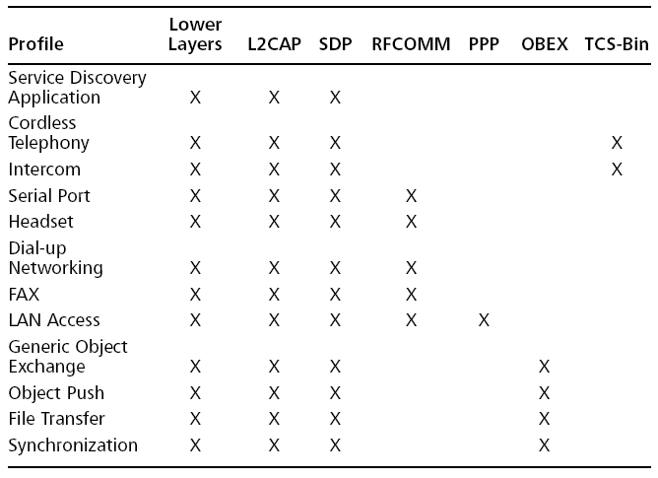

- Applications
Application Mix Profile like web browsing (HTTP 1.0 and 1.1), file transfer, e-mail
upload/download, voice and video over IP, and custom applications like:
• Application Instance Activation (interrarival PDF)
• Application Transaction Characteristics (interarrival and size PDFs) [4].

CONCLUSION
Bluetooth today iis used widly . PDA, PC and laptops are avoiding the data synchronization because of Bluetooth .Sending an e-mail, identifying to the Mic ,printer etc all are managed using Bluetooth. Bluetooth is the current technology that is widely spreading.

References
- David Kammer, "Bluetooth Application Developers Guide"

- JELENA,"Performance Modeling and Analysis of Bluetooth Networks Polling, Scheduling, and Traffic Control".
- Christian Ghermann "Bluetooth.Security.2004"
- Suitetooth. PDF from the internet.

