King Fahd University of Petroleum & Minerals
Electrical Engineering Department
EE418: Satellite Communications (121)
Satellite Antennas
In Class Practice
Name:

After two lectures, I can speak the antenna engineering language! Can you?

Define the Following Terms

- Radiation efficiency
- Antenna Directivity
- Aperture efficiency

What is the difference between gain and directivity?

What is the difference between dBi abd dBd?

What is the difference between power density and received power?

Find the 3dB Beamwidth, identify the nulls and the sidelobes.
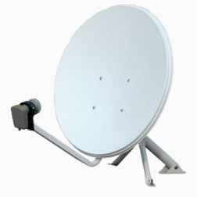
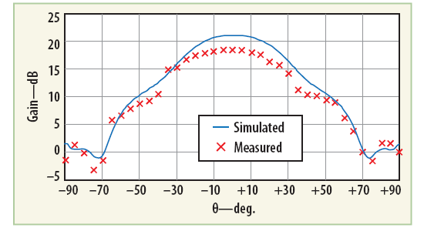
What type of antenna is this ? give all valid descriptions!

For an antenna working at 5GHz, how much is the distance to be in the far field?

_____________________________________________________________________
Good Luck, Dr. Ali Muqaibel

