King Fahd University of Petroleum & Minerals
Serial #0

- 1 points for not writing your serial number

Electrical Engineering Department
EE315: Probabilistic Methods in Electrical Engineering (112)
Quiz 4: Operation on One Random Variable- Expectation
Name: Key (Solution)

A random variable X has the density

$$f_{X}\left(x\right)=\left\{\begin{matrix}\left(\frac{3}{32}\right)(-x^{2}+8x-12) & 2≤x≤6 \\ 0 & elsewhere\end{matrix}\right.$$

Find the following moments:

- $m_{0}$

- Mean

- & d) If the second moment $m_{2}=16.8,$find the variance=$μ_{2}$?

In general

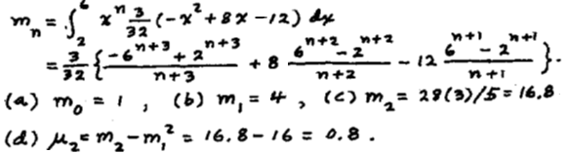

Good Luck, Dr. Ali Muqaibel

