Introduction to Discrete-Time Signals and Systems

Analog to Digital Conversion (Sampling)

The material to be covered in this lecture is as follows:

* Introduction to discrete-time signals and systems
* Analog to Digital Conversion
  + Sampling (Ideal and Non-ideal)
  + Quantization
  + Encoding

After finishing this lecture you should be able to:

* Distinguish discrete from continuous signals
* Perform the steps required for analog to digital conversion
  + Find the proper sampling instants and the associated sampled values
  + Perform quantization and estimate its effects on the signal quality
  + Convert the quantized values into code words
* Sketch the spectrum of the sampled signal using ideal and non-ideal sampling

Introduction to Discrete-Time Signals and Systems

* Signals in life can be analog or digital.
* Nowadays, with the advances in digital systems and personal computers one can do advance processing for digital signals. This includes: compression, encryption, error-control coding….
* There are many other advantages for digital systems.
* To be able to process an analog signal in the same way it has to be converted to a digital form.
* For the conversion to be accomplished there are three main steps
  + Sampling
  + Quantization
  + Encoding
* The analog signal is converted into discrete-time signal by means of sampling
* Discrete-time signals are defined by specifying the value of the signal only at discrete times (sampling instants)

Analog to Digital Conversion

The stages for analog to digital conversion may be summarized in the following figure

Sampler

Quantizer

Encoder

*discrete time*

*continuous amp.*

***Digital*** *output signal*

*discrete time*

*discrete amp.*

***Analog*** *input signal*

*continuous time*

*continuous amp.*

The emphasis on the remaining part will be on discrete-time signals which are signals after the sampler. We will assume that the error introduced by the quantizer to be relatively ignorable.

Example 37.1

Given the signal



which is sampled at the rate of (150 samples per second).Each sample is quantized to the closest integer between 0 and 15. Each of the integer values is encoded using a 4 bit code word according to the usual binary representation of integers (i.e. 0=0000,1=0001, ........, 15=1111)

Determine the sampled value, the quantized value and the binary code for the first three samples starting at t=0.

Answer

Sampling frequency,  = 150 Hz.

Sampling Interval, ms.

Sampling instants, 

= 0, 6.67,13.33 ms

The quantized values can be found by substituting .

The quantized values are found by first rounding to the closest integer between 0 and 15 and then represent the answer in binary form. The table summarizes the results.

|  |  |  |  |  |
| --- | --- | --- | --- | --- |
| ***n*** | **Time (ms)** | **Sampled value** | **Quantized value** | **Binary Code** |
| 0 | 0 | 16 | 15 | 1111 |
| 1 | 6.67 | 11.23 | 11 | 1011 |
| 2 | 13.33 | 6.76 | 7 | 0111 |

**Sampling**

* The sampled signal, *xs*(*t*) can be generated by applying a switch to the input signal *x*(*t*) as shown in the figure:

*x*(*t*)  *xs*(*t*)

The switch closes at the sampling instances.

* Ideally, the switch when it is closed it will pass the input signal to the output and when it is opened nothing will pass to the output.
* Mathematically, this is like multiplying the input signal by another periodic signal, *p*(*t*) which can take only two values 0 or 1.

The signal *p*(*t*) is represented in the figure

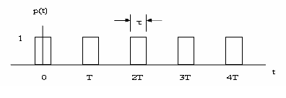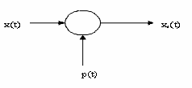

**×**

where ,and *τ* is the sampling duration which is theoretically zero.

 (1)

* Since *p*(*t*) is periodic it can be represented by it exponential Fourier series

 (2)

where  (3)

*fS* is the sampling frequency or the frequency of the periodic signal of *p*(*t*)



by substituting (2) into (1)

 (4)

Now, by substituting (3) into (4) with interchanging the order of summation and integration, the result can be put in the following form

**Spectrum of Sampled Signal**

**We can define the Fourier transform of *xs*(*t*) as,**



with interchanging summation & integration



**Hence, the Fourier transform of the sampled signal, *xs*(*t*) is,**





**Spectrum of the sampled signal**

The spectrum of the sampled continuous times-signal *f*(*t*) is composed of the spectrum of *f*(*t*) plus the spectrum of *f*(*t*) translated to each harmonic of the sampling frequency.

*F* (*ω*)

0

*ω* h

- *ω* h

*ω*

**…**

**…**

*Fs*(*ω*)

C0

C1

C2

C-1

C-2

*ω*h

- *ω* h

*ω*s

2*ω*s

- *ω* s

-2 *ω* s

*f*

*ω*s-*ω*h

***Note that****: $F(ω)=0 for ω ω_{h}$*  and $ωs 2ωh$

* From the spectrum of the sampled signal we can clearly see that the original continuous signal can be completely reconstructed by using a low pass filter. Note that constant scaling factor C0 can be easily accounted for using an amplifier with gain equal to 1/C0
* Now we are ready to state the sampling theorem.

Sampling Theorem

A bandlimited signal *f*(*t*), having no frequency components above *fh* Hertz is completely specified by samples that are taken at a uniform rate greater then 2 *fh* Hertz.

(the time between samples is no more than 1/(2*fh*) seconds).

2*fh* is known as Nyquist rate.

*Visit the website by John Hopkins University or at least provide link*

<http://www.jhu.edu/~signals/sampling/index.html>

Ideal Sampling: Impulse-Train Sampling Model

Consider *p*(*t*) is composed of an infinite train of impulse functions of period *T*. Thus,

$$δ_{T}\left(t\right)=\sum_{n=-∞}^{+∞}{δ\left(t-nT_{s}\right)}$$

which is the sampling function illustrated in the figure below:

Ideal sampler



*t*

*f*(*t*)



*t*



Continue.. Impulse-Train Sampling Model

The values of *Cn*, yields



Evaluated at *t*=0 (sifting property), Thus



*Cn = fs* for all *n*

Hence, the spectrum of *x*(*t*) yields,



Ideal Sampling: Impulse-Train Sampling Model

*F* (*ω*)

0

ωh

-ωh

*ω*

*M*

**…**

**…**

*F*s(*ω*)

ωh

-ωh

ωs

2ωs

-ωs

-2ωs

*ω*

ωs-ωh



More Examples will be given in the coming lecture when we consider signal reconstructionSelf Test:

The figure below shows Fourier spectrum of a signal *g*(*t*)

0

2π×105

*G*(*ω*)

*ω*

2

1. Determine the Nyquist interval and the sampling rate for *g*(*t*)
2. Sketch the spectrum of the sampled signal, if *g*(*t*) is sampled (using uniformly spaced impulses) at **1.5* Nyquist rate.**

**Solution**

Nyquist Interval =5 micro seconds

Nyquist rate = 200kHz

1.5*Nyquist rate=300 *k*Hz

0

2π×105

*G*(*ω*)

*ω*

**400 *k***

6π×105

12π×105

-6π×105

# Aliasing …. Illustrated in sampling

*Aliasing* is a phenomenon, wherein an erroneous signal is recovered from sample data because the sampling frequency was too low.

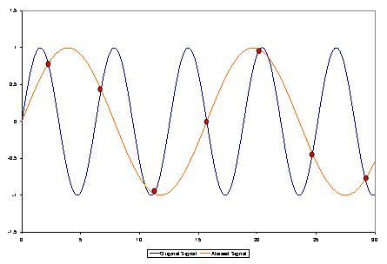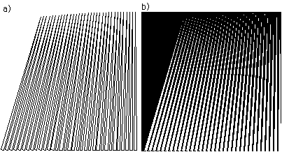

[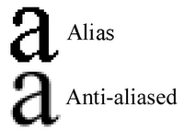](http://2.bp.blogspot.com/_ONp8HQSYM80/TKWyi1IHgnI/AAAAAAAAAt0/fir_z-ul5mc/s1600/antialias.gif)