Serial #
……

-1 point for not writing your serial #

King Fahd University of Petroleum & Minerals
Electrical Engineering Department
EE207: Signals & Systems (121)
Quiz 6: Laplace Transform
Dr. Ali Hussein Muqaibel
Name:
Tables are attached

Find the Laplace transform of $u\left(t-2\right)u(5-t)$

$$L\left[f\left(t-t_{0}\right)u\left(t-t_{0}\right)\right]=e^{-t_{0}s}F(s)$$
- $u\left(t-2\right)u\left(5-t\right)=u\left(t-2\right)-u(t-5)$
$note that u\left(t-2\right)=u\left(t-2\right)u(t-2)$ for which we can find the Laplace transform
$$recall that L\left[u(t)\right]=\frac{1}{s}$$
$$L[u\left(t-2\right)u\left(5-t\right)]=\frac{e^{-2s}}{s}-\frac{e^{-5s}}{s}$$

Find the Laplace transform of $3e^{-at}u(t-a)$

- $3e^{-at}u\left(t-a\right)=3e^{-a^{2}}e^{-a(t-a)}u\left(t-a\right)$
$$L[3e^{-at}u\left(t-a\right)]=3e^{-a^{2}}\frac{e^{-as}}{s+a}$$

Find the inverse Laplace transform of $Y\left(s\right)=\frac{10}{s^{2}+10s+16}$

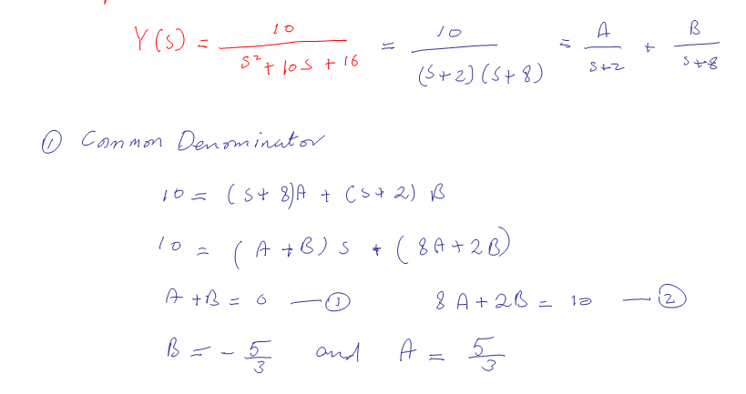 Method 3 is the preferred method!

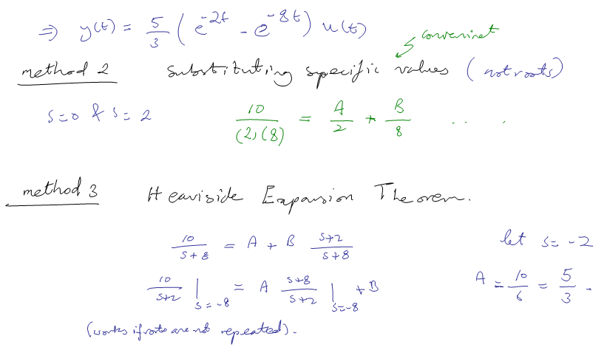

The first two parts are HW problems!
Good luck, Dr. Ali Muqaibel

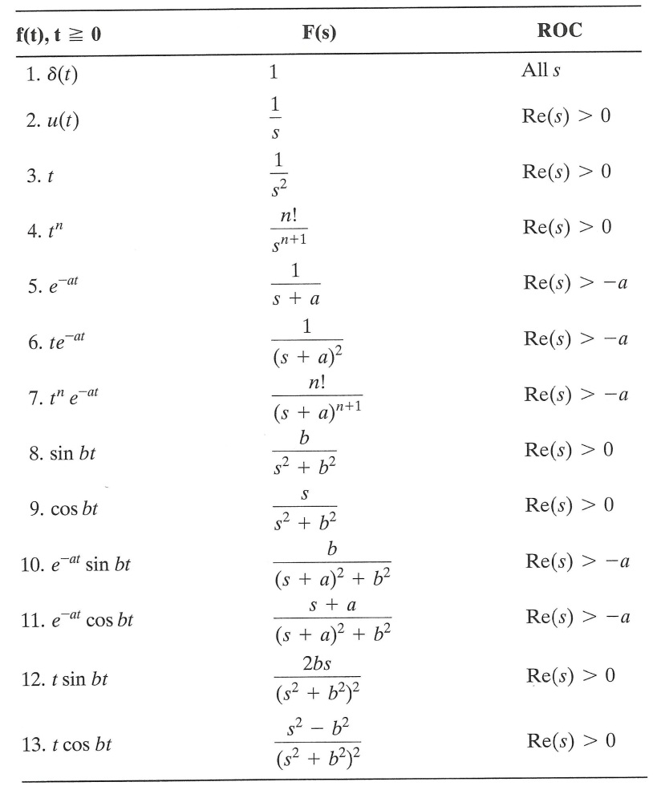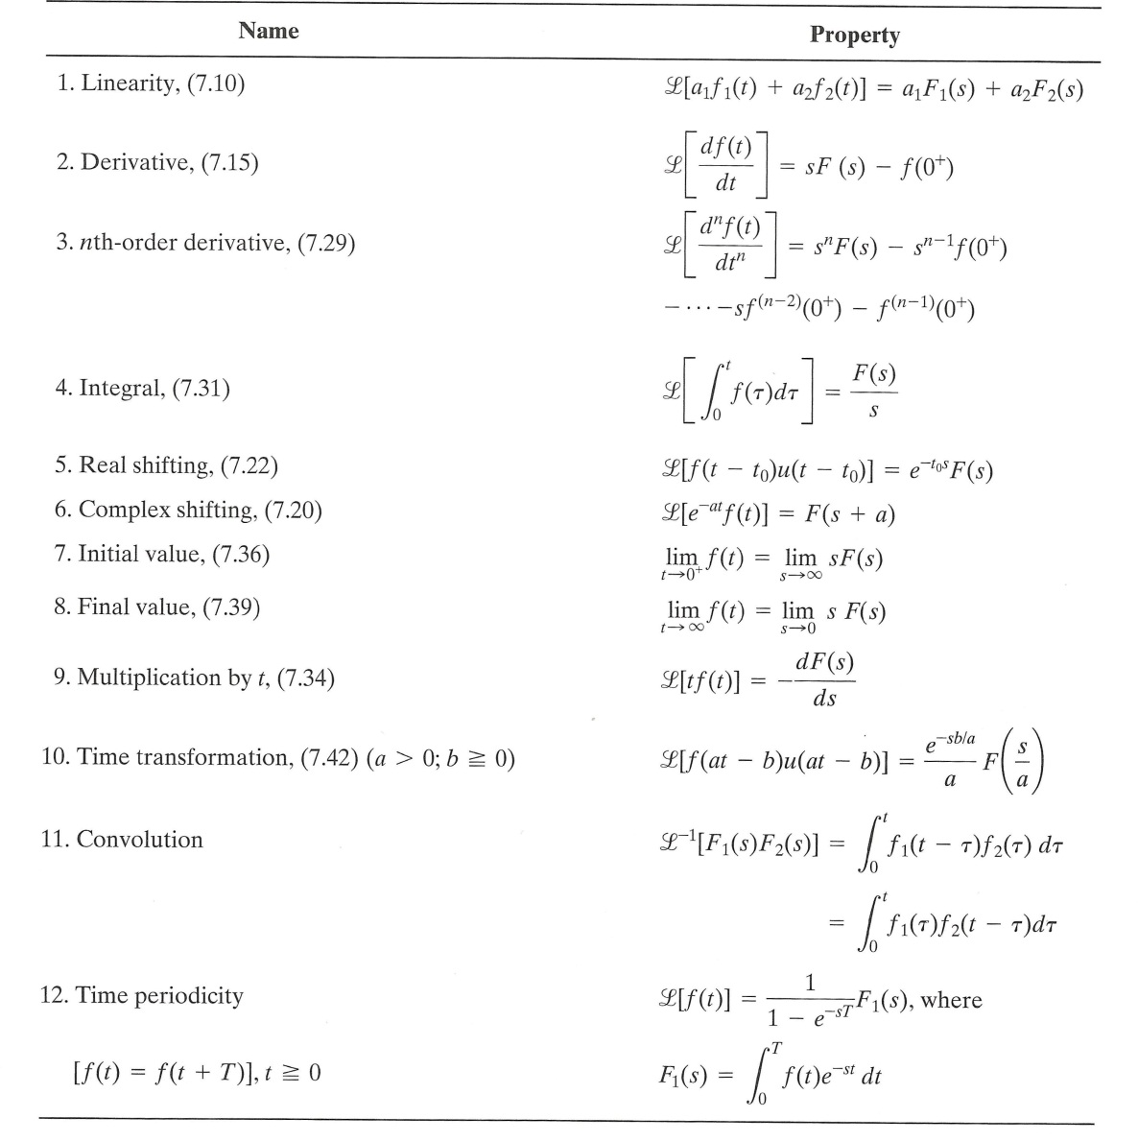
_____________________________________________________________________
Good Luck, Dr. Ali Muqaibel

