Serial #
……

-1 points for not writing your serial #
King Fahd University of Petroleum & Minerals
Electrical Engineering Department
EE207: Signals & Systems (122)
Quiz 4: Fourier Series
Dr. Ali Hussein Muqaibel
Name: Key Ver.2

Find the exponential Fourier series for the signal shown in the figure
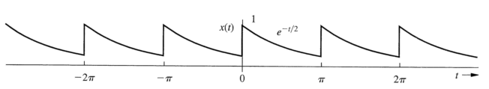
In this case $T_{0}=π, ω_{0}=\frac{2π}{T_{0}}=2$ and
$$x\left(t\right)=\sum_{-∞}^{+∞}{D_{n}e^{j2nt}}$$
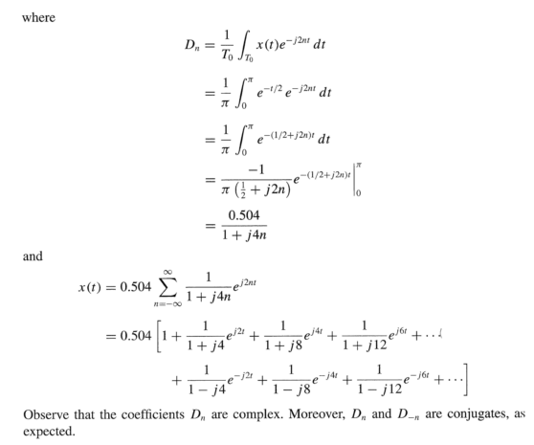
Find and plot the double sided magnitude and phase spectral $-7<ω<+7$ rad/sec
We are showing extra components up to 10 rad/sec $\left|D_{n}\right|=\frac{0.504}{\sqrt{1+16n^{2}}}$ ,phase $=-\tan^{-1}{4n}$
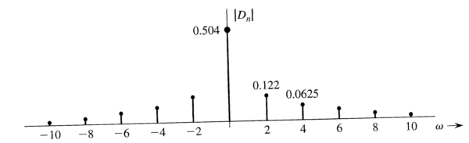
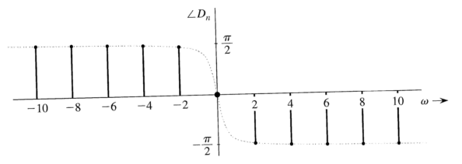
Good luck, Dr. Ali Muqaibel

