KING FAHD UNIVERSITY OF PETROLEUM AND MINERALS
University Diploma Programs
PHYS 012: Solid State Physics
Hussein Tawfiq Magharbi (Office: 14/214, Tel: 4010)
E-mail: huseintm@kfupm.edu.sa
Lab Experiment # 08
Transistor Applications – BJT Switch Transistor

NAME: ___________________________________________ ID: ___________________
==================================================================

- You are given two transistors. Identify the collector, base and emitter leads of each transistor. (The instructor will pass by to check your findings and mark your answer on this sheet.)

Instructors comments | Result (yes/no)
Student was able to identify leads.
2. Assemble the underneath switch transistor circuit. Use red LED. Use the following components: R_{C} = 1 KΩ, R_{B} = 10 KΩ, V_{CC} = 10 V, V_{in} = 5.7 V peak-to-peak. Measure V_{CE}, when transistor is "ON" and "OFF". Give your comments and state your observations.
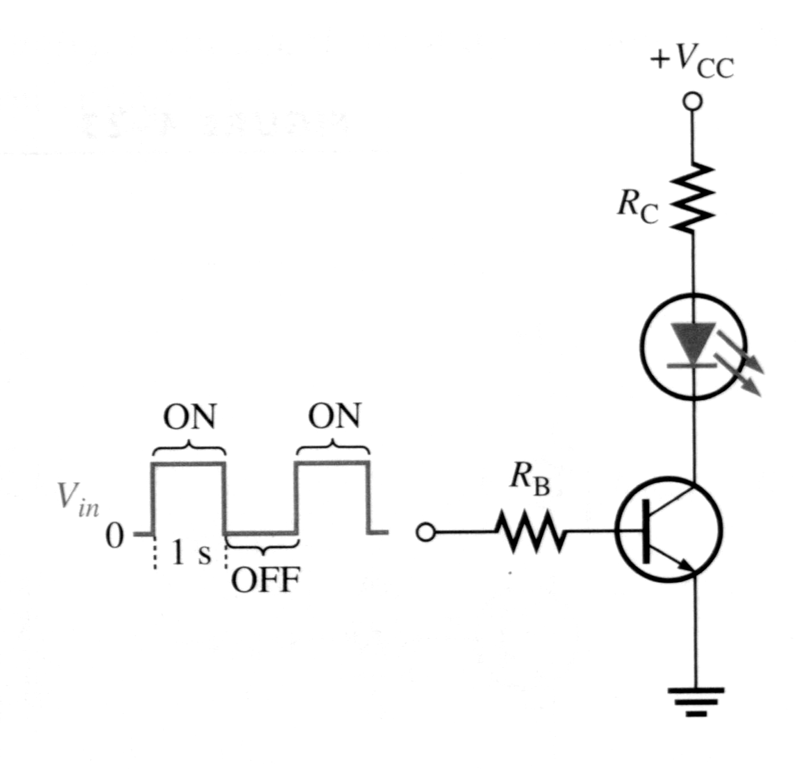
SWITCH TRANSISTOR CIRUIT
(All measurements, calculations and sketches are to be recorded directly beneath questions or attached. Fill your name and ID and return to instructor on next lab.)
Thursday, October 31, 2002.

