- Match the bullets
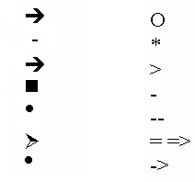
- The Number and bullets are the part of paragraph format (True/False)
- The word does not pick previously used bullet character automatically (True/False)
- You can choose graphic images as a bullet in your document. (True/False)
- You can even restart paragraph at a specified number. (True/False)
- You can not select any character as a bullet. (True/False)
- Explain lead-in?
Answer
- What will happen above the paragraph if you do the following:
  - Type 3 hyphen and press ENTER will become ______________________
  - Type 3 asterisk and press ENTER will become ______________________
  - Type 3 Tildes (~) and press ENTER will become ____________________
  - Type *solar system* and press SPACE will become _________________
  - Type _solar system_ and press SPACE will become _________________

