SECTION 1 Introduction

In a fast evolving educational environment, both domestically and internationally, coupled with fundamental changes in the Saudi Arabian demographic and economic structure, KFUPM needs to address the critical issues of a long term strategic plan that tries to answer some key questions, such as:

- What is KFUPM’s current role and future evolution?
- Can it still play the same role in the face of forecasted student entry numbers in higher education, as well as Government budgetary constraints?
- Can KFUPM continue to distinguish itself from other local and regional Universities by adopting a more specialized and focused approach in the science and engineering fields, that is more research and industry driven?
- In order to meet its future funding requirements, so as to allow for more operational freedom, what financial and budgetary emphasis will KFUPM adopt in obtaining non-Governmental funding?

These are some of the core questions to be tackled. Foremost though, is establishing a formal VISION and MISSION statement for KFUPM because without these, we will not be in a position to ascertain what is the basic purpose of KFUPM and our guiding principle for behavior.

Simply defined, a VISION is the reason for the University’s existence and the ideal state that KFUPM aspires to, unlike the MISSION statement, which identifies the major goals and performance objectives. While the Strategic Planning exercise is looking at a 20 year time frame, it must be clearly understood that any meaningful plan must take account of unforeseen events that will necessitate adaptation of the goals and objectives without compromising on the basic vision. If that vision changes, all the dependent variables will have to change.

KFUPM is not alone in carrying out such strategic plans and leading universities worldwide and regionally have carried out similar medium and long-term exercises to position themselves in a competitive environment. Regionally, such plans have been carried out by the Universities at Al-Ain in the UAE, Sultan Qaboos University in Oman, and the American Universities of Cairo, Beirut and Sharjah. The newly established private universities in Bahrain have carried out detailed market studies and student profiling to ensure that they provide what the student market needs.

Internationally, all major Universities have carried out strategic plans that encompassed the quality and direction of research and teaching as well as community services. The time spans vary from short to medium term (MIT, Rice) to longer time (Duke, West Virginia, Eastern Michigan). All such plans tried to formulate clear mission and vision statements and internal mechanisms for evaluation of performance.
The following brief synopsis captures the main thrust of some of these other Universities’ Long and medium term Strategic Planning philosophies. All the various plans examined established clear mission and vision statements that reinforce the particular strength of the concerned University and tried to set it apart from Academic competitors. The approaches differed though, some were bottoms-up driven, some were top-down driven, and some used an interesting approach called “foresight approach” by focusing on the long term future and providing a conceptual framework for desirable paths to an improved future and identifies the core competencies necessary to reach this goal. Rice University built its plan around its perceived strengths of size, leanness/efficiency, past history and agility to move with the times. It put great store on expanding and strengthening Rice activities beyond the “hedges” i.e. traditional teaching, to enhance the quality of a “Rice” education. Duke decided to invest strategically and where and how to invest in excellence in areas in which it has greatest potential while retaining leadership in some areas. Rensselaer continues to adhere to its founding mission “to apply science to the common purposes of life’, to be a catalyst of change for basic scientific research in unexplored territories. It firmly sets itself as a technological research University.

It does this through inter-disciplinary inquiry, interactive learning and technological entrepreneurship. Eastern Michigan University tries to build upon its strong undergraduate programs, with global and multicultural perspectives. Wider community participation is a key strategic priority for this University. West Virginia University opts for student centered, holistic education and a strong partnership with local industry and technology application as its main focus. MIT built its plan “bottoms up” via Departmental Strategic Planning that clearly identified each Department’s objectives, action plans and measures of success and benchmarking. Each goal had a rationale. The same approach was adopted by Bendigo, where the overall emphasis was on promotion of a high standard of teaching and learning as well as staff development.”

To this end, the Strategic Planning Committee will carry out a process that entails an internal and external environmental scan that embodies a SWOT analysis as well as a GAP analysis, by evaluating the differences between the current KFUPM position and desired future positioning against set targets and objectives. This will include benchmarking of tasks.
- The Strategic Planning team brings to bear various Faculty members with diverse Academic specializations, background and skills ,as well as relevant regional and international Consultancy and strategic planning experiences. This will materially assist in the Strategic Planning approach adopted ,resulting in a viable Strategic Plan that will be visionary but realistic, achievable yet flexible, cost effective but value added.

- The Strategic Planning team will be assigned specific tasks within sub groups, that matches their interests and specializations to achieve optimum results. In order to fairly represent and "shadow" as many KFUPM Faculty viewpoints and interests as possible , the overall Committee members will share their input into other areas, as the aim of the exercise is to ensure acceptability of the whole plan by all KFUPM community to enable wider acceptance and convert the Strategic Plan from being an Academic exercise into a live working document for the coming years.

- Wherever possible, the plan will set out quantifiable objectives, which will be measurable. These will be a “bottoms up exercise” that is in harmony with the “tops down” vision and mission statement of the University as formulated by the University Administration in light of internal and external constraints and opportunities.

- The Strategic Plan will address these tasks by setting out College and Departmental objectives, their specific action plans, and benchmark measures to review progress and implementation. Rationale will be given for each set of objectives that are addressed and why current areas are retained if they meet the long-term strategic objectives of the University. The tasks will cover teaching, research, and community services separately.

Figure 1 shows encapsulate the various forces that are changing the direction of Higher Education worldwide, as well as the internal and external pressures[REF World BANK] The pressure and challenges are not unique to Saudi Arabia. Many leading universities have had to incorporate these forces into their strategic plans depending on the stage of their development, and whether private or public sectors.
Despite the fact the KFUPM find itself in the public sector, yet over the next two decades it will also face similar qualitative, partnership, competitive funding and institutional autonomy pressure as illustrated by the fig. These issue will be brought out in the strategic plan.
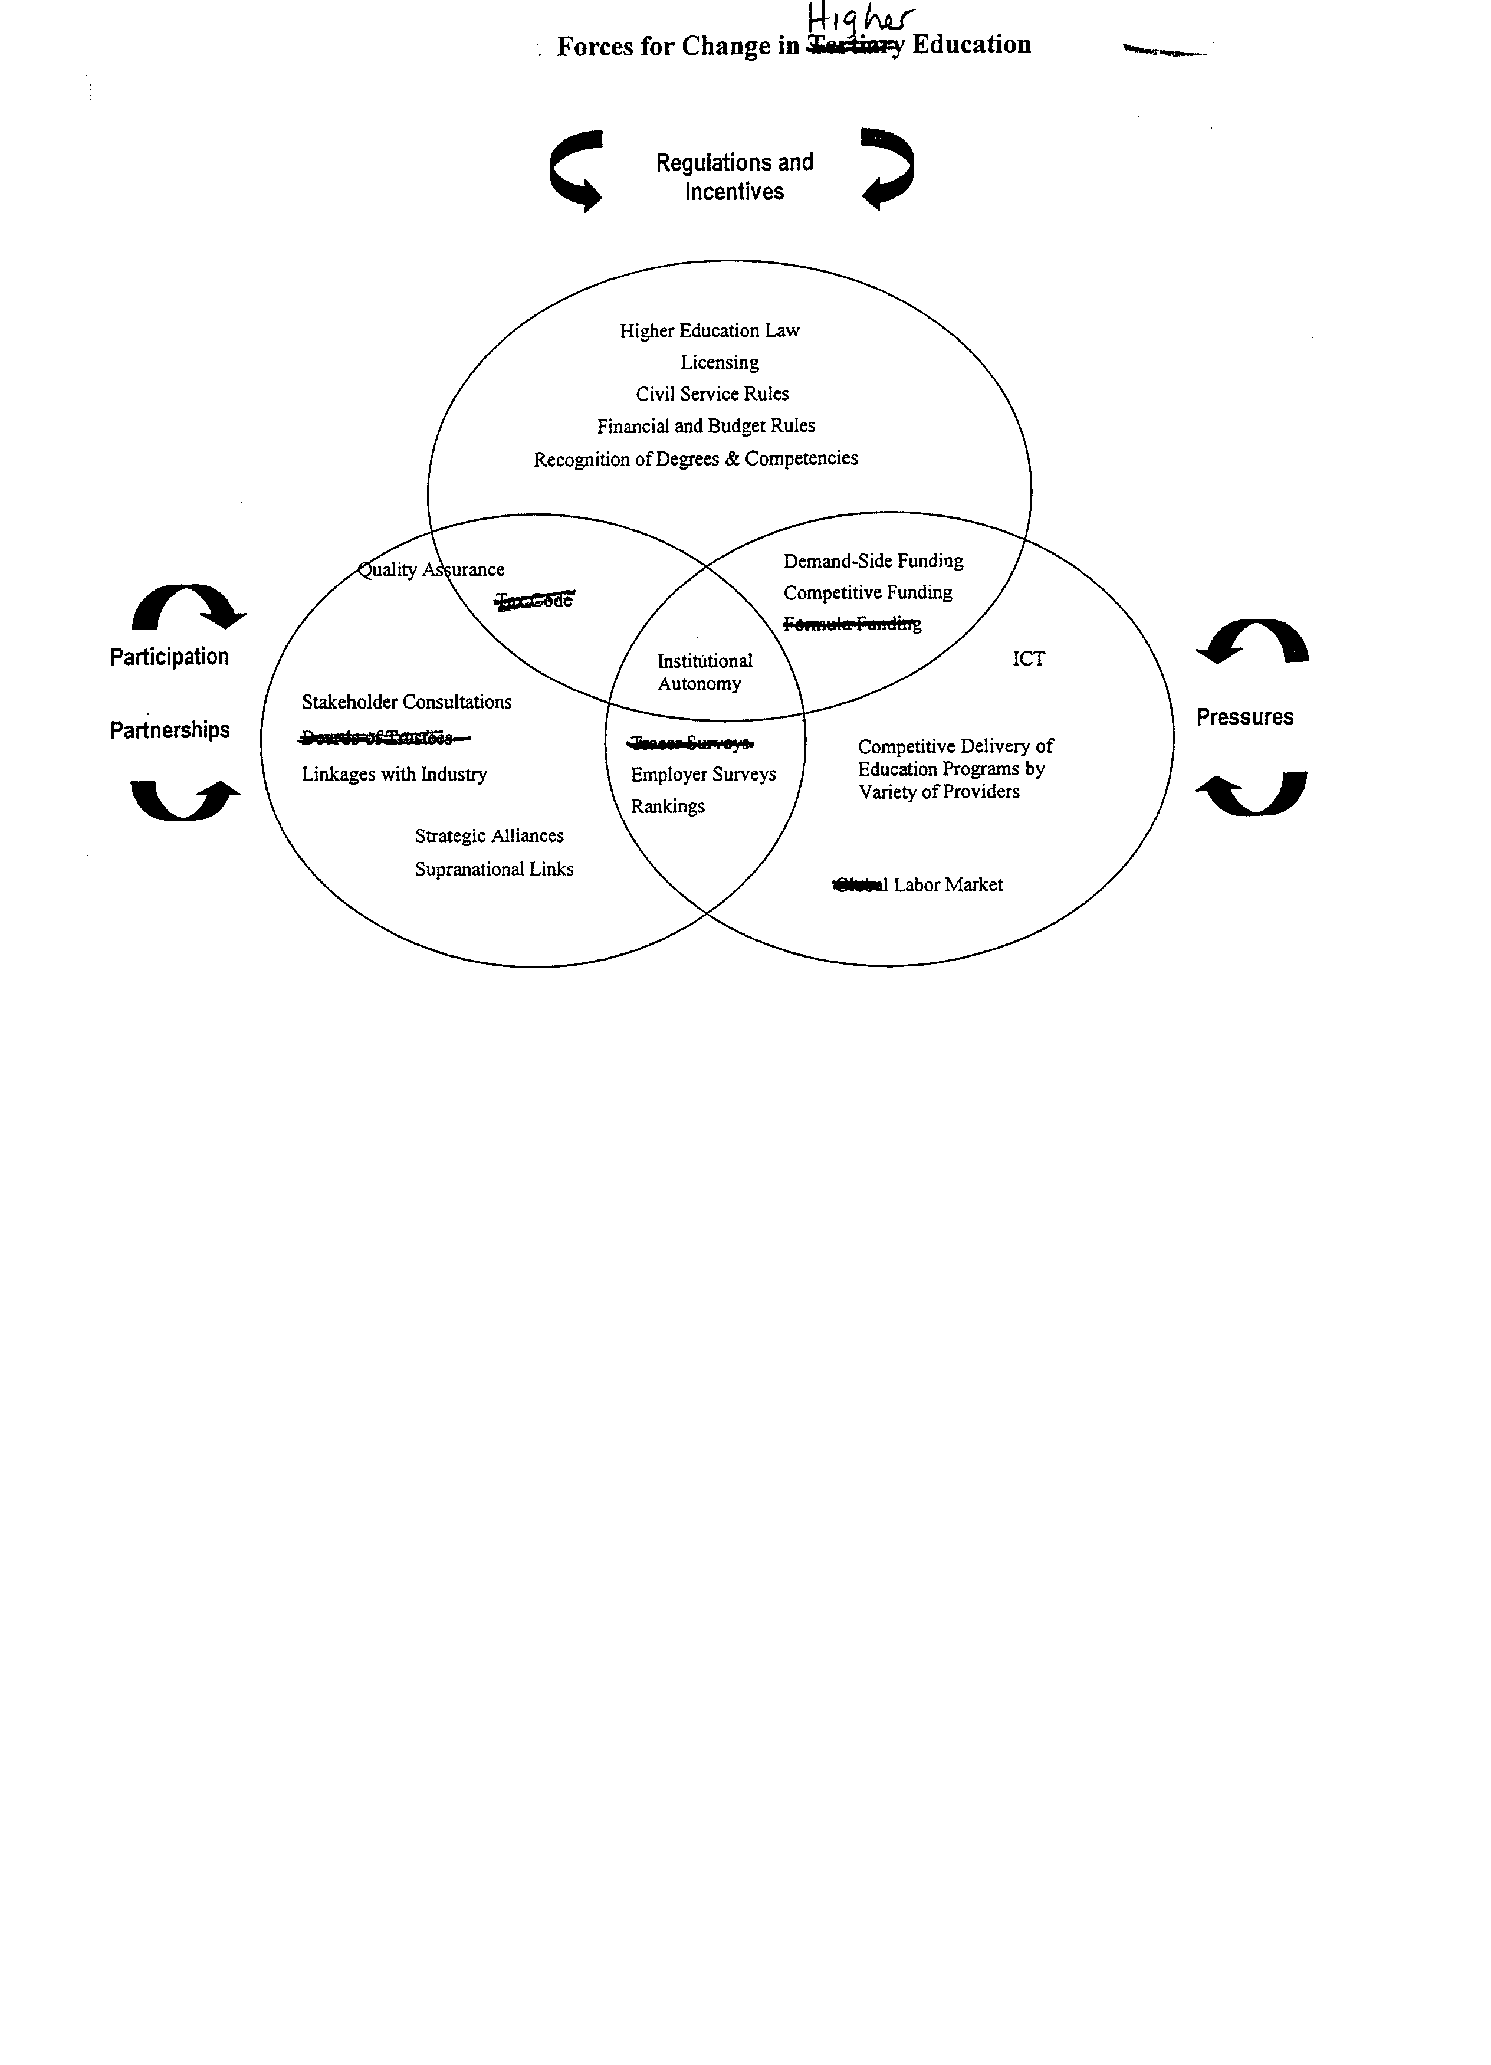

One of the critical elements in the exercise of the environmental scan, encompasses social, demographic, economic, political and technological factors, as well as international input. These issues will be addressed in the Strategic Planning, as they will have a direct bearing on the future vision of the University. For example,

- Demographic Issues: Saudi Arabia has one of the world’s highest population growth rates, averaging at between 3.2 and 3.4% per annum. Nearly 70% of the population are under the age of 29 years. The number of school entrants is increasing every year at secondary school level as well as at intermediate level. For the year 2001, there were 142,000 male bachelor level students at all Saudi universities and 30,000 new entrants. Total Master and Ph.D’s were 4,000 existing and 1,200 new entrants. The total number of students at secondary education were 390,000 and 582,000 in intermediate level and 1,190,000 at elementary stage respectively. The current University system cannot meet all aspirants to higher education. The figures above are for males only. Of the University graduates, 20% are in the science stream.

- Political: The Ministry of Higher Education enrollment plans for KFUPM for the coming years is uncertain. They could, and will be changed to accommodate social and political pressures of growing student numbers. As such, will the research-orientation of KFUPM suffer at the expense of teaching or both at the same time? The pressure of globalization, the need to diversify the Saudi economy, the competitive edge for WTO will also require that Saudi education be more market- and science-oriented. This will put pressure on science centered Universities.

- Funding: KFUPM funding has been stable over the past few years despite increasing Student enrollment. For example, the Government allocation was SR 460 million in 2000, SR 546 million in 2001, SR 540 million in 2002 and SR 560 million in the year 2003. In real terms, however, there has been negligible increases, and in fact, a decrease in funding taking into account inflation, fixed and increasing overheads and salaries. External funding is likely to play a vital role in the Strategic Planning discussion.

- Location: The location of KFUPM should be leveraged – it is the only major Saudi science-based University that is located in the hub of the key oil/petrochemical/ industrial complex of Saudi Arabia, and this gives it a comparative advantage over others in the Kingdom in terms of student placements, industrial-University linkages, short term exchange placements between faculty and industrial experts and businessmen, so as to provide a wider world perspective to our students and curriculum.

- Competition: Our Strategic Planning must factor the emergence of private higher educational institutions both within Saudi Arabia and in the nearby countries, especially in Bahrain and in the UAE. These will attract the higher fee paying students who are promised quality education. Any lowering of teaching standards at KFUPM, through larger student numbers without concomitant increases in teaching quality, will create a vicious cycle of attracting poorer quality students to KFUPM, poor graduates, less demand from industry and so on.

- Business/Employers Perceptions: This is a key ingredient in the Strategic Planning and an appropriate benchmarking for deliverables. Is KFUPM really the best in its field? Through objective input from past and prospective employers about the quality of our students, and more importantly the content and emphasis on courses followed and which industry wishes KFUPM to follow, the University will be in a more flexible position to achieve its vision and mission statements. This will confirm or dispel on whether this perception is faculty or industry drive.

SECTION 2 Study Objectives

- The objective of the Strategic Planning submission team will be to produce within the specified time frame of (XXXX) , a medium to long term Strategic Plan for KFUPM that embodies ,at the same time , necessary flexibilities for unforeseen events and allows for alternate strategies to be adopted.

SECTION 3 DISCUSSION OF THE PROBLEM

3.1 DESCRIPTION OF THE PROBLEM
- (KFUPM) establishment and its growth over its 40 years of age:
- Current status of KFUPM ant its graduates.
- Need for the development of Strategic plans and the changes in higher education philosophies.
- . Universities are engaged in strategic planning by a variety of reasons: increasing demand for higher education, decline in government funding and financial support, and the need to compete with emerging new forms of higher education.
- In this regard, it is time for KFUPM to re-examine and re-evaluate its position and potential. It must develop and pursue a new vision and mission which are consistent with its goals and aspirations to make it better place for learning, creative thinking and advancing knowledge.
- KFUPM embrace three distinct areas namely, Teaching, Research and Public Service. In developing its strategic goals and plans, the University wishes to address all three issues collectively, weaving them together in a coherent manner.
- . The development of strategic plan involves:
- The determination of a set of objectives
- The gathering of relevant data
- The definition of obstacles and opportunities
- The evaluation of alternatives
- The formulation of the recommended actions
- The communication of the results to the concerned individuals.
- The determination of the determined actions
- The follow-up process to make sure that the action plans are implemented.
3.2 APPROACHES TO THE PROBLEM
The strategic Planning Committee (SPC), or study team, will attempt to develop a strategic for KFUM in a well coordinated manner. SPC will follow standard scientific approach for the development of strategic plans, especially those adopted by universities. SPC will take into consideration the local operating constraints and conditions and will carry out its duties in close coordination with KFUPM administration.
- The first step is to establish a well defined KFUPM mission statement. This will guide the development of the strategic plan. The SPC will then work to collect and build an informational data base. This data should the past five years, 1997-2002.
- SPC will review and analyze the collected data and any KFUPM statistical publications. SPC will then seek to define and identify the present strategy. The elements of the present strategy may relate to decisions about the student selection processes, the teaching and research methods being utilized, types of financial support that are being employed for different activities etc.
- Concurrently, SPC will carry out an assessment of the external environment and factors that affect the university’s operating strategies. These are social, economic, legal/political, ecological, competition, and technological factors. The analysis could involve review of the kingdom’s five-year plans, Ministry of Planning strategies, Ministry of Higher Education plans. The review could be done through meeting and questionnaires.
- Analysis of the operating environment of the competing colleges within and outside the region will have to be carried out through questionnaire, Internet and etc.
- The next phase will be devoted to the development of KFUPM strategic plan. The plan should provide identifiable benchmark institutions and benchmark measures and a structured design to successfully follow-up the strategies by identifying the resource requirements and the operational management.
- The SPC will carry out a process that entails a scan of the internal and external environments. This embodies a SWOT analysis as well as a GAP analysis, by evaluating the differences between the current KFUPM position and desired future positioning against set targets and objectives.
- The SPC will develop a procedure for communicating, implementing, monitoring and evaluating the developed plan.

SECTION 4 STATEMENT OF WORK
The SPC intends to carry out the plan development through a number of overlapping tasks.

4.1. Task I : Preparation of an Informational Database
- Establishment of database for KFUPM activities for the last five years.
- The information may be collected from different sources such as annual reports from the Rector’s office and other literature available from other offices on-campus. The data should cover the following: budget, physical plants, student’s intake, no. of graduating students, faculty and support staff and others. The data will be collected from various KFUPM departments through meeting or questionnaires.
- This task is expected to take XXX working months.
- The task is divided into three sub tasks one for each of KFUPM activities.
4.1.1 Instructional Database
Data regarding the instructional activities collected from Academic deans, Admission and Student affairs:
1. Admission philosophy, goals, objectives and requirements
2. Admission policies.
3. Accreditation: External and Self Assessment.
4. Student academic performance: Degree awards, length of study, attrition rate etc.
5. Student faculty ratio
6. Others
4.1.2 Research Database
Data regarding the Research activities collected RI and college of Graduate studies: 1. Research Institute Mission and Objectives.
2. Basic Research Mission and Objectives
2. Contract Research Procedures, duration, budgeting, clients, faculty role, support services
3. Basic Research: Procedures, duration, budgeting, etc.:
4.1.3 Public Services Database
1. Short courses and training programs: Procedures, budgets etc
2. Exhibitions, Local and international Symposia
3. Professional Societies
4. Students’ Activities and career day
5. Special functions
6. Others
7. University Internal support services ( Is this task part of our work? )

4.2 Task II : Identification of the Present Strategy
- SPC will then seek to define the present KFUPM strategy through meetings with university officials.
- The present strategy may relate to decisions about the student selection processes, the teaching and research methods being utilized, types of financial support that are being employed for different activities etc.
This task is expected to take XXX working months
4.2.1 Present Teaching Strategy
- Key elements may relate to decisions about the student selection processes, the teaching methods. others
- Faculty development and the role of ADC.

4.2.2 Present Research Strategy
- Definition of research methodologies and applications
- Review of current research practices
- Classifications of research practices
4.2.3 Present Services Strategy
- Definition of practices in public services
- Review of procedures in continuing education, exhibitions, etc.
- Classifications of projects and services.

4.3. Task III: Analysis of the University’s Internal Environment
4.3.1 Teaching Internal Environment
- Analyze the university internal environment in relation to teaching and instructional services
- Examine exiting programs and degrees offered by KFUPM.
- Assessment of the various functional areas, the managerial team, and the overall financial conditions.
- Assess and analyze how the University stands against other competitors regionally and internationally.

4..3.2 Research Internal Environment
- The analysis of the university internal environment in relation to both contract and basic research programs
- Examine exiting research programs and procedures
- Assessment of the various functional areas, the managerial teams for research projects.
- Assess and analyze how the university stands against other competitors regionally and internationally in research funding, procedure etc.

4.3. 3. Public Services Environment

- Analyze the university internal environment in relation to public services.
- Assessment of the various functional areas, the managerial teams and their performance in relation to services.
- Assess and analyze how the university stands against other competitors regionally and internationally.

- This task is expected to take XXX working months

4.4. Task IV: Analysis of the External Environment
- This task deals with the assessment of the external environment and factors that affect the university’s operating strategies.
- Factors to considered are social, economic, legal/political, ecological, competition, and technological factors.
- Review of the kingdom’s five-year plans, Manpower Commission, and Ministry of Higher Education plans, others. Review of Ministry of Planning data.
- The review could be done through meeting and questionnaires.
- Analysis of the operating environment of the competing colleges within and outside the region will have to be carried out through questionnaire, Internet and etc.
- This task is expected to take XXX working months and can be carried out concurrently with task III.

4.5. TASK V: Development of a New Strategic Plan
- The plan should provide identifiable benchmark institutions and measures and a structured design to successfully follow-up the strategies by
- Identifying the resource requirements and the operational management.
- A scan of the internal and external environments.
- Carry out SWOT analysis as well as a GAP analysis, by evaluating the differences between the current KFUPM position and desired future positioning against set targets and objectives.
- The work in this task shall take XXXX working months.

4.6. Implementation of the Plan
- The development of a procedure for communicating, implementing, monitoring and evaluating the developed plan.
- Meetings with KFUPM official and concerned department will be arranged.
- The committee will also set and provide procedure to monitor fro the implementation of the plan.
- This task is expected to take XXX working months

