Poster to publicize the B.Sc. Program
in Computer Engineering

What is Computer Engineering!

The Computer Engineering department provides programs that develop the necessary skills and competence in order to design, analyze and implement computer systems and networks. The computer engineering curriculum emphasizes the areas of digital system architecture and design, microprocessors, integrated circuit technology, communication theory and computer networks.
In addition, enough emphasis is given to the study of computer science to provide a coherent view of computer systems and an understanding of the interdependencies of hardware and software components and their interfaces and tradeoffs.

Are Computer Engineers needed for the job market in Saudi Arabia!
The Kingdom of Saudi Arabia has focused on computer and communication technology and its utilization as one of the fundamental tools to modernize its industry to cope up with emerging areas such as:
- Mobile Communication,
- GPU HPC Computing,
- Wireless Sensor Networks,
- Smart Card Technology,
- Data and Information Security, etc.
It is, therefore, mandatory to prepare highly qualified computer engineers who are capable of mastering the last advances in such a rapidly growing technology.

Programs Offered at the COE
The computer engineering department offers programs leading to BS degree in computer engineering, programs leading to MS degree in computer engineering, and a program leading to PHD degree in computer engineering.

What a computer engineer will doing at work!
The profession of Computer Engineering has a vital role to play in the ongoing effort to prepare Saudi Arabia for the challenges of the 21st century. Computers and communication needs of Saudi companies are growing at a rapid pace. Highly qualified and trained professionals are needed to design, manage and maintain such computer systems.
The mission of COE BS programs at KFUPM is to produce such professionals. Indeed, KFUPM Computer Engineers are already contributing to the development of the Kingdom and the Gulf region. They are employed by both national and multi-national companies across the area.

Is the BSC Program in the COE accredited!
The COE program is currently accredited by ABET (American Board for Engineering and Technology) for the period 2008-2014 and this effort will be pursued in the future.
​

New BSC in Computer Engineering

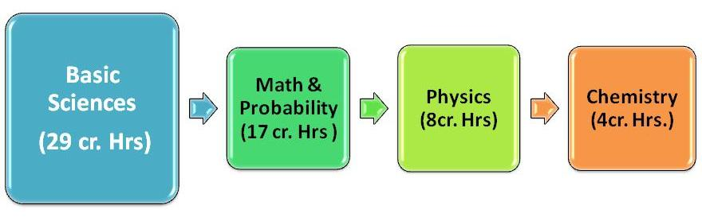

​
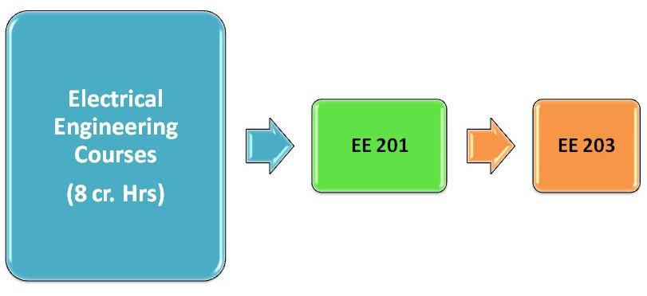

​
​

​
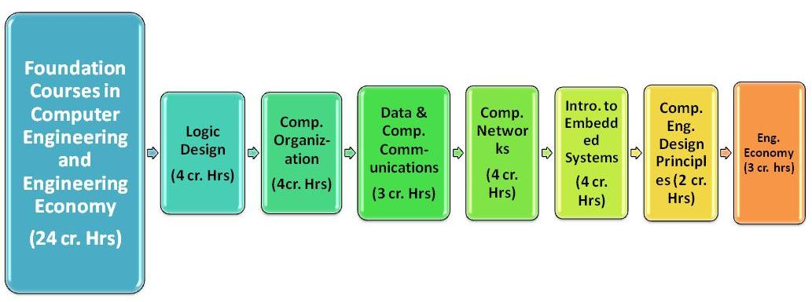

​
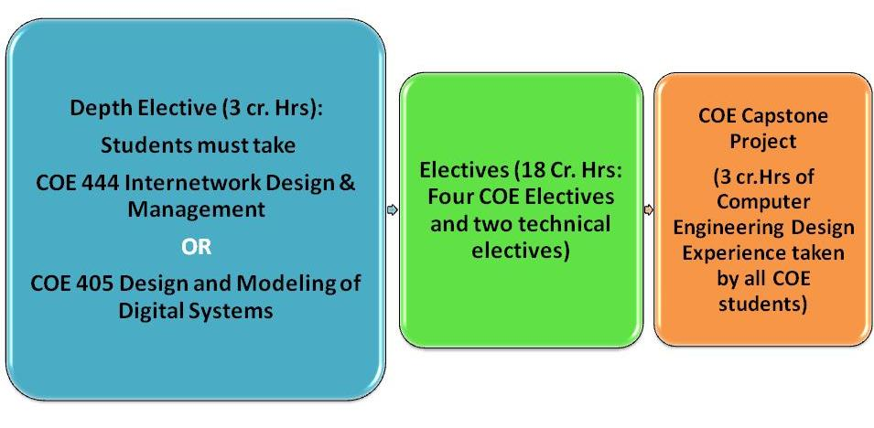

Degree Plan with Summer Training

Degree Plan with Co-op

Depth Electives

CNET Depth Elective (D.E.):  COE 444 Internetwork Design and Management | CSYS Depth Elective (D.E.):  COE 405 Design and Modeling of Digital Systems
Recommended Electives for the CNET Track:  COE 425 Data Management Systems  COE 441 Local Area Networks  COE 443 High Speed Networks  COE 445 Internet Engineering and Technologies  COE 446 Mobile Computing  COE 451 Computer and Network Security  COE 482 Pervasive and Ubiquitous Computing | Recommended Electives for the CSYS Track:  COE 403 Computer Architecture  COE 408 Reconfigurable Computing  COE 420 Parallel Computing  COE 421 Fault Tolerant Computing  COE 422 Real Time Systems  COE 461 Principles of VLSI Design
COE Electives: Any COE 4xx course.
Technical Electives (T.E.) List:
COE 4xx, ICS 353 (Algorithms), ICS 413 (introduction to SWE), SWE 378, Math…, MGT …, EE XXX, … The list of technical electives has been thoroughly revised. The complete new list of technical electives is in Appendix C.

