ENABLING TECHNOLOGIES FOR 4G NETWORKS

Prepared for

Dr. M. Ashraf
COE 543: Wireless Communication
Term Project

By
Al-Shahrani, Adel
ID# 986074

Abstract
This report covers several technologies about the Forth Generation Mobile Networks (4G). First, the needs for 4G are described. Then, the report discusses network technologies like Mobile IP and IDMP including differences network Architectures. Also, the physical layer technologies such as SDR, OFDM and M-ary MC-CDMA will be discussed in details.

May 20, 2003‏

TABLE OF CONTENTS

INTRODUCTION 1
- WHY 4G 2

- NETWORK LAYER TECNOLOGIES
  - 4G Wireless Network Architectures 3
    - Overlay network
    - Common access network
    - Multimode devices
  - All IP & IP mobility 4
  - Technologies
    - Software used in Mobile IP
      - MIPv6 5
      - HMIPv6 7
      - Comparison between MIPv6 &HMIPv6 8
    - Intra-Domain Mobility Management Protocol 8

- PHYSICAL LAYER TECHNOLOGIES
  - Software Define Radio (SDR) 12
  - Technologies
    - Orthogonal Frequency Division Multiplexing 14
      - MIMO-OFDM 16
      - Implementing OFDM using SDR 17
    - M-ary MC-CDMA 18

CONCLUSION 20
TABLE OF FIGURES 21
TABLE OF TABLES 22
REFERENCES 23

INTRODUCTION

Nowadays, wireless communication plays an important part in our life. Also, it has a wide spreading during last century by using 1G, 2G and 2.5G. in addition, the development from one generation to another brings new feature, service and technology for the end users.

The development from 1G to 2G was mainly the changing from analog to digital network with the same service, which is voice. Also, the development from 2G to 3G was on the mobile multimedia service with variant QoS.

In the same direction, scientists start thinking about 4G as the development for 3G, which will eliminate 3G limitations, which will be described in this report. Mainly, 4G is only an idea that is discussed now and specialists are trying to give an overview of how it is going to be look like. Since 4G will serve different user for different wireless networks and technologies such as WLAN, Public cellular and Bluetooth, it should integrate all these technologies with their different devices. Also, it will add new services like Internet on the fly. In addition, if 3G try to implement “every where, any time”, 4G aiming to implement “every thing works every where”. Moreover, 4G should be compatible with standard protocols and working with different WLAN. The economical part will play an important part on the time in which 4G will be present, however it is the future network for next decade.

Therefore, in order to reach the 4G network, enabling technologies are needed. The main purpose of this report is to highlight some of these technologies in the network and physical layers. Also, it will discuss the development in hardware technologies as well.

I. WHY 4G?
This section will highlight the reasons for looking to 4G. Also, it will describe what 4G will add to users. Then, it will give a brief overview for the paths to 4G.
First of all, 3G have some limitations, which needed to be overcome by implementing 4G. IMT-2000 (International Mobile Telecommunication-2000) uses UMTS (Universal Mobile Telecommunication System), CDMA2000(Code Division Multiple Access) and W-CDMA(Wideband Code Division Multiple access) as the standards for 3G in 1999 [S1:294-296]. The main development of 3G is that it is supporting multimedia with high data rate and quality [S1:294-296]. Also, it is an IP-based, which can support non-voice traffic and devices. Moreover, 3G improves the communication from person to person, person to machine and machine to machine [S3:111]. However, the need to move to 4G came from the limitations on 3G which can be summarized as follows [S1:294-296]
- The interface between services limits increasing the data rate when using CDMA.
- Due to the air interface between different standard, the difficulty to support full coverage is increased.
- The bandwidth for 3G which is 2GHz will suffered.
- Combining TDD and FDD to serve different environments has some constrains.
4G will overcome the disadvantages for 3G and provide more and better services. In 2010, 4G is expected to provide embedded radio as the development for short wireless networks [S1:296-297]. In addition to 3G services such as email, internet and database, 4G will support dynamic services in the user traffic, QoS and larger coverage area [S1:296-297]. 4G should be self configuring and operate in low power [S5:G127]. Also, it should integrate all systems and the service should be available any where and at any time [S5:G127]. Moreover, it should be compatible with all available mobiles and it can provide many services to them [S5:G127]. These services can be described as follow from technical point of view [S1:296-297]
- Full coverage area: this will provide the service to the user in large area with security and high performance with low power.
- Advance user devices: these devices are capable to support different services with high quality.
- Dependent on software: the mobile will help to manage the performance and all elements for user to utilize the network.
- Ubiquitous mobile access: it will allow a large verity of services to be accessed any where and any time.
- Automated network: this will implement a self-management network with cost effective and high performances.
In order to reach the aims for 4G several paths are taken by designers. On of these paths is to integrate all kinds of network in 4G is using IP since it is the best alternative, so designers will need to adapt the network into it [S6:109]. Also, 4G will use the smart spectrum which is efficiently used by all technologies and networks[S6:109]. In addition, dynamic spectrum assignment will be used to reach the highest possible efficiency. The enabling paths to 4G can be stated as follows [S1:296]
- Dynamic network and air-interference
- Security
- Enhancing converging technique
- Enhancing the dynamic spectrum usage
- Using IP with implementing QoS
- Allow machine-to-machine communication
- Location-dependent and e-business applications

II. NETWORK LAYER TECHNOLOGIES
A. 4G Wireless Network Architectures [S6: 94-95]
The design for 4G must be compatible with different networks. Moreover, it should allow fast handoff between different kinds of networks as well. Therefore, the users will be able to access different services using one device. Also, 4G will be able to support up to 50Mbps. There are several issues to be implemented in 4G which are handoff, location coordination, resource coordination to add new user, multicasting support, backup and network failure, security and pricing and billing. However, the architecture for the network will be very important to implement theses issues and there are three different architecture which are
1. Multimode devices: this technique was implementing in AMPS/CSMA (Advanced Mobile Phone System/Code Division Multiple Access) by using one physical device which can be access different services in different wireless networks as in figure 1. This configuration has many advantages such as it has a reliable coverage in the network, switch failure and link. Also, the handoff can be made among networks by the network, device or user. Network independent, where every network can build their own database in order to keep tracking user location, network constrains, user usage and his device capabilities.

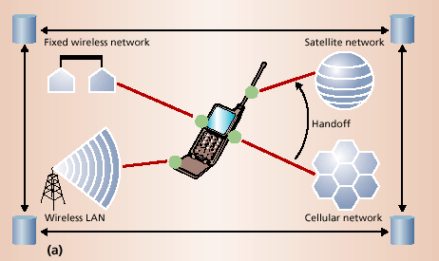
Figure 1: A multimode device

2. Overlay network: in this technique, the define UAP(Universal Access Points) which are the pointed contained in the network. Based on QoS, user choice and availability, the UAP choices which network to deal with as in figure 2. In addition, UAP is responsible to make the frequency and protocol translation, adoption and QoS tracing which is done in the user side. Not like Multimode devices architecture, UAP track network, user device capabilities and performance. Also, the handoffs are made by the overlay network, unlike multimode devices which is done by user or device. Finally, this architecture uses single subscription and billing since UAP can track various networks usages.

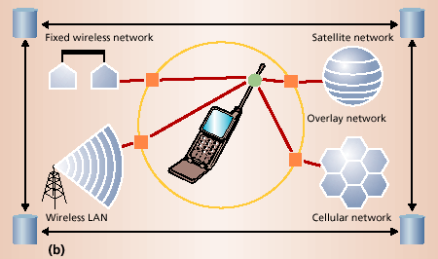
Figure 2: Overlay network

3. Common access protocol: The main idea of this technique is using a wireless network which can communicate with various access protocols see figure 3. An example of this is using W-ATM(Wireless Asynchronous transfer mode) network which needs every wireless network to allow the transition to W-ATM cells with their additional headers. In this architecture, satellite-based network can uses one protocol and other wireless network may user another protocol.

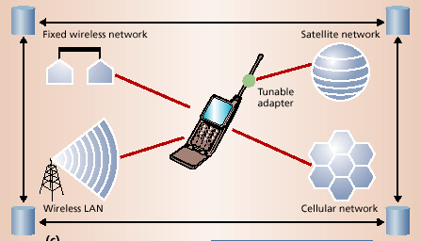
Figure 3: Common Access Protocol
B. All IP & IP mobility
IP is expected to be the underlying layer for 4G network because it doesn’t depend on the other architectures protocols [S2:6]. Seamless handover is needed on the IP, so it should be developed to provide less delay and lost of packets [S2:6]. However, using all-IP in wireless networks where the bandwidth is limited and IP protocols have a large amount of overhead, will decrease the efficiency for the radio spectral [S3:115].
4G will provide all its services over Internet Protocol (IP). According to S. Dixit state that “ the goal of 4G is to replace the current proliferation of core cellular networks with a single worldwide cellular core network standard based on IP for control, video, packet data and VoIP ”. The advantages of all-IP mobile/wireless network over 4G can be summarized as follow:
- It is flexible in term of access technology, so there is no relation between the networking protocol and radio access protocol.
- Less expensive, because the equipment are 60% cheaper then 3G. Also, it will reduce the service cost as well.
- IP will replace Signaling System 7 (SS7) which is used mainly on voice applications. Where IP is used by huge number of developers, SS7 is understood by small number. In addition, IP will bring more services in to picture compared with SS7.
The main goals for All-IP in 4G are mobility technology especially for real time applications. Also, it should provide different QoS and many applications. [S4:1-2]
In order to enhance the 4G mobility Hierarchical Mobile IPv6 (HMIPv6) will be used. In addition since Mobile IPv6 (MIPv6) doesn’t have router to manage the mobility, it will be used as mobility management. Also, HMIPv6 will integrate various 4G networks, so it is important to understand this protocol which will be in coming parts. [S2:6]

C. Technologies
1. Software used in Mobile IP
a. MIPv6
Mobile IP will provide a connection for network-application through wired, wireless and cellular network, MIPv6 is the software used to implement this technology. Also, MIP came to fulfill the needs for users’ applications which need to be connected during movement. There are three main component for MIP which are Mobile Node (MN), Home Agent (HA) and optionally Foreign Agent (FA). Where the MN is the mobile device which coordinate with HA to provide continuous connection and IP management. Also, the HA is sever or router that deployed the user’s base station. FA represents the visited network by the MN and manages the routing for MN’s traffic. [S9:1]
There are many reasons to develop MIPv6 due to the limitation in MIPv4. Table 1 show a comparison between MIPv4 and MIPv6 [S9:1-2]

Criteria | MIPv4 | MIPv6
Foreign Agent | Rely on HA and MN | Also, as MIPv4 but it doesn’t require FA to issue CoA (DHCP do it)-> location independent
Route optimization | Optional for CN and it need to be implemented | Allow direction connection from CN and MN but it need binding update to HA
Security | Use Virtual Private Network outside firewall and allow v4 IPsec VPN | As MIPv4 and it allow v6 IPsec VPN
Home Agent address discovery | -- | Using IPv6 anycast by sending binding update to HA anycast address.
Table 1: Comparison between MIPv4 & MIPv6

By using MIPv6 in IPv6 networks, MN will get new CoA every time it access foreign network using auto-configuration scheme like advertisement or by DHCPv6, then MN will inform HA with this new CoA by sending binding update and get binding acknowledgment. HA will intercept any packet go to MN and send it to registered CoA as in figure 4 and show the route optimization by eliminating the path from CN to HA by provide CN with CoA. [S9: 3]

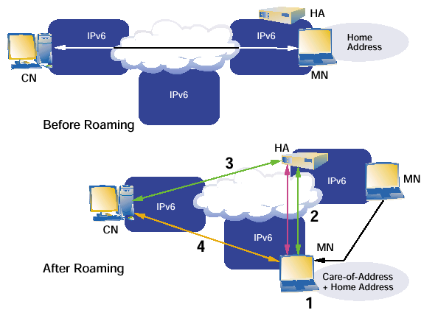
Figure 4: IPv6 before and after roaming using MIPv6

By using MIPv6 in IPv4, one different with IPv6 is that the packet will be capsulated/ de-capsulated using 6-to-4 roaming function. When MN moves to new network it will get new IPv4 address from DHCP, then MN will generate a mapping fromIPv4 to IPv6 CoA, then the same procedure will be applied in IPv6 will be applied here as well as in figure 5. [S9: 4]

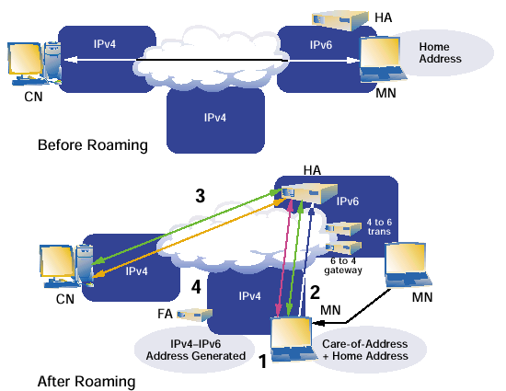
Figure 5: IPv4 before and after roaming using MIPv6

b. HMIPv6
The main purpose of HMIPv6 is to reduce lost data packet during movement and the inefficient using for wireless bandwidth [S10:1]. The main idea is to separate the local and global user by localizing mobility management [S10:1]. HMIPv6 is expected to reduce the amount of traffic to manage users’ movement and reduce the duration for handoffs [S10:1]. HMIPv6 is based on the fact that 69% of the time, the users are local not in mobility stage [S10:2]. Therefore, it will separate between micro-mobility and macro-mobility [S10:2]. As we knew in the previous section, the procedure for MIPv6, we will see what HMIPv6 will provide in next paragraph.
In HMIPv6, they have introduced Mobility Anchor Point (MAP) for every Access Router (AR) in MIPv6 that is located any where in hierarchical network. HMIPv6 will assign two CoAs which are Regional CoA (RCoA) and Local CoA (LCoA), RCoA is mainly given by MAP and LCoA is the CoA assigned by MIPv6 from the advertisement by AR or DHCP. Then, when MN access new MAP area it will know its MAP from Router Advertisement (RA). After that, MN will send Binding Update (BU) to MAP which will update binding cache, then BU will be sent to MN’s HA and CN. So, MAP will act as HA by forwarding received packets in RCoA to MN by building a tunnel to LCoA but MN can send data directly to CN without involving MAP or HA. When MN make any movement with MAP, its RCoA won’t change but its LCoA will change. Also, CN in the same MAP won’t need any action from MAP which will save extra bandwidth as in figure 6 which show the data flow in HMIPv6. [S10:3]

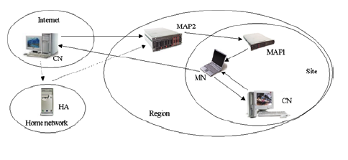
Figure 6: HMIPv6

c. Comparison between MIPv6 &HMIPv6
In evaluating HMIPv6, routing in HMIPv6 isn’t the same in MIPv6 because the incoming packets must go through MAP which will add extra cost and HMIPv6 scalability is not optimum [S10:4-5]. However, handoffs are better in HMIPv6 because of localizing the updates [S10:4]. Also, MN can send a BU earlier asking to foreword the incoming packets to new LCoA so the data drop during handoff will be minimized [S10:4]. However, this isn’t possible unless the direction for the MN is known. Also, the signaling load should be kept as minimum as possible and this what is done in HMIPv6 by reducing BU overheads and the local Updates within MAP is ignorable [S10:4]. Therefore, the gain in case of handover is 100% over MIPv6 during local movement and 0% during inter-site movement [S10:4]. Also, if MN change AR 70% of the time, the expected gain on average is 69% and the expected gain in signaling is about 90% [S10:4].

2. Intra-Domain Mobility Management Protocol (IDMP)
This is a proposal for 4G mobile networks. After evaluating the need for 4G as integrated network for many network technologies, authors have found that they need to reduce the handoffs and paging latency [S8:138]. Also, the latency during the intradomain movement isn’t acceptable for some 4G application and Mobile IP doesn’t support any form of paging, so the authors have proposed this protocol to overcome the limitations of MIP [S8:139].
Mobile IP is mobility management to provide redirection mechanism for the traffic from Correspondent Node (CN) to Mobile Node (MN) by assigning Care-of-Address (CoA). However, with real-time traffic and billion of MN, MIP will suffer from high update latency, large global signaling load and lack of paging support. In addition, those limitations are present in other variant of MIP such as MIPv6. Session Initiation Protocol (SIP) is another protocol that used to provide a real-time multimedia application from CN to MN. IDMP is a hierarchal mobility management which tries to localize the signaling on intradomain movement. There are two approaches to that, by route modification approach, characterized by Cellular IP (CIP) and HAWAII where the MN is assigned CoA which is valid through out the domain. Another approach is using multi-CoA where the MN is assigned many CoAs each one of them specifying MN’s location in intradomain level in the hierarchy. Also, MIP Regional Registration (MIP-RR) use Gateway foreign agent (GFA) that used to stabilize the CoA and act as proxy for home agent. Moreover, Hierarchical MIPv6 is used to localized the management of intradomain and reduce hand offs which will be compared in coming paragraphs. [S8:142]
IDMP is deferent than multi-CoA intradomain mobility solution like HAWAII and HMIPv6 in which it is designed to be standalone solution for intradomain mobility management and MIP isn’t assumed to be the global protocol for it [S8:140]. Figure 4 show the overview for IDMP where it is similar to Mobility Agent (MA) is like MIP-RR GFA and the Subnet Agent is like FA. Also, we have Local Care-of-Address (LCoA) which identify the MN’s subnet similar to MIP’s CoA [S8:141]. However, IDMP’s LCoA has only local domain-wide scope, so any change in LCoA will insure the packet to be arrived to MN [S8:141]. Also, Global Care-of-Address (GCoA) is used to locate MN in domain level [S8:141]. Therefore, packet to MN will be sent to GCoA and it will be intercepted by MA as in figure 7. Then, MA will tunnel these packets to MN using its LCoA [S8:141]. The advantages of IDMP is that it provide a uniform scheme for mobility management that allow cellular network supporting multiple global protocol using single common access infrastructure [S8:141]. Also, it allow dynamic assignment for one or more MAs to different MNs and IDMP uses Dynamic MA (DMA) architecture in order to offer different QoS [S8:141].

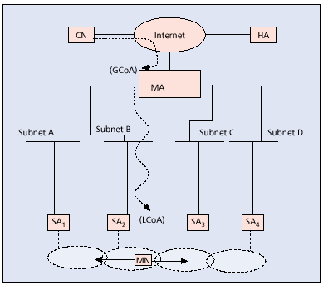
Figure 7: IDMP logical elements and architecture

Handoff delay is the needed by MA to be aware of MN’s new LCoA which contains of Link layer establishment delay ($Δ1$), IP subnet registration ($Δ2$) and Intradomain update delay ($Δ3$) [S8:141]. We see in figure 8 a comparison between IDMP and Cellular IP which show the number of packet lost during handoff as the packet interarrival time varies [S8:141]. What IDMP will offer is that it will delete ($Δ3$) and ($Δ1$) can be considered low component that equal 0 [S8:141]. Also, since old BS can’t discontinued until the new connection with BS is established, ($Δ2$) can’t be eliminated.

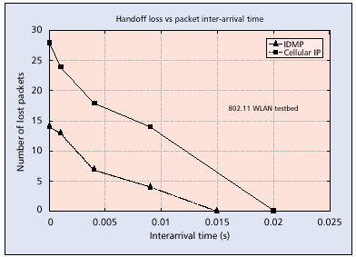
Figure 8: Packet loss in IDMP and CIP handoff

The procedure for fast handoff starts from layer 2 by indicating a change in the connectivity. As in figure 9, we see MN moves from SA2 to SA3, so in order to minimize the service interruption during handoff, IDMP will require that MN or old SA to send MovementImminent message to MA [S8:141]. As soon as this message is received, MA will send all packets to the entire close by SAs in our example SA3 or SA1 [S8:141]. Therefore, each of those SAs will buffer the received packets to minimize the lost in packets [S8:142]. Also, when MN finishes the subnet registration with SA3, SA3 will send all its buffered packets to it [S8:142]. The advantages of this handoff technique are that MovementImminent message is very small, even it can be implemented as bit in the IDMP frame [S8:142]. Also, it prevents waste of wireless bandwidth because BS won’t send all arriving packets and instead it will wait until it makes sure where the MN will be to forward them to it [S8:142]. However, it doesn’t eliminate ($Δ2$) because MN must make IDMP subnet registration before receiving any buffered packets [S8:142]. However, one issue to think about is the extra storage space needed to buffer these packets which can be considered as additional cost. But according to the article, it shows if the update latency is 200ms and the incoming data rate is 144 kb/s, then the buffer size is 200m*144k=3.6 kB which can be ignored [S8:143].

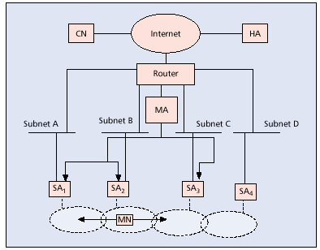
Figure 9: IDMP fast handoff

MIP provides fast handoff which required pre-registration with the new network by building new tunnel before making the handoff [S8:143]. And this approach need FA to know the neighboring FAs and build these secure tunnels unlike IDMP’s handoff [S8:143].
IDMP uses multicasting to reduce the lost in packets, it doesn’t reduce the frequency of intradomain location updates. So, MN must take new LCoA every time it change its place in the absent of paging support which will be power wastage. In addition, the situation will be worst for 4G network where we have a single device that have multiple wireless interface, so it needs to perform simultaneous binding and for Pico cellular layouts that lead to very often changes in the attachment point. For this problem, IDMP will provide an IP-layer paging solution which is flexible and radio-technology-independent, so it will reduce the wastage in MN’s power by eliminating unneeded signaling. IDMP will assume groups of SAs in Paging Areas (PAs) and every paging area identified by Paging Area Identifiers (PAIs). Therefore, MN will be able to know if there is a change in its paging area by listing to this identifier through SA advertisements. And example show this paging scheme in figure 10 which show SAs B, C and D belong to same PA where A in another PA, and as MN moves from B to C or D it will detect changes in its SA but not in its PA that it means it doesn’t care about the changing of LCoA. However, when it moves to A it will change its LCoA and it will change its PA. Also, when MA received a packet for MN that not have a valid LCoA that mean it is in movement, it will multicast a PageSolicitation packet to all the subnets associated with the MN’s current PA (SA2, SA3 and SA4) and it will buffer the coming packets. And when the MN completes its registration, these packets will be sent to it directly. In addition, this buffering should be very small because the intradomain update should have small latency. [S8:143]

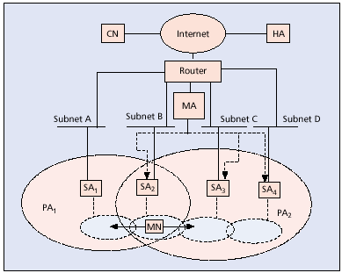
Figure 10: IDMP paging mechanism

III. PHYSICAL LAYER TECHNOLOGIES
A. Software Define Radio (SDR)
Allocating different frequency bandwidths for mobiles to work with on different countries created a problem with service provider which is dealing with different RF spectrum from country to another [S3:111]. Also, different technologies standards make the situation even worst, so the software solution for this problem is by using Software-Defined Radio. SDR can be implement using one infrastructure hardware system and by downloading the software for specific standard the handset can be used for this standard [S3:113]. Having a system, which can communicate with different standards and RF spectrum is possible by using the enhancement in the semiconductor and digital technologies [S3:113]. In addition, 4G doesn’t have a single standard, so we need to have hardware which is capable of changing standards [S12:4].
The development in analog-to-digital (A/D) and (D/A) converters ,which makes them operate in high speed with adequate dynamic range and the conversion made closer to antenna, will reduce the affect of radio component, so we will deal with digital component only as in figure 11. This conversion will help the HW to deal with different standards and frequencies in efficient way. In addition, the fast development on field programmable gate array (FPGA) and digital signal processing (DSP) helps to produce the general-purpose programmable devices with very low cost and high performance. [S3:133]

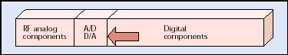
Figure 11: A high-level view for general radio system

The main idea of SDR to have a fabric that can prototype many MCM techniques to integrate several network types with high speed, scaleable and flexible fabric. One main different in SDR technique is that instead of using bussed and circuit switched architecture, they apply packet-based switch communications fabric. This fabric will consist of mainly switches, so the switching will be depended on the destination address attached in every transmitted packet. Therefore, parallel packets switched architectures have common characteristics like all of them are supporting high bandwidth and low protocol overhead by applying multiple data lines that are working in parallel with a separate data clock line on the other hand, serial packet switched architectures where they use less wires and they are more ideal for board-to-board communications. By applying packet-switched technologies we can design a system with multiple boards in a cPCI form factor. This systems contains an RF transceiver stage which is used to channelize, modem, and CODEC stage. Then other stages are implemented by using distributed network of processors nodes, which can be FPGA or general purpose processors. By using packet-switch embedded fabric we will hold all processing elements. So, we will have an architecture that will be able to operate with many transceiver channels, such as OFDM, W-CDMA, or some other protocol. The packet-switch embedded fabric have another advantage which is allow scalability for the system on the number of channels, dividing the applying algorithm among many processors and auto-reconfigure the system when it is needed in the case of switching to new network technology. [S12: 5-6]
Many difficulties face the SDR. One of these is using ASIC which manufactured in low cost, because service provider needs specific standard infrastructure system which can be designed with low cost using ASIC since less HW and SW overheads will be needed [S3:113]. In addition, the fast developments on HW in term of processing speed won’t show the advantage of SDR which need only SW updates [S3:113]. Moreover, using ASIC is less power consumable then SDR and the handset size is much smaller which may delay the implementation of SDR [S3:114]. Also, using ASIC may be suitable for many users who are in specific country using specific standard, so they won’t prefer to go for SDR because it is more expensive then ASIC [S3:113].
One important issue to think about it when designing such system is the speed of switching which depends on the firmware and software. Many FPGA vendors tried to speed up their designs and they developed many cores and algorithm for FPGAs and PowerPC processors. [S12:6]. Implementing OFDM using SDR is an example, which will be discussed in the following section.
Moreover, SDR has many benefits besides operating with different standard such as it is easier to implement the services using software upgrades which is good for the existing standard and end users. It is fixable solution, which can be modified using the software updates. [S3:113]

B. Technologies
1. Orthogonal Frequency Division Multiplexing (OFDM)
In order to provide high digital transmitting data rates over radio wave, OFDM is used to bring date rate up to 54Mbps and real traffic up to 22Mbps [S5:19]. In the 60s, OFDM was used to reduce the interface but it was high cost technology [S5:19]. In addition, the main objective for OFDM is that it will provide multimedia services [S5:19]. Also, since OFDM is based on high-speed digital signal processors (DSP) and DSP cost was reduced, OFDM can be implemented on reality now [S5:19].
The main technique that is used on OFDM is that the it signal is dividing the signal into smaller signal sets and then assigned every one onto different subcarrier which will be sent then at the same time in different frequencies [S5:19] as in figure 12 [S12:2]. By using parallel subcarriers as close as possible which are orthogonally and by minimizing the interfacing and overlapping as much as possible, OFDM can provide higher bandwidth then other kind of multiplexing [S5:19]. Also, all those subcarriers have a low symbol rate which has the previous high data rate advantage and reducing Inter-Symbol-Interference (ISI) [S12:2]. According to Joan Douglas, professor of electrical and computer engineering at the University of Illinois said “ OFDM uses the Fast Fourier transform (FFT) algorithm on both transmitter and receiver to mathematically transform signals and thereby efficiently space the frequencies so that they are as close as together as possible, yet still orthogonal”. Therefore, more data is expected to be transmitted using OFDM [S5:19]. The problem in using IEEE 802.11a is that if we need to increase the data rates using BPSK or QPSK, more power is required and more interface is expected, so it isn’t suitable [S5:19].

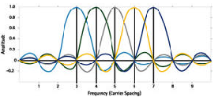
Figure 12: OFDM modulation scheme

In addition, 6-bit-data segments is used on OFDM which can send a lot of data in small bandwidth [S5:20]. What OFDM try to minimize is the interface between channels and it doesn’t concern about the quality of each channel which can be overcome using error correction technologies [S5:20]. Figure 13 show what are the major component to implement OFDM such as radio transceivers, FFT processors, system I/O, serial-parallel and parallel-serial converters and OFDM logic.

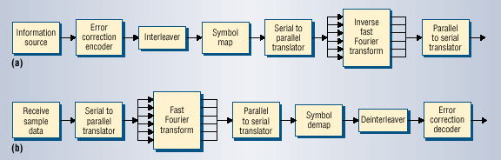
Figure 13: OFDM (a) transmitter (b) receiver

Moreover, OFDM tries to minimize the multipath effects by forwarding error correction and transmitting each bit using slow bit rates such as to transmit 1Mbps, the system will transmit 1000 bits in parallel on 1000 OFDM subchannels by transmitting 1 bit every millisecond [S5:20]. The disadvantage of OFDM is that its radio parts are designed to run at system peak which mean it will consume a lot of power [S5:20].
There are many kinds of OFDM which are
- Vector OFDM: this system uses spatial diversity, which utilizes the multipath signal reflections in order to improve the bandwidth by using signal processing and special antennas.
- F-OFDM: this uses fast frequency hoping spread spectrum technology, which will increase the signal capacity by, spread the signal among large frequency bandwidth.
- W-OFDM: this type reduces the interface between OFDM channels by adding additional frequency space.
- MIMO-OFDM: this type divides the signal, and then transmits them simultaneously through multiple antennas. [S5:21]
There are many issues which should be take care by the designers in order to make OFDM reaches the expected performance which can be stated as follows
- Frequency offset: this is caused in the case when the oscillator for the receiver isn’t oscillating at the same frequency for the transmitter. In addition, when there is any different in the sampling frequency, the error rate will increase. One disadvantage of OFDM is that it is very sensitive for frequency offset due to the power for adjacent sub-carriers that have been offset frequency will destroy orthogonality for sub-carriers. In order to overcome this problem, they have added training sequence at the beginning for every packet to help receiver to know the amount of offset and this method can be implemented easily using FPGAs. [S12:3-4]
- Phase noise: the oscillator will cause a phase noise in additional to frequency offset as a result of jitter for the oscillator. Moreover, using the training symbols and PLL will reduce the effects for phase noise. Also, pilot tones can be used as training sub-carriers which can be modulated using BPSK sequence known for the receiver.[S12:4]
- Peak to average power ratio PAR: a general problem for MCM systems is the big difference between the average and peak power for the signal and it is known as PAR. The main cause for this different is that those multiple carriers will add together to form very large signal or destroy each other to form very small signal. The solution for this problem is to design power amplifier to reduce the distortion and keep the average power low enough to accommodate large peak. [S12:4]

a. MIMO-OFDM
Now, I will take about MIMO-OFDM as an example of OFDM technology. The main idea of this technology that it is a combination of multi-input and multi-output antennas (MIMO) and OFDM modulation [S11:143]. The advantage of Multiple antenna technologies it is allowing higher capacities for internet and multimedia application [S11:143]. The future need for broadband access increase for 4G, which will required the applied technology to provide QoS, low RF equipment cost [S11:143]. Diversity in the fading environment will be created by multiple antennas in the transmitter and receiver [S11:143]. Also, the fade for created channels won’t be simultaneous and OFDM system will have two antennas in the transmitter side and three in the receiver side (2*3 downlink), and one transmit antenna and three receive antennas at he customer premises equipment (CPE) (1*3 uplink). MIMO-OFDM has many advantage which can be summarizes as follows: [S11:143]
- By using spatial diversity, it improves the link up to 10-20 dB by reducing the fade margin when it compared to single-input single-output (SISO)
- Using two base transceiver station (BTS) antenna will double the data rate by transmitting independent data through those antenna
- It has lower equalization complexity when compared with single-carrier solution for higher data rates
- By using frequency diversity, multipath became and advantage when we have proper coding and interleaving between frequency
- In MIMO each channel is equalized independently and multipath remain an advantage since frequency selectivity caused by multipath improve the rank for distribution
- MIMO-OFDM allows different data rates to be for different users base on the conditions for their channels
There are many design constraints for Non-LOS channels which need to ve taken care of them like channel dispersion, K-Factor, Doppler, Cross-Polarization discrimination, antenna correlation and condition number [S11:144-145]. In addition, there are some HW considerations which will affect the performance for MIMO-OFDM. DAC/ADC will generate distortion through saturation [S11:145]. The synchronization issue between the transmitter and receiver due to clock sampling non-uniform [S11:145]. Also, the up and down-converter oscillators will generate frequency drift and add phase noise which must be less then 30 dBc to have SDR>30 dB [S11:145]. In addition, all HW parts will introduce noise which has specific range on which the signal won’t be destroyed and this need to have a power control and automatic gain control [S11:145].
As in [S11] they did an experiment to make a performance evaluation by applying the HW and SW models. Also, they have each transceiver with six multipath channels and they use Matlab/C code (Physim) they have found the following: [S11:148-149]
- Fading Margins-it is function of Ricean K-Factor, delay spread and antenna correlation. OFDM will lower the fading margins because higher delay spread will cause frequency selectivity. In Rayleigh fading channels with (K=0) and no delay spread and zero antenna correlation, the fade margins in 99.9% link reliability are 35dB, 23dB and 10dB for 1*1, 1*2 and 2*3 antenna configurations.
- Cell Size- when the power to be transmitted is the same and 99.9% reliability, higher fade margins for 1*2 and 1*1 will reduce the cell size when we compare them with 2*3 system.
- Measured Data Rates- when the user is close to base station, high data rate can be achieved because of lower path lose and SNR. And by the experiment, authors stated that the peak data rates for 1*1 and 1*2 is 6.8Mb/s, where it is double for 2*3. Also, the study shows that 80% of the user will have data rates greater then 6.8Mb/s when they close to BTS because they are operating in multiplexing mode. However, the 2*3 system will operate in diversity mode which will combine the signals to lower fading margins and improve the coverage area. Moreover, the effect of multiple antennas on measuring the data rate is dramatic when compare it with 1*1 or 1*2 systems.
To, sum up MIMO-OFDM, has higher performance in terms of capacity, coverage and reliability over SISO, MISO and SIMO systems.

b. Implementing OFDM using SDR
To reach high data rate, Multi-Carrier Modulation (MCM) can be used which will divide the stream to lower bit rates parallel streams. Also, it will modulate several subcarriers and one of its main advantages is that it will provide high symbol rates [S7:2234]. OFDM, W-CDMA and MC-CDMA are examples for MCM technologies [S12:2]. Before modulation OFDM transmitter will converts and encodes data after receiving it from IP network into serial stream before the modulation stage [S12:2]. OFDM signal is created by using Inverse Fast Fourier Transform (IFFT) which will be converted into IF analog signal, then it will be sent to RF transceiver Also, the receiver stage is the reverse process for the transmit stage.
An OFDM transmitter will converts data to serialized PSK or QAM symbols, then it will convert this stream to parallel stream by using IFFT, after that the generated stream will be serialized and modulated by single carrier. Then, the receiver will apply the same process in reveres and using FFT. This scheme will need FFT/IFFT processing engine which should be able to make the real-time computations. In the past, the implement them using ASICs, but today the use high speed Field Programmable Gate Arrays (FPGA) which can be provided by many companies like Xilinx, Motorola or Texas where they have more features like extended memory, build-in HW multipliers or they can be general purpose processor like PowerPC. [S12:3]
To design OFDM using SDR platform, PowerPC processor will be as network interface to manage the incoming and outgoing IP packets. Also, CODEC which is implemented in FPGA processing nodes is the next stage and they are connected to the modem stage. Modem stage is implemented by using general purpose processor or Digital Signal Processor (DSP). In addition, to allow a processing element like PowerPC to run more then one signal processing functions for single channel, distributed transceiver architecture can be used. Moreover, the available communications fabric and inter-processor communication library will help scaling the system to handle many channels. [S12:6]

2. M-ary MC-CDMA technology
The main purpose of this technology is to provide high data rate for 4G which can reach 20Mbps. Since 4G will provide an interactive multimedia service like wireless internet and teleconferencing, it will need high data rate . MC-CDMA is a combination of OFDM and CDMA which will overcome the disadvantage of OFDM that is in the case of deep frequency selective fading, data will be lost in the corrupted subcarrier. We can summaries the advantage of MC-CDMA as follows: [S7:2234]
- High data rates
- High BW efficiency
- Reducing interference and frequency diversity
The main idea, in transmitter side the date rate will be converted to parallel, and by applying M-ary orthogonal modulation which will spread each symbol by orthogonal codes. Then, every spreaded symbol will be modulated on its corresponding carrier. After that, the multiple branches are transmitted after they combined. M-ary use a group of orthogonal codes which driven by Hadamard matrices and it has high spectrum efficiency when it is compared with other modulation technique. By using quadrature spread codes, MC-CDMA can reduce the effects of multipath fading and interference The main idea, in transmitter side the date rate will be converted to parallel, and by applying M-ary orthogonal modulation which will separate each symbol by orthogonal codes. [S7:2234]
As in figure 14 we see the transmitter structure, the first stage is converting the binary data from serial-to-parallel which will be grouped into m=${\text{log}}_{2}(M)$bits where each group map to one M orthogonal Walsh-Hadamard sequence W(t). Then, the signal is spreaded by using use’s complex quadrature orthogonal codes

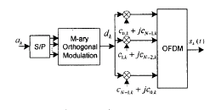
Figure 14:Transmitter structure

The kth user’s transmitted signal is
$$s_{k}(t)=\sum_{i=−x}^{x}{\sqrt{\frac{E_{s}}{2T}}}\sum_{n=0}^{N−1}{d_{n}[i](c_{n,k}+{\text{jc}}_{N−1−n,k})ϕ_{n}(t−\text{iT})}$$
and $ϕ_{n}(t)=\left\{\begin{matrix}e^{\frac{j2πm}{{\text{NT}}_{\text{mh}}}}−T_{g}t≤{\text{NT}}_{\text{sub}} \\ 0\text{__}\text{Otherwise}\end{matrix}\right.$
where Es is energy per M-ary orthogonal modulated bit. Also, T-Ntsub=Tg is a guard time interval to minimize the effect of the delay spread and N is code length and Tsub is the sampled period in the. Cn,k is Walsh-Hadamard orthogonal code where Cn,k=${±1}/{\sqrt{N}}$.[S7:2235]
The receiver structure is shown in figure 15 where the signal is sampled every Tsu sec in [0,Ntsub]. Then, the N samples are fed into N FFT points in order to find the received symbols

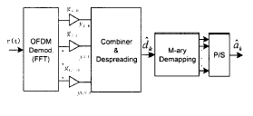
Figure 15: Receiver structure

And the received signal r(t) is
$$r(t)=\sum_{l=1}^{L}{α_{l}\sqrt{\frac{E_{s}}{2T}}}\sum_{k=1}^{K}{}\sum_{n=0}^{N−1}{d_{n}[i](c_{n,k}+{\text{jc}}_{N−1−n,k})\text{.}e^{\frac{j2π(1−τi)}{\text{NTsub}}}+n(t)}$$
n(t) is the additive Gaussian noise. [S7:2235]

CONCLUISION

It is clear that 4G is very challengeable proposed network generation. Therefore, scientists have tried to overcome those challenges by many proposals and technologies.

One of these solutions is the Software Define Radio which is a great breakthrough that will allow one HW design to communicate with many wireless technology. Also, OFDM is coming into the picture again to act as a major solution to increase the data rate. In addition, Mobile IP will solve the mobility problem for IP address and there are many software solutions like MIPv4, MIPv6 and HMIPv6. In additional, there are other proposals which act as enhancement for MIP like IDMP which were discussed in the report.

4G is the future generation, so it will take time to reach this stage of development that is estimated to be in 2010. However, the time isn’t a major factor but what is relay make different are the proposed capabilities for 4G to be reached.

TABLE OF FIGURES

Figure No. Figure Title page
1 A Multimode device 3
2 Overlay network 4
3 Common Access Protocol 4
4 IPv6 before & after roaming using MIPv6 6
5 IPv4 before & after roaming using MIPv6 7
6 HMIPv6 8
7 IDMP logical elements and architecture 9
8 Packet loss in IDMP and CIP handoff 10
9 IDMP fast handoff 11
10 IDMP paging mechanism 12
11 A high-level view for general radio system 12
12 OFDM modulation scheme 14
13 OFDM (a) transmitter (b) receiver 15
14 Transmitter structure 18
15 Receiver structure 19

TABLE OF TABLES

Table No. Table Title page
1 Comparison between MIPv4 & MIPv6 6

REFERENCES

- B.G. Evans, and Baughan K. “ Visions of 4G”. Electronics & Communication Engineering Journal: 293-303, 2000.

- Frderic Paint, Pall Engelstad and etc. “ Mobile Aspects in 4G Networks- White Paper”. Telenor Communication AS, 2002.

- Qi Bi, George, I. Zysman and etc. “Wireless Mobile Communication at the Start of the 21st Century”. IEEE Communication Magazine: 110-116,2001.

- S.S. Dixit. “Evolving to seamless all-IP wireless/mobile networks”. IEEE Communications Magazine: 31-32, 2001.

- Steven J. “ OFDM: Back to the Wireless Future”. Computer Magazine: 19-21, 2002.

- Upkar Varshney and Radhika Jain. “ Issues in Emerging 4G Wireless Networks”. Computer Magazine: 94-96, 2001.

- Wuyang Zhou and etc. “ M-ary MC-CDMA System for 4G”. IEEE Conference: 2234-2238, 2001.

- Archan Misra, Subir Das and Sajal Das. “ IDMP-Based Fast Handoffs and Paging in IP-Based 4G Mobile Networks”. IEEE Communication Magazine: 138-145, 2002.

- Paul, Schmitz and Geoff Weaver. “ MIPv6: New Capabilities for Seamless Roaming Among Wired, Wireless and Cellular Networks”. Intel Developer Update Magazine. 1-7, 2002.

- Esko Kupiainen. “ Hierarchical Mobility IPv6 Mobility Management”. IEEE Communication Magazine. 1-5, 2002

- Hemanth Sampath and etc. “ A Fourth-Generation MIMO-OFDM Broadband Wireless System: Design, Performance, and Field Trial Results”. IEEE Communications Magazine. 143-149, 2002.

- J. Cyrus Sy “ Implementation of an OFDM Transceiver using an SDR Platform”. http://wirelessdesignmang.com/scripts/ShowPR.asp. 1-7, 2002

