Name: Id#

ISE 307, Term 173

ENGINEERING ECONOMIC ANALYSIS

Quiz# 5 Solution

Date: Wednesday, August 8, 2018

Q1. An investor bought 200 shares of stock at a cost of $20 per share. He held the stock for 15 years and wants to sell it now. For the first three years, he received no dividends. For each of the next seven years, he received total dividends of $200 per year. For each of the remaining five years, no dividends were paid. In the last 15 years, the investor's marginal tax rate and capital gain tax rate were averaging about 30% and 20%, respectively. What would be the break-even selling price for the 200 shares to earn a 15% return on investment after tax?

(a) $35,390
(b) $35,590
(c) $35,790
(d) $35,990

PW(15%) = -$4,000 + $200(1 - 0.30)(P/A, 15%, 7)(P/F, 15%, 3) + [X - (X -4,000)0.2](P/F, 15%, 15) = -$4,000 + $382.976 + 0.0983X + $98.316 = 0
0.0983X = $3518.7
X = $35,789.9

Q2. Given the following sensitivity graph, which of the following statements are incorrect:

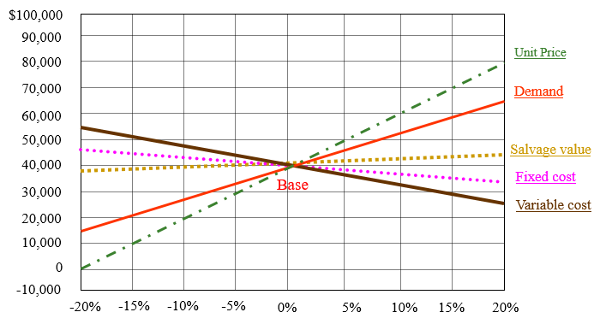

(a) The project is very sensitive to changes in unit price
(b) The project is very sensitive to changes in demand
(c) The project is fairly sensitive to changes in variable cost
(d) The project is at high risk for changes in unit price

Q3. Lane Construction Lld. is considering the acquisition of a new dump truck. The truck's price is $90,000. This truck falls into the MACRS five-year class. It will be sold after five years for $20,000. The truck purchase will have no effect on revenues, but it is expected to save the firm $35,000 per year in before-tax operating costs mainly in leasing expenses. The firm 's marginal tax rate (federal plus stare) is 40%. The net cash flow at year 5 is:

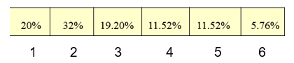
(a) $39,021
(b) $39,221
(c) $39,421
(d) $39,621

Book Value: 90000*(5.76%+11.52%/2) = 10368
Gain (or loss): 20000-10368 = 9632
Gain tax (or credit): 9632*0.40 = 3852.8

Q4. You purchased an industrial oven five years ago for $70,000. O&M costs are $20,000 this year but are expected to increase by $1,500 each year for the next five years. The current salvage value of the machine is $20,000; salvage value after one year is estimated to be $10,000; after two years, $9,000; after three years, $8,000; after four years, $7,000; and so on. At i = 12 %, find the remaining economic life of the asset.

(a) N=1
(b) N=3
(c) N=4
(d) N=5

Q5. The following data for a defender and a challenger in the tables given below show the market value, operation and maintenance cost (O&M Cost), capital recovery cost (CR), annual operation cost (AOC) and annual equivalent cost (AEC). Assuming 15% MARR and that the service of either machine is needed for an indefinite period of time:

Defender
n | Market Value | O&M Cost | CR(15%) | AOC(15%) | AEC(15%)
0 | $200,000
1 | $160,000 | $100,000 | $70,000 | 100000 | $170,000
2 | $128,000 | $111,000 | $63,488 | 105116.3 | $168,605
3 | $102,400 | $122,000 | $58,107 | 109978.4 | $168,085
4 | $81,920 | $133,000 | $53,647 | 114588.8 | $168,236
5 | $65,536 | $144,000 | $49,943 | 118951 | $168,894
6 | $52,429 | $155,000 | $46,858 | 123069.1 | $169,927

Challenger
n | Market Value | O&M Cost | CR(15%) | AOC(15%) | AEC(15%)
0 | $450,000
1 | $337,500 | $60,000 | $180,000 | $60,000 | $240,000
2 | $253,125 | $60,000 | $159,070 | $60,000 | $219,070
3 | $189,844 | $60,000 | $142,419 | $60,000 | $202,419
4 | $142,383 | $60,000 | $129,105 | $60,000 | $189,105
5 | $106,787 | $60,000 | $118,404 | $60,000 | $178,404
6 | $80,090 | $60,000 | $109,757 | $60,000 | $169,757

Determine when the defender should be replaced by the challenger.

(a) Immediately.
(b) At the end of the third year.
(c) At the end of the fourth year.
(d) At the end of the fifth year.

Economic service life of defender, N_{d}*=3, and AECd* = $168,992.
Economic service life of challenger, N_{c}*=6, and AEC_{c*} = $169,757.

Since AEC_{d*}=$168,992< AEC_{c*} = 169,757, then we need to keep the defender for its economic service life i.e., 3 years.

Next, we need to find the cost of using the defender for the fourth year.

I = 102,400, S = 81,920, OMC = 133,000
Cost = 102,400 (F/P,15%,1)+ 133,000-81,920
=102,400*1.15+133,000-81,920=168,840

Since 168,840< AEC_{c*} = 169,757, this means that we should keep the defender for the fourth year.

Next, we need to find the cost of using the defender for the fifth year.
I = 81,920, S = 65,536, OMC = 144,000
Cost = 81,920 (F/P,15%,1)+144,000-65,536
= 81,920*1.15+144,000-65,536 = 172,672

Since 172,672 > AEC_{c*} = 169,757, this means that we should replace the defender by the challenger at the end of the fourth year.

