Name: Id#

ISE 307, Term 173

ENGINEERING ECONOMIC ANALYSIS

Quiz# 4 Solution

Date: Monday, August 6, 2018

Q1. A machine purchased for $50,000 has a depreciable life of five years. It will have an expected salvage value of $5000 at the end of the depreciable life. Using the straight-line method, what is the book value at the end of year 2?

(a) $25,000
(b) $27,000
(c) $30,000
(d) $32,000

n | Dn | Bn
0 |  | 50000
1 | 9000 | 41000
2 | 9000 | 32000
3 | 9000 | 23000
4 | 9000 | 14000
5 | 9000 | 5000

Q2. A machine purchased for $60,000 has a depreciable life of five years. It will have an expected salvage value of $10,000 at the end of the depreciable life. Using the double-declining balance (200% DB) method, what is the depreciation amount for year 4?

(a) $800
(b) $2,960
(c) $4,320
(d) $5,184

n | Dn | Bn
0 |  | 60000
1 | 24000 | 36000
2 | 14400 | 21600
3 | 8640 | 12960
4 | 2960 | 10000
5 | 0 | 10000

Q3. A machine purchased for $36,000, has a depreciable life of five years. It will have an expected salvage value of $1000 at the end of the depreciable life. Using the double-declining balance (200% DB) method with switching to straight line method, what is the depreciation amount for year 4?

(a) $3,110.4
(b) $3,388
(c) $2,888
(d) None of the given answers

n | Depreciation | Book Value | Depreciation | Depreciation
0 |  | 36000 | SL | DDB
1 | 14400.0 | 21600.0 | 7000.0 | 14400.0
2 | 8640.0 | 12960.0 | 5150.0 | 8640.0
3 | 5184.0 | 7776.0 | 3986.7 | 5184.0
4 | 3388.0 | 4388.0 | 3388.0 | 3110.4
5 | 3388.0 | 1000.0 | 3388.0 | 1755.2

Q4. A truck for hauling coal has an estimated net cost of $50,000 and is expected to give service for 200,000 miles, resulting in $5,000 salvage value. The book value of the truck after it has been driven for 20,000 miles in the first year and 30,000 miles in the second year is:

(a) $11,250
(b) $12,500
(c) $37,500
(d) $38,750

=50000-50000/200000*(50000-5000)= 38,750

Q5. Suppose that you placed a commercial building (warehouse) in service in May. The building depreciates in 39 years. The cost of the property is $300,000, which includes the $100,000 value of land. Determine the amount of depreciation that is allowed during the first year of ownership.

(a) $3,205.13
(b) $3,418.80
(c) $4,807.69
(d) $5,128.21

= (7.5/12)*200,000/39 = 3,205.13

Q6. A company purchased a drill press priced at $170,000 in year 0. The company additionally incurred $30,000 for site preparation and labor to install the machine. The drill press was classified as a seven-year MACRS class property. The company is considering selling the drill press for $70,000 at the end of year 5. Compute the book value at the end of year 5 that should be used in calculating the taxable gains.
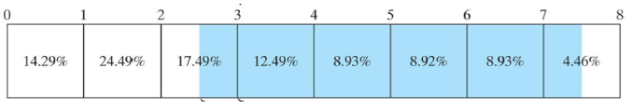

(a) $37,927.0
(b) $44,620.0
(c) $45,517.5
(d) $53,550.0

=200000-200000*(14.29+24.49+17.49+12.49+8.93/2)/100

Q7. The average tax rate for a taxable income of $250,000 using the US Corporate tax schedule given below is around:

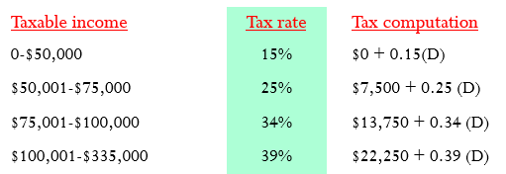

(a) $32.3%
(b) $34.0%
(c) $39.0%
(d) $40.4%

=(22250+0.39*150000)/250000*100 = 32.32%

Q8. Given an asset that has a cost basis of $300,000 and was sold for $400,000. The book value for the asset at the time of sale was $100,000. Assume that the capital gain tax rate is 40% while the ordinary gain tax rate is 30%. Then, the net proceeds from this sale is:

(a) $100,000
(b) $200,000
(c) $300,000
(d) $400,000

= 400,000 – [(400,000-300,000)*0.40 + (300,000-100,000)*0.30]
= 400,000 – [40,000 + 60,000] = 300,000

