Name: Id#

ISE 307, Term 173

ENGINEERING ECONOMIC ANALYSIS

Quiz# 4 Solution

Date: Monday, August 6, 2018

Q1. A machine purchased for $50,000 has a depreciable life of five years. It will have an expected salvage value of $5000 at the end of the depreciable life. Using the straight-line method, what is the book value at the end of year 3?

(a) $15,000
(b) $18,000
(c) $20,000
(d) $23,000

n | Dn | Bn
0 |  | 50000
1 | 9000 | 41000
2 | 9000 | 32000
3 | 9000 | 23000
4 | 9000 | 14000
5 | 9000 | 5000

Q2. A machine purchased for $50,000 has a depreciable life of five years. It will have an expected salvage value of $10,000 at the end of the depreciable life. Using the double-declining balance (200% DB) method, what is the depreciation amount for year 4?

(a) $0
(b) $800
(c) $3,456
(d) $4,320

n | Dn | Bn
0 |  | 50000
1 | 20000 | 30000
2 | 12000 | 18000
3 | 7200 | 10800
4 | 800 | 10000
5 | 0 | 10000

Q3. A machine purchased for $26,000, has a depreciable life of five years. It will have an expected salvage value of $1000 at the end of the depreciable life. Using the double-declining balance (200% DB) method with switching to straight line method, what is the depreciation amount for year 4?

(a) $2,246.4
(b) $2,308
(c) $2,808
(d) None of the given answers

n | Depreciation | Book Value | Depreciation | Depreciation
0 |  | 26000 | SL | DDB
1 | 10400.0 | 15600.0 | 5000.0 | 10400.0
2 | 6240.0 | 9360.0 | 3650.0 | 6240.0
3 | 3744.0 | 5616.0 | 2786.7 | 3744.0
4 | 2308.0 | 3308.0 | 2308.0 | 2246.4
5 | 2308.0 | 1000.0 | 2308.0 | 1323.2

Q4. A truck for hauling coal has an estimated net cost of $60,000 and is expected to give service for 200,000 miles, resulting in $5,000 salvage value. The book value of the truck after it has been driven for 30,000 miles in the first year and 40,000 miles in the second year is:

(a) $19,250
(b) $21,000
(c) $39,000
(d) $40,750

=60000-70000/200000*(60000-5000) = 40,750

Q5. Suppose that you placed a commercial building (warehouse) in service in March. The building depreciates in 39 years. The cost of the property is $300,000, which includes the $100,000 value of land. Determine the amount of depreciation that is allowed during the first year of ownership.

(a) $4,059.83
(b) $4,273.50
(c) $6,089.74
(d) $6,410.26

= (9.5/12)*200,000/39 = 4,059.83

Q6. A company purchased a drill press priced at $170,000 in year 0. The company additionally incurred $30,000 for site preparation and labor to install the machine. The drill press was classified as a seven-year MACRS class property. The company is considering selling the drill press for $70,000 at the end of year 4. Compute the book value at the end of year 4 that should be used in calculating the taxable gains.
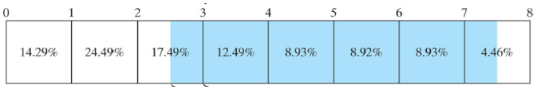

(a) $53,108.0
(b) $62,480.0
(c) $63,724.5
(d) $74,970.0

=200000-200000*(14.29+24.49+17.49+12.49/2)/100

Q7. The average tax rate for a taxable income of $200,000 using the US Corporate tax schedule given below is around:

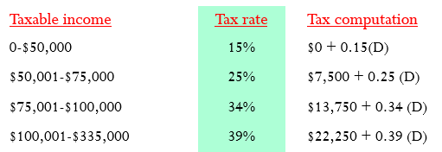

(a) $30.6%
(b) $34.0%
(c) $36.5%
(d) $39.0%

=(22250+0.39*100000)/200000*100=30.625%

Q8. Given an asset that has a cost basis of $250,000 and was sold for $300,000. The book value for the asset at the time of sale was $150,000. Assume that the capital gain tax rate is 40% while the ordinary gain tax rate is 30%. Then, the net proceeds from this sale is:

(a) $150,000
(b) $250,000
(c) $300,000
(d) None of the given answers

= 300,000 – [(300,000-250,000)*0.40 + (250,000-150,000)*0.30]
= 300,000 – [20,000 + 30,000] = 250,000

