Name: KEY Id#

ISE 307, Term 153

ENGINEERING ECONOMIC ANALYSIS

Quiz# 4

Date: Wednesday, August 24, 2016

Q1. A manufacturing company has purchased three assets:

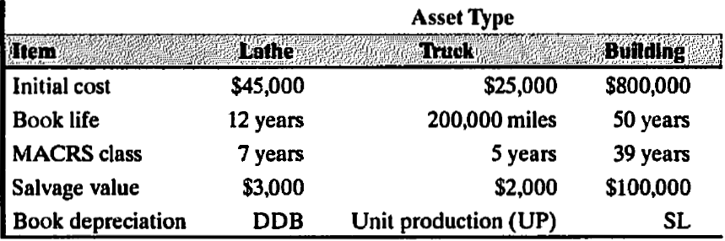

The truck was depreciated by the units-of-production method. Usage of the truck was 22,000 miles and 25,000 miles during the first two years, respectively.
- Calculate the book depreciation for each asset for the first two years.
- If the lathe is to be depreciated over the early portion of its life by the DDB method and then by a switch to the SL method for the remainder of its life, when should the switch occur?
(a) Book depreciation:

- Truck

- Lathe and building:

 | Lathe |  |  | Building
 | DDB |  |  |  | SL
n | D_{n} | B_{n} |  | n | D_{n} | B_{n}
0 |  | $45,000 |  | 0 |  | $800,000
1 | $7,500 | $37,500 |  | 1 | $14,000 | $786,000
2 | $6,250 | $31,250 |  | 2 | $14,000 | $772,000

- Allowed annual depreciation:

 | With switching
 | From DDB to SL
n | D_{n} (DBB) | B_{n} | D_{n} (SL Method)
0 |  | $45,000
1 | $7,500 | $37,500 | (45000-3000)/12=3500
2 | $6,250 | $31,250 | (37500-3000)/11=3136
3 | $5,208 | $26,042 | (31250-3000)/10=2825
4 | $4,340 | $21,701 | (26042-3000)/9=2560
5 | $3,617 | $18,084 | (21701-3000)/8=2338
6 | $3,014 | $15,070 | (18084-3000)/7=2155
7 | $2,512 | $12,559 | (15070-3000)/6=2012
8 | $2,093 | $10,466 | (12559-3000)/5=1912
9 | $1,744 | $8,599 | (10466-3000)/4=1867
10 | $1,433 | $6,732 | (8599-3000)/3=1866
11 | $1,122 | $4,866 | (6732-3000)/2=1866
12 | $811 | $3,000

The switching occurs at the 9th year.

Q2. To automate one of its production processes, Milwaukee Corporation bought three flexible manufacturing cells at a price of $400,000 each. When they were delivered, Milwaukee paid freight charges of $30,000 and handling fees of $15,000. Site preparation for these cells cost $50,000. Six employees, each earning $15 an hour, worked five 40-hour weeks to set up and test the manufacturing cells. Special wiring and other materials applicable to the new manufacturing
cells cost $2,000.
- Determine the cost basis (the amount to be capitalized) for these cells.
- Suppose that these cells were sold after 3 years for $50,000 each and they were depreciated using the 5-year MACRS Table given below. Determine the book value and tax gains or losses assuming 35% tax rate.
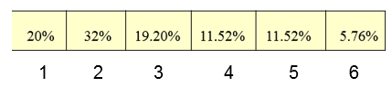

- Cost basis for flexible manufacturing cells:

flexible manufacturing cells (@$400,000×3) | $1,200,000
freight charges | $30,000
handling fee | $15,000
site preparation costs | $50,000
start up and testing costs | $18,000
special wiring and material costs | $2,000
cost basis | $1,315,000

(Note: start-up and testing costs = $15 x 40 x 6 x 5 = $18,000)

- Book Value = 1,315,000 * [ 1 – (0.20 + 0.32 + 0.192/2) ] = $504,960
Tax gains (losses) = 0.35*(150,000 - 504,960) = -$124,236
Thus, there will be tax credit (gains) of $124,236.

