Name: Id#

ISE 307, Term 173

ENGINEERING ECONOMIC ANALYSIS

Quiz# 3 Solution

Date: Tuesday, July 24, 2018

Q1. Given an investment project with MARR=10% that has a zero net present worth value, we can conclude the following about the project:

(a) The project has made a loss
(b) The project has made a profit <10%
(c) The project has made a profit =10%
(d) The project may or may not have made a profit

Q2. You invested $100,000 in a project and received $40,000 at n = 1, $40,000 at n = 2, and $30,000 at n = 3 years. You need to terminate the project at the end of year 3. Your interest rate is 10%; what is the project balance at the time of termination?

(a) Gain of $10,000
(b) Loss of $8,039
(c) Loss of $10,700
(d) Just break even

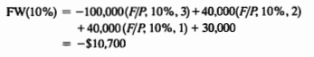

Q3. A&M Corporation purchased a vibratory finishing machine for $20,000 in year 0. The machine's useful life is 10 years at the end of which the machine is estimated to have a zero salvage value. The machine generates net annual revenues of $9,000. The annual operating and maintenance expenses are estimated to be $1,000. If A&M's MARR is 15%, how many years does it take before this machine becomes profitable?

(a) 2 years < n ≤ 3 years
(b) 3 years < n ≤ 4 years
(c) 4 years < n ≤ 5 years
(d) 5 years < n ≤ 6 years

0 | -20000 | 0.0 | -20000.0
1 | 8000 | -3000.0 | -15000.0
2 | 8000 | -2250.0 | -9250.0
3 | 8000 | -1387.5 | -2637.5
4 | 8000 | -395.6 | 4966.9

Q4. Consider manufacturing equipment that has an installed cost of $120,000. The equipment is expected to generate $45,000 of the annual energy savings during its first year of installation. The value of these annual savings is expected to increase by 5% per year (over previous year) because of increased fuel costs. Assume that the equipment has a service life of 10 years (or 5,000 operating hours per year) with $20,000 worth of salvage value. Determine the equivalent dollar savings per each operating hour at i = 10% per year.

(a) $6.99 per hour
(b) $7.24 per hour
(c) $4.45 per hour
(d) $4.29 per hour

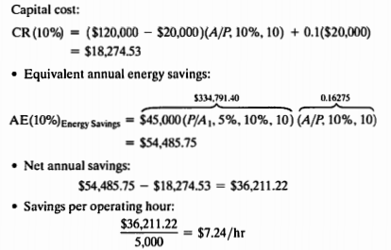

Q5. You invest in a piece of equipment costing $200,000. The equipment will be used for three years, and it will be worth $40,000 at the end of three years. The machine will be used for 5,000 hours during the first year, 6,000 hours during the second year and 7,000 hours during the third year. The expected annual savings associated with the use of the piece of equipment will be $40,000 for the first year, $45,000 for the second year and $50,000 for the third year. Your interest rate is 10%.
- What is the capital recovery cost?

𝐶𝑅(10%) = (200,000 – 40,000)(𝐴/𝑃, 10%, 3) + 0.1 * 40,000
= 160,000*0.4021 + 4,000
= $68,336

- What is the annual equivalent worth?

AE_{savings}(10%) = [40,000(𝑃/𝐹, 10%, 1) + 45,000(𝑃/𝐹, 10%, 2) + 50,000(𝑃/𝐹, 10%, 3)](𝐴/𝑃, 10%, 3)
= [40,000*0.9091 + 45,000*0.8264 + 50,000*0.7513]*0.4021
= 111,117*0.4021 = $44,680.1

AE(10%) = 44,680.1- 68,336= $-23,655.9

- What is the net savings generated per machine-hour?

Let C be savings per machine hour
Then, AE(10%) = 5000C(𝑃/𝐹, 10%, 1) + 6000C(𝑃/𝐹, 10%, 2) + 7000C(𝑃/𝐹, 10%, 3)](𝐴/𝑃, 10%, 3)
= [5,000C*0.9091 + 6,000C*0.8264 + 7,000C*0.7513]*0.4021
= 14,763C*0.4021= 5,936.2C

Thus, C = -23,655.9/5,936.2 = -$3.985 per machine hour
Thus, there is a loss of $3.985 per machine hour.

