Name: KEY Id#

ISE 307, Term 153

ENGINEERING ECONOMIC ANALYSIS

Quiz# 2

Date: Monday, August 8, 2016

Q1. The accompanying table shows a cash flow for a company along with CPI:

Year | Cash | CPI | Inflation Rate
0 | 100,000 | 180
1 | 115,000 | 184 | =(184/180)-1=2.22%
2 | 128,000 | 189 | =(189/184)-1=2.72%
3 | 145,000 | 196 | =(196/189)-1=3.70%

Assuming that year 0 is the base period, determine the inflation rate for each period, and calculate the average inflation rate over the three years.

Average inflation rate over the three years = (196/180)^{1/3} – 1= 2.88%

What will be the equivalent cash of year 3 stated in terms of year 1 cash?

= 145,000 (1.037)⁻¹(1.0272)⁻¹ = 136,122.4

Q2. The average starting salary for engineers was $8,000 a year in 1985. John, a mechanical engineer, got an offer for $48,000 a year in 2012. Knowing that the CPIs for 1985 and 2012 are 36.87 and 205.43, respectively, what is John's real salary in terms of constant 1985 dollars?

f' = (205.43/36.87)^{1/27} – 1 = 0.065686

John's real salary in terms of constant 1985 dollars = 48,000 (1+0.065686)⁻²⁷ = $8,614.91

Q3. Consider the following two mutually exclusive investment projects:

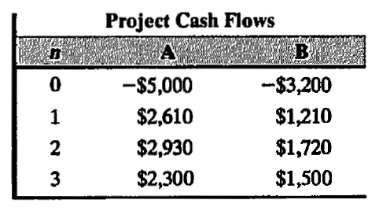

At an interest rate of 12%, which project would you recommend choosing?

Select project A.

