Name: KEY Id#

ISE 307, Term 153

ENGINEERING ECONOMIC ANALYSIS

Quiz# 2

Date: Monday, August 8, 2016

Q1. The accompanying table shows a cash flow for a company along with CPI:

Year | Cash | CPI | Inflation Rate
0 | 100,000 | 179.8
1 | 115,000 | 183.8 | =(183.8/179.8)-1=2.22%
2 | 128,000 | 188.0 | =(188.0/183.8)-1=2.29%
3 | 145,000 | 194.6 | =(194.6/188.0)-1=3.51%

Assuming that year 0 is the base period, determine the inflation rate for each period, and calculate the average inflation rate over the three years.

Average inflation rate over the three years = (194.6/179.8)^{1/3} – 1= 2.67%

What will be the equivalent cash of year 1 stated in terms of year 3 cash?

= 115,000 (1.0229)(1.0351) = 121,757.3

Q2. Suppose that you borrow $60,000 at 9% compounded monthly over five years. Knowing that the 9% represents the market interest rate, you compute the monthly payment in actual dollars as $1245.51. If the average monthly general inflation rate is expected to be 0.25%, determine the equivalent equal monthly payment series in constant dollars.

i' = (i-f)/(1+f) => i_{m}' = (0.09/12-0.0025)/1.0025 = (0.0075-0.0025)/1.0025 = 0.00499

A = 60,000 (A/P, 0.00499, 60) = 60,000*0.019326 = $1159.55

Q3. Consider the following two mutually exclusive projects:

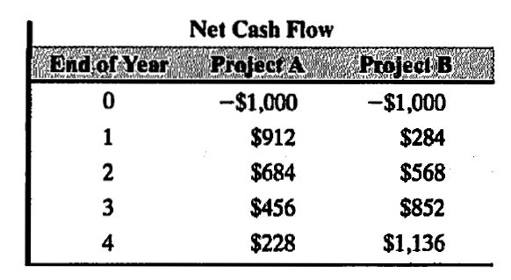

At an interest rate of 25%, which project would you recommend choosing?

Select project A.

