Name: Id#

ISE 307, Term 153

ENGINEERING ECONOMIC ANALYSIS

Quiz# 2

Date: Monday, August 8, 2016

Q1. The accompanying table shows a cash flow for a company along with CPI:

Year | Cash | CPI | Inflation Rate
0 | 100,000 | 179.8
1 | 115,000 | 183.8
2 | 128,000 | 188.0
3 | 145,000 | 194.6

Assuming that year 0 is the base period, determine the inflation rate for each period, and calculate the average inflation rate over the three years.

What will be the equivalent cash of year 1 stated in terms of year 3 cash?

Q2. Suppose that you borrow $60,000 at 9% compounded monthly over five years. Knowing that the 9% represents the market interest rate, you compute the monthly payment in actual dollars as $1245.51. If the average monthly general inflation rate is expected to be 0.25%, determine the equivalent equal monthly payment series in constant dollars.

Q3. Consider the following two mutually exclusive projects:

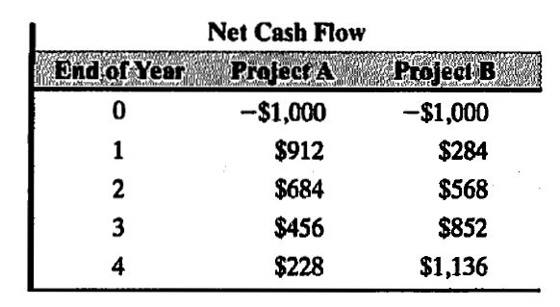

At an interest rate of 25%, which project would you recommend choosing?

