Name: Id#

ISE 307, Term 173

ENGINEERING ECONOMIC ANALYSIS

Quiz# 1 Solution

Date: Sunday, July 1, 2018

Q1. If you borrow $20,000 at an interest rate of 8%, compounded annually with the following repayment schedule, what is the required amount A?

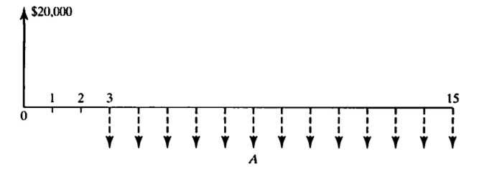

(a) A = $2,951
(b) A = $3,967
(c) A = $3,101
(d) A = $2,324

20,000(F/P, 8%, 2) =A (P/A, 8%, 13)

20,000*1.1664 =A*7.9038

=>A = 20,000*1.1664/7.9038 = $2,951.49

Q2. What is the amount of 10 equal annual deposits that can provide five annual withdrawals, when a first withdrawal of $2,000 is made at the end of year 11 and subsequent withdrawals increase at the rate of 5% per year over the previous year's rate if the interest rate is 7% compounded annually?

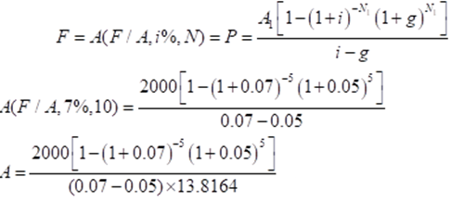

= 651.61

