Name: KEY Id#

ISE 307, Term 153

ENGINEERING ECONOMIC ANALYSIS

Quiz# 1

Date: Wednesday, July 20, 2016

Q1. Explain what makes economic decisions different from other design decisions?

Economic decisions involve predicting, or forecasting product sales, product selling price, and various costs overt future time frame. Such forecasts are never completely accurate. A prediction or forecast made today is likely to be different than one made in future. Engineering design outcomes are often time invariant.

Q2. What value of A makes the two annual cash flows shown in the following diagram equivalent at 12% interest compounded annually?

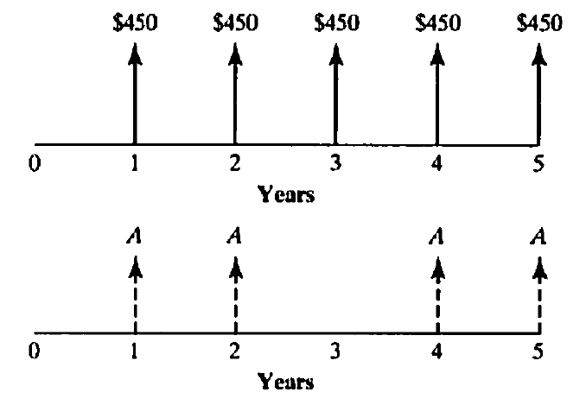

450 (P/A, 12%, 5) = A (P/A, 12%, 5) – A (P/F, 12%, 3)

450*3.6048 = A*3.6048 – A*0.7118

1622.16 = A (2.893)

A = 1622.16/2.893 = $560.72

Q3. Matt Christopher is a 30-year-old mechanical engineer, and his salary next year will be $80,000. Matt expects that his salary will increase at a steady rate of 6% per year until his retirement at age 60. If he saves 10% of his salary each year and invest these savings at an interest rate of 8%, how much will he have at his retirement?

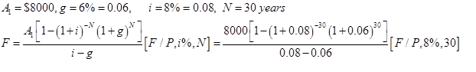

= 171690.9*10.0627 = $1,727,673.69

