Name: Id#

ISE 307, Term 153

ENGINEERING ECONOMIC ANALYSIS

Quiz# 1

Date: Wednesday, July 20, 2016

Q1. Explain what makes economic decisions different from other design decisions?

Q2. What value of A makes the two annual cash flows shown in the following diagram equivalent at 12% interest compounded annually?

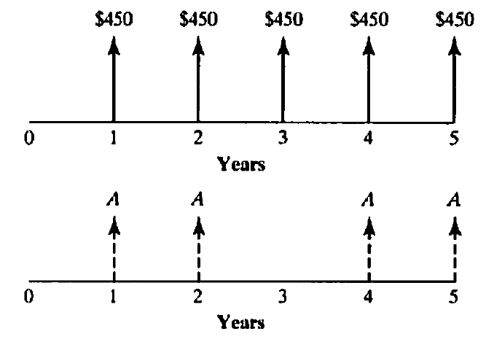

Q3. Matt Christopher is a 30-year-old mechanical engineer, and his salary next year will be $80,000. Matt expects that his salary will increase at a steady rate of 6% per year until his retirement at age 60. If he saves 10% of his salary each year and invest these savings at an interest rate of 8%, how much will he have at his retirement?

