Name: Id#

ISE 307, Term 153

ENGINEERING ECONOMIC ANALYSIS

Quiz# 1

Date: Wednesday, July 20, 2016

Q1. List the Fundamental Principles in Engineering Economics.

Q2. Compute the value of P for the accompanying cash flow diagram. Assume i=6% per year.

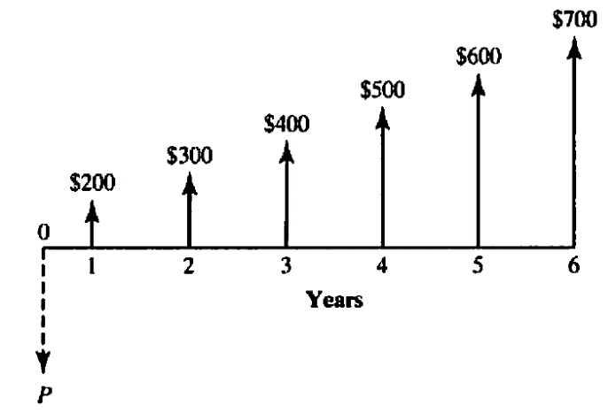

Q3. From the following cash flow diagram, find the value of C that will establish economic equivalence between the deposit series and the withdrawal series at an interest rate of 8% compounded annually.

